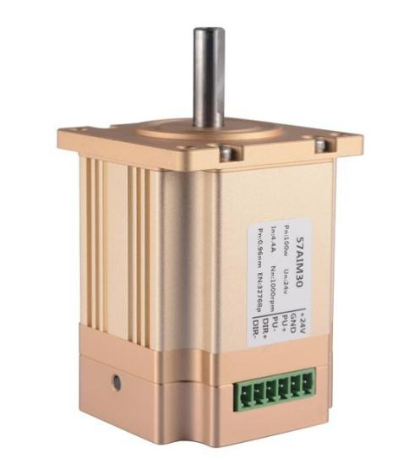

**Product Features :**

1. Isolated can communication (easycan protocol, simple, fast to use, speed 1m).

Support contour position mode, and, periodic synchronization mode.

2. 15 bit absolute encoder, one cycle pulse up to 32768.

3. Multi turn absolute value (battery required).

Pulse mode: power on again and return to power off position automatically.

Communication mode: power off recording position.

4. Multistage DD motor structure, large torque output.

5. Integrated servo, simplified wiring, ultra small volume.

6. Low noise, low vibration, high speed positioning, high reliability.

7. FOC field oriented vector control, supporting position / speed closed-loop.

8. It can work in the given pulse state of zero lag and follow the zero lag.

9. 16 bit electronic gear function.

10. Provide serial port upper computer, which can monitor motor status and modify parameters.

11. Position mode, support pulse + direction signal, encoder follows

12. Speed mode, support PWM duty cycle signal speed regulation

13. It has locked rotor, over-current protection and over-voltage protection.

# 参数表

|  |  |  |  |  |  |  |
| --- | --- | --- | --- | --- | --- | --- |
| **Model No. 57AIM15C 57AIM15CH 57AIM30C 57AIM30CH** | | | | | | |
| **Power** | | Voltage | 24~36VDC | 24~36VDC | 24~36VDC | 24~36VDC |
| Cuttent | 2.2A | 2.2A | 4.4A | 4.4A |
| **Motor parameter** | | Torque | 0.48NM | 0.24NM | 0.96NM | 0.48NM |
| Rated speed | 1000RPM | 2000RPM | 1000RPM | 2000RPM |
| Max speed | 1500RPM | 2500RPM | 1500RPM | 2500RPM |
| Power | 50W | 50W | 100W | 100W |
| Resistance | 2.65Ω | 2.65Ω | 1.3Ω | 1.3Ω |
| Inductance | 1.1mH | 1.1mH | 0.5mH | 0.5mH |
| Rotor inertia | 9.139*x*105  *KG* / *M* 2 | 9.139*x*105  *KG* / *M* 2 | 1.184*x*105  *KG* / *M* 2 | 1.184*x*105  *KG* / *M* 2 |
| **Feedback signal** | | | Multi turn absolute encoder (single turn 32768 pulse, single turn 15 bit) | | | |
| **Cooling mothed** | | | Natural cooling | | | |
| **Weight** | | |  | | | |
| **Position control mode** | **Max pulse input frequency** | | 500KHz | | | |
|  | **Pulse instruction mode** | | Pulse + Direction， A phase +B phase | | | |
|  | **Electronic gear ratio** | | Setting range from 1~65535 to 1~65535 | | | |
|  | **Position sampling frequency** | | 2KHz | | | |
| **Protect function** | | | Blocked alarm | | | |
| **Communication interface** | | | Easycan（CAN communication, speed 1M） | | | |

|  |  |  |
| --- | --- | --- |
|  | | 串口 TTL（19200,8,N,1）（监测电机状态和修改参数）。 |
| **Using environment** | **Temperature** | 0~40° |
| **Motor allowed max temperature** | 85° |
| **Humidity** | 5~95% |

**Interface Definition:**

Terminal No.:Face to terminal,the left one is the first.

|  |  |  |
| --- | --- | --- |
| **Terminal No.** | **Name** | **Function** |
| 1 | +24V | Positive pole of DC power ，+24V。 May short circuit or damage driver if positive and negative connect wrong |
| 2 | GND | DC power gound  (May short circuit or damage driver if positive and negative connect wrong) |
| 3 | PU+ (+5V) | Pulse control the signal:pulse rising edge is effective;PU-high power usually 3.3-5V,low power usually 0-0.5V.In order to reliablity respond to the pulse,the pulse width should greater than 1.2μs.If use +12V or +24V,resistance is required. |
| 4 | PU- (PU) |
| 5 | DIR+ (+5V) | Direction signal:High/low level signal,to ensure reliable reversing of the motor, the direction signal should be established at least 5μs before the pulse signal.DIR-high power usually 3.3-5V,low power usually 0-0.5V. |

Terminal No.:Face to terminal, from left to right, the low row is 12345, the up row is 678910 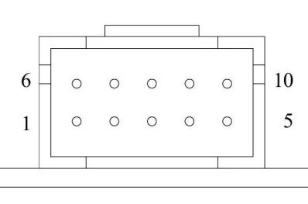

|  |  |  |
| --- | --- | --- |
| **Terminal No.** | **Name** | **Function** |
| 1 | CANL | Can communication port, CAN_5V n COM need 5V power input if use CAN communication |
| 2 | RX | Driver serial port sending port (TTL level) |
| 3 | TX | Driver serial port sending port (TTL level) |
| 4 | CANH | Can communication port, CAN_5V n COM need 5V power input if use CAN communication |
| 5 | GND | GND/Serial port |
| 6 | COM | Output signal and 485 power supply are common ground. |
| 7 | WR | Alarm signal output, internal for optocoupler NPN output.Normal for high resistance state,when alarm,conect with COM. |
| 8 | RDY/PF | Servo ready signal/in place signal.Have signal when power on and automatic operation(On)，Have signal when the following error is less than 0.5 °(On)，No signal when the following error is greater than 0.5(high resistance state) |
| 9 | ZO | Encoder zero output.Zero signal optically coupled NPN output signal. |
| 10 | CAN_5V | 485 communication 5V power supply,external power supply is requested.(The power supply is powered by the controller) |

**Motor Dimension :**

57AIM15:

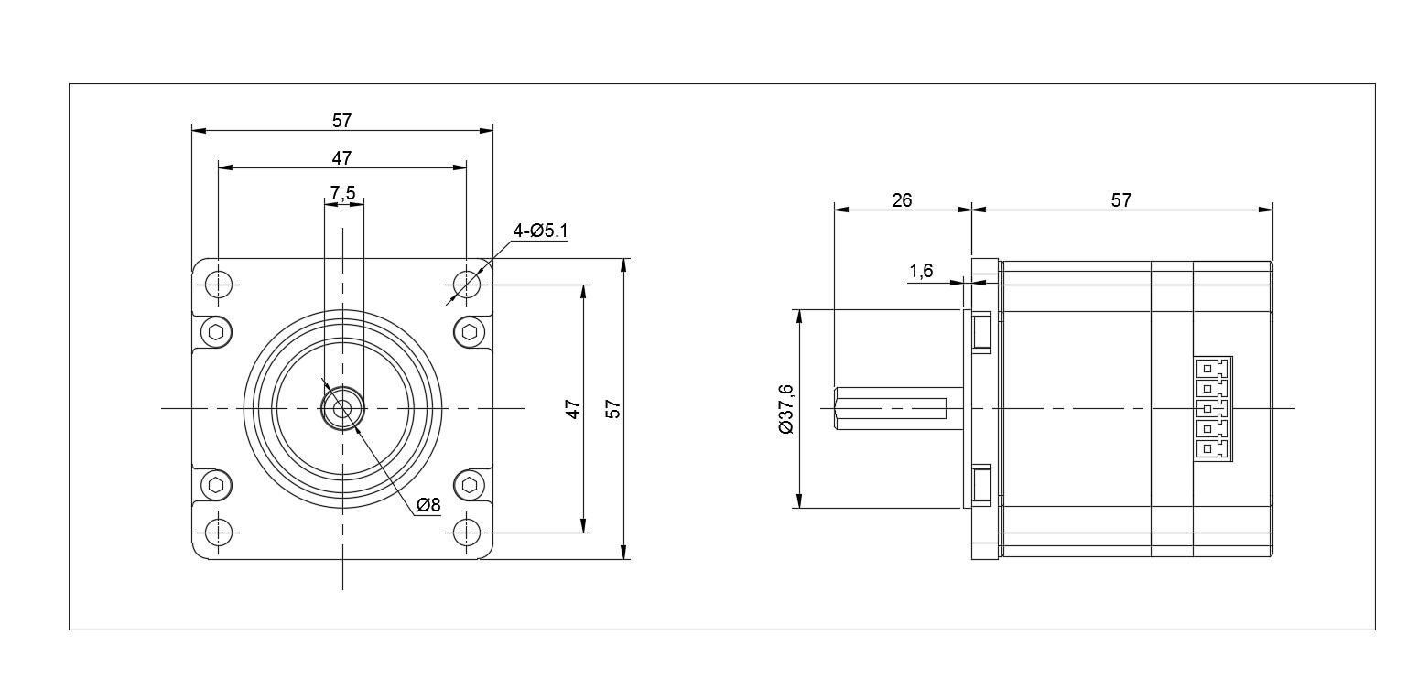

57AIM30：

