1. Add project to GitHub repository.(28/Dec/2021 Done)
2. Scrape data from myhome.ie(28/Dec/2021 Done)
3. Convert address into latitude and longitude

<https://towardsdatascience.com/geocode-with-python-161ec1e62b89>

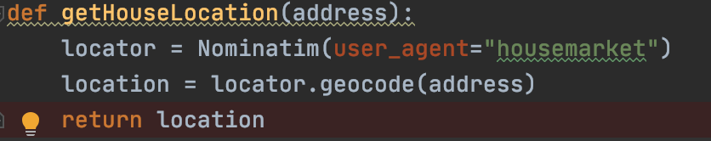

1. create virtual environment and use virtual environment

* install virtualenv

pip install virtualenv

* pip list

* Create virtual environment

virtualenv housemarket

* Enter virtual environment  
  source /Users/lwj/housemarket/bin/activate  
  


* Quit virtual environment  
  deactivate

Time serious

https://zhuanlan.zhihu.com/p/379486476

Dublin data set

https://data.smartdublin.ie/dataset/dublin-residential-property-price-register

Other data set

https://www.gov.ie/en/collection/2a8bf-house-price-statistics/

**Secondhand house price** (Data set)

https://data.gov.ie/dataset/second-hand-property-prices-by-area-by-year/resource/52c41149-b1c7-4938-aad8-bef26ab4476d

纯随机性检测

<https://mlln.cn/2017/10/26/python%E6%97%B6%E9%97%B4%E5%BA%8F%E5%88%97%E5%88%86%E6%9E%90-%E7%BA%AF%E9%9A%8F%E6%9C%BA%E6%80%A7%E6%A3%80%E9%AA%8C/>

使用Python建立时间序列(ARIMA、MA、AR)预测模型

<https://www.its404.com/article/WHYbeHERE/109277597>

利用python进行时间序列分析——数据挖掘

https://zhuanlan.zhihu.com/p/35128342

<https://zhuanlan.zhihu.com/p/60648709>

https://www.biaodianfu.com/arima.html