Aromas Country Garden Tour-
Featuring:
Artists in the Gardens
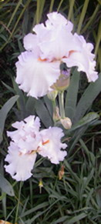
Saturday, May 9
Starts at 10:00
Gardens close
at 4:00pm

Tickets-$15
Seniors- $10

Aromas Grange
Rose & Bardue Aves

Presented by-
Aromas Hills Artisans

