The Basics of
Going Solar
If you’ve ever considered going solar,
this is the workshop for you!

You’ll learn:
- What options exist
- Which one is best for you
- How to pay for it


Monday, May 4th
7 – 9 pm
Aromas Grange
$5

The workshop will be taught by Joel Kauffman. Joel has worked in solar energy and energy efficiency since 2003. He is a NAPCEP solar installer. He co-founded Independent Energy Systems, was VP of Marketing and Business Development at Real Goods, and is currently the VP of Energy Consulting at Ecology Action in Santa Cruz.
We are very excited to have him come to Aromas!
Please arrive early so we can start at 7:00.
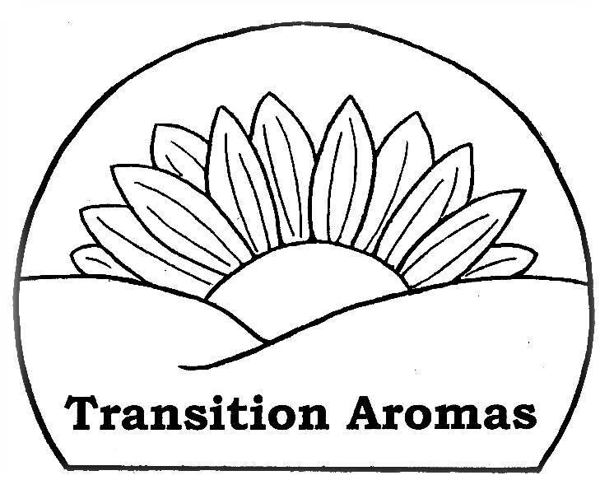
For more info contact info@TransitionAromas.org or call 726-3406

