Project report

**SDU Universitet**

**07/03/2013**

Alejandro Jorge Álvarez and Christoffer R. Clausen

Content

1. Introduction 2

2. Wideframe GUI design 2

3. Statechart diagrams for user action 2

4. Updated class diagram with methods and properties 2

5. Conclusion 2

# Introduction

Mandatory exercise of an administration system for a car dealer who sales and leases cars/trucks. His customer is both business and private customer.

# Wireframe GUI design

Mr. Chris.

# Statechart diagram for user action

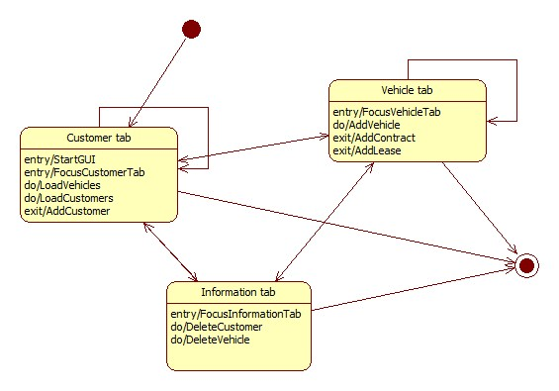

# Updated class diagram with methods and properties

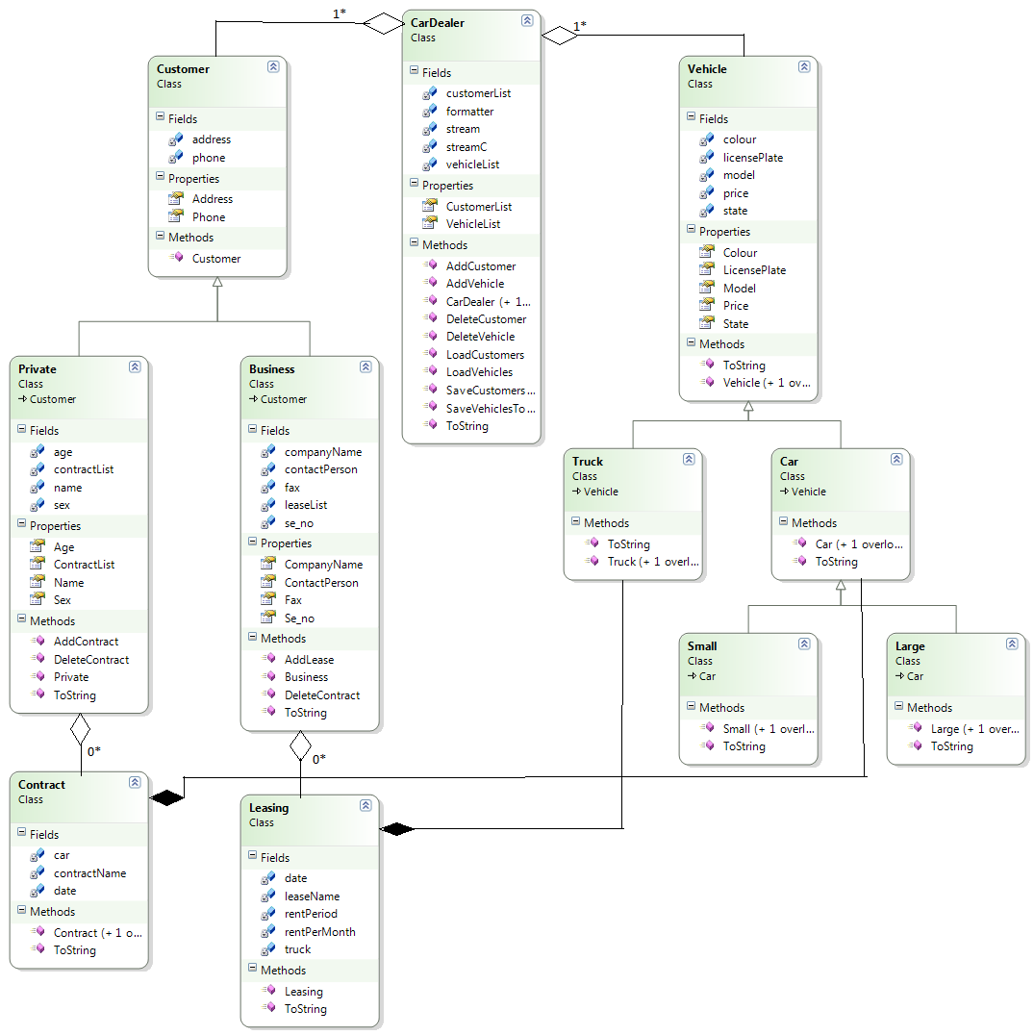

# Conclusion

To big