Alex Nguyen

CS290

10-25-15

Fall 2015

Web Development Project Proposal

**Description**: A flavor-pairing database. Users can register and favorite their flavor pairing. Favorite flavor pairs will show up at the top

**Sitemap**: Welcome, Login, Signup, About, Pairings, Nutrition

**Webpage Layout:**

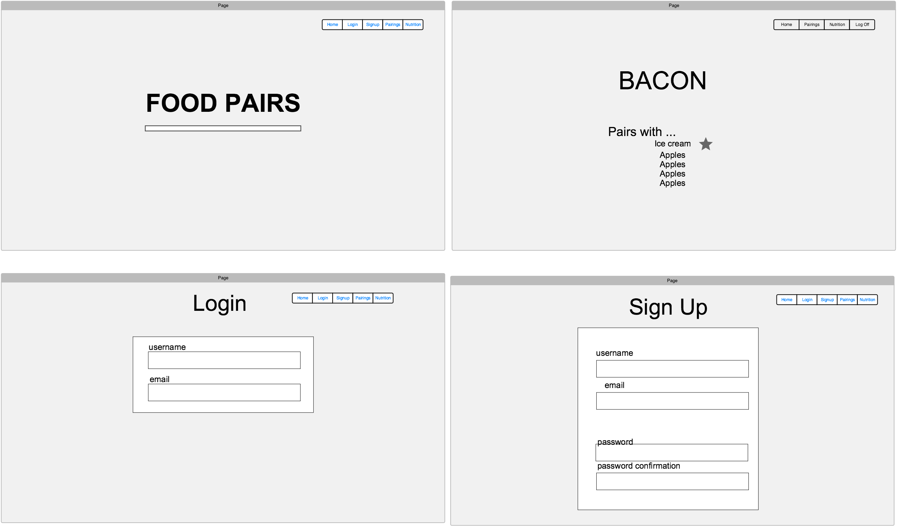

**Database tables:**

* Username, password, email
* IngredientOne, IngredientTwo, pairingID
* Username, pairingID