Раздел 1

**tnsping xe**

Used parameter files:

C:\oraclexe\app\oracle\product\11.2.0\server\network\admin\sqlnet.ora

Used TNSNAMES adapter to resolve the alias

Attempting to contact (DESCRIPTION = (ADDRESS = (PROTOCOL = TCP)(HOST = Alex-PC)(PORT = 1521)) (CONNECT_DATA = (SERVER = DEDICATED) (SERVICE_NAME = XE)))

OK (280 msec)

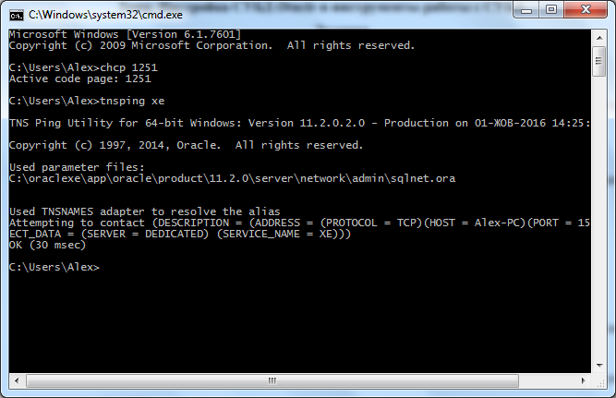

**alter user system identified by 123**

User altered

**sqlplus system/1234**

**sqlplus system/1234@XE**

**sqlplus system/1234@localhost**

**sqlplus system/1234@localhost:1521/xe**

Connected to:

Oracle Database 11g Express Edition Release 11.2.0.2.0 - 64bit Production

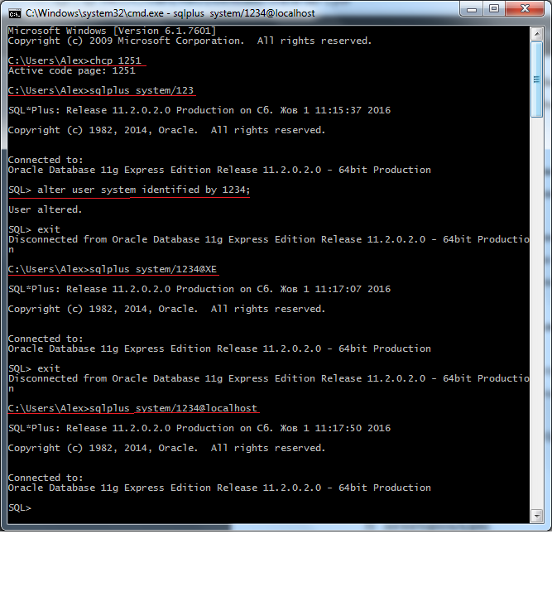

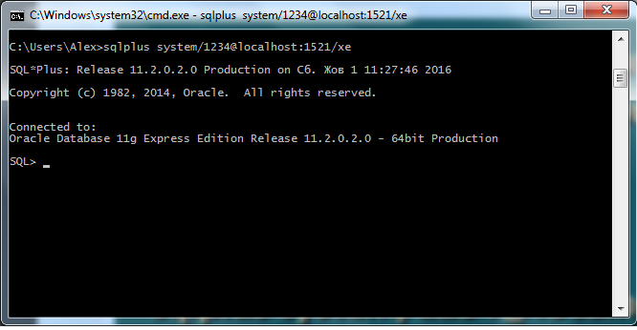

**show user**

User is “SYSTEM”

**create user Parpalak identified by 123;**

User created

**exit**

Disconnected from Oracle Database 11g Express Edition Release 11.2.0.2.0 - 64bit Production

**sqlplus Parpalak/123**

Error

QRA-01045: user PARPALAK lacks CREATE SESSION privilege: logon denied

SYSTEM: **grant connect to Parpalak**

grant succeeded

**sqlplus Parpalak/123**

Connected to:

Oracle Database 11g Express Edition Release 11.2.0.2.0 - 64bit Production

SYSTEM: **grant resource to Parpalak**

grant succeeded

**show user**

User is “PARPALAK”

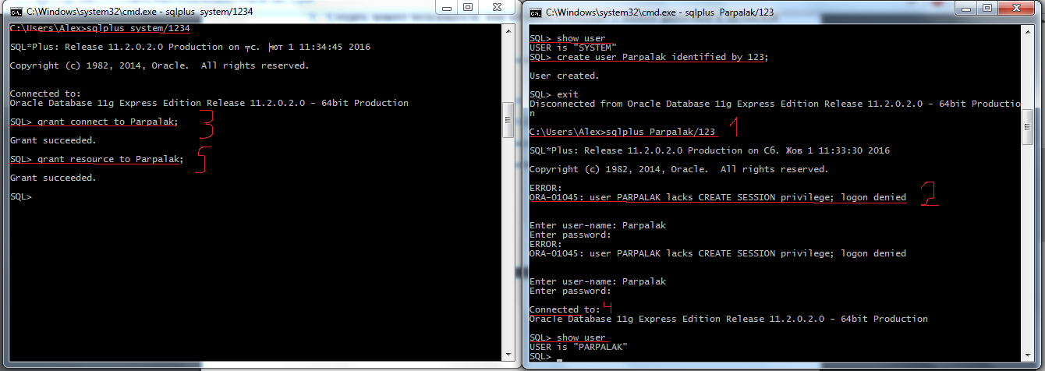

**@C:\Users\Alex\Downloads\db_example.sql**

Commit complete

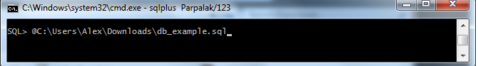

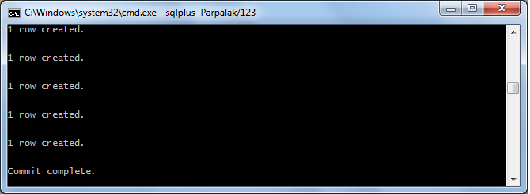

**select deptno, dname, loc from dept;**

*// при копировании из cmd, Word не сохраняет пробелы*

*DEPTNO DNAME LOC*

*---------- --------------- ---------------*

*10 ACCOUNTING NEW_YORK*

*20 RESEARCH DALLAS*

*30 SALES CHICAGO*

*40 OPERATIONS BOSTON*

**select empno, ename, job, mgr, hiredate, sal, comm, deptno from emp;**

*EMPNO ENAME JOB MGR HIREDATE SAL COMM*

*---------- ---------- ---------- ---------- ---------- ---------- ----------*

*DEPTNO*

*----------*

*7839 KING PRESIDENT 17.11.1981 5000*

*10*

*7698 BLAKE MANAGER 7839 01.05.1981 2850*

*30*

*7782 CLARK MANAGER 7839 09.06.1981 1500*

*10*

*EMPNO ENAME JOB MGR HIREDATE SAL COMM*

*---------- ---------- ---------- ---------- ---------- ---------- ----------*

*DEPTNO*

*----------*

*7566 JONES MANAGER 7839 02.04.1981 2975*

*20*

*7654 MARTIN SALESMAN 7698 28.09.1981 1250 1400*

*30*

*7499 ALLEN SALESMAN 7698 20.02.1981 1600 300*

*30*

*EMPNO ENAME JOB MGR HIREDATE SAL COMM*

*---------- ---------- ---------- ---------- ---------- ---------- ----------*

*DEPTNO*

*----------*

*7844 TURNER SALESMAN 7698 08.09.1981 1500 0*

*30*

*7900 JAMES CLERK 7698 03.12.1981 950*

*30*

*7521 WARD SALESMAN 7698 22.02.1981 1250 500*

*30*

*EMPNO ENAME JOB MGR HIREDATE SAL COMM*

*---------- ---------- ---------- ---------- ---------- ---------- ----------*

*DEPTNO*

*----------*

*7902 FORD ANALYST 7566 03.12.1981 3000*

*20*

*7369 SMITH CLERK 7902 17.12.1980 800*

*20*

*7788 SCOTT ANALYST 7566 09.12.1982 3000*

*20*

*EMPNO ENAME JOB MGR HIREDATE SAL COMM*

*---------- ---------- ---------- ---------- ---------- ---------- ----------*

*DEPTNO*

*----------*

*7876 ADAMS CLERK 7788 12.01.1983 1100*

*20*

*7934 MILLER CLERK 7782 23.01.1982 1300*

*10*

*14 rows selected.*

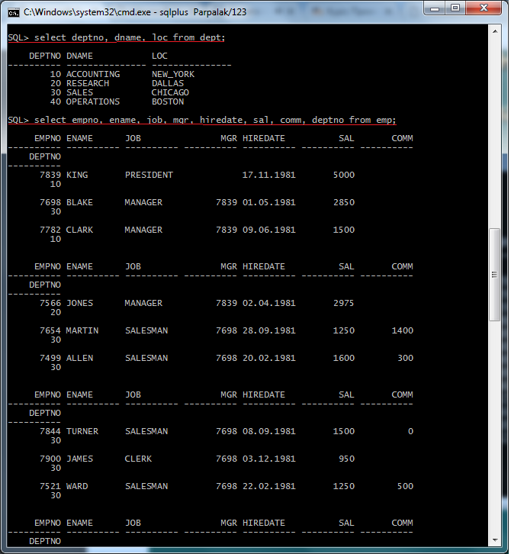

**set pagesize 80;**

**set linesize 120;**

**col ename format 99999;**

**col mgr format 9999;**

**col sal format 99999;**

**col comm format 99999;**

**col deptno format 999;**

**select * from emp;**

*// при копировании из cmd, Word не сохраняет пробелы*

*EMPNO ENAME JOB MGR HIREDATE SAL COMM DEPTNO*

*---------- ---------- ---------- ----- ---------- ------ ------ ------*

*7839 KING PRESIDENT 17.11.1981 5000 10*

*7698 BLAKE MANAGER 7839 01.05.1981 2850 30*

*7782 CLARK MANAGER 7839 09.06.1981 1500 10*

*7566 JONES MANAGER 7839 02.04.1981 2975 20*

*7654 MARTIN SALESMAN 7698 28.09.1981 1250 1400 30*

*7499 ALLEN SALESMAN 7698 20.02.1981 1600 300 30*

*7844 TURNER SALESMAN 7698 08.09.1981 1500 0 30*

*7900 JAMES CLERK 7698 03.12.1981 950 30*

*7521 WARD SALESMAN 7698 22.02.1981 1250 500 30*

*7902 FORD ANALYST 7566 03.12.1981 3000 20*

*7369 SMITH CLERK 7902 17.12.1980 800 20*

*7788 SCOTT ANALYST 7566 09.12.1982 3000 20*

*7876 ADAMS CLERK 7788 12.01.1983 1100 20*

*7934 MILLER CLERK 7782 23.01.1982 1300 10*

14 rows selected.

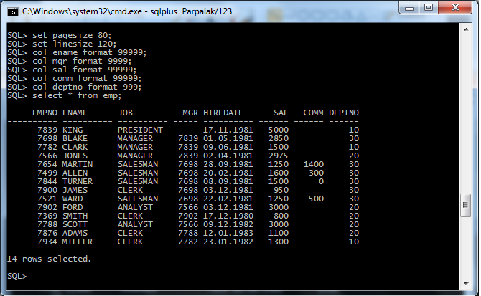

**spool C:\Users\Alex\Desktop\Parpalak_1.sql**

**select * from emp;**

**spool off;**

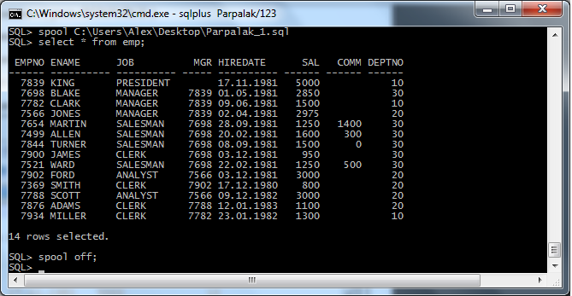

SYSTEM: **select * from parpalak.dept;**

*DEPTNO DNAME LOC*

*---------- --------------- ---------------*

*10 ACCOUNTING NEW_YORK*

*20 RESEARCH DALLAS*

*30 SALES CHICAGO*

*40 OPERATIONS BOSTON*

**drop user parpalak cascade;**

User dropped.

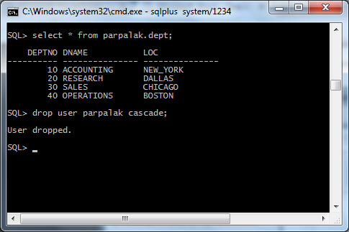

**create user Alexandr identified by 123;**

User created.

**grant connect, resource to Alexandr;**

grant successed

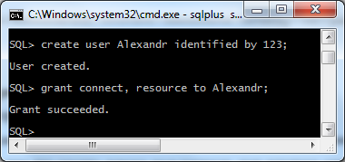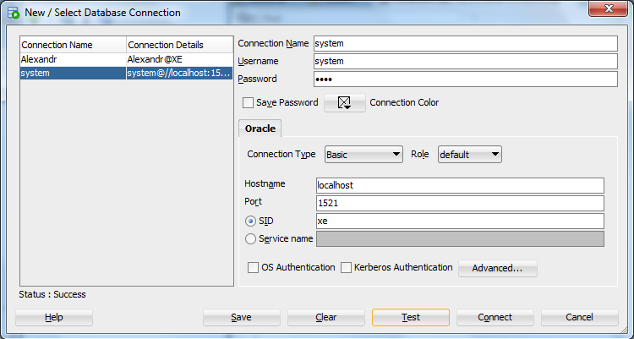

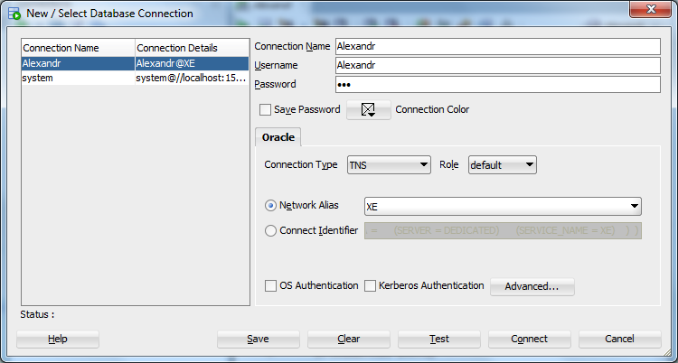

**@C:\Users\Alex\Downloads\db_example.sql**

Commit complete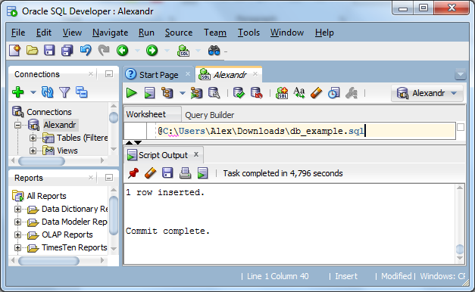

**select deptno, dname, loc from dept;**

*DEPTNO DNAME LOC*

*---------- --------------- ---------------*

*10 ACCOUNTING NEW_YORK*

*20 RESEARCH DALLAS*

*30 SALES CHICAGO*

*40 OPERATIONS BOSTON*

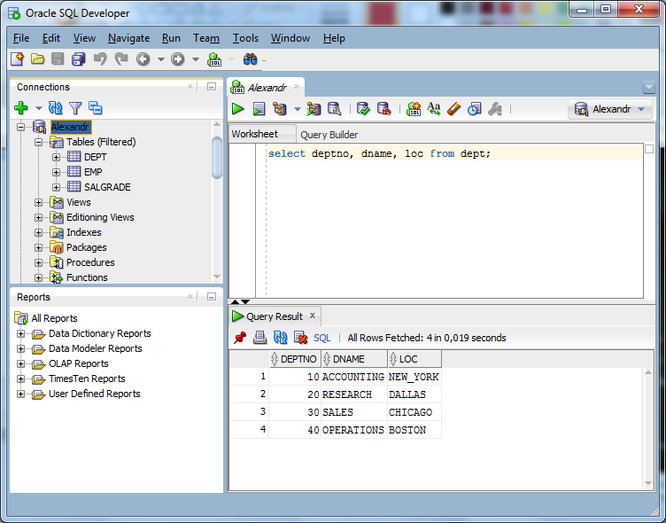

Раздел 2

**alter user system identified by 123;**

User altered;

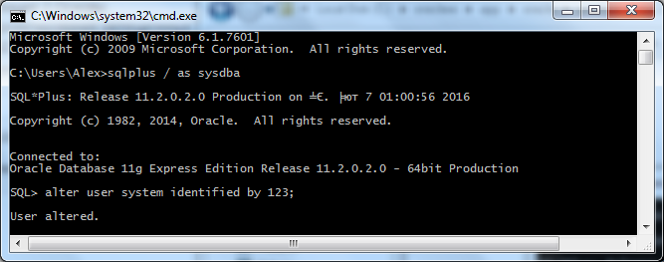

**orapwd file=%oracle_home%\database\pwdsid.ora**

Enter password for SYS:123

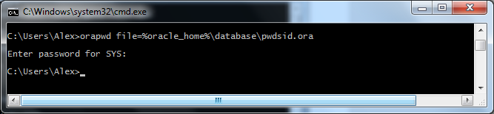

**sqlplus / as sysdba**

Connected to:

Oracle Database 11g Express Edition Release 11.2.0.2.0 – 64bit Production

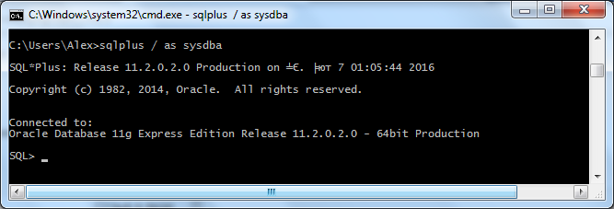

**shutdown immediate**

Database closed.

Database dismounted.

ORACLE instance shut down.

**startup**

ORACLE instance started.

Total System Global Area 1068937216 bytes

Fixed Size 2260048 bytes

Variable Size 704644016 bytes

Database Buffers 356515840 bytes

Redo Buffers 5517312 bytes

Database mounted.

Database opened.

