Eagle Delivery Report
A report discussing program test runs, agent learning, results charts and table, and map design for the project ‘Eagle Delivery’.
Part A
Map | Delivery task | BFS route length | A* route length | BFS expanded node count | A* expanded node count
Baseline | S -> W | 18 | 18 | 67 | 22
Baseline | L -> D | 22 | 22 | 79 | 42
Baseline | H -> P | 16 | 16 | 41 | 16
Detour | S -> W | 26 | 26 | 70 | 37
Detour | L -> D | 22 | 22 | 65 | 40
Detour | H -> P | 16 | 16 | 41 | 16

The above table represents 12 different search runs with varying maps, delivery starting points and goals, as well as search method. The first noticeable pattern in the table is that the route length for BFS and A* are all the same with the same starting conditions. This implies that both methods are always going to find the most optimal path. We know this from how these algorithms work. We can also easily tell which paths are affected by the detour by checking which numbers match between the baseline and detour maps. For example, BFS route length for baseline H -> P is 16 and the same for detour. This route is not affected by this detour. The other thing we can notice is the efficiency of these algorithms. The expanded node count columns show us the total number of nodes expanded while searching. Because the expanded node count is always higher for BFS when compared to A*, A* is much more efficient. This is another fact we know about these algorithms.

Part B
In this scenario, the agent will learn from previous episodes to achieve the optimal scenario without using BFS or A* search algorithms. This also means that the agent doesn’t need to have prior information about the environment, it will discover and learn through the episodes. Below are charts displaying the results of this learning agent.

The chart above describes the success over time with training. This is pretty self explanatory as we can see that after a small percentage of the total iterations, the success rate stays at 1. It should be noted as well that success is either 0 or 1.
In this chart, we show the steps or actions taken in each episode. This is much more useful at describing what the optimization or learning curve looks like. As the agent learns about the environment, less steps are taken to reach the goal.

Lastly, we have the return over time, which is essentially the inverse of the steps graph. We see that the starting return is very low, even negative. As the agent gathers information, it stabilizes until it is optimized.

Part C
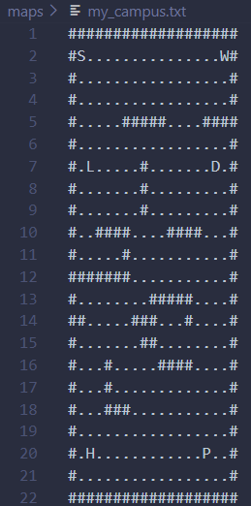
In this part, a custom map was designed separate from the initial maps. Some of the things considered were to make the map bigger with more obstacles that may cause more difficulty in finding an optimal path.
The map looks as so
Ultimately, there is still a lot of open space, but there are a few dead ends which may cause the algorithm to take a bit longer in finding an optimal route.
After running with BFS and A*, we get
Map | Delivery task | BFS route length | A* route length | BFS expanded node count | A* expanded node count
custom | S -> W | 16 | 16 | 112 | 16

As we can see from the results, the obstacles were not enough to impact A* search’s ability to find an optimal path quickly. BFS on the other hand, really struggled to come up with an optimal path.

Experimental Question
How much does the learning value affect outcome?
Prediction: Since this means changing alpha, which represents the learning value, increasing that value means that the agent is going to respond more to things it learns about its environment. My prediction is that learning will be faster with a higher learning value but may not have consistent results or may vary a lot during training. With a lower learning value, learning will likely be slower, but a more stable result will exist.

Alpha | Training success in first 100 episodes | By episode 200 | Final evaluation success | Mean evaluation return* | Mean steps to success*
0.1 | 32.0% | 67.7% | 100% | 24.0 | 16.0
0.3 | 53.0% | 97.3% | 100% | 23.3 | 16.7
0.7 | 68.0% | 99.7% | 100% | 24.0 | 16.0
0.9 | 65.0% | 82.2% | 100% | 24.0 | 16.0

The table above shows the results of each training run varying only the alpha value. We can see that a higher learning value trains quicker and gets to an optimal outcome faster. There seems to be no downside to these three numbers to increasing the training value up to 0.7. I tested one more alpha value of 0.9 and got the results. We can see that the results start to fall off with too high of a learning value. The agent is too sensitive to environment information and will completely change it’s approach after any new information.
Compared to my expectations, the value didn’t matter as much as I thought, and it only mattered when it got as high as 0.9 compared to an initial value of 0.1. I expected more downside with more alpha values, but the agent held up well.

