SAC 5: Networking – Alexander Xu (XU-0025)

Part 1:

1. Design a labelled network diagram of the **current** setup

Current:

1. Identify what needs, current issues or limitations exist in the current setup (Consider structural, security/safety, accessibility, usability & efficiency)

Dreambuilders needs 2 more session rooms, each with their own PC. They also need internet access, which means a wireless access point will need to be added.

Currently, there are many limitations in the network design. Structurally, the devices are not really connected to each, and the session rooms do not have access to the internet. Additionally, the connection to the internet is unsafe as there is no protection. There is also no offsite backup of data. Furthermore, there is no easy way to access the internet wirelessly. Also, only the reception room PC can print.

1. What would you propose and implement in a new network to improve or solve the issues identified above (within reasonable cost and other constraints)?

Switches need to be added to connect devices to the internet. The printer should also be connected via the switch so all PCs can access it. Firewalls need to be added at any connections to the internet for safety. Data should be backed up on a server and this server should be placed elsewhere in case anything goes wrong. A wireless access point should be added for wireless internet. The 2 PCs required for the 2 new session rooms should be connected like the others.

**In short:**

Structural: + Switch, Connect PCs to internet through switch

Security/Safety: + Firewall, Server -> offsite

Accessibility: + Wireless Access Point

Usability: + 2 PCs, + Server

Efficiency: Connect PCs to printer through switch

1. List the new and additional devices, cabling and software (and quantities) required to implement the above for the new/improved network.

Devices:

* + 2 x PCs
  + 1 x Wireless Access Point
  + 2 x Firewall
  + 1 x Router
  + 1 x Server
  + 2 x Switch

Cabling:

* + CAT6 Ethernet Cables

Software:

* + Network management software
  + Network storage and data archiving software
  + Firewall and security software
  + Printer software

1. Design a proposed network diagram of the new network, including the new additions, and your recommended improvements.

Improved:

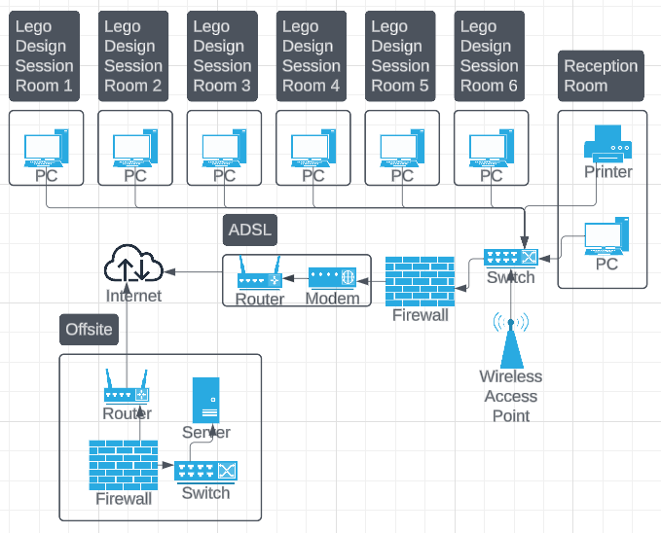

Part 2:

1. Provide an overview of details of the company (who, what, company size, location(s), history).

The company is a coffee shop that has recently been purchased by a new owner. It has two locations, one in the city and one in the suburbs. Each shop has 25 employees. Stakeholders include customers, baristas, cashiers, chefs, managers and the owner.

In short:

Who: Customers, Baristas, Cashiers, Chefs, Owner/Managers

What: Coffee Shop

Company Size: 25 employees per shop

Locations: 2: City, Suburbs

History: Recently purchased and opened by a new owner

1. Explain their existing scenario, current IT/network setup, and list the existing equipment used (if applicable).

The owner of the company has left the network as it was when he bought the company. This is the current setup:

Current:

Current Devices:

* + 7 x PCs
  + 2 x Router
  + 1 x Switch
  + 1 x Hub
  + 1 x Printer

1. Identify what needs, current issues or limitations exist in the current setup (Consider structural, security/safety, accessibility, usability & efficiency).

The hub used in the back office of the suburb’s location is outdated and has much less functionality than a switch. The owner wants all devices to be connected to the internet and wants to ensure a safe backup of data is kept elsewhere in case anything is destroyed. Both locations require wireless internet for customers and employees. All connections to the internet need to be safe and efficient.

1. What would you propose and implement in a new network to improve or solve the issues identified above (within reasonable cost and other constraints)?

The hub used at the suburb’s location should be replaced with a switch and more switches will need to be added to connect the counter PCs to the main switch effectively (by running only one cable between the two switches) so there is an internet connection. Firewalls need to be added wherever there is an internet connection for safety. An offsite server will ensure there is a safe backup of data. Wireless access points should be added to both locations’ networks so that customers and employees have wireless internet access.

**In short:**

Structural: - Hub, + Switches, Connect counter PCs to internet through switch

Security/Safety: + Firewalls, Server -> offsite

Accessibility: + Wireless Access Points

Usability: + Server

Efficiency: Connect counter PCs to a switch first, then that switch to the main switch

1. List the new and additional devices, cabling and software (and quantities) required to implement the above for the new/improved network.

Added Devices:

* + 3 x Switch
  + 1 x Router
  + 3 x Firewall
  + 1 x Server
  + 2 x Wireless Access Point

Removed Devices:

* + 1 x Hub

Cabling:

* + CAT6 Ethernet Cables

Software:

* + Network management software
  + Network storage and data archiving software
  + Firewall and security software
  + Printer software
  + Point of sale (POS) software
  + Accounting software

1. Design a proposed network diagram of the new network, including your additions and recommended improvements.

Improved:

Part 3:

Write a reflection answering the following questions:

1. What did you do/how did you go about completing this assessment?

I started by completing the network diagram for part 1, then brainstormed changes to improve the network. After implementing these to create a new network diagram, I filled out all the questions. Unfortunately, I was unable to get information on an actual network from a small business for part 2, so I based one off a plausible network and situation of a small business. After designing an older, less modern network diagram, I identified problems with it and went about fixing it to make it safer and up to date.

1. What issues or difficulties did you experience and how did you overcome it?

I found it difficult to get a real network diagram from a small business, as it is not extremely easy to find out about this information. I was able to overcome this by making a network diagram based on what a small business may have set up. I also had difficulty organising items together as it was confusing when they were all bunched up on the network diagram. I was able to fix this by separating the diagram into smaller pieces by using boxes as containers.

1. What would you do differently or how would you improve your learning outcomes if you had to do again?

If I were to do this again, I would try to manage my time better and complete the assignment before holidays. I would also try to add all devices (e.g. card readers) even if they are not a significant part of the network.