Problem Chosen  C | 2025  MCM/ICM  Summary Sheet | Team Control Number  2501203
Olympic Medal Prediction Model: Machine Learning Analysis of 2028 Country Performance and Influencing Factors
Summary
Predicting Olympic medals helps assess a country's sports development, guide resource allocation, and boost motivation. It also aids in improving strategies for future success and fostering national pride.This paper constructs and analyzes multiple models to predict the performance of countries in the 2028 Olympic Games, as well as explores the influencing factors in depth.
For problem 1, we first used the Topsis to classify strong and emerging sports nations, helping better reflect the performance of countries with no medal data. For strong sports nations, we trained the Random Forest model, predicting the top three countries in the 2028 Olympic medal standings to be the United States, China, and the United Kingdom, with total medal counts of 174, 90, and 70, and gold medal counts of 54, 41, and 20. The United States and Germany are likely to improve, while South Korea may slightly decline.For emerging sports nations, we used XGBoost, concluding that Czechia and Serbia are most likely to improve, though strong nations will still lead in total medals. Using the Cox Proportional Hazards model, we predicted 17 countries will win their first medal in the next Olympics.We also applied the DQN-DeepQ-Network model to study potential events for first-time medal-winning countries, with athletics identified as the top event. This deeper insight enhances future research and adds significant value.Furthermore, Pearson correlation analysis showed that as the number of events increases, expected medal counts tend to decrease. Using a weighted algorithm for key sports, we found Argentina's men's football (49.16) and the USA's men’s 4×100 meters medley relay (35.92) to be the most influential events. Finally, host countries tend to win more medals, including gold, silver, and bronze, compared to non-host countries.
For problem 2, we selected data from the Chinese women's volleyball team and the U.S. women's volleyball team for training with ridge regression. We concluded that the influence of great coaches is always positive, with Lang Ping's impact on the Chinese women's volleyball team being more significant than that on the U.S. team. However, over time, the performance of the U.S. team gradually improved, while China's performance might slightly decline. Then, we applied Lasso regression to process data from the U.S. women's gymnastics team and the Nigerian women's gymnastics team. The conclusion is that the great coach effect is positive for both, with a more significant impact on the U.S., but Nigeria's progress over the years shows a larger growth trend compared to the U.S.
Keywords: Random Forest; XGBoost; Cox Proportional Hazards Model; Medal Prediction

Contents
1 Introduction 3
1.1 Problem Background 3
1.2 Restatement of the Problem 3
1.3 Literature Review 3
1.4 Our Work 3
2 Assumptions and Justifications 4
3 Notations 5
4 Random Forest model:projections for the 2028 medal count and gold medal count 5
4.1 Data Description 5
4.2 The Establishment of Random Forest model 7
4.3 The Solution of Random Forest model 8
5 XGBoost 10
5.1 The Establishment of XGBoost 10
5.2 The Solution of XGBoost 11
6 Cox Proportional Hazards Model+DQN-DeepQ-Network Model:prediction of the probability of winning the first prize for non-winning countries 13
6.1 Data Description 13
6.2 The Establishment of Cox Proportional Hazards Model 13
6.3 The Solution of Cox Proportional Hazards Model 14
7 Pearson correlation analysis: exploring the relationship between the events and medals 15
8 Weighted average algorithm: Exploring the most important events for countries and the host country effect 17
9 Ridge regression model + Lasso regression model:A Study on the Effect of Great Coaches 18
9.1 Data Description 18
9.2 The Establishment of Model 18
9.3 The Solution of Model 19
10 Sensitivity Analysis 20
11 Model Evaluation and Further Discussion 21
11.1 Strengths 21
11.2 Weaknesses 21
11.3 Further Discussion 21
12 Conclusion 22
References 23
Appendices 24

Introduction

Problem Background
The prediction of medal distribution pattern will be affected by many factors, such as: previous awards, home country impact, Olympic sports,individual Olympic competitors, and “great coach” effect.However,forecasting the number of Olympic medals for each nation is highly relevant for different stakeholders.It helps gauge the effectiveness of a nation's sports development programs, talent identification systems, and overall athletic infrastructure. It can also guide resource allocation, inform strategies for future international competitions, and fuel national pride and motivation. Accurate predictions can help organizations, coaches, and athletes focus on key areas for improvement, increasing the chances of success on the world stage.

Restatement of the Problem
Considering the background information and restricted conditions identified in the problem statement, we need to solve the following problems:
- Problem 1: Using the officially provided data,develop a model to predict the medal counts for each country and make a projection of medal distribution pattern in the Los Angeles, USA summer Olympics in 2028.In addiction,the predictive amount of countries that earn their first medal should also be given.The types and number of events and home country impact should also be taken into consideration.
- Problem 2:Evaluate the contribution of the “great coach” effect to the number of Olympic medals, and predict the benefits and impact of investing in great coaches and their programs.
- Problem 3:Based on the model, excavate other information about the distribution of Olympic medals, and put forward fruitful insights for the country Olympic Committee.

Literature Review
With the great leap of technology,the idea of using predictive analytic in athletic sport has been more frequently mentioned.There has been many results using machine learning,which had excellent behavior as an efficient tool .For instance,Bunker and Thabtah (2019) have used decision trees and support vector machines to predict the football game[1].Park et al. (2021) have employed neural network to make the prediction of medal distribution pattern[2].Jhankar et al.(2024) have focused on using random forest model in medal projections of the 2024 Summer Olympics[3].

Our Work
The following is a flow chart of our model framework.
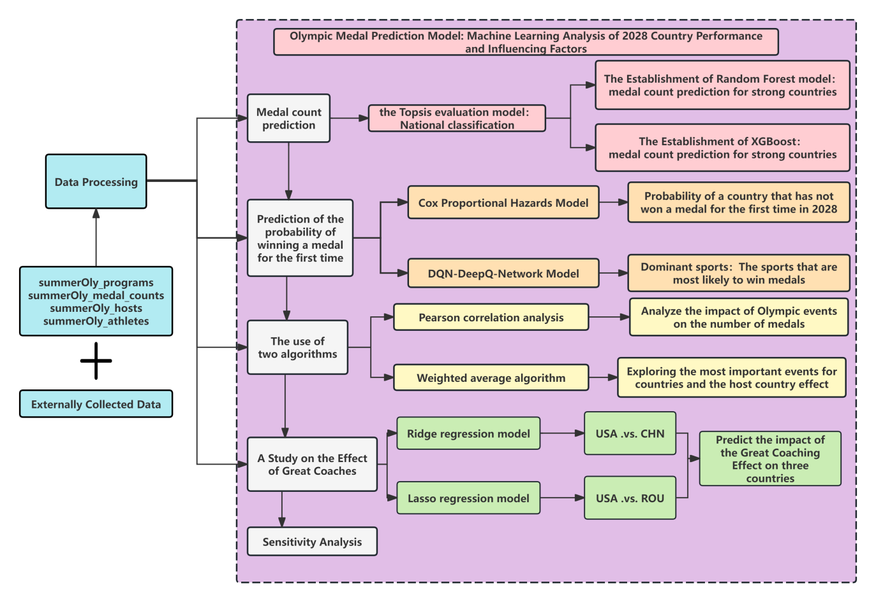

Assumptions and Justifications
When building and analysing the model that predicts the number of medals at Los Angeles 2028, we base it on the following key assumptions:
▼Assumption 1：Data integrity and accuracy assumption:
▲Explanations：The data used (including national economic level, number of athletes, number of competing events, historical medal data, human development index, etc.) are complete and accurate. Although there may be gaps or errors in the actual data, in this study we assume that the data has been properly pre-processed and validated to be reliably used for model training and prediction.
▼Assumption 2：Linear relationship hypothesis
▲Explanations：In the Cox.proportional risk model, it is assumed that there is a linear relationship between the total number of entries before the first prize and the total number of entries before the first prize and the logarithmic risk function. Although the actual situation may contain nonlinear relationships, in order to simplify the model and improve interpretability, we assume that these relationships can be carred out through a linear model.
▼Assumption 3：Independence Assumption
▲Explanations：Assume that the individual characteristic variables are independent of each other.While there may be some correlation in practice, in order to simplify the model, we assume that the interactions between these variables are negligible or dealt with through model adjustments.
▼Assumption 4：Quantification of the coach effect
▲Explanations：When analyzing the"great coach" effect, it is assumed that the coach's historical achievements and coaching time can be quantified, and these quantitative indicators can effectively reflect the coach's impact on the medal count. Although the influence of a coach may contain factors that are difficult to quantify, we assume in our model that these major factors can be reasonably quantified.
▼Assumption 5：Stability of the program setup
▲Explanations：Assuming that the Olympic program setup remains relatively stable in the short term, that is, new events or major rule changes will have less impact on the medal distribution. While there may be changes in the programme set-up, we are assuming that these changes will not have a significantimpact on the overall medal distribution in our 2028 projections.

Notations
The key mathematical notations used in this paper are listed in Table 1.
- Notations used in this paper
Symbol | Description
$$x_{ij}$$ | represents the j-th feature of the i-th country
i | denotes the total number of countries
j | denotes the total number of feature
$$y_{i1}$$ | represents the gold medals of the i-th country
$$y_{i2}$$ | denotes the total number of medals for the i-th country.

Random Forest model:projections for the 2028 medal count and gold medal count

Data Description
First, our team performed data cleaning to improve the quality and the accuracy of subsequent applications. We checked the completeness, validity and accuracy of the data. Among them, we took the method of filling in the missing data with zero. We had fully consulted the relevant data, especially the research on the historical data on the IOC official website, and we had full confidence that the missing data are mostly the cases of no awards or even no participation. It can be concluded that zero-padding is a very accurate and effective data processing method.In addition, we processed the country data, removed countries and organizations that do not exist now based on the information on the World Political Regions Index, and merged the data of the Soviet Union under Russia to facilitate the subsequent training of the model.

Next, feature engineering is the process of developing new variables that represent certain characteristics of a given data set. For this, we used a moving average window for the given data.Moving average window can effectively smooth data, reduce the impact of data fluctuation, highlight the trend and pattern of data, and is very suitable for time series data processing. In this regard, we choose a window of size three to process the number of gold medals and medals awarded in the last three years.Then we merged the sports data with the medal data, and our modeling is based on this total data set.

After that,we find that a significant challenge when predicting Olympic medals is correctly reflecting the large number of countries that do not have medals. Due to the difference in the amount of data between sports power countries and emerging sports countries, applying the same model will lead to large errors. In this regard, we creatively divided all countries into strong and weak countries. In order to improve the rationality of the division, we creatively adopt the Topsis evaluation model. We do an assessment of the entire country based on:

- Social development factors
The Human Development Index (HD1)3 measures the level of human development and reflects the progress of a society.In order to reflect the degree of social and economic development of a country. It mainly uses official figures published by the United Nations.
- Political stability factors
The political environment has a non-negligible impact on a country's performance at the Olympics. According to the Global Governance Indicators (WGI) provided by the World Bank, there are six comprehensive governance dimensions, one of which is "political stability and lack of violence/terrorism". By definition, the higher the political stability and violence/terrorism absence index, the more stable the political environment.
- The number of MEDALS won in the last Olympic Games
The historical results not only reflect the country's sports strength, but also reflect the country's continuous investment and successful experience in Olympic events. Countries that have performed well over a long period of time usually have mature selection systems and ongoing athlete development mechanisms.
- GDP
The national economy directly affects the training conditions of athletes, the support for events, the coaching team and the treatment of athletes. High levels of sports funding usually provide better infrastructure and training systems to improve a country's performance at the Olympics.

The main steps:
- Forward: Based on the user input, the specified column is forward processed. The forward methods include minimal, intermediate, and interval types. In fact, it's all positive data.
- Normalization: Depending on whether the data contains negative numbers, either vector normalization or range normalization methods are selected.
- Calculate the entropy weight: By calculating the information entropy and the difference coefficient, the weight of each column is finally obtained.
- TOPSIS evaluation: For the existence of these indicators given above, the analysis method of scoring and evaluating countries is used. That is, according to the weight of the indicators, it is judged that each country in the data is good or bad. Among them, since the weight of GDP is too high, we introduce the adjustment matrix β according to the previous papers to adjust the previous weights.[4]

Finally, we consider a country with a score below 0.03 as a weak country and a country with a score above 0.03 as a strong country.
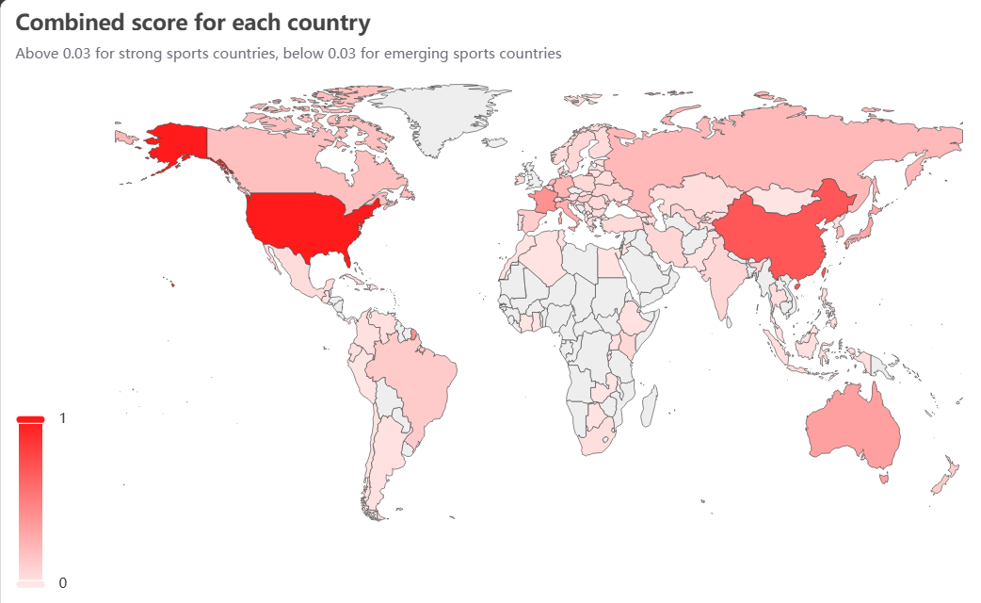
Figure 1:A reflection of the strength of the awards in each country

The Establishment of Random Forest model
Based on the following considerations, we ultimately chose the Random Forest model to predict sports powerhouse countries:

Nonlinear Relationships: The prediction of medal counts is typically influenced by multiple factors (such as the number of athletes, the number of events, and the country’s economic strength), which exhibit complex nonlinear relationships. For instance, an increase in the number of athletes may not linearly lead to an increase in medal counts, but rather show a certain threshold effect.
Advantages of Random Forest: Random Forest captures these nonlinear relationships by constructing multiple decision trees. Random forest is an ensemble learning algorithm. Bootstrap Sampling is used to extract multiple sub-datasets from the original training data set with replacement, and then a decision tree is constructed for each sub-data set. In the process of building the decision tree, part of the features are randomly selected at each node for splitting, which can reduce the correlation between the decision trees. Finally, the prediction results of all decision trees are integrated to obtain the final prediction result.

Let $x_{ij}$ represent the j-th feature of the i-th country, where i=1,2,…,n (denoting the total number of countries), and j=1,2,…,m (denoting the total number of features), which may include factors such as population, sports investment, and historical awards. Furthermore, $y_{i1}$ represents the gold medals of the i-th country, while $y_{i2}$ denotes the total number of medals for the i-th country.

In this study, we employ the Random Forest algorithm to construct the model. The random forest consists of T decision trees, each of which is represented by $h_{t}\left(x\right)$, where t=1,2,…,T.

Prediction of Gold Medals by the Model:
$$\hat{y_{i1}}=\frac{1}{T}\sum_{t=1}^{T}{h_{t}\left(x_{ij}\right)}$$ | ()
Prediction of Total Medals:
$$\hat{y_{i2}}=\frac{1}{T}\sum_{t=1}^{T}{h_{t}\left(x_{ij}\right)}$$ | ()

The Solution of Random Forest model
To predict medal counts for 2028 using the Random Forest model, we first predicted the feature data (athletes and events) for 2028, as this data was not provided. This was done by analyzing growth rates for athletes and events in previous years, setting a threshold for minimum growth. Using this threshold, the growth rates for 2024 were predicted, which were then used to forecast the number of athletes and events for 2028.

The team built a Random Forest regression model to predict Olympic gold and total medals at the country level. The model used features such as the year, number of athletes, and number of events, and set gold medal and total medal counts as target variables. The data was split into training and testing sets (80% and 20%, respectively), and two separate Random Forest models were trained to predict gold medals and total medals. Both models consisted of 300 decision trees, and their performance was evaluated using mean squared error (MSE) on the test set.

For countries with data for 2028, predictions were made using the trained models, and the uncertainty of these predictions was assessed by calculating the standard deviation from multiple predictions. The results and uncertainty were stored for further analysis.

The prediction for the medal standings is shown in the following chart.
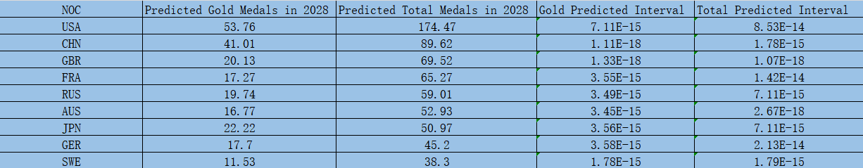
Figure2:the prediction for the medal

As can be seen, the top three countries in the medal standings are the United States, China, and the United Kingdom, with total medal counts of 174, 90, and 70, and gold medal counts of 54, 41, and 20, respectively. Based on the above models, and comparing with the 2024 Olympic data, it is likely that the United States and Germany will make significant progress, while South Korea may experience a slight decline.
Figure3:top 3 countries with potential progress and their predicted intervals.
Figure4:top 3 countries with potential retrogress and their predicted intervals.
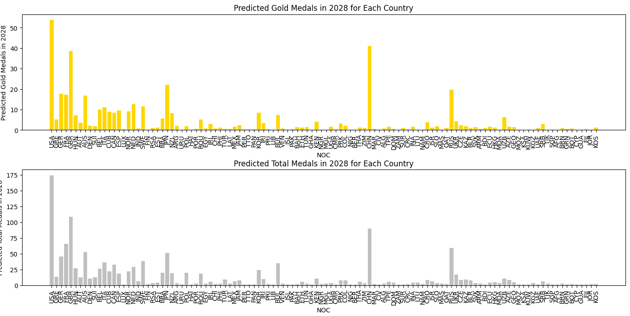
Figure5:Predicted performance for each country.
The following is the residual plot of the predictions. It can be seen that the model has good predictive performance.
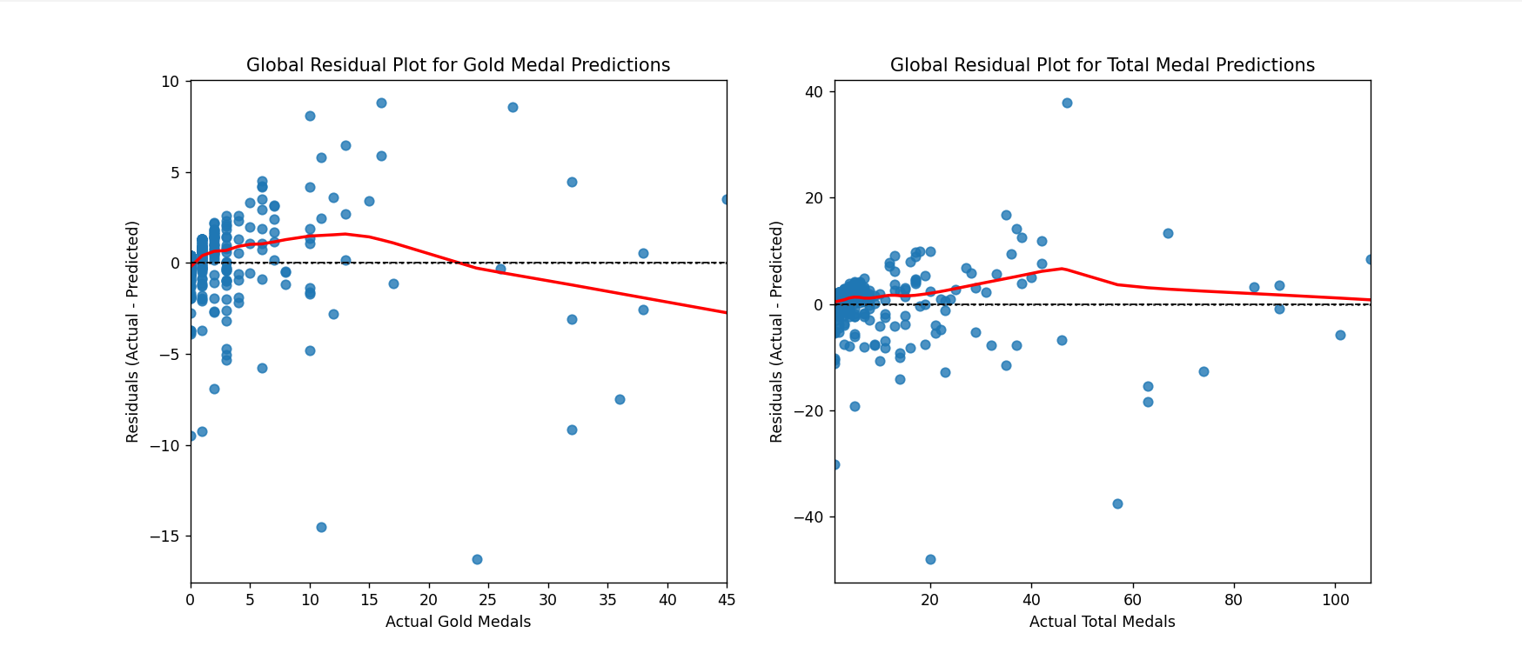
Figure6:Residuals of gold medal count prediction and total medal count prediction

XGBoost

The Establishment of XGBoost
In the context of predicting Olympic medal counts, "weaker countries" can be understood as those with poor historical performance in the Olympic medal rankings, where the number of medals won is relatively low. The XGBoost model is chosen for predicting the medal counts of these countries, primarily due to its advantages in handling complex data relationships, addressing data features, and offering strong model performance and generalization capabilities.

XGBoost is an ensemble learning model based on the gradient boosting algorithm. The factors influencing Olympic medal counts are numerous and complex, exhibiting relationships that are not purely linear. For instance, factors such as the number of sports events a country participates in, the number of athletes, and the trends in medal acquisition across previous Olympic Games all contribute to a complex nonlinear relationship with the total medal count. XGBoost addresses this complexity by constructing multiple weak learners (usually decision trees) and continuously fitting the complex patterns within the data using an additive model.The prediction made by the XGBoost model can be expressed as:
y=$\sum_{k=1}^{K}{f_{k}\left(x\right)}$ | (3)

Here is a detailed explanation about the construction of the XGBoost model and the meaning of the variables:

y(Target Variable):
Total Medal Count: The target variable represents the predicted outcome, i.e., the total number of medals that under performing countries will win at the 2028 Olympics. This is the outcome that the model aims to predict.
x=$\left(x_{1},x_{2},…{,x}_{5}\right)$(Features):
- Rolling Average of Gold Medals in the Last 3 Olympics: This feature is calculated by averaging the number of gold medals won in the past three Olympic Games. It reflects the trend of a country's performance in terms of gold medals.
- Rolling Average of Total Medals in the Last 3 Olympics: This feature is computed as the average of the total number of medals won in the past three Olympic Games. It provides insight into the overall performance trend of a country over recent Olympiads.
- Number of Athletes: The total number of athletes from a country participating in the Olympics in a given year. This reflects the level of a country's engagement in the Olympics.
- Number of Events: The number of events in which a country participates during the Olympics in a given year. This metric reflects the diversity of the country's participation, which may influence the total number of medals won.
- Historical Athlete Performance: The past performance of athletes from the country, such as the number of medals won by athletes in previous Olympic Games. This helps the model understand the level of athletes' capabilities and their contribution to the medal tally.

The Solution of XGBoost
We calculate the rolling averages of gold medals and total medals for the past three Olympic Games, and compile various features such as the number of athletes, the number of events, and the historical performance of athletes for different countries and years. These features are then selected as inputs for the model, with the total medal count as the target variable. The data is divided into a training set (for years prior to 2020) and a test set (for the year 2020). Using the training set, the XGBRegressor model is instantiated with the objective function set to "reg:squarederror" (mean squared error regression), the number of estimators set to 100, and the random seed set to 42. The model is trained by calling the fit method.

Finally, the trained model is used to predict the medal count for the year 2028. To calculate the confidence interval of the prediction, the standard deviation is computed by performing multiple predictions. The 95% confidence interval is then determined by calculating the lower and upper bounds (Predicted_Total_Lower and Predicted_Total_Upper). Additionally, the model's performance is evaluated on the test set using several metrics, including the mean squared error, root mean squared error, mean absolute error, and coefficient of determination (R-squared).We present our predictions in the form of charts.

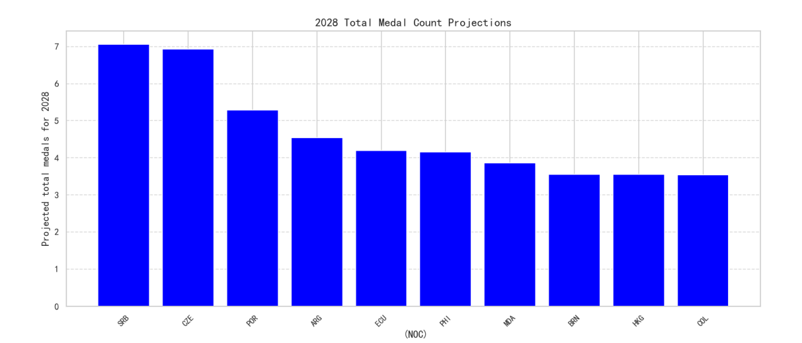

Figure 7：Projected total medal count in 2028
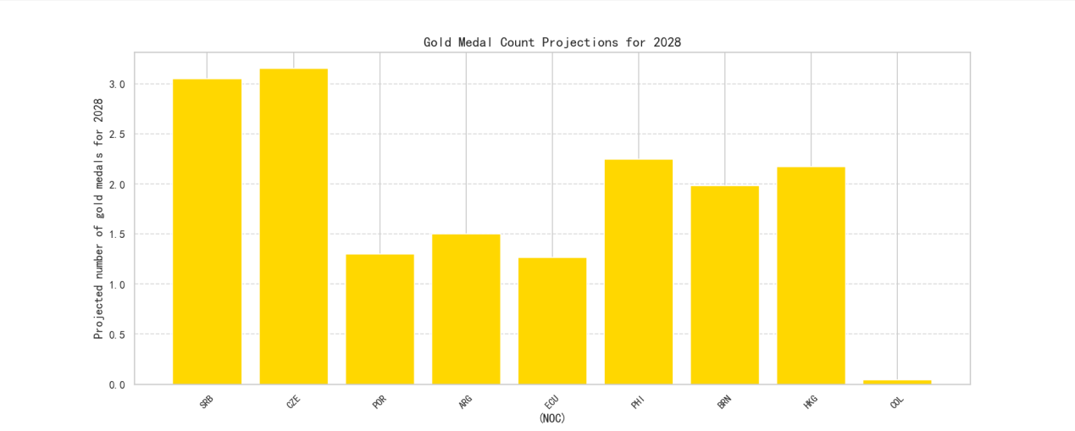
Figure 8：Projected gold medal count in 2028

The following are the performance metrics for this model:
- Total Medals - MSE: 1.358107089996338
- Total Medals - RMSE: 1.165378517905808
- Total Medals - MAE: 0.8560859560966492
- Total Medals - R²: 0.7331554293632507
- Gold Medals - MSE: 0.4540795087814331
- Gold Medals - RMSE: 0.6738542192354613
- Gold Medals - MAE: 0.4553260803222656
- Gold Medals - R²: 0.5445146560668945

The model demonstrates good performance in predicting medal counts, especially in gold medal predictions, with low mean squared error (MSE), root mean squared error (RMSE), and mean absolute error (MAE). This indicates the model's high accuracy and expertise in capturing and predicting medal counts.

Cox Proportional Hazards Model+DQN-DeepQ-Network Model:prediction of the probability of winning the first prize for non-winning countries

Data Description
Using the processed datasets clean_summerOly_athletes.csv and clean_summerOly_medal, we filter the data to create two new datasets: no_medal.csv for countries that have not won any medals and have_medal.csv for countries that have won medals. For the no_medal.csv data set, we calculate the time elapsed from the first participation year to 2024. For the have_medal.csv data set, we calculate the time elapsed from the first participation year to the year the country won its first medal. Additionally, we compute the total number of Olympic participation and the total number of events participated in for each data set.

Next, we define an event status variable, denoted as first_win, where:
- 1 indicates that the country has won its first medal.
- 0 indicates that the country has not won any medals yet.

We then merge the two datasets to obtain the first_medal.csv data set. Finally, we apply Robust Standardization to the first_medal.csv data set in order to reduce the influence of outliers on the data. Robust standardization normalizes the data using the median and interquartile range (IQR) rather than the mean and standard deviation. This method is particularly useful in cases where extreme values exist in the data, as is common in Olympic participation, where there can be a significant disparity between strong and weak countries.

The Establishment of Cox Proportional Hazards Model
For predicting the probability of countries that have not won a medal in the next Olympic Games winning their first medal, we chose survival analysis, specifically the Cox Proportional Hazards Model. The Cox Proportional Hazards Model, introduced by British statistician David Cox in 1972, is a semi-parametric regression model used to analyze survival data. Survival data typically contains two key pieces of information: survival time and event status. In this case, we treat "winning the first medal" as the event and analyze the impact of national characteristics on the risk of the event occurring. The features selected are the total number of participation and the total number of events participated in before winning the first medal. Thus, the survival time is defined as the time from a country's first participation to the year they win their first medal, while the event status indicates whether or not they win a medal. The output of this model will be the probability of a country winning its first medal in the 2028 Olympics.
(4)

- λ$\left(t | X\right)$This represents the hazard function at time given the covariates X=($X_{1},X_{2},…,X_{p})$ . Specifically, this hazard function indicates the rate at which a country experiences the "first medal" event at time t.
- $λ_{0}\left(t\right)$: The baseline hazard function, which represents the underlying rate of the event occurring when all covariates X are 0 (no covariate effect). This is the constant part of the model, meaning that we do not need to make assumptions about other features when modeling the risk over time.
- $β_{i}$ : The regression coefficient for the i-th covariate. It measures the effect of each feature (e.g., "total participation count," "number of different events participated in") on the risk of the first medal. Specifically, exp$\left(β_{i}\right)$is the hazard ratio (HR), which indicates how the risk (rate of winning the first medal) changes when the feature $X_{i}$ increases by one unit.
If $β_{i}$>0, increasing $X_{i}$ will increase the risk of winning the first medal.
If $β_{i}$<0, increasing $X_{i}$ will decrease the risk of winning the first medal.
- $X_{i}$ : The i-th covariate, which in this context could be features such as "total number of participation" or "number of different events participated in."

The Solution of Cox Proportional Hazards Model

In fact, the probability should be smaller because the model only uses two features: the total number of participation before the first medal and the total number of event types participated in before the first medal. It does not consider other characteristics of countries that have not yet won medals, such as economic strength or sports infrastructure development. In most cases, countries that have not yet won medals are likely to lag behind medal-winning countries in these aspects.

To make better predictions about the first medal of countries that have not yet won any medals, we further used the DQN-DeepQ-Network model to predict the first sports event in which they would win a medal. The country is designed as the agent, the action is to invest in sports events, and the reward is the increase in the number of medals.Using the DQN algorithm, we calculate the reward based on the number of events. A simple assumption is that the reward is proportional to the number of events, aiming to explore the optimal investment strategy and identify high-potential events.

We concluded that "the first medal is most likely to come from athletics" and hypothesized that this could be related to several factors:

- Popularity of Athletics: Athletics is a core event in almost every Olympic Games, and nearly all participating countries take part in it. For countries that have not yet won medals, athletics is often the field where breakthroughs can be made with relatively less investment and training, especially in individual events like sprints and long jump.
- Number of Participants and Competition Opportunities: Athletics offers a wide variety of events, with multiple competitions in every Olympic Games, thus increasing the potential opportunities for medals. A country can improve its chances of winning by participating in several events.
- Cost-effectiveness: Compared to events that require heavy equipment and specialized facilities (such as swimming and weightlifting), athletics demands less in terms of hardware, relying more on the athletes' physical abilities and skills. This makes it easier for resource-constrained countries to make breakthroughs in this field.
- Lower Barriers to Entry: In athletics, particularly in speed and middle- to long-distance running events, performance improvement is often more noticeable. For countries that have not yet won medals, this could be the best path for a breakthrough.
- Historical Data and Trends: Historically, many countries' first Olympic medals have come from athletics. This pattern might have been further reinforced in the model, leading the DQN algorithm to identify athletics as the most promising event.

The top 25 countries by probability of winning a medal are shown in the figure below.The number of countries expected to win their first medal in the next Olympic Games is approximately 17.
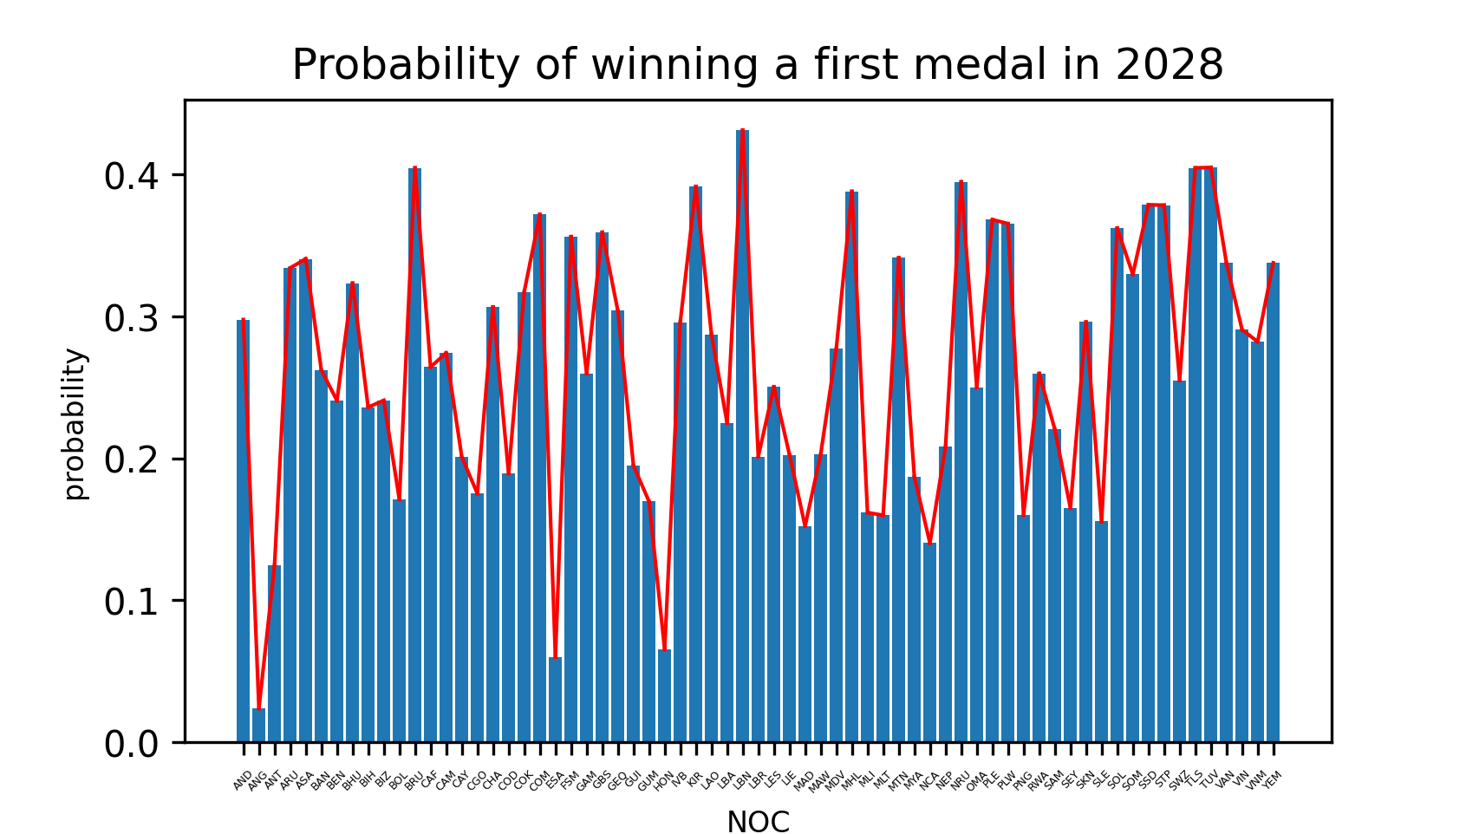
Figure9:Probability of winning a first medal in 2028

7 Pearson correlation analysis: exploring the relationship between the events and medals
Our team used the Pearson correlation coefficient to explore the relationship between the number of events and the number of medals won by a country. When exploring the relationship between event count and medal count, we first consider whether there is a linear relationship between the two. The Pearson correlation coefficient is a widely used method in statistics, and its calculation results are easy to interpret and understand. It can intuitively reflect the strength and direction of the relationship between two variables, effectively measuring the degree of linear correlation. This helps us understand whether changes in the number of events will linearly affect the changes in medal count.

The results show that the number of events and the number of medals in each Olympic Games generally exhibit a negative correlation.
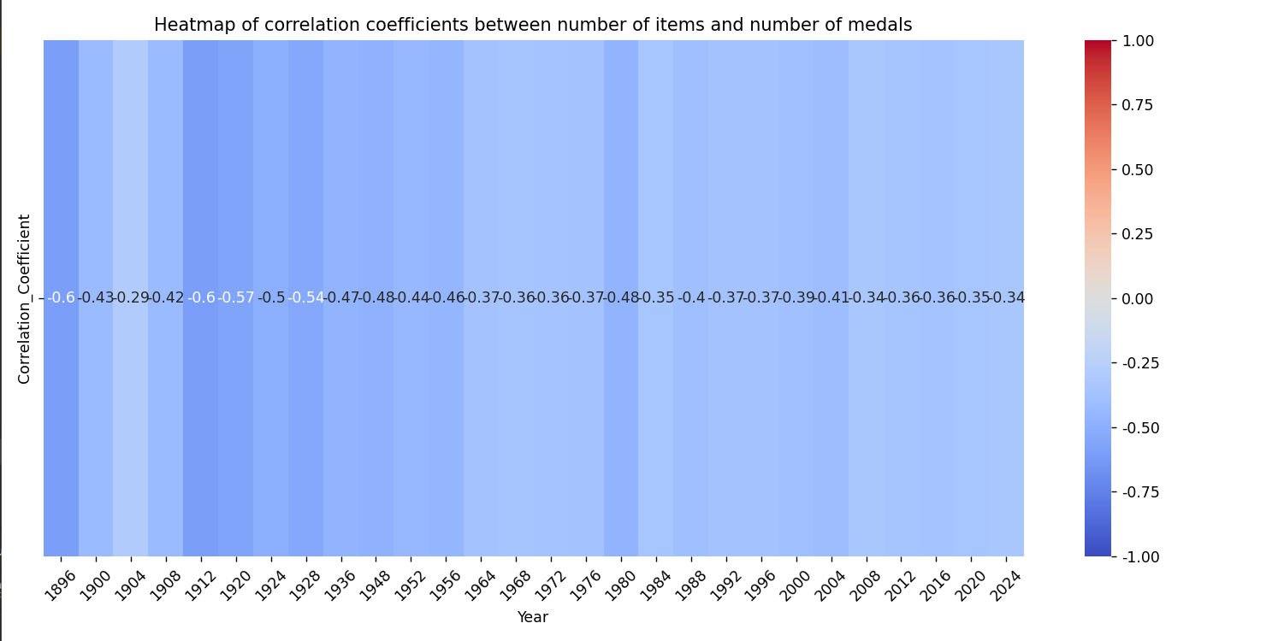
Figure10:Heatmap of correlation coefficients between number of items and number of medals

We visualized our results and observed that while the number of events increased, the number of medals won by countries decreased. Through further data analysis and research, we concluded that this trend is mainly influenced by the characteristics of the events themselves. The reasons can be summarized as follows:

- Competition Intensity: The global competition levels of different events vary significantly. Popular events (such as athletics and swimming) are highly competitive, so even with more events, the chances of winning medals may be lower. In contrast, less popular events have less competition and higher chances of winning medals.
- Event Strength: A country's strength in specific events largely determines its medal count. If most of the events a country participates in are not its strong suit, the probability of winning medals may not increase significantly, even with more events.
- Impact of New Events: Some newly added events (like street basketball and rock climbing) have a relatively small impact on medal distribution, especially for traditional powerhouses. The increase in such events may result in a decrease in the medal-to-event ratio, lowering the likelihood of winning medals for these countries.

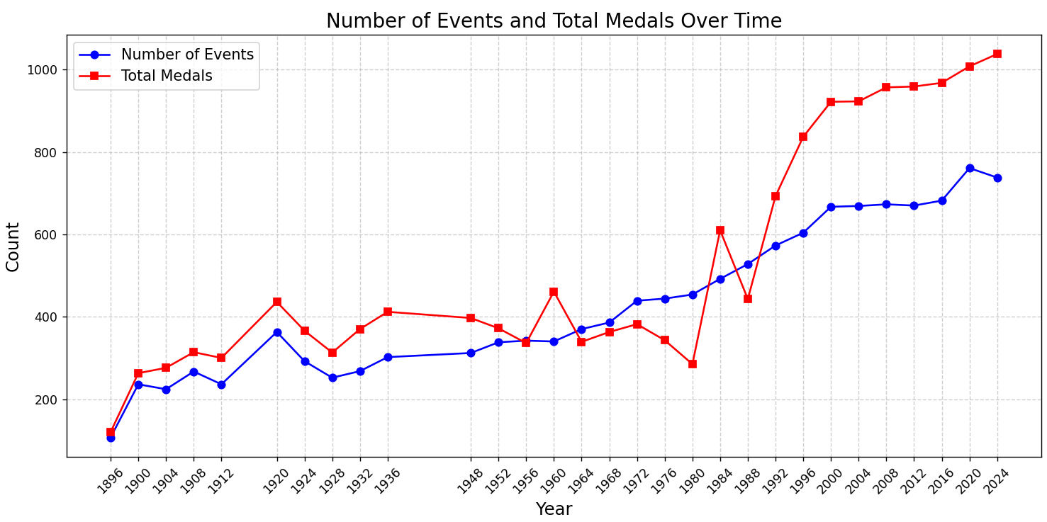
Figure11:Line chart of the total number of medals and total number of events by country

8 Weighted average algorithm: Exploring the most important events for countries and the host country effect
Based on the MEDAL column (which includes medal types: Gold, Silver, Bronze, None), the gold, silver, and bronze medal counts are filled. The data is grouped by NOC (National Olympic Committee code) and EVENT (event name) to summarize the medal counts. For each country and event, the number of gold, silver, and bronze medals, as well as the total medal count, are calculated. Then, the ratio of each medal type to the total medal count is computed. After calculating the ratios, a combined score for gold, silver, and bronze medals is calculated for each event, where the score for each medal type is the product of the medal count and the corresponding ratio. Finally, using the weighted ratio algorithm, the most important three events for each country are selected based on their overall score (including the combined scores for gold, silver, and bronze).By the weighted scores, Argentina's men's football, with a score of 49.16, is the most influential event for the country’s medal prospects. In the USA, the men's 4×100 meters medley relay in swimming, with a weighted score of 35.92, is the most promising event for their medal hopes.

We compiled the medal data from previous years and calculated the average for the host country’s past data. Similarly, we calculated the average for the non-host countries’ past data.
We can get the following:
- The average number of three-time wins by a host in the USA-CHN Olympics is: 56.5
- The average number of three-time wins by a non-host in the USA-CHN Olympics is: 3.5025015634771735

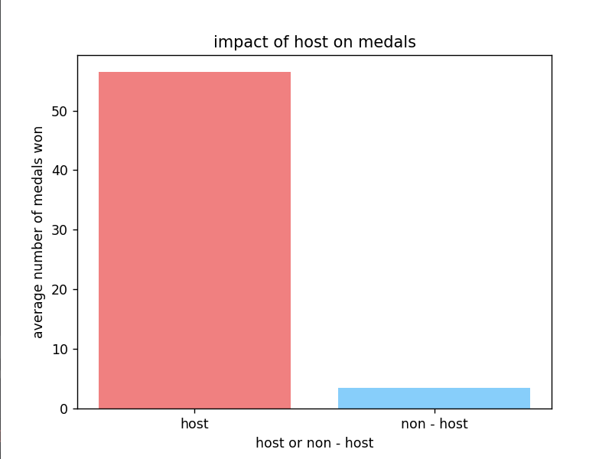
Figure12:impart of host on medals
Host countries typically win more medals due to psychological and material advantages from hosting the games. Non-host countries, however, rely on factors like athlete qualities and training systems to succeed. This highlights the importance of understanding medal distribution and can inform resource allocation and strategic planning for the International Olympic Committee and national sports organizations.

9 Ridge regression model + Lasso regression model:A Study on the Effect of Great Coaches

9.1 Data Description
We selected China, the USA, and Nigeria to explore the "Great Coach Effect." Using the "merged_Olympics_data," we filtered and quantified the coaching effect for volleyball. After 2015, Lang Ping became China's coach, and the USA lost her. We added a binary "Great Coach" variable (1 for having the coach, 0 for not) and assigned values based on Lang Ping's coaching career. We used medal weights: gold = 3, silver = 2, bronze = 1. Similarly, we analyzed Bela Karolyi's coaching career with the same approach.

9.2 The Establishment of Model
We used Ridge regression to model the data for China and the USA, analyzing the impact of coach changes on medal performance. Positive coefficients suggest a positive effect, while negative ones indicate a potential negative impact. For the USA and Nigeria, we applied Lasso regression with alpha set to 0.1 to optimize the model and further explore the "Great Coach" effect.[5]

9.3 The Solution of Model
In the USA model, the coefficient for coach change is 3.05, indicating a positive impact. This means that after the coach change, the total medal weight (weighted sum of gold, silver, and bronze) increased by approximately 1.35 units, showing an improvement in the USA women's volleyball team’s performance, confirming Lang Ping’s effectiveness. The year coefficient is 4.66, indicating that as the years progress, the total medal weight has increased, suggesting that the team's performance has improved over time. The intercept is 10.16, representing the baseline total medal weight when all independent variables are zero, meaning that without a coach change and at the baseline year, the model predicts a total medal weight of 10.16.

In the China model, the coefficient for coach change is 7.71, indicating a positive impact. This suggests that the coach change led to an improvement in the performance of the Chinese women's volleyball team. The year coefficient is -0.53, which is negative, indicating that over time, the team's performance has declined.Lang Ping's impact on the Chinese women's volleyball team was more significant than on the USA team, possibly due to her coaching style and training plans being better suited to the Chinese team, and the advantage of cultural and linguistic similarities in communication and understanding. The performance decline over time may be attributed to factors such as changes in players' physical condition, increased international competition, and delayed tactical updates.

Similarly, we found similar conclusions in the Nigeria model. In summary, the "Great Coach Effect" is crucial in sports. A great coach not only brings tactical expertise but also motivates athletes, strengthens team cohesion, and adapts strategies to maximize performance. However, the effect is not immediate—it requires time to develop, as even the best coaches face challenges in adapting to different cultures and external pressures. The coach's impact depends on factors like team dynamics, player cooperation, and the external environment. Ultimately, while a great coach's role is vital, its success relies on the right timing, conditions, and support.

We use the model trained above to make predictions for three countries: (same dataset as above, but with 0 great coaches)
Table3:The Impact of the Great Coach Effect in Other Countries
Country | Olympic Sport | Coach Change Effect
Japan | Gymnastics | 2.99518734
Brazil | Volleyball | 3.05273441
India | Athletics | 0.43371428

That is, the coaching effect has increased the average number of MEDALS in Japanese gymnastics: 2-3.The coaching effect increases the average number of MEDALS awarded in volleyball in Brazil: 3-4.The coaching effect has increased India's track and field medal count by an average of 0-1.

10 Sensitivity Analysis
10.1 Random Forest Model
Parameter/feature variable inputs: number of athletes in each country (x1), number of sports participated in (x2).
Sensitivity analysis method: We assume that x1 and x2 obey normal distribution, and generate 1000 samples by random sampling to simulate and predict the distribution of the number of gold medals and total medals. By analyzing the results, the uncertainty of the number of athletes and the number of sports involved in each country has a large impact on the prediction of the number of medals, with a mean change of 3.25 and a standard deviation of 6.504 in the simulation of predicted medals.

Key finding: the number of athletes and the number of sports involved in each country were found to have the greatest impact on the model's prediction of the final number of medals to be won in the Monte Carlo simulation.

10.2 XGboost model
Parameter/Characteristic Variable Inputs: Gold_MA3(x1), Gold_MA3(x1), Total_MA3(x2), Number of Athletes Participating in the Olympics (x3), Number of Sports Participated in (x4), Athletes' Historical Medal Count (x5), Athletes' Historical Gold Medal Count (x6), Athletes' total number of historical silver medals (x7), and the athlete's total number of historical bronze medals (x8).
Sensitivity analysis method: Assuming that the values of all parameters obey normal distribution, 1000 samples were generated through random sampling to simulate the predicted distribution of gold medals and total medals. Through the analysis of the results, the uncertainty of the number of participating sports and the number of athletes from each country has a large impact on the prediction of the number of medals, with a mean change of 2.325 and a standard deviation of 0.219 in the simulation of predicted medals.

The main finding: the number of athletes from each country and the number of sports involved in the Monte Carlo simulation, obtained through simulation exploration, had the greatest impact on the model's prediction of the final number of medals won.

10.3 Survival Analysis (Cox proportional hazards model):
Parameter/characteristic variable inputs: total number of participation before the first medal (x1),total number of types of sports participated before the first medal (x2).
Sensitivity analysis method: Assuming that the values of x1, x2 follow a normal distribution, 1000 samples were generated through random sampling to simulate the distribution of the predicted number of medals. The analysis results show that the uncertainty of the total number of entries before the first award, and the total number of types of programs participated before the first award has a greater impact on the prediction of the number of medals, with a mean change of 0.5313 and a standard deviation of 0.01993.

Key Findings: Through Monte Carlo simulation and sensitivity analysis, we found that the total number of entries before the first prize and the total number of types of events participated in before the first prize had the most significant effect on the model's prediction of the final number of medals.

From there , we can further control the fluctuation of these key variables, which can effectively improve the accuracy and stability of the prediction.

11 Model Evaluation and Further Discussion

11.1 Strengths
- Classification first, then prediction: We creatively used the entropy weight method to classify strong sporting nations and emerging sports countries, and then trained different models for each category. This greatly improved the accuracy of predicting the performance of many countries that have never won a medal before.
- Introducing machine learning: We incorporated machine learning methods in predicting medal standings, evaluating potential sports for countries, and exploring the great coach effect, all of which demonstrated good performance. This can provide valuable insights and references for future research.
- Comprehensive data mining: For example, when exploring the probability of countries that have not yet won medals obtaining their first medal, we also conducted an in-depth analysis of potential sports for these countries. This made the conclusions more valuable.

11.2 Weaknesses
- Prone to overfitting: The above models contain a large number of parameters, and the current data set may not have enough samples to ensure the identification of suitable parameters, making it prone to overfitting. Expanding the sample size may allow the model to perform better.
- Slow runtime: The model is too complex, with too many computational tasks, and the model needs to be simplified.

11.3 Further Discussion
Our above approach is mainly based on the data provided in the problem, which includes the medal standings of all Summer Olympic Games, host countries, the number of Olympic events categorized by sport for each Olympic Games, and individual Olympic athletes' event and performance data. However, in reality, the Olympic medal standings are also influenced by many other factors, such as the country's sports funding and investments from major social organizations in this area, the country's population size, and the athlete base. Additionally, political factors, socio-economic conditions, global events like pandemics, etc., may affect the preparation of participating countries and the athletes' mental state, indirectly influencing the medal distribution. In future research, we can expand our data set and incorporate these factors into the model's training, thereby obtaining more rigorous and authoritative predictions.

12 Conclusion
Based on data from previous Summer Olympic Games, including medal standings, host countries, the number of Olympic events, event classification, and the performance data of all Olympic athletes, we provide predictions for the 2028 Olympic medal standings and gold medal rankings, the probability of first-time medal-winning countries, as well as the impact of Olympic events, host country effects, and the great coach effect on Olympic performance.

We comprehensively applied the entropy weight method, Random Forest, and XGBoost to predict the 2028 Olympic medal standings and gold medal rankings, providing confidence intervals that demonstrate the good performance of our models. We also predicted countries likely to improve or decline in their performance. Subsequently, we used the Cox Proportional Hazards model and the DQN-DeepQ-Network model to assess the number of countries expected to win their first medal in the next Olympic Games and identified their potential events. Additionally, we conducted Pearson correlation analysis to explore the relationship between sports events and medal counts, and used a weighted algorithm to analyze key events for each country and the host country effect. Finally, we employed Ridge and Lasso regression to further analyze data for the Chinese women's volleyball team, the U.S. women's volleyball team, the U.S. women's gymnastics team, and the Nigerian women's gymnastics team to explore the great coach effect.

References
- R. Bunker and F. Thabtah, “Machine learning in sports: A case study on football match prediction,” Journal of Sports Analytics, vol. 5, no. 4, pp. 235–242, 2019.
- S. Park and S. Kim, “Predicting olympic medal counts with machine learning: An analysis of historical data,” International Journal of Sports Science, vol. 9, no. 2, pp. 112–125, 2021.
- J. Moolchandani, V. Chole, S. Sahu, R. Kumar, A. Shukla and A. Kumar, "Predictive Analytics in Sports: Using Machine Learning to Forecast Outcomes and Medal Tally Trends at the 2024 Summer Olympics," 2024 4th International Conference on Technological Advancements in Computational Sciences (ICTACS), Tashkent, Uzbekistan, 2024, pp. 1987-1992, doi: 10.1109/ICTACS62700.2024.10840553.
- Shi Huimin, Zhang Dongying, Zhang Yonghui. Can Olympic Medals Be Predicted? — From the Perspective of Interpretable Machine Learning [J]. Journal of Shanghai University of Sport, 2024, 48 (04): 26-36.
- Nagpal, P., Gupta, K., Verma, Y., Kirar, J.S. (2023). Paris Olympic (2024) Medal Tally Prediction. In: Sharma, N., Goje, A., Chakrabarti, A., Bruckstein, A.M. (eds) Data Management, Analytics and Innovation. ICDMAI 2023. Lecture Notes in Networks and Systems, vol 662. Springer, Singapore.

Appendices
Report on Use of AI
Introduction
In the 2025 Mathematical Contest in Modeling (MCM), our team utilized AI tools to enhance our modeling process and improve the quality of our solution. This appendix provides a detailed report on the AI tools we used, the specific tasks they were employed for, and the rationale behind their use.
AI Tools Used
1.Doubao
Version: Doubao1.5-Pro (January 26th, 2024)
Tasks:Code modification: Assist in modifying the error-prone code for our model.
Data collection: Assist us in collecting the required external data.
Specific Use Cases
Query1: "I get an error in my reinforcement model code:DtypeWarning: Columns (8) have mixed types. Specify dtype option on import or set low_memory=False."
Output: This 'DtypeWarning' warning appears when reading a CSV file using the 'read_csv' function of 'pandas', indicating that the data types in column 8 (index starting at 0) are mixed. That is, there are many different types of data in this column, such as strings and numbers, and 'pandas' has difficulty automatically inferring the data type. Here are a few ways to solve this warning: Method 1: Set 'low_memory=False' When using the 'read_csv' function, set the 'low_memory' parameter to 'False', so that 'pandas' will read the entire file at once, instead of reading in chunks, so as to avoid the problem of data type inference caused by chunked reads. Method 2: Specify the data type of the column You can manually specify the data type of column 8 via the 'dtype' parameter. The first thing to do is to determine which data type should be used for this column, such as the string type 'str'. Method 3: Check the data and clean If possible, you can manually check the data in column 8 to find out the reason for the mixing type and clean it. For example, convert all data to a uniform type.
Choose the appropriate method: Method 1: Simple and straightforward, suitable for situations where the amount of data is not particularly large. However, setting 'low_memory=False' may increase memory usage. Method 2: It is effective to know the data type of the column clearly to avoid unnecessary memory overhead. Method 3: If further analysis and processing of the data is required, cleaning the data is a better option to ensure data consistency. You can choose the appropriate method to solve this warning problem according to the actual situation.

Query2: "Help me search for the coaching experience of Lang Ping and Béla Károlyi"
Output2: Lang Ping and Béla Károlyi's coaching experience is as follows:
### Lang Ping's coaching experience
- **Domestic Coaching**
- In 1986, as an assistant coach, she assisted head coach Zhang Rongfang and helped the Chinese women's volleyball team win the 10th World Championships.
- On February 15, 1995, he served as the head coach of the Chinese women's volleyball team, and led the team to win the third place in the Women's Volleyball World Cup in the same year.
- In 1996, he led the Chinese women's volleyball team to win the silver medal in the Atlanta Olympic Games.
- In 1997, she led the team to win the gold medal in the 9th Asian Women's Volleyball Championship.
- In 1998, she led the team to win the runner-up in the 13th World Women's Volleyball Championship and the gold medal in the 13th Asian Games volleyball competition.
- In 2009, she returned to China to coach the Guangdong Evergrande women's volleyball team, and led the Evergrande women's volleyball team to win the 2009-2010 National Women's Volleyball League A B championship and the 2010-2011 National Women's Volleyball League A A runner-up.
- On April 25, 2013, she served as the head coach of the Chinese women's volleyball team again and led the team to win the runner-up in the 2014 Women's Volleyball World Championship.
- In 2015, he led the Chinese team to regain the Asian Championships; In the same year, he led the team to win the Women's Volleyball World Cup.
- In 2016, he led the Chinese women's volleyball team to win the Rio Olympic championship.
- In 2018, she led the Chinese women's volleyball team to win the third place in the 2018 Women's Volleyball World Championships.
- In 2019, she led the Chinese women's volleyball team to win the Women's Volleyball World Cup with a record of 11 wins.
- **Coaching Abroad**
- In 1989, he became the head coach of the women's volleyball team of Modina Club in Italy, leading the team to the Coppa Italia championship.
- In 1991, she led the University of New Mexico women's volleyball team to win the Eastern Conference Women's Volleyball Championship.
- In 1999, she became the head coach of the women's volleyball team in Modena, Italy, and led the team to win the Italian Women's Volleyball League championship in 2000.
- In the 2002-2003 season, he served as the head coach of Novara FC in Italy, leading the Novara women's volleyball team to win the Italian Super Cup and the 2004 Italian League championship.
- In February 2005, he became the head coach of the U.S. women's volleyball team, led the U.S. women's volleyball team to win the third place in the World Cup in 2007, and led the team to win the silver medal in the Beijing Olympics in 2008.
### Béla Károlyi's coaching experience
- **Romanian period** - led the Romanian women's gymnastics team to two team silver medals at the 1976 and 1980 Olympic Games.
- Coached Romanian gymnast Nadia Comaneci, making him the first gymnast in Olympic history to score a perfect 10 points under the grading system at the time. - **American Period**
- After moving to the United States in 1981, he coached at a private gymnastics club in Houston, producing famous athletes such as Juliana McNamara.
- In 1984, he coached Mary Lou Layton to win the all-around gold medal at the Los Angeles Olympics.
- In 1992, he was appointed head coach of the Olympic gymnastics team.
- In 1996, she led the U.S. women's gymnastics team to an Olympic team gold medal, embracing Kelly Struger, who had performed a vault with only one foot due to an ankle injury.
- In 1997, he was inducted into the International Gymnastics Hall of Fame. - In 1999, he was appointed the first national team coordinator of the U.S. Gymnastics team.
AI Tools Used
2.Deepseek
Version: DeepSeek-R1: January 20, 2025
Tasks:Code modification:Explanation of code ideas: for some of the logic is easy to mess up the code to be explained .
Query3: “Why do I get an error when merging two datasets?”
OUTPUT: The code you provided runs with the error KeyError: 'Year', which indicates that the Year column in the programs_data dataframe does not exist when you try to access it. To resolve this issue, you need to confirm that the programs_data dataframe actually has a Year column. You can troubleshoot and resolve this in several ways: check the data read to confirm that when you read the CSV file corresponding to programs_data, the Year column does exist in the file. You can add code to the preprocess_data function to see the basic information about the data and the column names. If you find that the column name is misspelled or the actual column name is not Year, change the corresponding column name in the code to the correct name. For example, if the actual column name is year (lowercase), change the code to lowercase. If the Year column does not exist, but you need to generate year information based on another column, you need to write the appropriate code to generate that column. For example, if there is a Date column in the data that contains year information, you can extract the year to generate Year column by the following way, please choose the appropriate method to solve this problem according to the actual data situation.
Output4: “How to total all the gold, silver, and bronze medals that a country has historically won in a particular sport.”.
Output: Read CSV file using read_csv function of Pandas.Pandas is a powerful data processing library that can easily load CSV files as DataFrame objects for subsequent operations. Country Condition: NOC == 'Specify Country Code', for example, NOC == 'CHN' means filter out the data of China. Project condition: Sport == 'Specify project name', for example, Sport == 'Basketball' means filter out the data of basketball project. Apply filtered conditions: Use Pandas' Boolean indexing feature to combine country conditions and project conditions to filter out data rows that meet both conditions. For example: filtered_df = df[(df['NOC'] == 'CHN') & (df['Sport'] == 'Basketball')].
Query:
Output:
Query: "What potential issues might reviewers find in our paper?"
Output: ChatGPT identified potential weaknesses in our arguments and suggested improvements.
Validation of AI Results
To ensure the reliability of the AI-generated results, we performed the following validation steps:
Cross-Verification: Compared AI-generated results with manual analysis and other sources.
Peer Review: Submitted our paper to peer review to identify any discrepancies or errors.
Expert Consultation: Consulted with domain experts to validate the AI-generated insights.
Conclusion
The use of AI tools significantly enhanced our modeling process and improved the quality of our solution. By leveraging the capabilities of ChatGPT and Ernie, we were able to optimize our paper's language, validate our results, and enhance its originality. We believe that the responsible use of AI tools can greatly benefit teams participating in the MCM, provided that the results are thoroughly validated and verified.
References
OpenAI. (2023). ChatGPT-4 Documentation. Retrieved from https://openai.com/chatgpt-4

Baidu. (2023). Ernie 4.0 Documentation. Retrieved from https://ernie.baidu.com
This report provides a comprehensive overview of our use of AI tools during the 2025 MCM. We hope that this information will be useful for other teams considering the use of AI in their modeling efforts.

