|  |
| --- |
| College LaSalle |
| Project - P55 - Internet Programming I Technical Manual |
|  |
| Presented to: Mihai Maftei |

|  |
| --- |
| Author: Alexey Zapromyotov  7/26/2018 |

Description:

**This project is a simulation of the ‘FAN’ site of football fans (soccer game) dedicated to the recent World Cup FIFA 2018 in RUSSIA**.

It has some required attributes, recent information (as of July 2018) on World Cup and Football squads, little ‘on-line’ shop etc.

**Limitations:**

Please be adware all of the project features were fully functional only when tested with **Safari Browser** on Mac OS X **(Safari version 11.1.2).**

Also functionality tested with browser **Firefox (Quantum v 61.0.1)** – both Windows 7/10 and MacOSX High Sierra. With Firefox (v 61.0.1) cookies are used only within current session. Once you close the browser window all cookies will be deleted (may be possible to change this behaviour in browser settings)

Full functionality not supported with **Google Chrome** (Version 67.0.3396.99 (Official Build) (64-bit)) since this browser does not support locally used cookies:

* <https://productforums.google.com/forum/#!topic/chrome/iow88FsnNhQ>
* <https://bugs.chromium.org/p/chromium/issues/detail?id=535>

Languages and technologies were used:

1. JavaScript
2. HTML5 and CSS3
3. jQuerry library 3.11 (mini & online link)
4. sessionStorages and local Cookies….

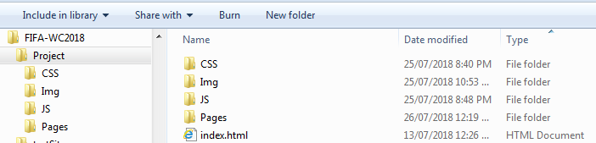Presenting how the files/folders are organised.

Index.html

1. 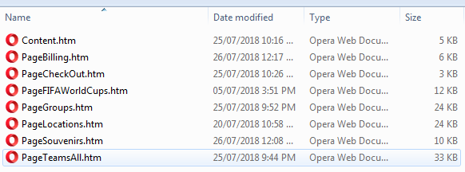css
2. Img
   1. Various images
   2. Flags
   3. imgCAD
3. Pages
   1. Content.htm
   2. PageBilling.htm
   3. PageCheckOut.htm
   4. PageFIFAWorldCups.htm
   5. PageGroups.htm
   6. PageLocations.htm
   7. PageSouvenirs.htm
   8. PageTeamsAll.htm
4. JS
   1. topmenu.js
   2. jquery-3.1.1.min.js

Below you may find some functions and methods that were used in the project:

|  |  |
| --- | --- |
| **Function/Method** | **Description** |
| 1. Document.getElementById() | Used in many situations to get the content of specific element (using ID). For example, used in my javascript file to create custom CSS:  *var mainStyle = document.getElementById("mainStyle").innerHTML;*  Another example is used to set the value:  *document.getElementById("mainStyle").innerHTML = mainStyle;* |
| 1. alert() | Used to notify the user of some actions taken.  *alert("All content of the Shopping Cart will be removed now!!!");* |
| 1. USR_showShoppingCart () | Function to display the content of a Shopping Cart  Uses sessionStorage.getItem('userName') to get the current logged user account name  and cookies to display the content of a user shopping cart:  getCookie('basket'+userID); |
| 1. USR_showBillingTotals () | Function to display the content of a Shopping Cart  Uses sessionStorage.getItem('userName') to get the current logged user account name  And a cookie to get the TOTAL amount: getCookie('totals'+userID) |
| 1. USR_addToBasket(id,name,price) | Function to add items to the user shopping cart. |
| 1. getCookie(cname) | Function to retrieve the cookie (and its contents) with parameter ‘cname’ – i.e. name of the cookie… |
| 1. deleteCookie(cookieName) | Function to delete the cookie (and its contents) |
| 1. setCookie(cname, cvalue, exdays) | Function to set the cookie (and its contents) with parameter ‘cname,cvalue,expiration-days’ – i.e. name of the cookie… |
| 1. tablesShowHide(objToShowHide) | Function to show or hide tables containing information on the different games of different stages (1/16, 1/8, ¼ etc)  Can be seen in action on page: PageGroups.htm |
| 1. authenticate_login() | This function used to check the user name and password in order to allow/decline login and usage of the site links.  For simplicity only 3 users were used:  username=['admin','teacher','test'];  login_password=['12345','teacher','123'];  Once a user successfully authenticated a user allowed to click the links in the top floating menu |
| 1. authenticate_logout() | To provide logout feature for a user. Allow to logout so other user account could be used to login. After user logs out of the system no other links made available for a user – meaning navigation between pages is not possible using top-floating menu. |