|  |
| --- |
| College LaSalle |
| Project - P55 - Internet Programming I User Manual |
|  |
| Presented to: Mihai Maftei |

|  |
| --- |
| Author: : Alexey Zapromyotov  7/26/2018 |

Description:

**This project is a simulation of the ‘FAN’ site of football fans (soccer game) dedicated to the recent World Cup FIFA 2018 in RUSSIA**.

It has some required attributes, recent information (as of July 2018) on World Cup and Football squads, little ‘on-line’ shop etc.

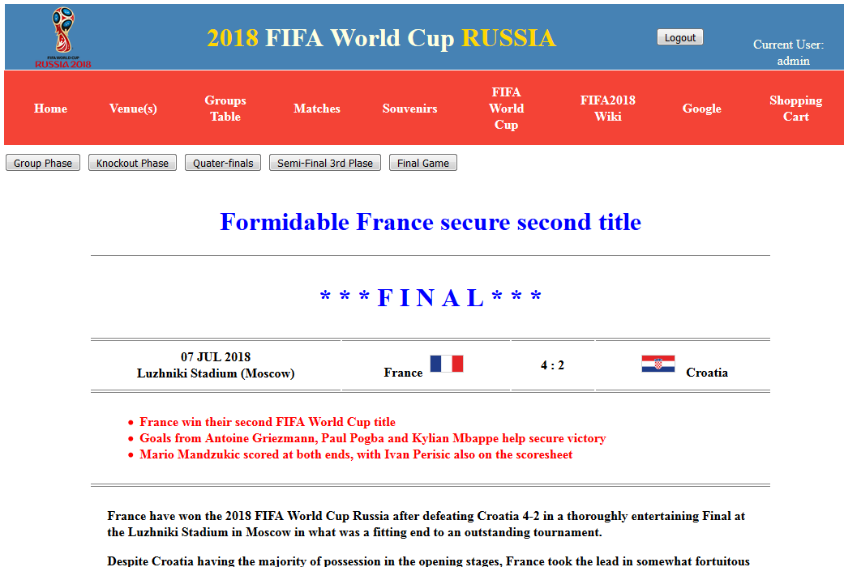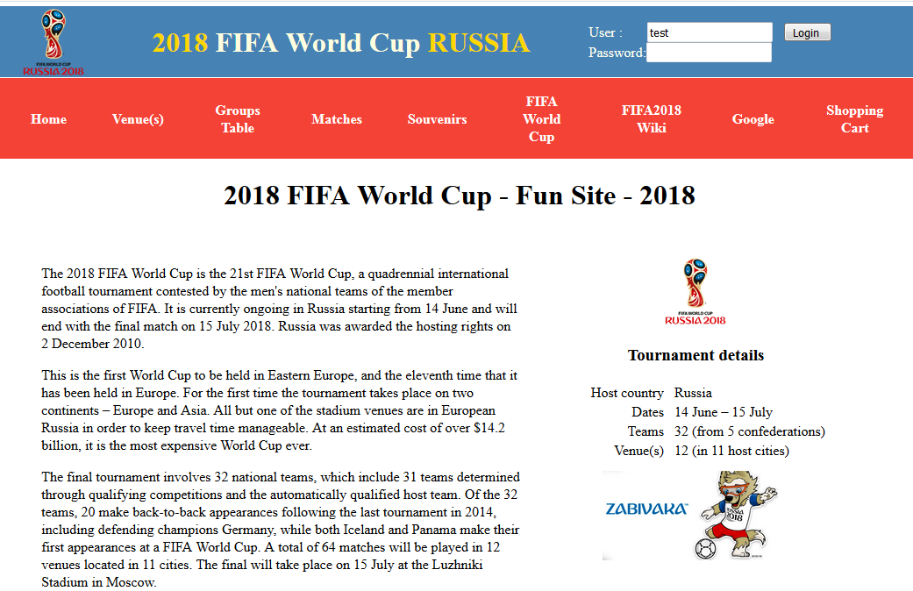Some demo pictures. :

How to use:

1. Enter your Username and Password in order to enter to my web site. (admin: 12345; test: 123; teacher: teacher)
2. Click on one of the links in the top floating menu to have access to different web-pages.
3. If you click the link of Google, another web page will open, giving you the possibility to search on the internet.
4. 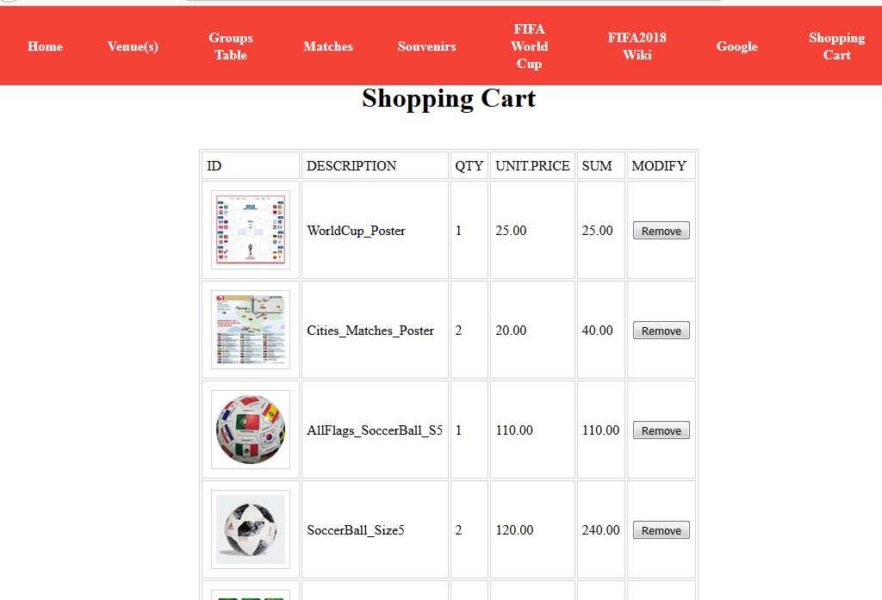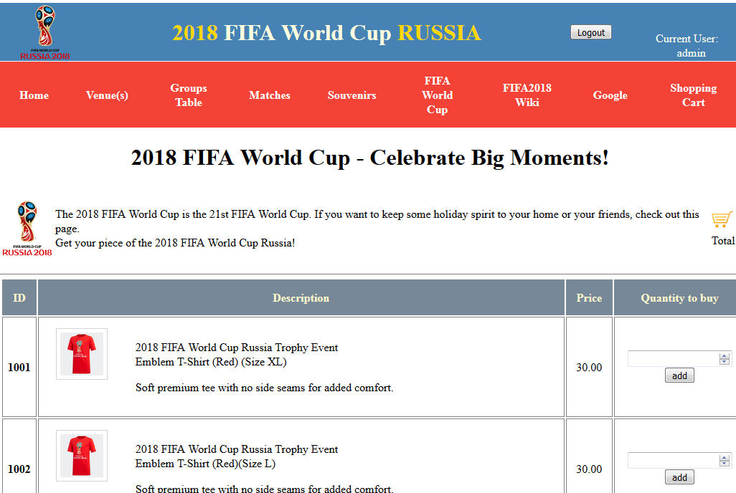To use shopping cart you will have to visit ‘Souvenirs’ page to add some items to the shopping cart.

The last option is payment:

