
Eye-Gaze Communication App
QUICK START GUIDE · 5-Minute Essentials
Once the app is installed on a smartphone or tablet, the user launches it and is shown a disclaimer and a short set of instructions. After accepting the disclaimer, the user begins a session.
The camera preview should show the eye region of the face clearly — this confirms the app is tracking correctly. From there, the user selects a phrase from the phrase board using eye movements alone.
Every phrase on the board is mapped to a binary codeword. The user builds that codeword one digit at a time: a glance LEFT enters 0, a glance RIGHT enters 1. Holding the gaze at the CENTER for two seconds ends the entry, and the device speaks the selected phrase aloud.

No special hardware. No keyboard. No spelling. Just a Galaxy phone or tablet and its front camera.

The three gaze movements
Look LEFT | = 0 | Adds the digit 0 to the code
Look RIGHT | = 1 | Adds the digit 1 to the code
Look CENTER | 2 sec | Confirms — the phrase is spoken aloud

Example: "Uncomfortable" = 011 → LEFT, RIGHT, RIGHT, then CENTER for 2 seconds.
 |  |  | 
LEFT (0) | RIGHT (1) | RIGHT (1) | CENTER (2 s)

Made a mistake? Just look at the center for 2 seconds. Codes that do not exist are thrown away automatically, and you can start again.

Safety: This is a communication aid, not a medical device. A caregiver must always be present, and there must always be a backup way to call for help.

1. Setting Up
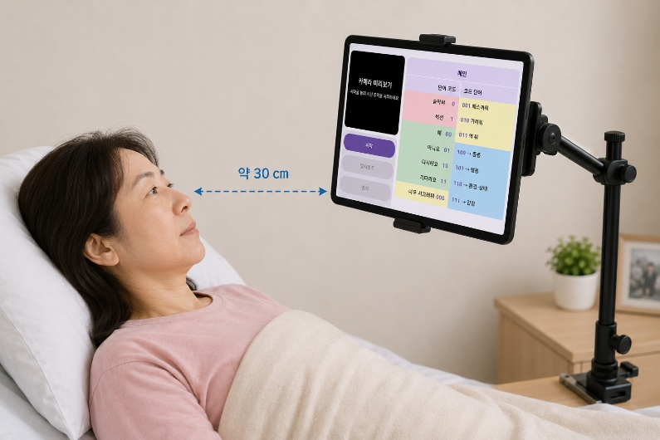  Mounting position | Position the device  - About 30 cm from the user's face  - Camera at eye level, slightly above the line of sight so it does not block the view  - Face centred in the camera preview  - Light in FRONT of the user — never a window behind them  - Wipe the camera lens before use

Glasses: remove them if possible. If they must be worn, tilt the device until no glare shows on the lenses in the camera preview — reflections block eye detection.

First launch — 3 taps
1 | Choose the language at the top of the screen: English or 한국어. This sets the menus, the phrase list and the voice.
2 | Read the disclaimer and tap Accept.
3 | On the Instructions screen choose the device type — Galaxy Phone or Galaxy Tab — so the app knows where the camera is.

The three buttons
Button | What it does
Start | Turns the camera on and starts tracking. The status light turns GREEN (TRACKING).
Pause / Resume | Suspends tracking; the camera stays on. Status light turns ORANGE (PAUSED).
Stop | Turns the camera off and stops everything.

The user can pause without help. Closing the eyes for five seconds or longer pauses tracking; closing them again for five seconds resumes it. Use this while resting or sleeping, or whenever the user is not composing a phrase so that ordinary eye movements are not read as input

Which orientation?
- Galaxy Tab: use LANDSCAPE. In portrait the camera sits far to the side and accuracy drops.
- Galaxy Phone: either orientation works.

Before the user starts: the caregiver should try the app first. Ten minutes of practice makes teaching much easier.

2. The Main Phrase Chart
This is the only page most people need. Short codes are the most urgent phrases — emergencies take a single look.
Code | Gaze | Says
0 | L → centre | Can't breathe
1 | R → centre | Suction
00 | L L → centre | Yes
01 | L R → centre | No
10 | R L → centre | Repeat
11 | R R → centre | Wait
000 | L L L → centre | Thirsty ★
001 | L L R → centre | Urinate ★
010 | L R L → centre | Defecate ★
011 | L R R → centre | Uncomfortable ★
100 | R L L → centre | opens the PAIN page
101 | R L R → centre | opens the ACTION page
110 | R R L → centre | opens the ENVIRON · STATE page
111 | R R R → centre | opens the FEELING page

Red | Emergency — one look only
Green | Yes / No / Repeat / Wait — answering questions
Yellow | ★ Shortcuts — these four slots change by themselves (see below)
Blue | Doorways to the four category pages

★ The yellow shortcuts learn from use
- Every time a phrase is chosen from a category page, its counter goes up by one.
- The four most-used phrases automatically move into the yellow slots (000–011), so frequent needs get shorter codes.
- Until enough phrases have been used, the defaults stay: Thirsty, Urinate, Defecate, Uncomfortable.
- To see or clear the counters: Setup → Zone 3A – Usage Frequency → Show / Reset all usage counts.

Teaching order: practise the red and green phrases first (1–2 looks) until they are reliable. Add the yellow shortcuts next, then introduce the category pages one at a time. Sessions of 10–15 minutes work better than long ones.

3. The Four Category Pages
Entering a 3-digit code opens a category page. The counter then resets to empty, and the user enters a second, shorter code to select a phrase within that category. After the phrase is spoken the app returns to Main by itself. Looking LEFT + centre (code 0) always goes back to Main.
PAIN enter code 100 (R L L)  0 ← back to Main  1 Stomachache  00 Headache  01 Back pain  10 Neck pain  11 Chest pain  000 Nausea  001 Mouth dry  010 Eyes dry  011 – 111 empty — free to add | ACTION enter code 101 (R L R)  0 ← back to Main  1 Medicine  00 Change posture  01 Turn me  10 Lift head  11 Lower head  000 Wipe  001 Cover me  010 Call nurse  011 Come here  100 Sit  101 Stay still  110 Rest  111 Urinate
ENVIRON · STATE enter code 110 (R R L)  0 ← back to Main  1 Cold  00 Hot  01 Too bright  10 Too dark  11 Too loud  000 Sleepy  001 Itchiness  010 Thirsty  011 Uncomfortable  100 – 111 empty — free to add | FEELING enter code 111 (R R R)  0 ← back to Main  1 Thank you  00 Sorry  01 Anxious  10 Scared  11 Sad  000 Lonely  001 Happy  010 Exhausted  011 Angry  100 Miss you  101 – 111 empty — free to add

Adding your own phrases: Instructions screen → Setup → tap any empty *** slot → type the phrase → Save, then Save & Return. Keep phrases to 1–3 words so the voice stays clear. Three items cannot be changed: "Can't breathe" (code 0), "back to Main" (code 0 on category pages), and the four category doorways (100–111).

4. Four Worked Examples
To say | Do this
"Can't breathe" | LEFT → centre 2 s. Spoken immediately.
"Headache" | RIGHT LEFT LEFT → centre 2 s (PAIN page opens) → LEFT LEFT → centre 2 s.
"Thank you" | RIGHT RIGHT RIGHT → centre 2 s (FEELING page opens) → RIGHT → centre 2 s.
Go back to Main | LEFT → centre 2 s. Nothing is spoken.

5. If Something Is Not Working
Problem | What to do
Camera will not start | Android Settings → Apps → ALS Eye-Gaze → Permissions → allow Camera.
No voice | Check the volume buttons. Then Android Settings → General Management → Language & Input → Text-to-Speech.
Gaze not detected | More light. Clean the lens. Move the device closer. Remove glasses, or tilt the device until the glare disappears.
Reacts to every small movement | Check the eyelids are fully open, not half-closed. Ordinary small eye movements should not enter a digit.
Wrong phrase was spoken | Use Repeat (10) or Wait (11) to signal the caregiver, then enter the intended code again.
Unexpected phrases in the yellow slots | Setup → Zone 3A – Usage Frequency → Reset all usage counts.
Phrases in the wrong language | Go back to the Disclaimer screen and select the language again.

Safety notice
This application is a communication aid only. It is not a medical device and must never be the only way the user can alert someone in an emergency.
- Use only with a caregiver present and monitoring.
- Always keep a backup alert method within reach.
- Have a speech-language pathologist assess the user before long-term use.

The developers accept no liability for consequences arising from use of this application. By using it you accept these risks.

This is a short guide. The full User Manual contains the complete Setup screen reference, screen layouts for every device and orientation, and detailed training guidance.

