
Eye-Gaze Communication App for ALS Patients

User Manual

Assistive Technology for ALS Patients

Table of Contents
1. Overview 4
1.1 Key Features 4
1.2 How It Works — the Binary Gaze System 4
1.3 Example Scenario 5
1.4 Installation 5
2. Getting Started 6
2.1 Device Setup 6
2.2 Device Type Selection 6
2.3 First Launch — Language & Disclaimer 6
2.4 Launching the Camera 8
2.5 Pausing with Eye Closure 9
2.6 Building Words with Left/Right Gaze (Important) 9
3. The Codeword System 10
3.1 Zone Overview 10
3.2 Main Page — Full Word List 11
3.3 Category Pages 12
PAIN page (enter with code 100) 12
ACTION page (enter with code 101) 12
ENVIRON·STATE page (enter with code 110) 13
FEELING page (enter with code 111) 13
4. Zone 3A Adaptive Shortcut 15
4.1 How Frequency Tracking Works 15
4.2 Viewing and Resetting Counts 15
5. Setup Screen 16
5.1 Navigating the Word List 17
5.2 Editing a Word 17
5.3 Words That Cannot Be Edited 18
6. Screen Layout 19
6.1 Galaxy Phone — Landscape 19
6.2 Galaxy Phone — Portrait 19
6.3 Galaxy Tab — Landscape 19
6.4 Galaxy Tab — Portrait 19
7. Step-by-Step Examples 20
7.1 Saying “Can't breathe” (emergency) 20
7.2 Saying “Headache” via PAIN page 20
7.3 Returning to Main page from a category 20
7.4 Saying “Thank you” 20
8. Tips and Best Practices 21
8.1 Camera Positioning 21
8.2 Training New Users 21
8.3 Optimising Zone 3A 21
8.4 Adding Custom Words 21
8.5 Gaze Sensitivity 21
9. Troubleshooting 22
10. Safety Notice 23

1. Overview
This app enables ALS (Amyotrophic Lateral Sclerosis) patients who have lost the ability to speak or move to communicate using only their eye movements. Using an Android phone (Galaxy phone) or tablet (Galaxy Tablet), the standard front-facing camera — no special hardware required — detects left and right gaze to build a binary codeword (e.g. 01). The codeword is matched to a word (e.g. “No”) or phrase, which is then spoken aloud through the device speaker via text-to-speech.
Unlike conventional gaze-tracking communication devices, which reconstruct words letter-by-letter from an on-screen virtual keyboard, this tool is designed around the small set of words a patient uses most. By selecting whole words with only a few gaze movements, the patient can communicate with far less fatigue.

1.1 Key Features
- Hands-free, hardware-free operation using the device's built-in camera
- Hierarchical word system covering 70+ words across 5 categories
- Automatic Zone 3 shortcut that adapts to the patient's most-used words
- Category pages for Pain, Action, Environ·State, and Feeling
- Text-to-speech output when a word is selected
- Eye-closure pause/resume for breaks
- Customizable vocabulary via the Setup screen
- Optimized layouts for Galaxy Phone and Galaxy Tab
- Full bilingual support: Korean / English — selectable on first launch

1.2 How It Works — the Binary Gaze System
The patient communicates by looking left or right to build a binary sequence. Looking left adds a 0; looking right adds a 1. After completing the sequence, gazing at the center for 2 seconds confirms the selection.
Gaze direction | Bit added | Example
Look LEFT | 0 | Left → Right → Right = 011 = “Uncomfortable”
Look RIGHT | 1 | Right = 1 = “Suction” (emergency)
Center gaze (2 s) | Confirm | Hold gaze at center for 2 seconds to confirm

NOTE: For best accuracy, remove glasses before use. If glasses must be worn, adjust the device angle until lens reflections are no longer visible in the camera preview — reflections reduce iris-detection accuracy.

1.3 Example Scenario
For the word “Uncomfortable,” the codeword is 011 (left–right–right). The following images show a person generating this sequence (left/right are from the user's perspective). To complete the codeword, the patient gazes at the center for more than 2 seconds at the end.
 |  |  | 
Left gazing (0) | Right gazing (1) | Right gazing (1) | Center gazing (> 2 seconds)

1.4 Installation
As shown in Figure 1, mount the phone or tablet roughly 30 cm from the patient's face — positioned so it does not block the patient's line of sight, while still capturing the patient's eye movements clearly.
TIP: Before the patient uses the app, the caregiver should try it out first to become familiar with the gaze workflow.
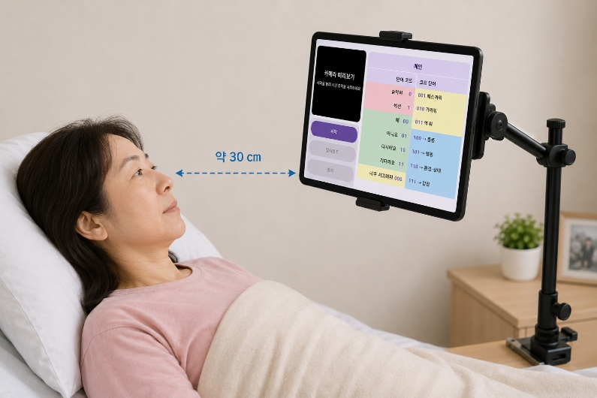
Figure 1 — Tablet (app) installation / mounting position

2. Getting Started

2.1 Device Setup
- Supported devices: Samsung Galaxy Phone and Galaxy Tab (Android)
- Mount the device so the front camera is at eye level for the patient
- Ensure the room is well-lit — natural or overhead light works best
- Clean the camera lens before use
- Use without glasses, or adjust the camera angle to eliminate lens glare/reflections

2.2 Device Type Selection
On the Instructions screen, select the correct device type:
Device | Typical camera position
Galaxy Phone | Portrait: camera at top-center  Landscape: camera at left-center
Galaxy Tab | Portrait: camera at right-center  Landscape: camera at top-center

NOTE: The patient must look toward the phone/tablet camera for gaze to be recognised reliably.

2.3 First Launch — Language & Disclaimer
On first launch a safety disclaimer is displayed (Figure 2). At the top of the screen tap English or 한국어(Korean) to choose the interface language — this is remembered across sessions. Read the disclaimer and tap Accept to continue. This app must always be used under caregiver supervision.
Button | Effect
English | Sets all UI text, word dictionary, and TTS to English
한국어(Korean) | Sets all UI text, word dictionary, and TTS to Korean

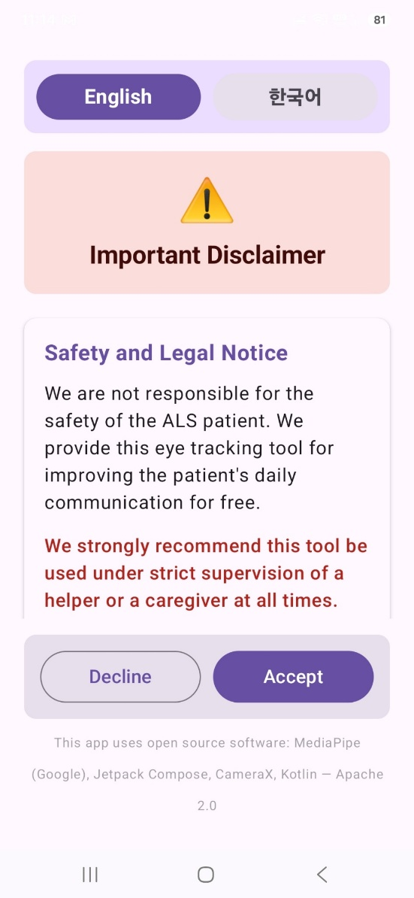
Figure 2 — Disclaimer page

2.4 Launching the Camera
On the main screen (Figures 3 and 4), tap Start. The camera activates, facial-landmark tracking begins, and the status indicator turns green (TRACKING).
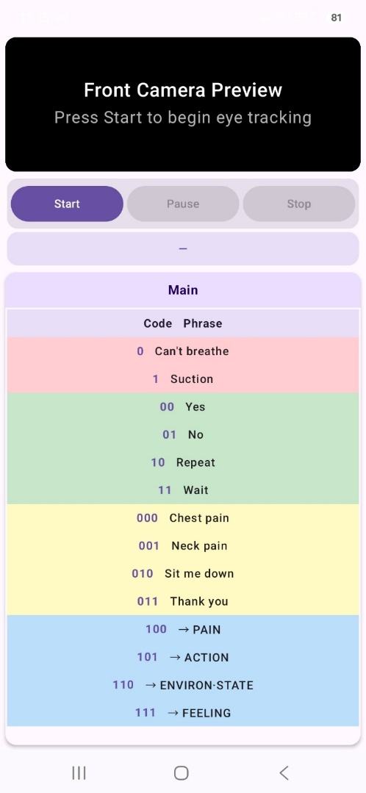
Figure 3 — App main page (Landscape mode)

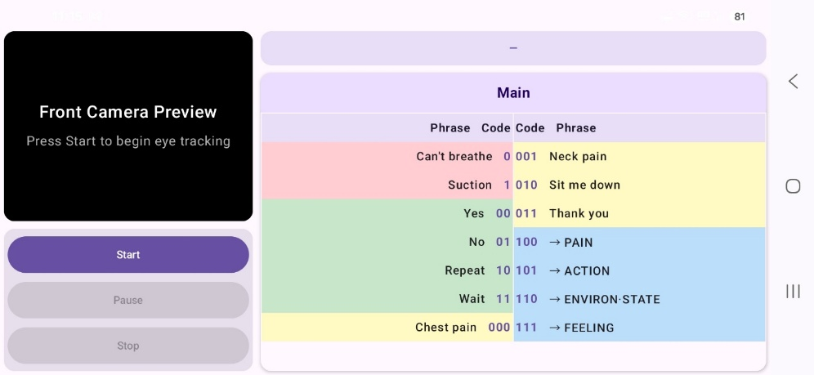
Figure 4 — App main page (Portrait mode)

Button | Function
Start | Activates camera and begins eye tracking
Pause/Resume | Temporarily suspends tracking (camera stays on). Press again to resume. The same pause/resume action can be triggered by closing the eyes for 5 seconds — so a patient who cannot press buttons can pause by closing their eyes for 5+ seconds during use, and resume by closing them again for 5+ seconds.
Stop | Deactivates camera and stops all tracking

2.5 Pausing with Eye Closure
Keeping the eyes closed for 5 or more seconds pauses or resumes tracking without caregiver assistance. The status indicator turns orange (PAUSED). Closing the eyes again for 5 seconds resumes tracking.

2.6 Building Words with Left/Right Gaze (Important)
- The words an ALS patient can use are listed in the main window (shown by the dashed outline in Figure 2). The patient identifies the available words and the codeword that corresponds to each one. For example, the codeword for “Can't breathe” is “0”.
- Each word is produced by building its codeword through left/right gaze. For example, gazing left then right once each produces the codeword “01”, which corresponds to the word “No”.
- As the codeword is built, each gaze adds one digit shown in the blue dashed area of Figures 3/4, so the patient can watch the codeword being formed in real time.
- After the left/right gaze sequence, gazing at the center for 2 or more seconds completes the codeword. If the completed codeword exists in the word book, it is spoken aloud.
- If an incorrect codeword is formed, gazing at the center for 2+ seconds immediately will discard it automatically when the codeword does not exist in the word book; after 2 seconds the patient can build a new word with left/right gaze. If the mistakenly-formed codeword does happen to exist in the word book, it will be spoken — this is unavoidable.

3. The Codeword System
Words are organized into four zones based on code length (the differently-colored regions [red, green, yellow, blue] in Figure 5) plus four category sub-pages. By design, a single screen can show only 12 words (as in Figure 3). To fit more words into the word book, Zone 3B (blue) is used to select sub-categories: when a Zone 3B codeword is chosen, the app opens the corresponding category sub-page.

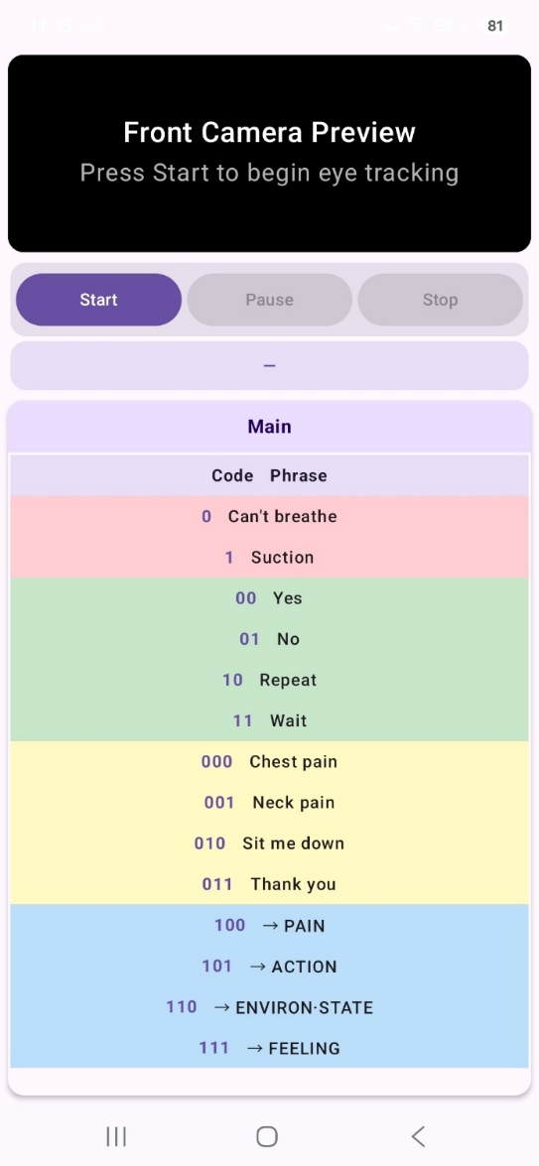
Figure 5 — App main page (zone colour map

3.1 Zone Overview
Zone | Code length | Gaze actions | Purpose
Zone 1 | 1 bit | 1 + center | Emergency words — fastest access with a single left/right gaze
Zone 2 | 2 bits | 2 + center | Meta responses (Yes / No / Repeat / Wait) — selected with two gazes
Zone 3A | 3 bits (000–011) | 3 + center | 4 most-used words — auto-updated by frequency, selected with three gazes
Zone 3B | 3 bits (100–111) | 3 + center | Category triggers (Pain / Action / Environ·State / Feeling), selected with three gazes
Sub-pages | 1–3 bits | 3+center, then 1–3+center | Up to 13 words per category (code 0 = back to main)

3.2 Main Page — Full Word List
Code | Zone | Gaze steps | Phrase
0 | Zone 1 🔴 | 1 + center | Can't breathe
1 | Zone 1 🔴 | 1 + center | Suction
00 | Zone 2 ✅ | 2 + center | Yes
01 | Zone 2 ✅ | 2 + center | No
10 | Zone 2 ✅ | 2 + center | Repeat
11 | Zone 2 ✅ | 2 + center | Wait
000 | Zone 3 🟡 | 3 + center | Thirsty ★
001 | Zone 3 🟡 | 3 + center | Urinate ★
010 | Zone 3 🟡 | 3 + center | Defecate ★
011 | Zone 3 🟡 | 3 + center | Uncomfortable ★
100 | Zone 3 🔵 | 3 + center | → PAIN page
101 | Zone 3 🔵 | 3 + center | → ACTION page
110 | Zone 3 🔵 | 3 + center | → ENVIRON·STATE page
111 | Zone 3 🔵 | 3 + center | → FEELING page

NOTE: ★ Zone 3 shortcuts (000–011) automatically update to show the 4 most-frequently used category words. See Section 4.

3.3 Category Pages
Entering a category page resets the code to – (empty). Code 0 (look left + confirm) always returns immediately to main. After any word is selected the app automatically returns to main.

PAIN page (enter with code 100)
Code | Phrase
0 | ← Back to Main
1 | Stomachache
00 | Headache
01 | Back pain
10 | Neck pain
11 | Chest pain
000 | Nausea
001 | Mouth dry
010 | Eyes dry
011 | *** (empty)
100 | *** (empty)
101 | *** (empty)
110 | *** (empty)
111 | *** (empty)

ACTION page (enter with code 101)
Code | Phrase
0 | ← Back to Main
1 | Medicine
00 | Change posture
01 | Turn me
10 | Lift head
11 | Lower head
000 | Wipe
001 | Cover me
010 | Call nurse
011 | Come here
100 | Sit
101 | Stay still
110 | Rest
111 | Urinate

ENVIRON·STATE page (enter with code 110)
Code | Phrase
0 | ← Back to Main
1 | Cold
00 | Hot
01 | Too bright
10 | Too dark
11 | Too loud
000 | Sleepy
001 | Itchiness
010 | Thirsty
011 | Uncomfortable
100 | *** (empty)
101 | *** (empty)
110 | *** (empty)
111 | *** (empty)

FEELING page (enter with code 111)
Code | Phrase
0 | ← Back to Main
1 | Thank you
00 | Sorry
01 | Anxious
10 | Scared
11 | Sad
000 | Lonely
001 | Happy
010 | Exhausted
011 | Angry
100 | Miss you
101 | *** (empty)
110 | *** (empty)
111 | *** (empty)

4. Zone 3A Adaptive Shortcut
The four Zone 3A frequency slots (codes 000, 001, 010, 011) automatically update to show the patient's most-used words from any category page.
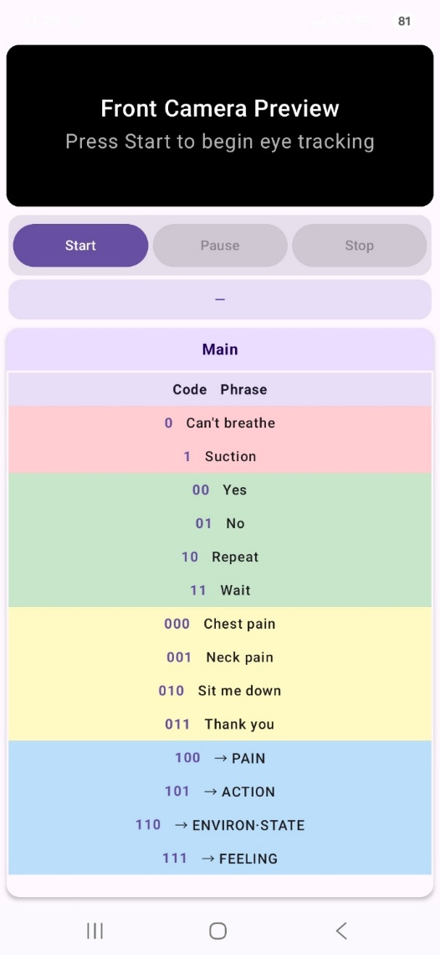
Figure 6 — Zone 3A shortcut display

4.1 How Frequency Tracking Works
- Each time a word is selected from a category page, its usage count increases by 1
- Counts are saved to the device and persist between sessions
- After every selection the Zone 3A slots are recalculated and updated immediately
- The four highest-count words appear in Zone 3A in descending order
- If fewer than 4 words have been used, defaults fill the remaining slots: Thirsty, Urinate, Defecate, Uncomfortable

4.2 Viewing and Resetting Counts
Open Setup and scroll to the yellow Zone 3A — Usage Frequency panel. Tap Show to expand: this displays the current Zone 3A shortcuts with their usage counts and the overall top 10 words. To reset all counts, tap Reset all usage counts.

5. Setup Screen
The Setup screen allows caregivers to customize the vocabulary — words can be added to or removed from the word book. To add or remove words, tap Setup on the Instructions screen (Figures 7 and 8).

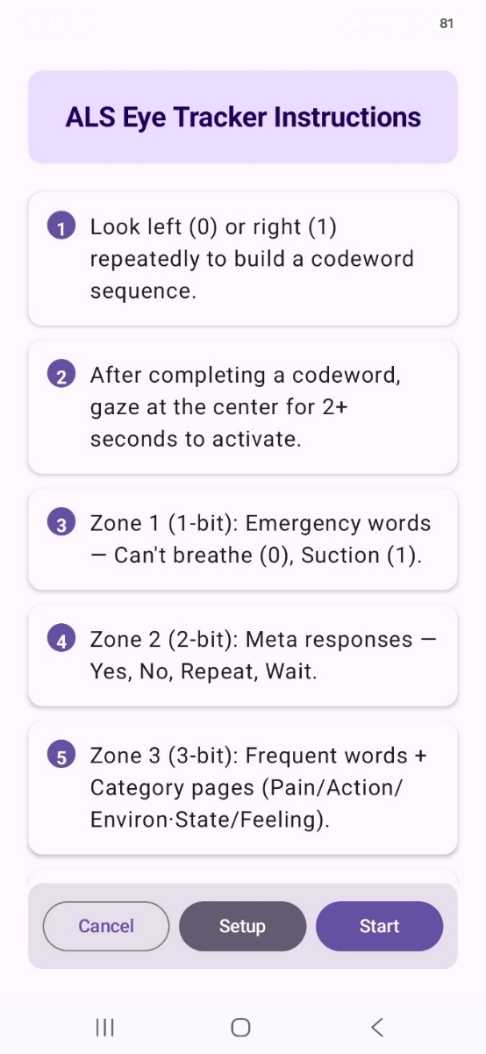  Figure 7 — Instruction screen — before entering Setup | 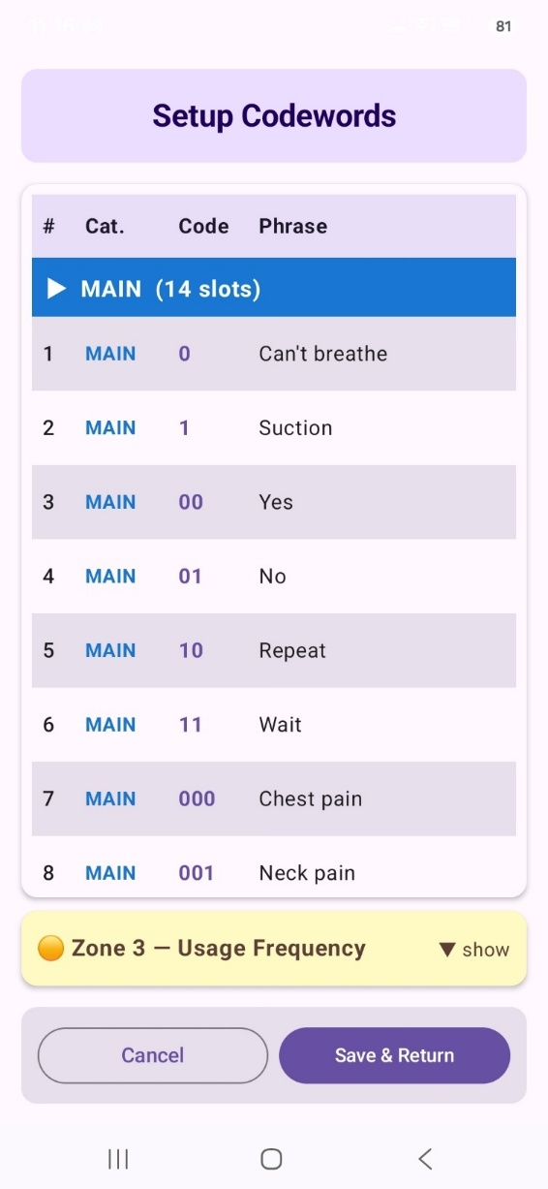  Figure 8 — Setup page — after entering Setup

5.1 Navigating the Word List
Words are grouped by category with color-coded headers:
Color | Category | Contains
Blue | MAIN | Emergency, meta, Zone 3 shortcuts, category triggers
Red | PAIN | 14 pain / symptom slots
Dark blue | ACTION | 14 caregiver action slots
Green | ENVIRON·STATE | 14 environment / condition slots
Orange | FEELING | 14 emotional expression slots

Each category has exactly 14 slots for codes 0, 1, 00, 01, 10, 11, 000, 001, 010, 011, 100, 101, 110, 111. Empty slots show *** in grey.

5.2 Editing a Word
- Tap any row to open the Edit dialog
- Type the new phrase and tap Save
- To clear a word back to ***, tap Clear (set to ***)
- Tapping an empty slot shows the Add new word dialog — type the phrase and tap Save
- Tap Save & Return to write all changes to storage

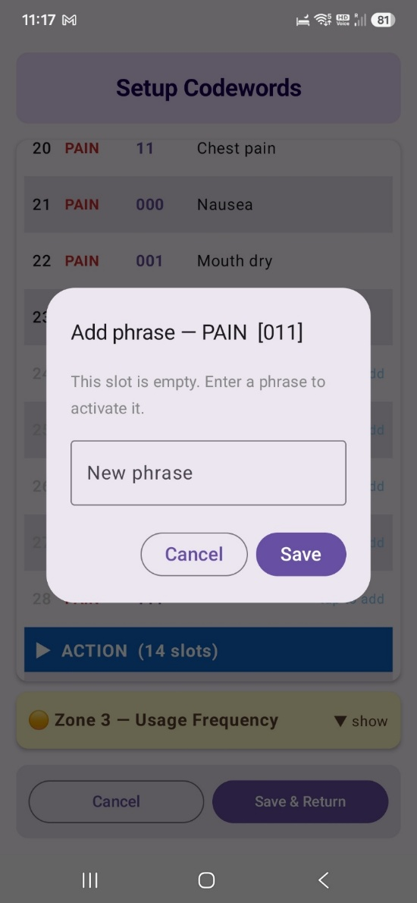
Figure 9 — Add-word dialog popup after tapping a row

NOTE: Changes take effect on the main screen immediately. Closing with Cancel discards all changes.

5.3 Words That Cannot Be Edited
- Code 0 on main page: Can't breathe (emergency — always fastest access)
- Code 0 on any category page: Back to Main (navigation — essential)
- Codes 100–111 on main page: category page triggers

6. Screen Layout

6.1 Galaxy Phone — Landscape
Left region | Right region
Camera preview (left 1/3), Start / Pause / Stop buttons | Status bar, Code table (right 2/3, two-column)

6.2 Galaxy Phone — Portrait
Top to bottom:
- Camera preview (top)
- Start / Pause / Stop buttons
- Status bar
- Code table (portrait, most of screen)

6.3 Galaxy Tab — Landscape
Top region
Camera preview (top-left 2/3) | Controls (top-right 1/3)
Status bar + Code table (bottom, large text, two-column centered)

6.4 Galaxy Tab — Portrait
- Camera preview (top)
- Start / Pause / Stop buttons
- Status bar
- Code table (large text, centered, most of screen)

NOTE: In Galaxy Tab portrait mode, the front camera can be far from the camera view, which may reduce recognition accuracy. Landscape mode is recommended for the Galaxy Tab.

On Galaxy Tab, text is enlarged approximately 1.7× and aligned toward the screen center. In landscape mode the left column is right-justified and the right column is left-justified so content converges toward the center, minimizing unnecessary left-right eye movement.

7. Step-by-Step Examples

7.1 Saying “Can't breathe” (emergency)
Step | Action
1 | Look LEFT (adds bit 0)
2 | Gaze at center 2 s → “Can't breathe” is spoken

7.2 Saying “Headache” via PAIN page
Step | Action
1 | Look RIGHT → LEFT → LEFT (builds code 100 — PAIN trigger)
2 | Gaze center 2 s → PAIN page opens
3 | Look LEFT → LEFT (builds sub-code 00)
4 | Gaze center 2 s → “Headache” spoken → app returns to Main

7.3 Returning to Main page from a category
Step | Action
1 | Look LEFT (builds sub-code 0)
2 | Gaze center 2 s → returns to Main (no speech output)

7.4 Saying “Thank you”
Step | Action
1 | Look RIGHT → RIGHT → RIGHT (builds code 111 — FEELING trigger)
2 | Gaze center 2 s → FEELING page opens
3 | Look RIGHT (builds sub-code 1)
4 | Gaze center 2 s → “Thank you” spoken → app returns to Main

8. Tips and Best Practices

8.1 Camera Positioning
- Camera should be at the same height as the patient's eyes
- Keep the patient's face within the center of the camera frame
- Avoid back-lighting (e.g. a window behind the patient) — position light sources in front of the patient
- Distance: approximately 30 cm
- To avoid blocking the patient's line of sight, mount the phone or tablet slightly above eye/face level

Eyeglasses: For best tracking accuracy, remove glasses before use if possible. If glasses must be worn, adjust the device or head angle slightly until reflections (glare) from the lenses are no longer visible in the camera preview. Reflections interfere with iris detection and reduce accuracy.

8.2 Training New Users
- Start with Zone 1 and Zone 2 (1–2 bit codes) and practice until consistent
- Introduce Zone 3A shortcuts once Zones 1 and 2 are reliable
- Introduce category pages one at a time
- Short sessions (10–15 minutes) are better than long ones when starting out

8.3 Optimising Zone 3A
- Use category pages regularly — Zone 3A adapts automatically after real use
- Review the Usage Frequency panel weekly via Setup → Zone 3A — Usage Frequency

8.4 Adding Custom Words
- Open Setup and tap any *** slot to add a custom phrase
- Keep phrases short (1–3 words) for clear TTS output

8.5 Gaze Sensitivity
If the system is not registering gaze correctly:
- Increase room lighting
- Ensure the patient's eyes are fully visible (no drooping eyelids)
- Wipe the camera lens
- Check that the device has not been moved from its original position

9. Troubleshooting
Problem | Solution
Camera does not start | Grant camera permission: Android Settings → Apps → ALS Eye-Gaze → Permissions
No speech output | Check device volume (physical volume buttons). Verify the TTS engine: Android Settings → General Management → Language & Input → Text-to-Speech
Gaze not detected | Improve lighting. Clean lens. Move patient closer. Remove glasses if possible; if not, adjust device angle to eliminate lens reflections
Tracking too sensitive | Make sure the eyelids are not half-closed. Ordinary small eye movements should not enter a code
Wrong word selected | Use Repeat (10) or Wait (11) to signal the caregiver, then re-enter the intended code
Zone 3 shows unexpected words | Setup → Zone 3 — Usage Frequency → Reset all usage counts to restore defaults
Words shown in wrong language | Return to the Disclaimer screen and re-select the language to reload the correct default dictionary

10. Safety Notice
This application is an assistive communication aid only. It is not a medical device and must not be used as the sole means of alerting caregivers to emergencies. Always ensure a caregiver is present and monitoring the patient during use.

- The app must be used under caregiver supervision at all times
- Do not rely solely on this app for emergency communication — always have a backup alert method
- The developers are not liable for any consequences arising from use of this application
- Obtain a speech-language pathology evaluation before introducing this system for extended use

By using this application, you acknowledge and accept all risks associated with its use.
EYEUM — Eye-Gaze Communication App | User Manual

