

**JSC “Kazakh-British Technical University”**

Faculty of Information Technology

**Object-Oriented Programming and Design**

Project: **INTRANET**

Developed by:

Safargaliev Temirlan

Muratbekova Muragul

**Almaty, 2019**

Table of Contents

**Objective of the Project3**

**Part A. UML Diagrams4**

Use Case Diagram4

Class Diagram5

**Part B. Code Implementation6**

Package Users7-8

Package Course9

Package Report10

Package Database11

Package Enums12

Objective of the Project

Our aim was to create University System (Intranet), using all skills learned in the course of Object-Oriented Programming.

Used components:

* TopCoder UML Tool
* Eclipse IDE

Part A.

UML Diagrams

UML Diagrams has been designed using TopCoder UML Tool.

**Use Case Diagram** is used to present a graphical overview of the functionality system affords in terms of actors, their actions and any dependencies between.

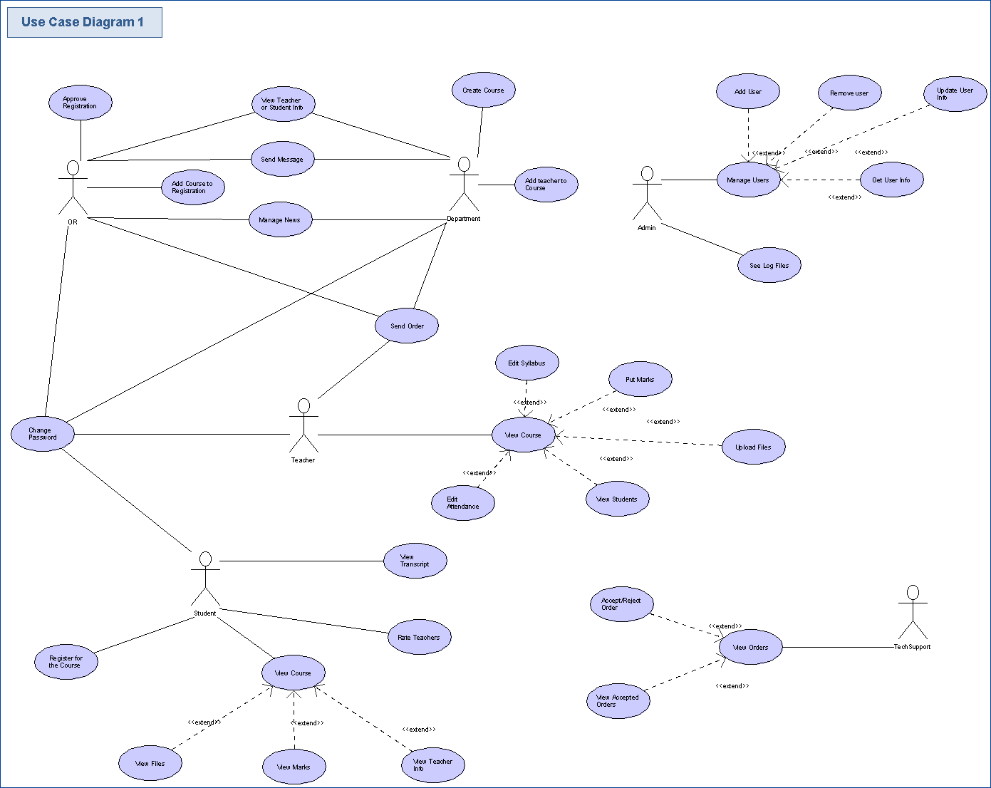

**Class Diagram** describes the types of objects in the system and the various kinds of static relationships that exist among them.

Our Class Diagram has several packages which will be described below.

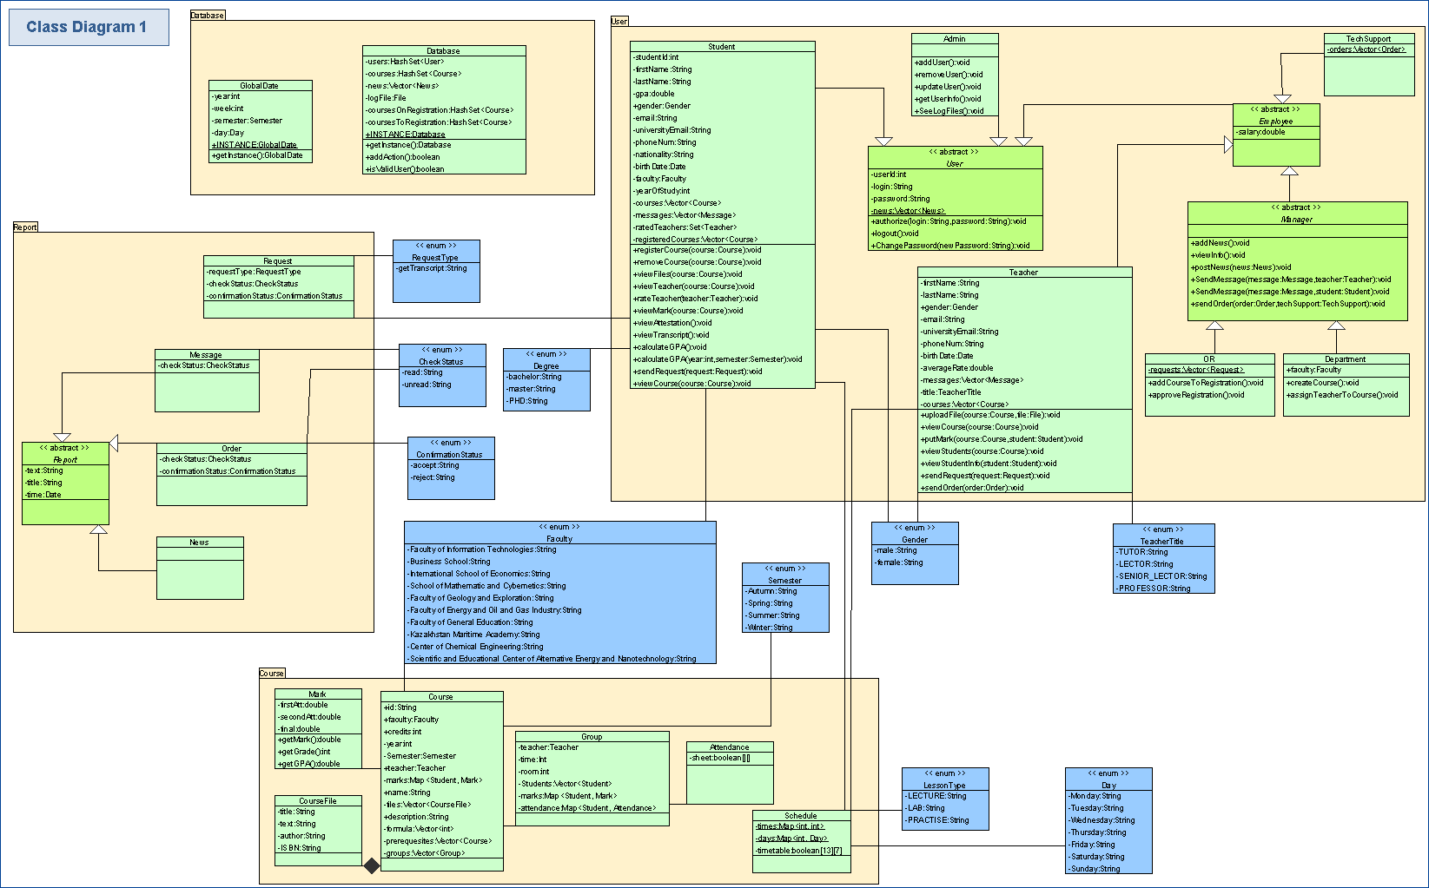

Part B.

Code Implementation

We divided the system to a several **packages**:

* Users (contains all types of users)
* Course (all classes related to course)
* Report (classes which provide communication between users)
* Database (contains global data which is common to all classes)
* Enums (all created ENUMs)

Package Users

1. User (abstract)

This abstract class stores id, login, password, first name and last name of each user. It has methods for authorization, logging out and changing password.

2. Admin (inherited from User)

Can create, remove and update users. Admin can also see log files.

3. Student (inherited from User)

Besides inherited fields, student information contains birthdate, gender, nationality, email and university email, phone number, faculty, year of study, GPA, lists of courses, messages, current registered courses and rated teachers. Student can register/unregister for courses, view files, teacher info and the description of the specific course. He can also view transcript, attestation (total or for a semester) and marks for a specific course. Student can send requests to Office of Register and rate teachers.

4. Employee (abstract, inherited from User)

Each employee has salary.

5. Teacher (inherited from Employee)

Teacher information consists from birthdate, gender, phone number, email and university email, rate, title, lists of courses and messages. This class also has inner class “TeacherRate” which stores sum of all rates and count of rated students, so that we can easily update total rate. Teacher can view course, upload files, view journal, put marks and view student information. He can also send orders to Tech Support.

6. TechSupport (inherited from Employee)

Class stores list of orders, which is common for all instances. Tech Support functionality includes view, accept or reject orders.

7. Manager (inherited from Employee)

Manager has methods to post news, view info and send messages both to Student and Teacher, send orders to TechSupport.

8. Department (inherited from Manager)

Has faculty, right to create course and assign teacher to course.

9. Office of Register (inherited from Manager)

Has a list of student requests, can add/remove courses on registration and approve registration.

10. UserFactory (Factory pattern)

Has method to create specific User according to request.

Package Report

1. Report (abstract)

It contains text, title and date of sending.

2. News (inherited from Report)

3. Message (inherited from Report)

Has check status, which UNREAD by default and changes when the recipient reads the text.

4. Order (inherited from Report)

Has check status, which UNREAD by default and changes when the recipient reads the text. In addition it has confirmation status, that changes when Tech Support decides whether accept or reject order.

5. Request

Class stores student who sent the request, type of this request, check status and confirmation status. When request is accepted it sends this student the confirmation message.

Package Course

1. Mark

Consist from first, second attestation and final exam. Provide methods to calculate total mark, grade and GPA.

2. Course File

Class contains title, text, author and ISBN.

3. Course

Course information includes id, name, faculty, credits, description, journal, files, lists of prerequisites and groups, formula, semester and year.

4. Schedule

Stores course, types of lessons and their time, day and room.

5. Group

Stores course, teacher, schedule, list of students, their marks and attendance.

6. Attendance

Class stores student, schedule and table of attendance. It provides method to set whether student visited lesson or not.

Package Database

1. GlobalDate (Singleton pattern)

Class contains information about current year, semester, week and day.

2. Database (Singleton)

It contains lists of users, all courses, courses on the registration and future courses, news and log files. This class has methods to check user validation and write actions in log file. Database is stored encrypted in txt file.

Package Enums

1. Check Status

READ/UNREAD (message, order)

2. Confirmation Status

ACCEPT/REJECT (order)

3. Day

Days of the week

4. Degree

BACHELOR/MASTER/PHD

5. Faculty

Faculties in the University

6. Gender

MALE/FEMALE

7. Lesson Type

LECTURE/LAB/PRACTICE

8. Request Type

Types of student requests

9. Semester

AUTUMN/WINTER/SPRING/SUMMER

10. Teacher Title

TUTOR/LECTOR/SENIOR_LECTOR/PROFESSOR