**Ministerul Educaţiei și Cercetării al Republicii Moldova Universitatea Tehnică a Moldovei**

**Facultatea Calculatoare, Informatică și Microelectronică**

Laboratory work 4:

Empirical analysis of Depth First Search and Breadth First Search.

Elaborated:

st. gr. FAF-213 Konjevic Alexandra

Verified:

asist. univ. Fiștic Cristofor

Chişinău – 2023

**ALGORITHM ANALYSIS**

**Objective:**

Study and analyze algorithms for searching in graphs or trees: Depth First Search and Breadth First Search.

**Tasks:**

1. Implement the listed algorithms in a programming language
2. Establish the properties of the input data against which the analysis is performed.

3. Choose metrics for comparing algorithms.

4. Perform empirical analysis of the proposed algorithms.

5. Make a graphical presentation of the data obtained.

6. Make a conclusion on the work done.

**Introduction:**

Depth First Search (DFS) and Breadth First Search (BFS) are two of the most fundamental and widely used algorithms in computer science. These algorithms are commonly used to traverse graphs, trees, and other data structures in order to find specific information, determine connectivity, or perform other useful computations.

DFS and BFS are both algorithms for exploring a graph, but they differ in how they traverse the graph. DFS explores a graph by visiting as far as possible along each branch before backtracking, while BFS explores the graph by visiting all the neighboring nodes at the current depth before moving on to the next depth.

In this report, we will provide an overview of the DFS and BFS algorithms, explain their differences, discuss their applications, and provide examples of their implementation in various scenarios. Additionally, we will compare the performance of DFS and BFS and provide insights on when to use each algorithm based on the problem requirements.

**Comparison Metric:**

The comparison metric for this laboratory work will be considered the time of execution of each algorithm (T(n)).

**Input Format:**

I generated random graphs of lengths from 500 vertexes to 7000. For each graph I measured the time of executing of functions `bfs` and `dfs`.

**IMPLEMENTATION**

First of all, I used python library `networkx` to generate random graphs, via the method:

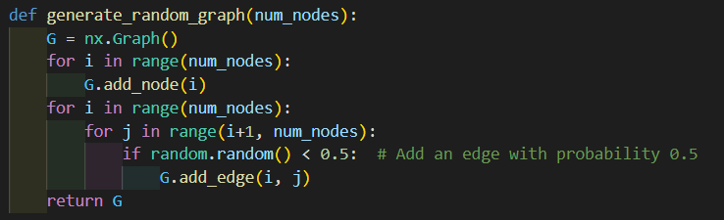

*Figure 1. Method to generate random graphs in python*

Using the method `draw` of this library, I also visualized a random graph:  


*Figure 2. Random graph*

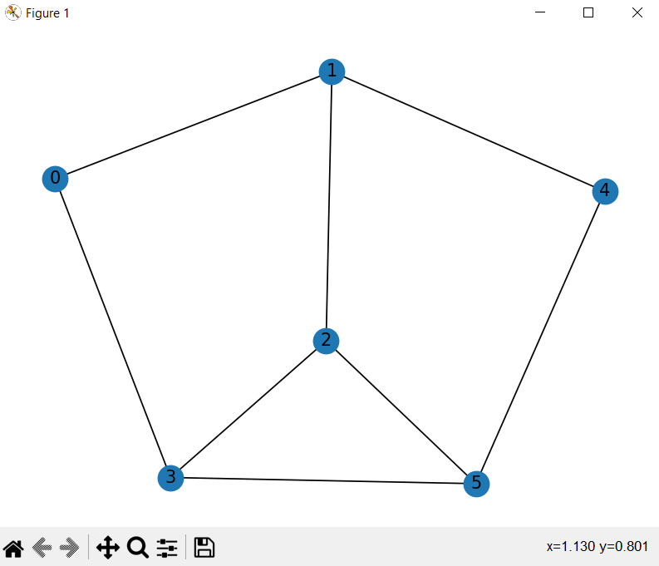

*Figure 3. Visualization of random graph*

1. **BFS method implementation**

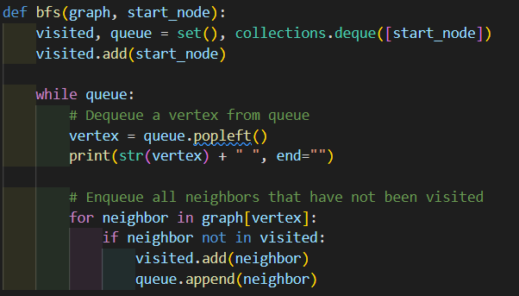

*Figure 4. BFS implementation in python*

Algorithm Description:

The algorithm traverses the graph in a breadth-first manner, meaning that it visits all the nodes at the same level before moving on to the next level.

Here's how the algorithm works step-by-step:

* The algorithm creates an empty set called visited to keep track of the nodes that have already been visited, and a queue data structure initialized with the starting node.
* The starting node is added to the visited set.
* The algorithm enters a loop that continues until the queue is empty.
* In each iteration of the loop, the algorithm dequeues a vertex from the left side of the queue using the popleft() method, which returns the leftmost item in the deque and removes it from the deque.
* The algorithm then prints the vertex that has just been dequeued.
* The algorithm then enqueues all the neighbors of the dequeued vertex that have not yet been visited. This is done by iterating over the list of neighbors of the vertex obtained from the graph parameter, and checking if each neighbor is in the visited set. If a neighbor is not in the visited set, it is added to the visited set and to the right end of the queue using the append() method.
* The loop continues until the queue is empty, at which point the algorithm has visited all the nodes reachable from the starting node in a breadth-first order.

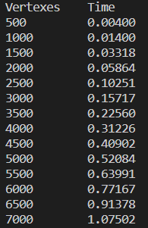

*Figure 5. Results for BFS*

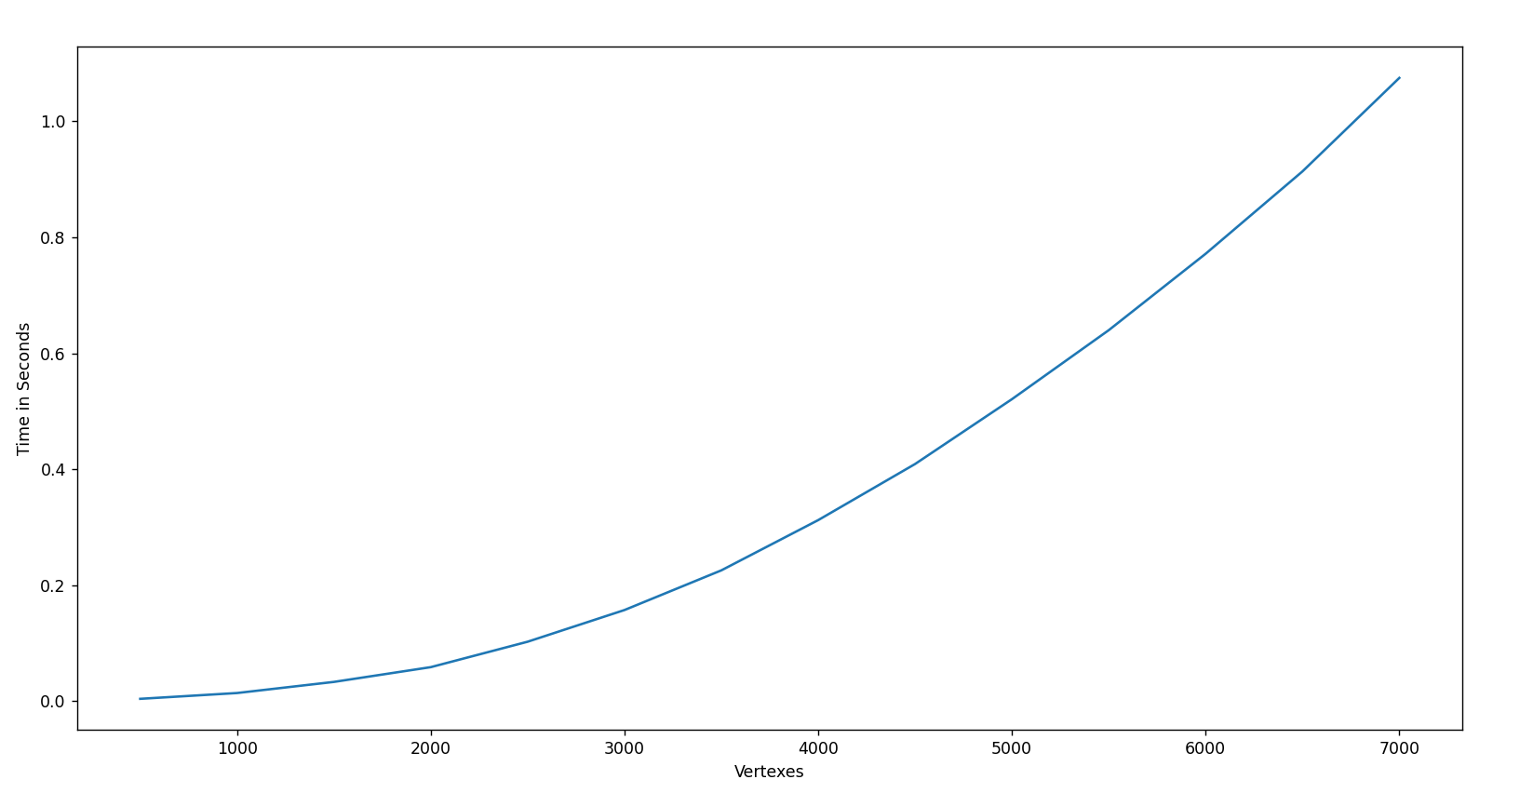

*Figure 6. Graph for BFS*

1. **DFS method implementation**

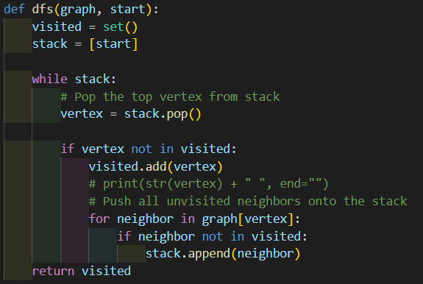

*Figure 7. DFS implementation in python*

Algorithm Description:

The algorithm takes two inputs: a graph data structure represented as a dictionary and a starting vertex from where the DFS traversal begins.

Here are the step-by-step instructions for the DFS algorithm:

* Create an empty set called visited to keep track of visited vertices.
* Create a list called stack and add the starting vertex to it.
* While the stack is not empty, do the following steps:

a. Pop the top vertex from the stack and assign it to the variable vertex.

b. If the vertex has not been visited yet, then add it to the visited set.

c. For each unvisited neighbor of the vertex, do the following:

i. Add the neighbor to the stack.

- When the while loop terminates, return the visited set containing all visited vertices.

The DFS algorithm works by traversing a path as far as possible before backtracking. The algorithm uses a stack data structure to keep track of the vertices to visit in the next step. It starts with the given starting vertex and explores the neighboring vertices by adding them to the stack. It continues to explore the neighboring vertices until it reaches a vertex with no unvisited neighbors, and then backtracks to the previous vertex in the stack. The algorithm repeats this process until it visits all the vertices reachable from the starting vertex.

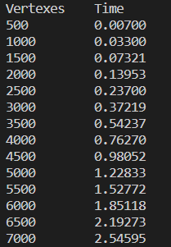

*Figure 8. Results for DFS*

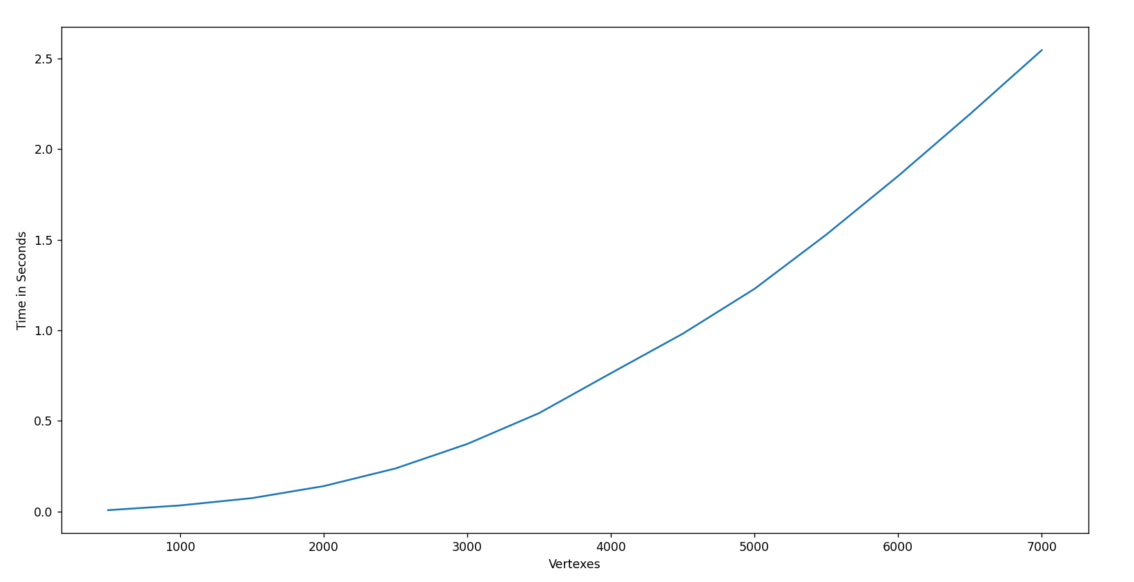

*Figure 9. Graph for DFS*

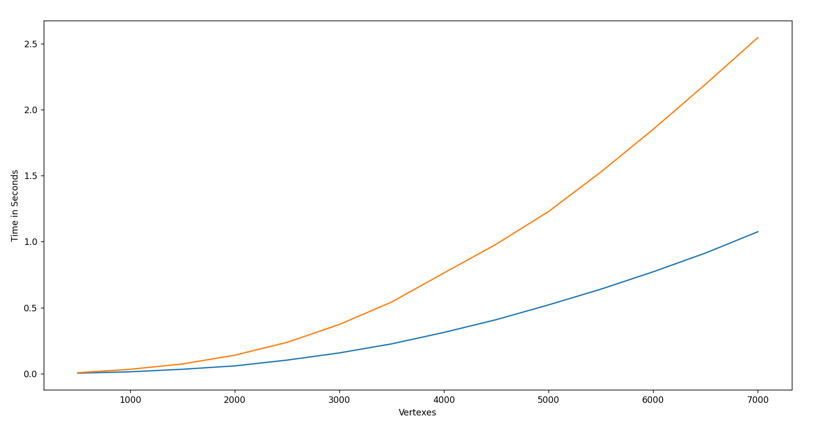

*Figure 10. Graph with both BFS and DFS*

● – DFS ● – BFS

**Conclusion**

In conclusion, the Breadth-First Search (BFS) and Depth-First Search (DFS) algorithms are two fundamental and widely used graph traversal algorithms in computer science. Through the implementation of these algorithms in Python, we have demonstrated their practical applications in graph analysis and search.

BFS explores all the vertices at the same level before moving on to the next level, making it useful for finding the shortest path or distances between nodes in unweighted graphs. On the other hand, DFS explores the graph by going as deep as possible, making it useful for applications such as topological sorting and cycle detection.

Overall, the efficiency of BFS and DFS depends on the structure and size of the graph being traversed. BFS has a higher memory requirement and can be slower than DFS for dense graphs, while DFS can get stuck in infinite loops or take longer to find a solution for disconnected graphs.

Despite their limitations, BFS and DFS remain important tools in graph analysis and search, and their implementation in Python provides a useful framework for further experimentation and exploration of these algorithms. Further research can investigate the optimization of BFS and DFS for specific use cases or explore more advanced graph traversal algorithms.

Github repository: https://github.com/alya1007/Labs-semester-4/tree/master/AA