**MINISTRY OF EDUCATION AND RESEARCH**

**OF THE REPUBLIC OF MOLDOVA**

Technical University of Moldova

(TUM)

Faculty of Computers, Informatics

and Microelectronics

**Laboratory work 1:**

**“Karnaugh mapping”**

Student: Konjevic Alexandra

Group: FAF-213

Verified: Voitcovschi Vladislav

asist. univ.

Chișinău 2023

**Objective:**

Revising the knowledge about the boolean algebra, logic gates and relay gates and Karnaugh maps.

**Tasks:**



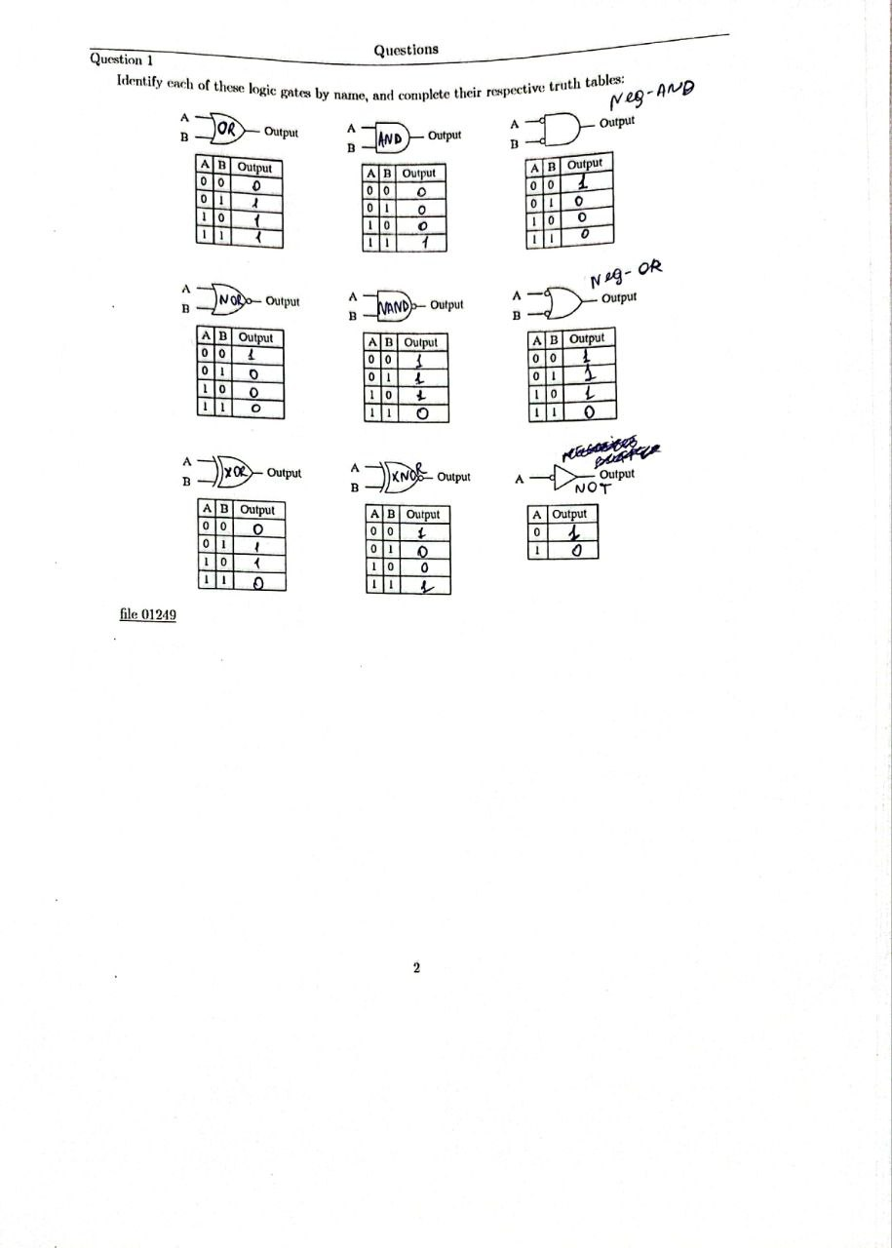

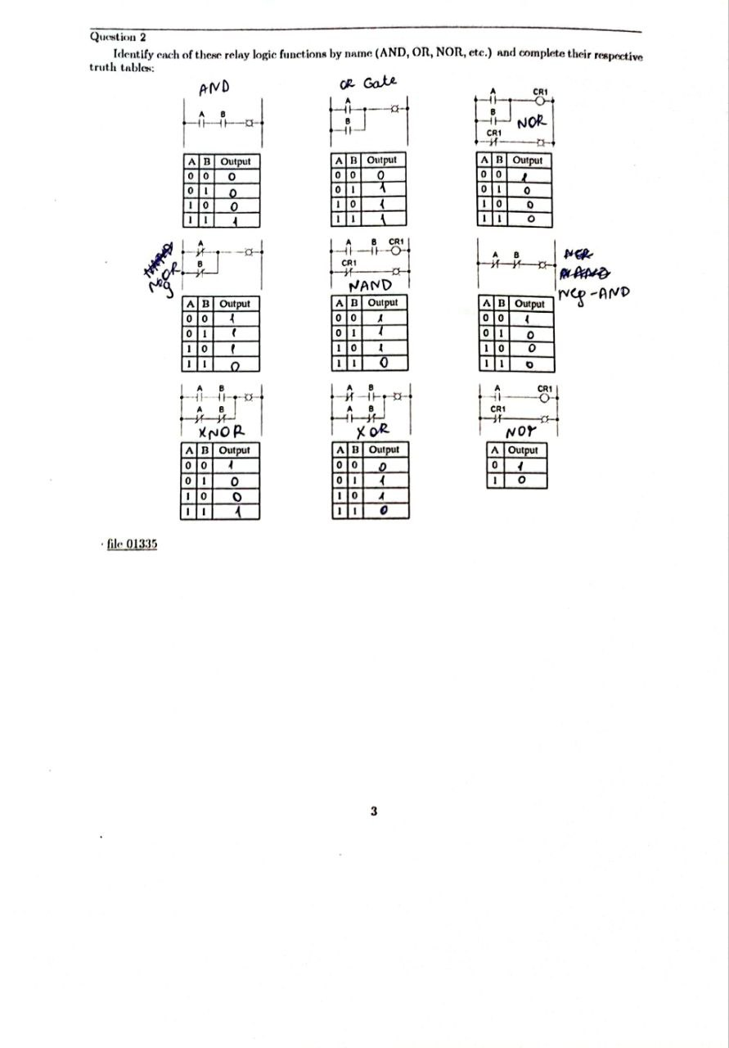

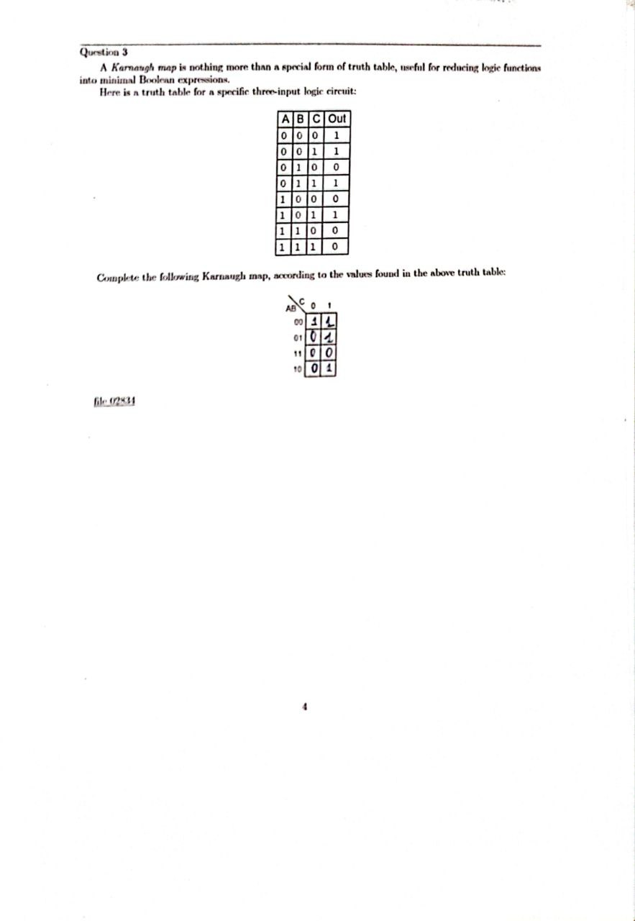

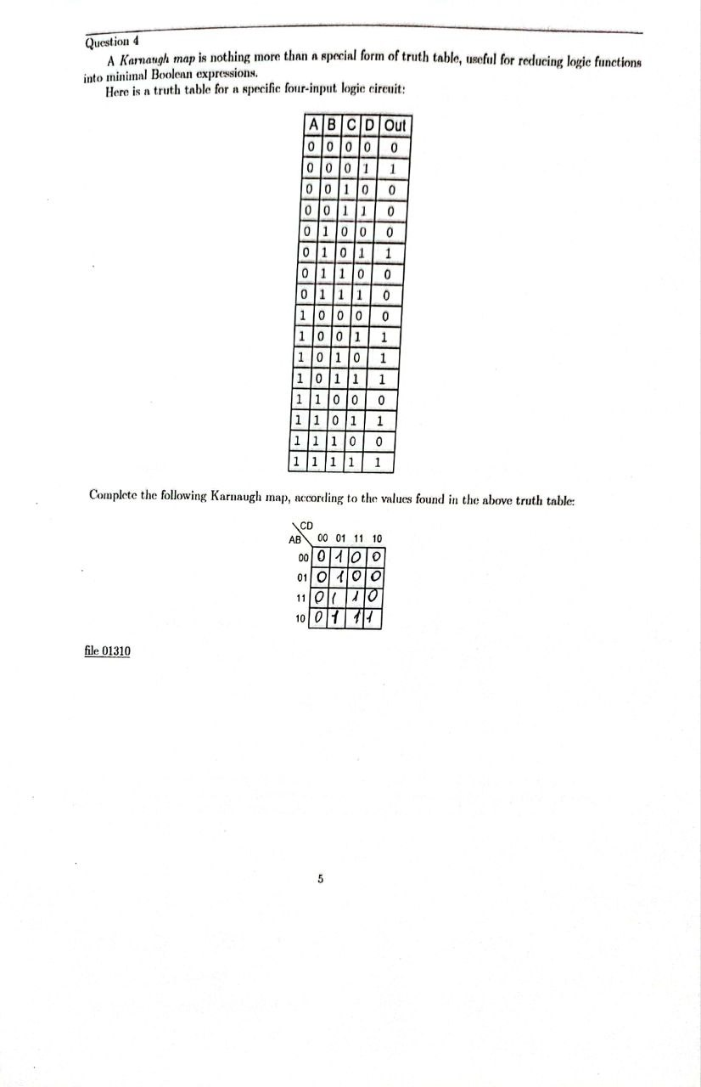

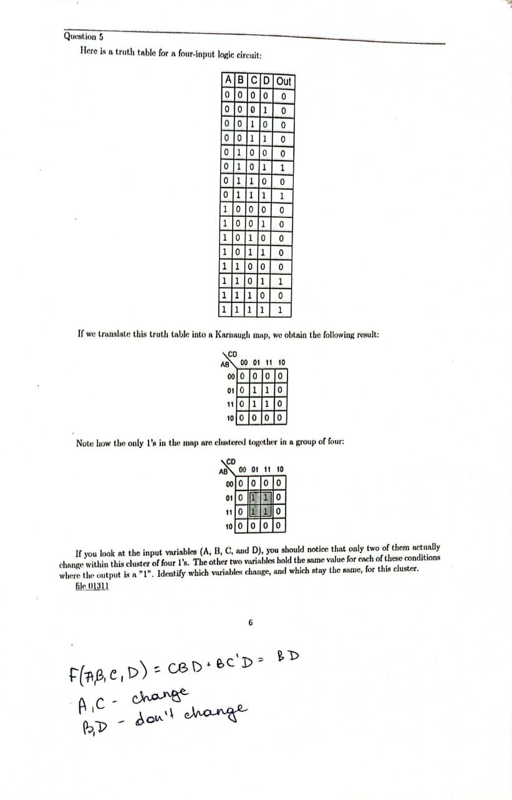

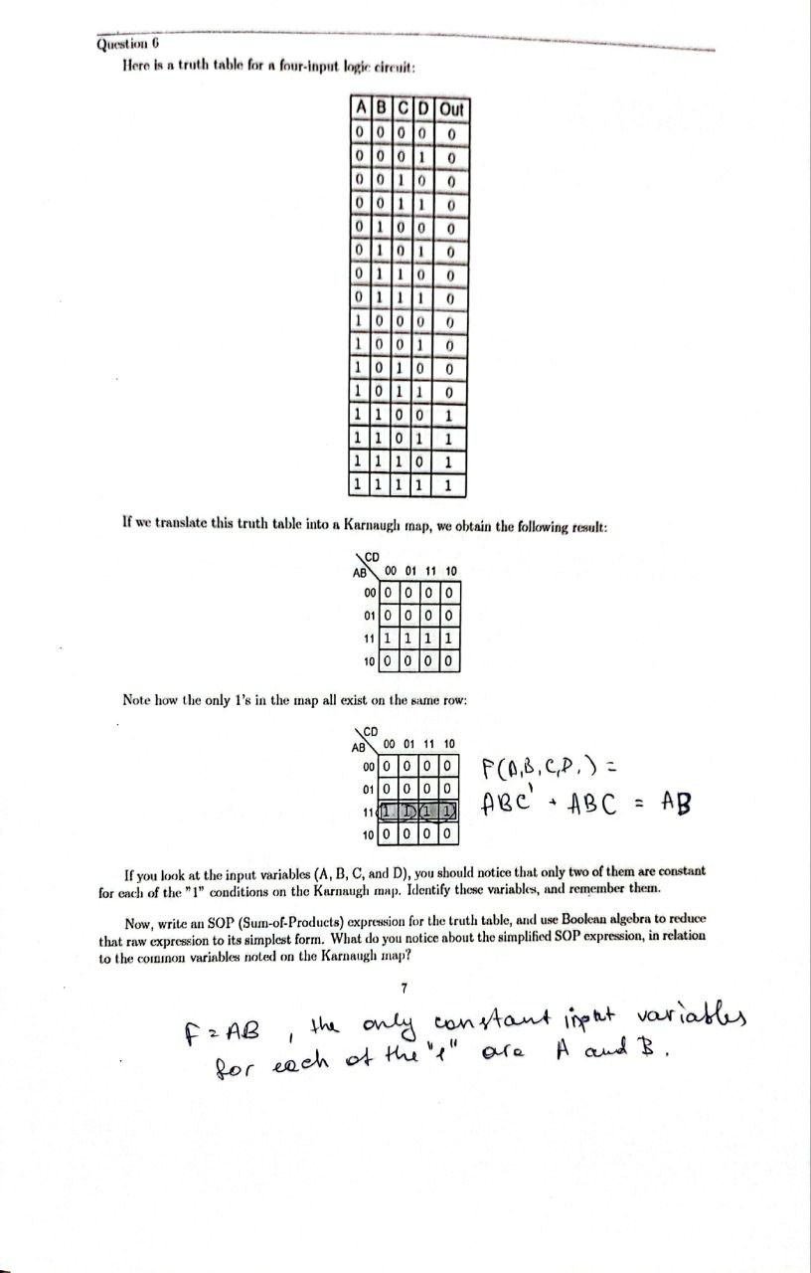

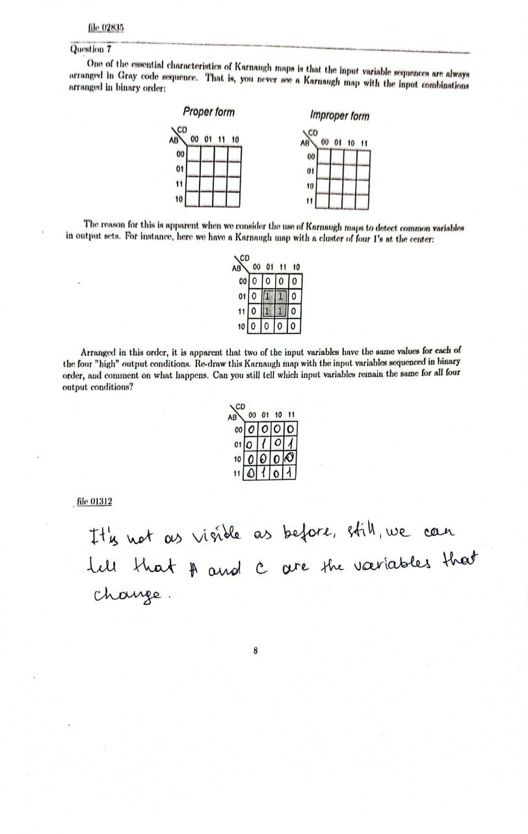

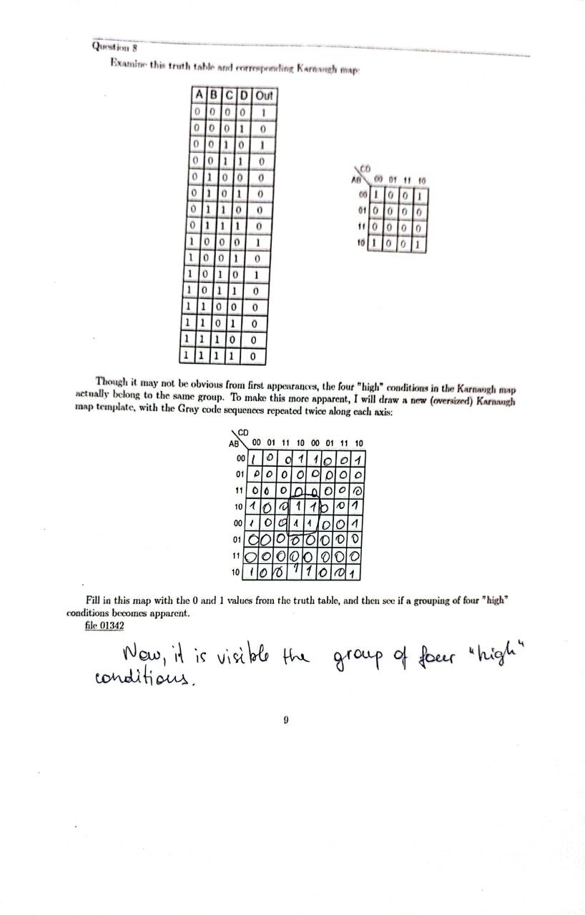

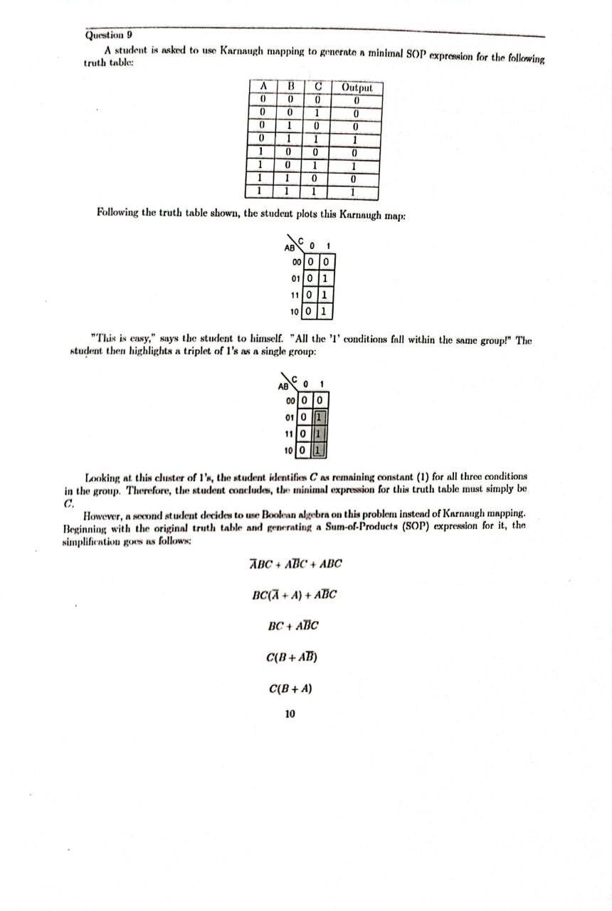

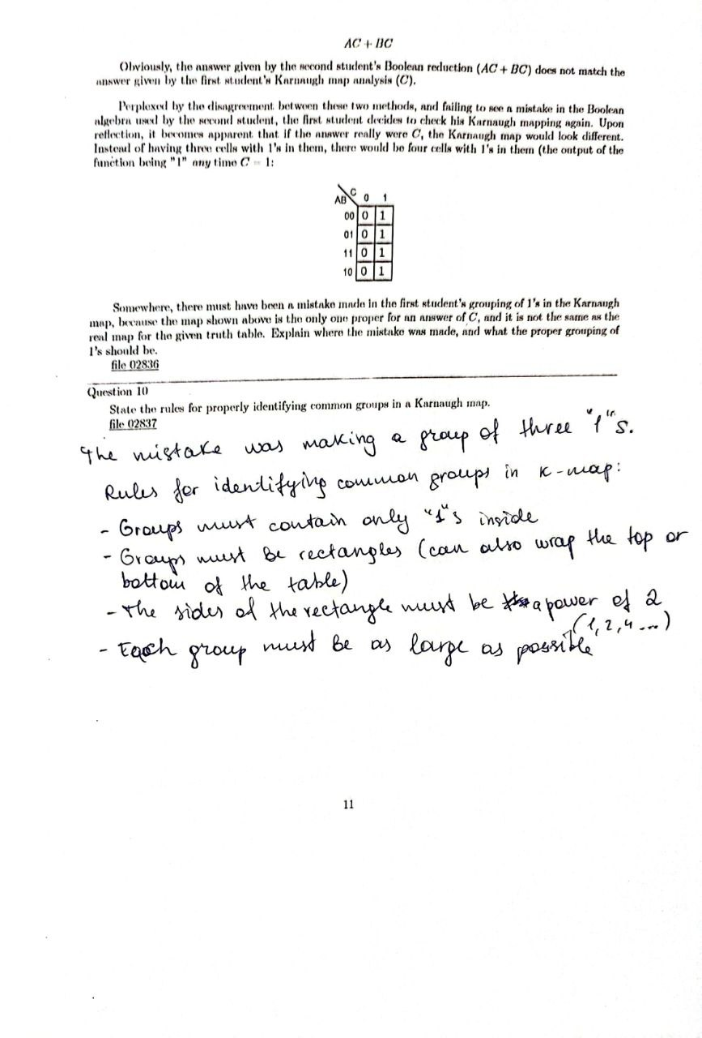

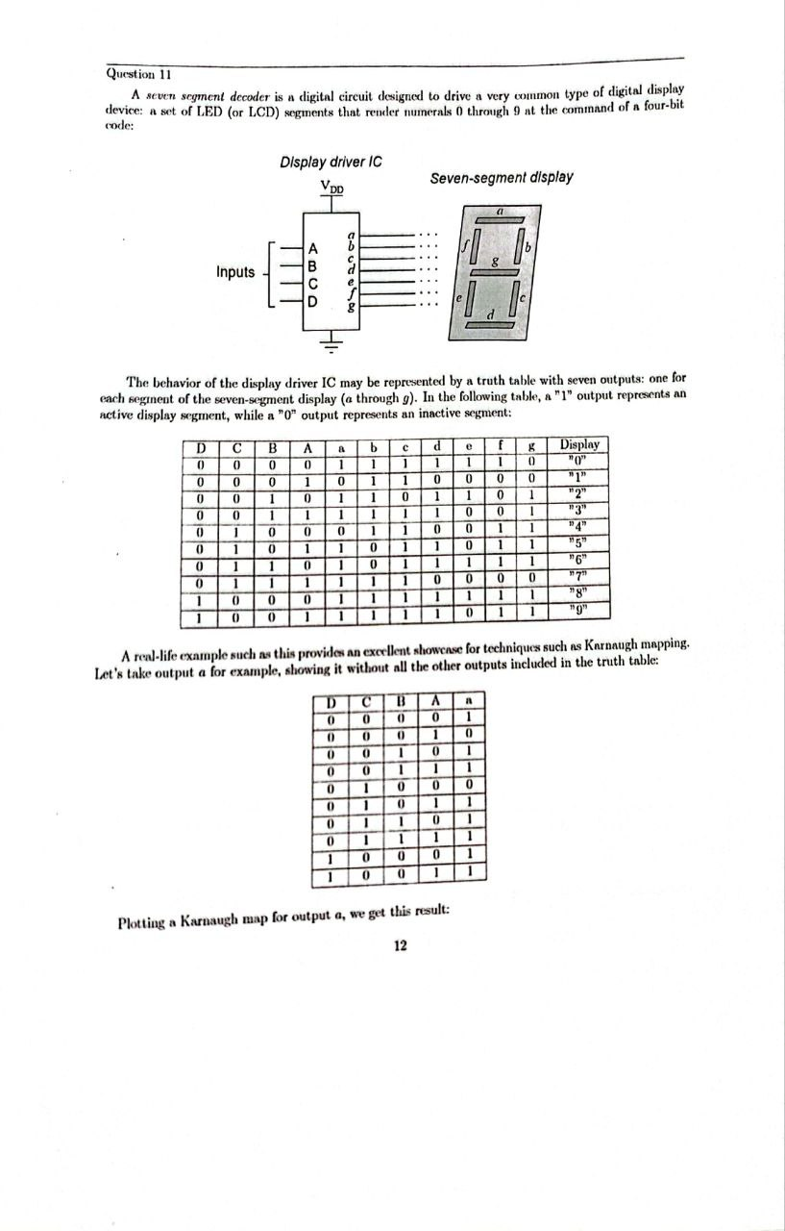

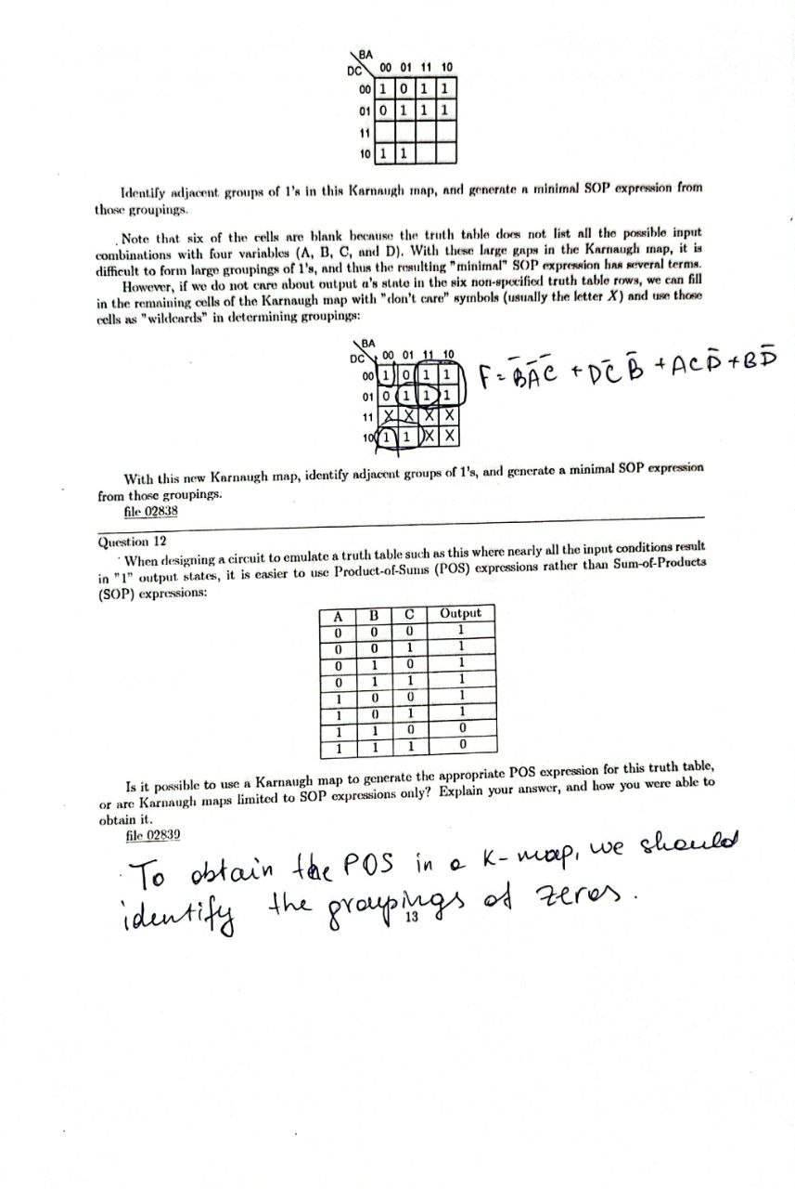

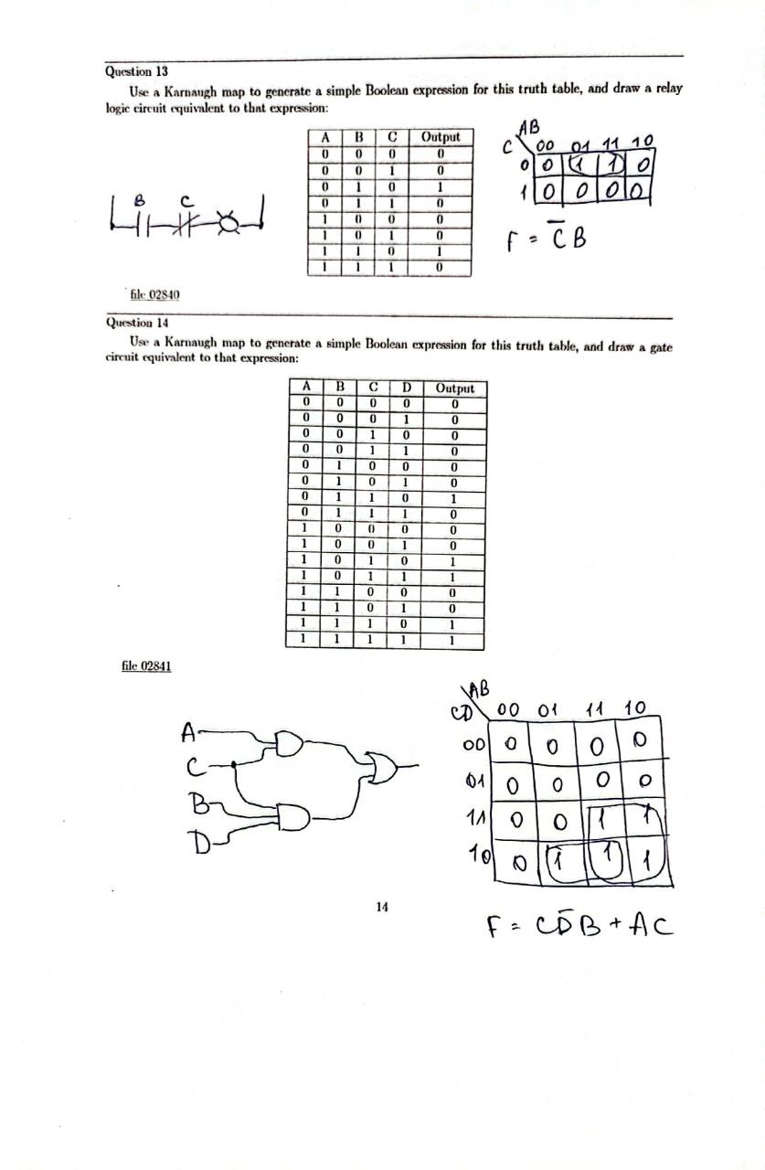

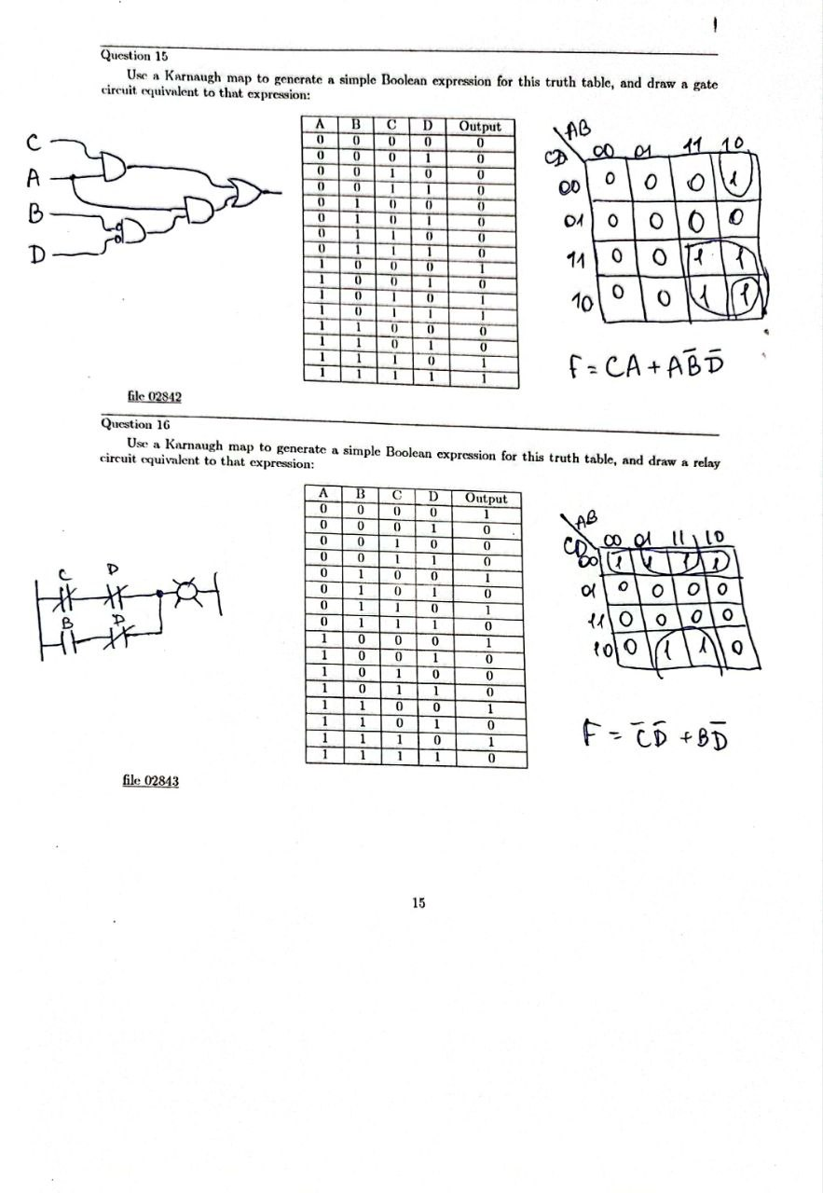

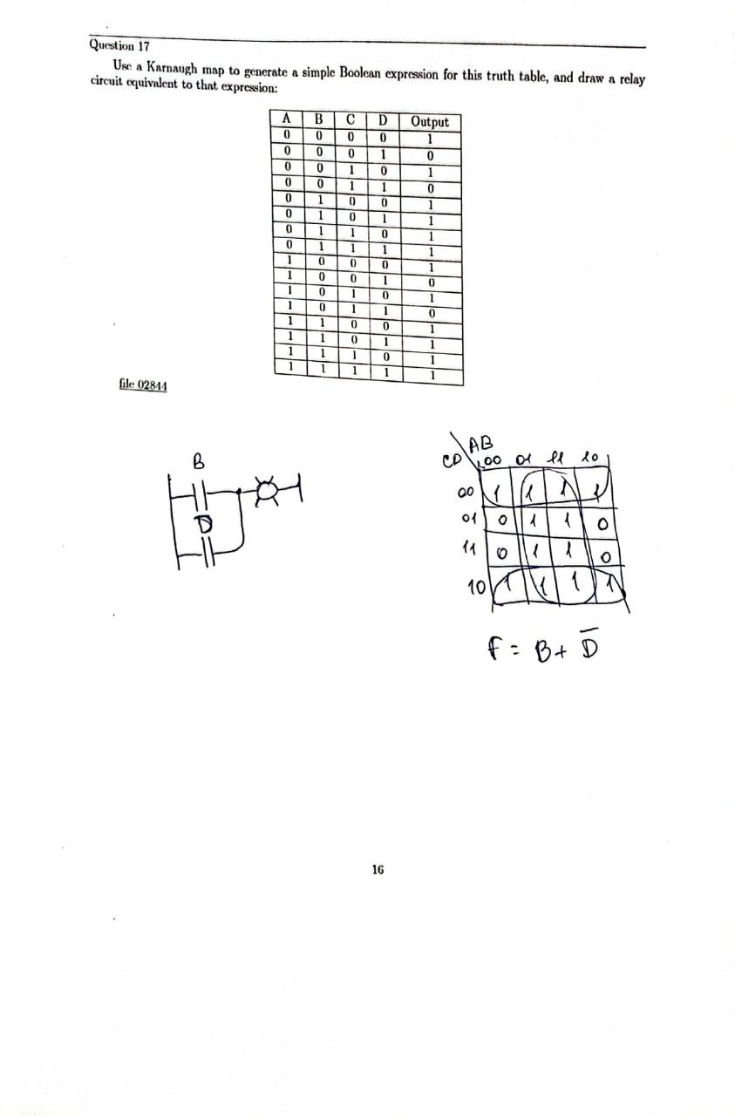

**Conclusion:**

In conclusion, this laboratory work provided a comprehensive overview of the fundamental concepts and tools of digital logic design, including Boolean algebra, logic gates, relay gates, and K-maps. By solving a variety of exercises, we were able to apply these concepts in practice and gain hands-on experience with designing and analyzing digital circuits. This experience will be valuable for future studies in electronics and digital systems, as well as in various fields that require digital logic design, such as computer science and electrical engineering. Overall, this laboratory work was an important step in building a solid foundation in digital logic design and provided valuable insights and skills for future endeavors.