Ministerul Educaţiei și Cercetării al Republicii Moldova Universitatea Tehnică a Moldovei
Facultatea Calculatoare, Informatică și Microelectronică

Laboratory work 4: Operational Systems

Elaborated:
st. gr. FAF-213 Konjevic Alexandra

Verified: Rastislav Călin

Chişinău – 2023

Topic: Boot Loader
Objectives: Create in assembly language an application that will act as a Boot Loader and will perform the following tasks:
1. It will display a greeting message that includes the author's name and will await keyboard input for the 'source' address on the floppy disk, from where the kernel (or other compiled code intended to be loaded and executed) will be read. The address should be entered in the SIDE, TRACK, SECTOR format and must strictly fall within the range reserved for the author student, as it was in Lab3.
2. It will wait for keyboard input for the 'destination' address in RAM where the data block read from the floppy disk will be loaded. The RAM address should be in the format XXXXh:XXXXh, identical to how it was in Lab3.
3. It will transfer the FLOPPY ==> RAM data and display the error code with which the operation was completed.
4. It will display a message to press a key to launch the kernel (or execute the desired code).
5. Upon completion of the kernel execution or executed code, it will display a message to press a key to repeatedly execute the Boot Loader.
Implementation:
To create a boot loader system capable of loading a kernel or other compiled code from the floppy disk into RAM, and then, executing it, there were created two bootloaders: `bootloader.asm` and `mini_boot.asm`. The first part (`bootloader.asm`) contains the main functionality, while the second part (`mini_boot.asm`) is a small boot loader meant to load the main boot loader.
The code begins with the org `7d00h` directive, setting the origin point where the bootloader code will reside in memory.
Various data sections (`section .data` and `section .bss`) are declared to hold prompts, user inputs, and intermediate variables:
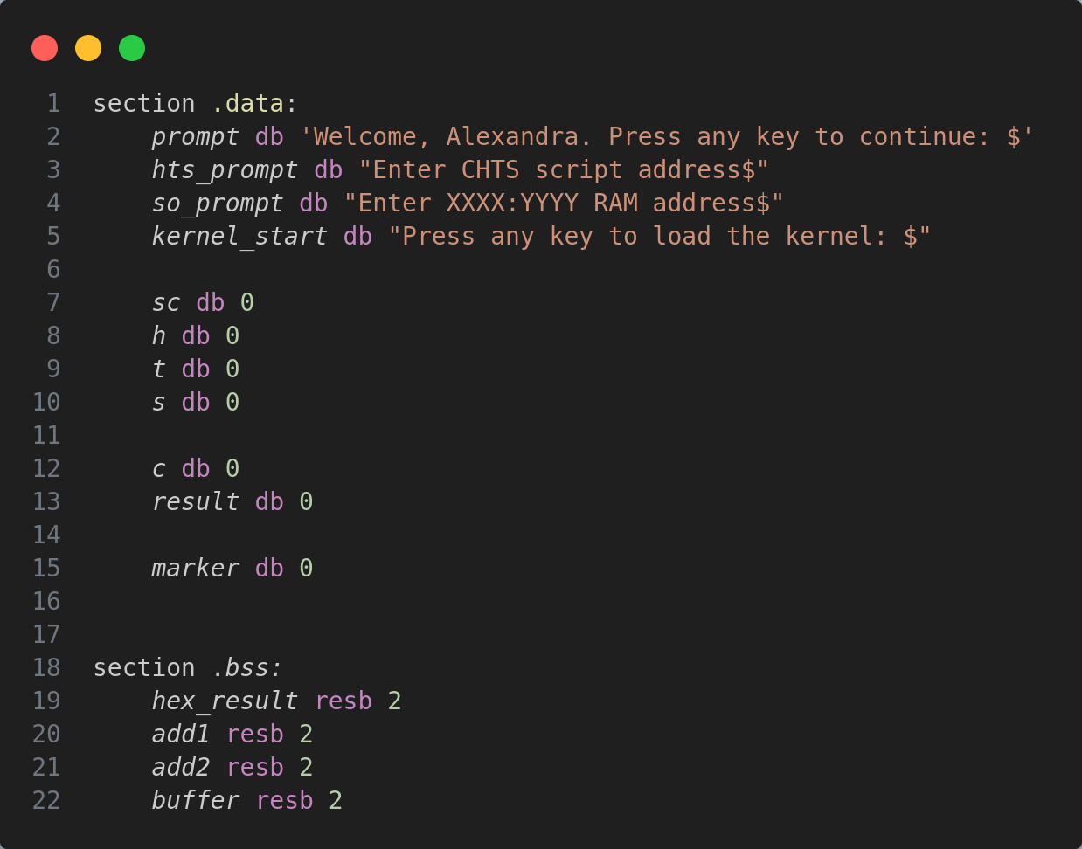
The line that follows after this - `dw 0AA55h` - is marking the end of a boot sector, indicating to the BIOS that the sector is bootable and the code contained within it should be executed during the boot process.
The next step is displaying the initial prompt (`Welcome, Alexandra. Press any key to continue: $`):
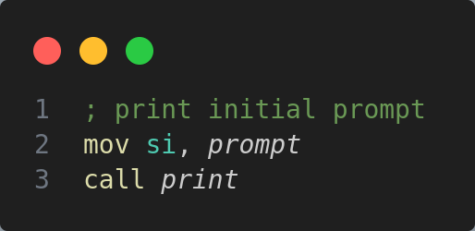
The function `print` is being called:
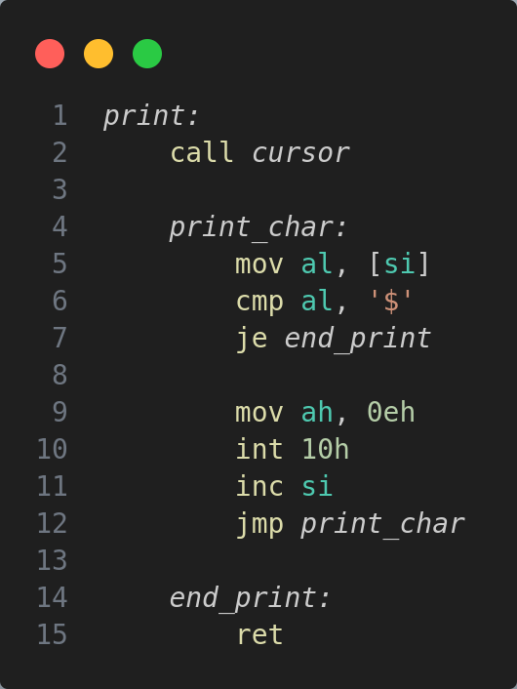

This function also calls another function: `cursor` which sets the position of the cursor using the function `03h` of the interruption `10h`:

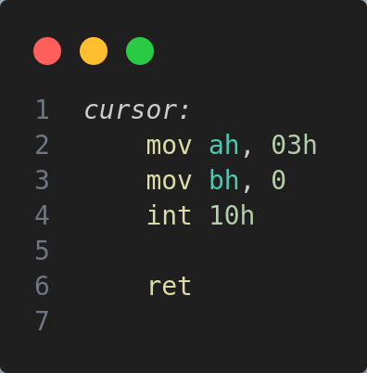
Next, the printing function declares the `print_char` label, which loads the character from the memory address pointed to by `si` into the `al` register and compares the character loaded with the ASCII value of '$'. This symbol '$' marks the end of the prompt. If the character loaded is '$', it jumps to the `end_print` label, which effectively ends the printing process.

Printing characters occurs in the following mode: the function sets up the video display function (`0eh`) of BIOS interrupt `10h` for displaying characters. After that, there is incremented the memory address in `si` to point to the next character in the string and the function jumps back to the `print_char` label to continue printing the next character.

After the prompts are displayed, the user input is read, using the function `00h` of the interruption `16h`:
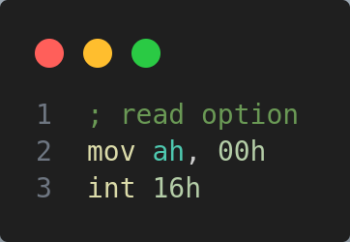

And this character is displayed:
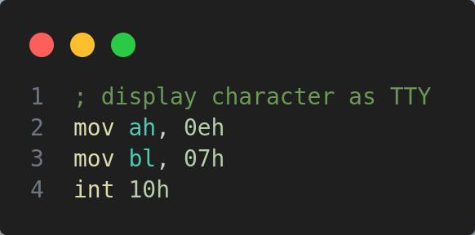

After that, there is printed a new line, by calling the function `newline`:

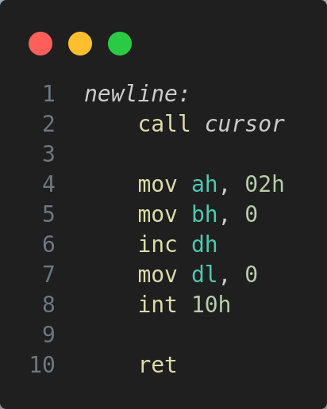

This function sets the position of the cursor on a new line.

Next, the next prompt is displayed, to get the CHTS script address (`Enter CHTS script address$`):

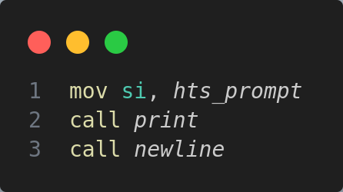

The next block of code is responsible for displaying the `>` symbol in front of the user input:

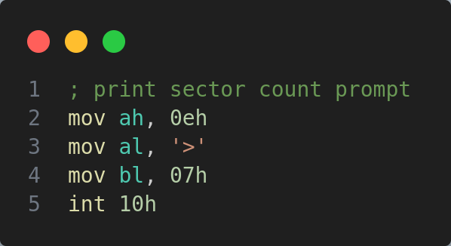

Next, we have the code:

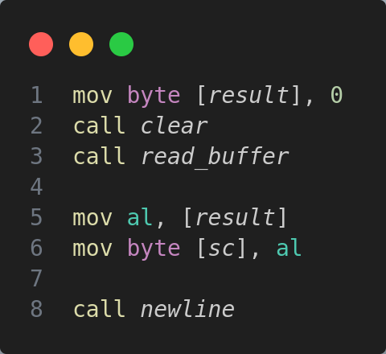

This instruction moves the value 0 into the memory location pointed to by the label `[result]`. After that, the functions `clear` and `read_buffer` are called:

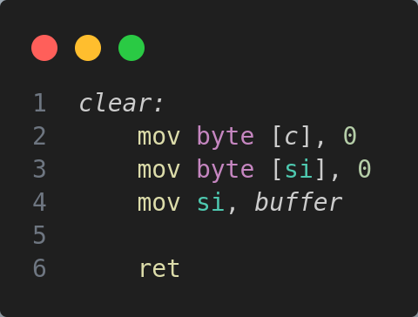

The clear function sets the value 0 to the memory locations pointed by `c` and `si`, and moves the value of the `buffer` to the register `si`.

Next, we have the `read_buffer` function:

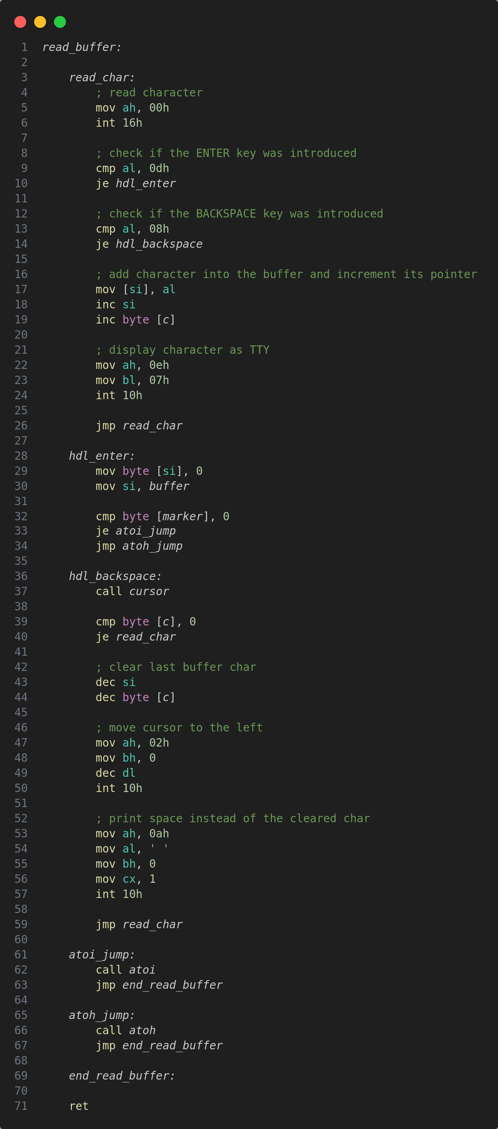

First of all, it read a character from the keyboard (with function `00h` of the `16h` interruption), after that, handles the enter or backspace keys. If the keys are neither of them, then the introduced character is added to the buffer, and the buffer pointer is incremented. The character read from the keyboard is also displayed on the screen.

The handling of the enter key uses also additional helper functions:

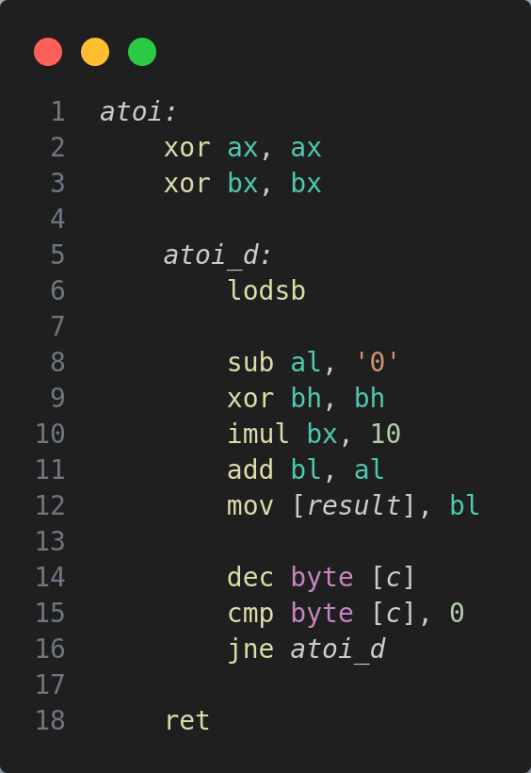

This function is responsible for converting a sequence of ASCII characters representing a decimal number into its corresponding numerical value. The instructions `xor ax, ax` and `xor ab, ab` set the values of this registers to zero. `atoi_d` label marks the beginning of the loop where the actual conversion takes place. `lodsb`: This instruction loads the byte addressed by the `si` register into the `al` register and increments `si` automatically, this means it loads the next character from memory into `al` on each iteration.

Conversion steps: `sub al, '0'` subtracts the ASCII value of character '0' from the ASCII value of the current character in `al`. ASCII values are numeric representations of characters, and subtracting the ASCII value of '0' effectively converts the character to its numerical value. Next, the `bh` register is cleared. `imul bx, 10` multiplies the value in `bx` (which initially holds the previously processed part of the number) by 10. This prepares for the next digit to be added. `imul` stands for "integer multiply". It effectively multiplies BX by 10 and stores the result back in `bx`. `add bl, al` adds the converted numerical value in `al` to the `bl`. It accumulates the digits to form the final integer value. Next, this value is stored into the memory location labeled as `result`. This is the accumulating result of the conversion. `dec byte [c]` decrements the byte in memory pointed to by `c`. `cmp byte [c], 0`: Compares the value pointed to by `c` with zero to check if the conversion is complete. If there are more characters to convert (`[c]` is not zero), the loop continues (`jne atoi_d`) to process the next character. If all characters have been processed, the subroutine proceeds to `ret`, indicating the end of the conversion.

Also, the handling of enter uses the function:

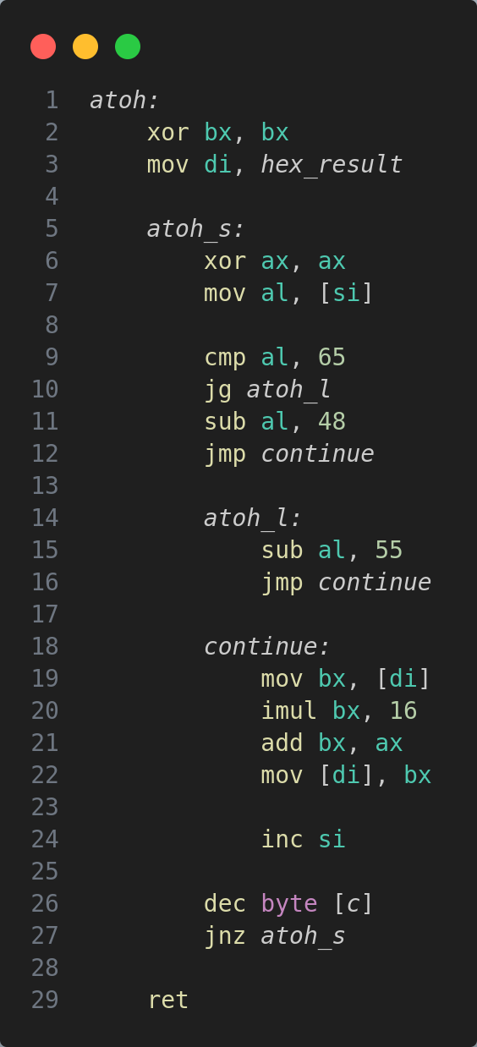

The `atoh` (ASCII to Hexadecimal) subroutine is responsible for converting a sequence of ASCII characters representing a hexadecimal number into its corresponding numerical value.

First of all, it clears the value of register `bx` and sets the value of register `di` to the value of `hex_result`. `atoh_s` label marks the beginning of the loop where the actual conversion takes place.

`mov al, [si]` loads the byte addressed by the `si` register into the `al` register. This retrieves the next character from memory for processing. After that, if the value from `al` is greater than 65, the code jumps to `atoh_l`. If the character is less than or equal to '9', it proceeds directly to the next step. `jg atoh_l` (if the character is greater than 'A', it means the character is in the range 'A' to 'F').

The function subtracts 55 from the ASCII value (`al`), converting characters 'A' to 'F' into their respective hexadecimal values ('A' = 10, 'B' = 11, ..., 'F' = 15). `sub al, 48`: If the character is '0' to '9', subtracts 48 from the ASCII value (al) - this converts ASCII characters '0' to '9' into their respective numerical values (0 to 9).

`continue` label moves the current value in `bx` into memory location `[di]` (hex_result); multiplies the value in `bx` by 16 to shift it left by one hexadecimal digit. After that, it adds the converted value in `ax` to `bx` and stores the updated value in `[di]`. It then increments the `si` register to move to the next character and decrements the byte in memory pointed to by `c` to track the length of the input string. If there are more characters to convert (`[ci]` is not zero), the loop continues (`jnz atoh_s`).

The handling of the backspace is done this way:

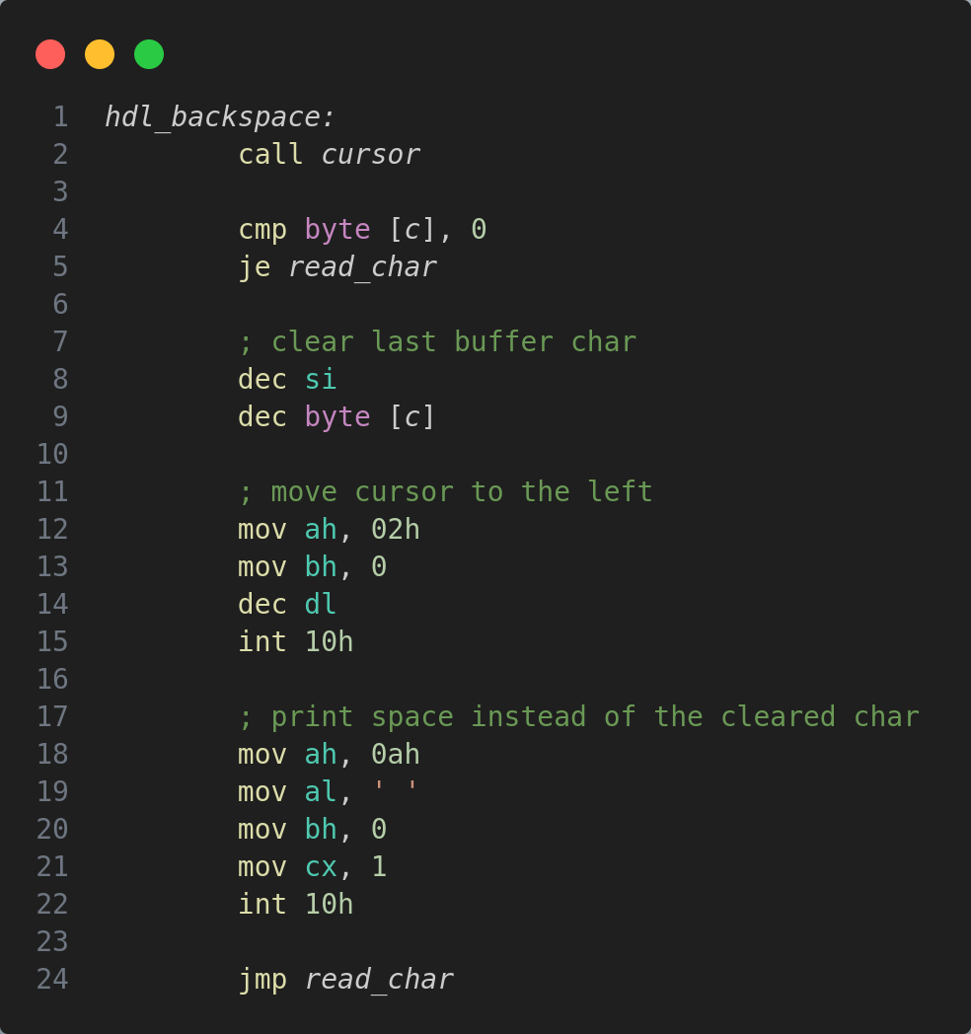

The `hdl_backspace` segment checks if there's a character in the buffer to be deleted. If there's a character present, it erases the last character in the buffer, moves the cursor back one position on the screen, prints a space character to visually erase the character on the display, and then resumes waiting for new input by jumping back to the read character section. If there are no characters in the buffer, it continues to wait for new input without any erasing action.

So, there are read from the input the values of the sector count:
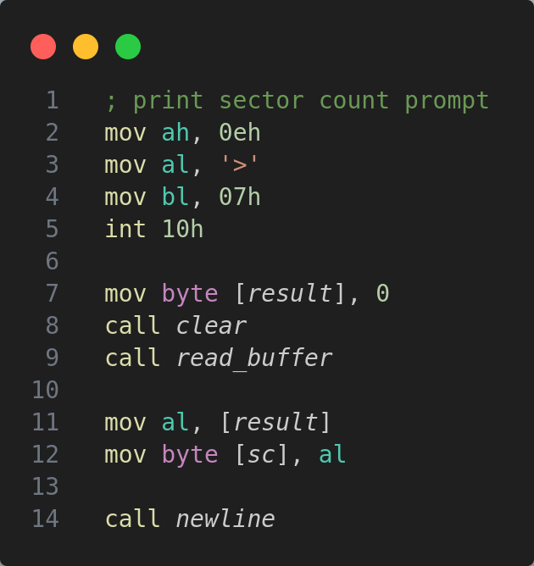

And in the same way there are read the head, track and sector values. After that, also the values of offset and segment, and after that, when we have all the values, the function `load_kernel` is called:

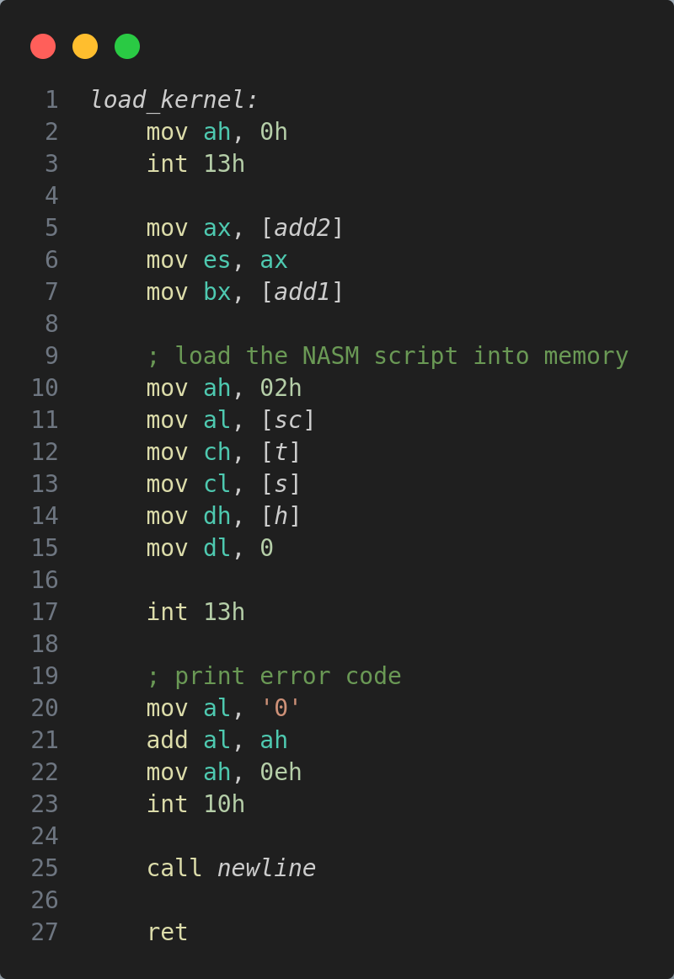
Individual task:
My individual task consists in counting the number of occurrences of a character in a string. Both the string and character are given from input.
First of all, the program receives the segment and offset values from bootloader. They are stored in the variables add1 and add2. Also, here are initialized other variables of the program:
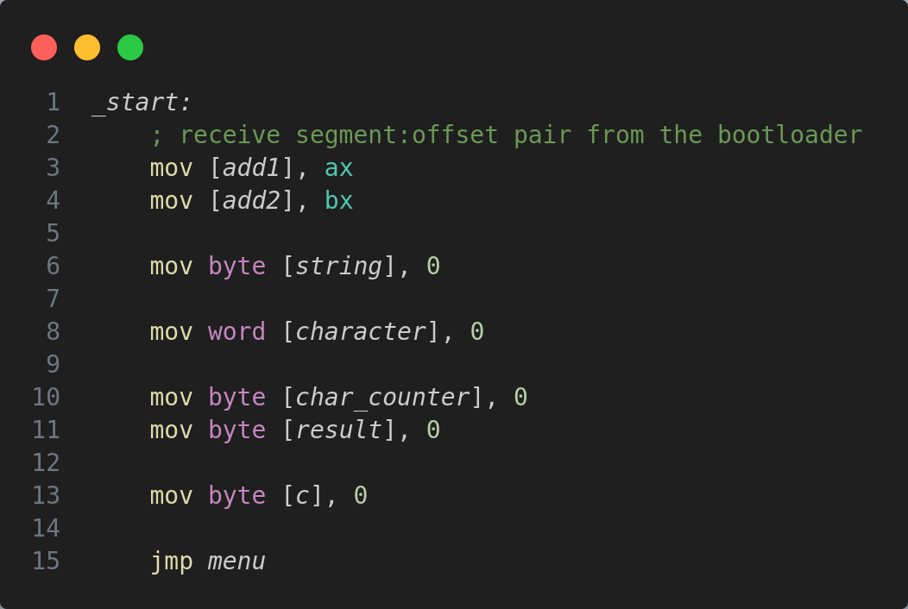
After that, there is the menu of the program. Initially, I set there the video mode, clear the screen and find the position of the cursor, using the function `find_current_cursor_position`:
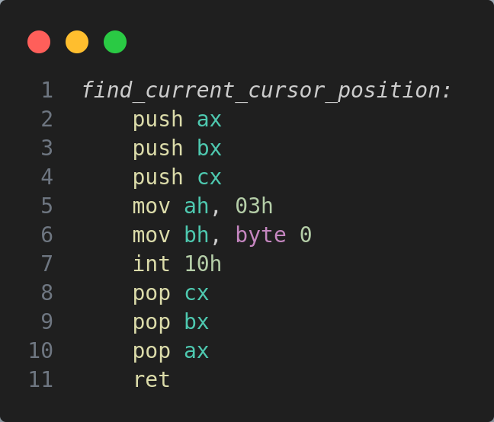
This function resets the registers `ax`, `bx` and `cx` and then, using the function `03h` of the interruption `10h` (function to query cursor position and size), obtains the current cursor position and the size/shape of the cursor for a specified video page, storing the row and column values in the `dh` and `dl` registers.
After that, the program prints the disclaimer. For every string predefined in the data section of the program, I add to the register that points to them the value of the offset, stored in the `add1`.
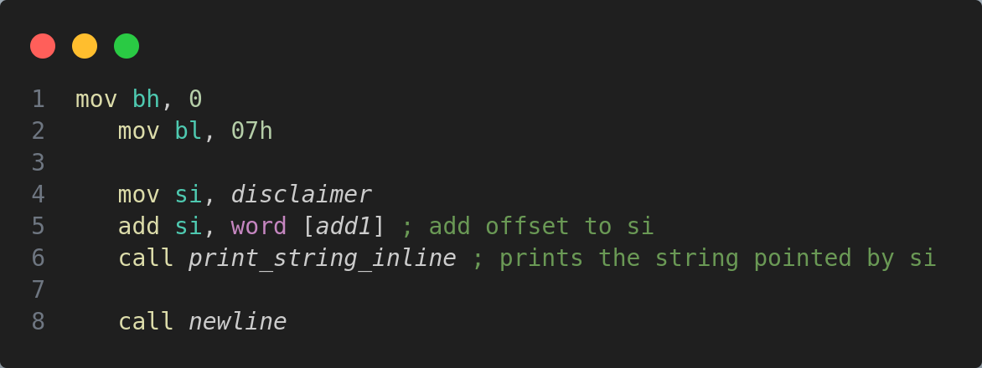
Here, I use two helper functions: `newline` and `print_string_inline`:
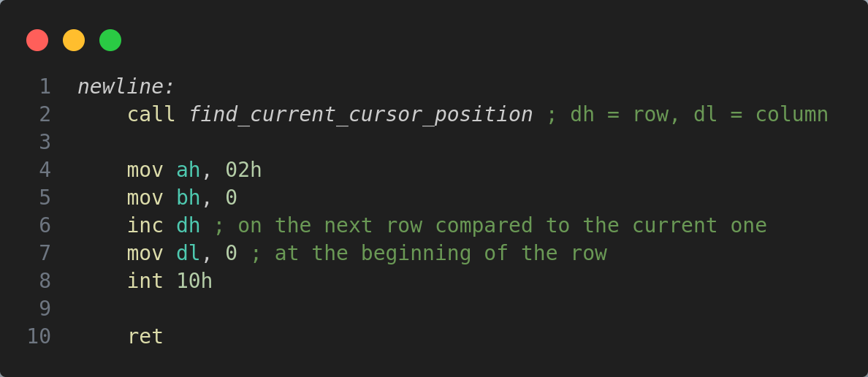
Newline executes the `find_current_cursor_position` and stores the values of the cursor in `dh` and `dl`, and increments the value of the row, where the cursor should be placed, and sets the value of the column to zero, thus, the cursor is on the beginning of the next line.
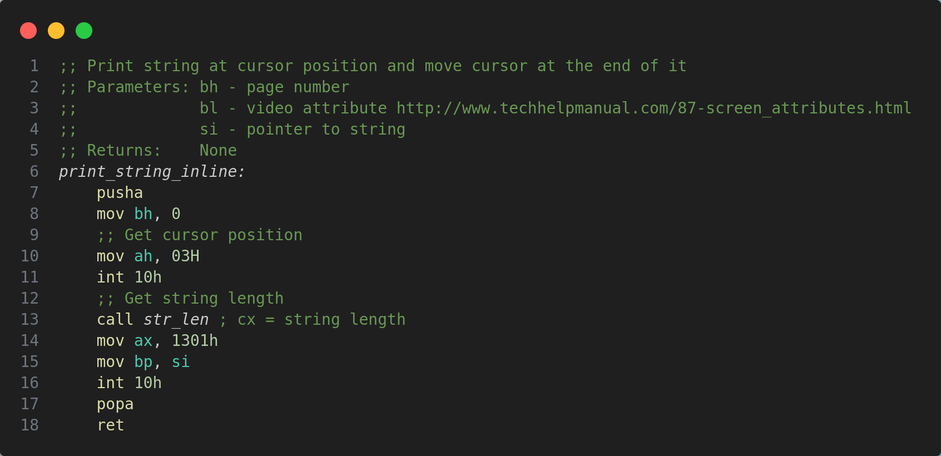

The helper function above expects a pointer to the string in the `si` register, that it will print. To print the string, we need to have its length, for which I use another helper function - `str_len` that returns the length in the `cx` register. This is the function `str_len`:

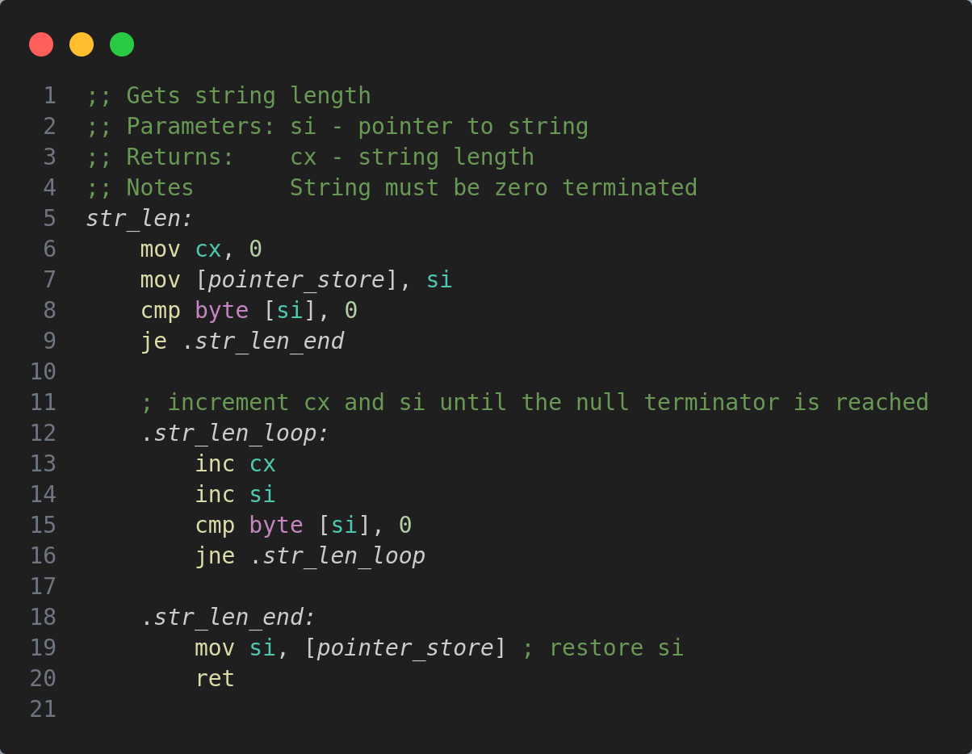
It expects a null terminated string that is pointed to by `si` register. The function loops through every character of the string, until it reaches the null terminator. The length is returned in the `cx` register. Next, in the initial menu, we have the function to reboot the window and return to the initial screen, by pressing the `r` key. If it is not pressed, the program proceeds to reading from input the values of the string and character that needs to be find in the string. For reading the input, I use the functions `read_buffer`, that adds characters in the buffer, and as soon as the enter key is pressed, the value from the buffer is first stored in the `string` and after that, in `character`, and the function `clear_buffer`, that resets the buffer and the character counter.

After the value of string and character are read from input, the prompt for the result is displayed on the screen, and also, the `find_character_occurrence` function is executed. First of all, it initializes the counter for the occurrences in the string; it sets the beginning of the string in the register `si`; sets the character to find in the register `al`; sets counter to 0.
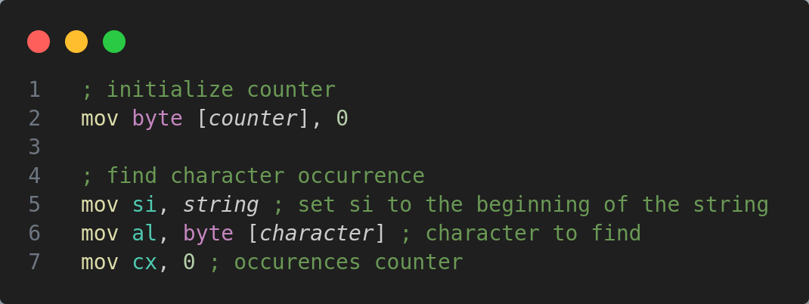

After that, there is the loop to find occurrences. It advances through every character of the string, and compares it with the value pointed by `al`. If there is an occurrence, the `cx` value is incremented, and if not, the pointer moves to the next character of the string, and executes the loop again:
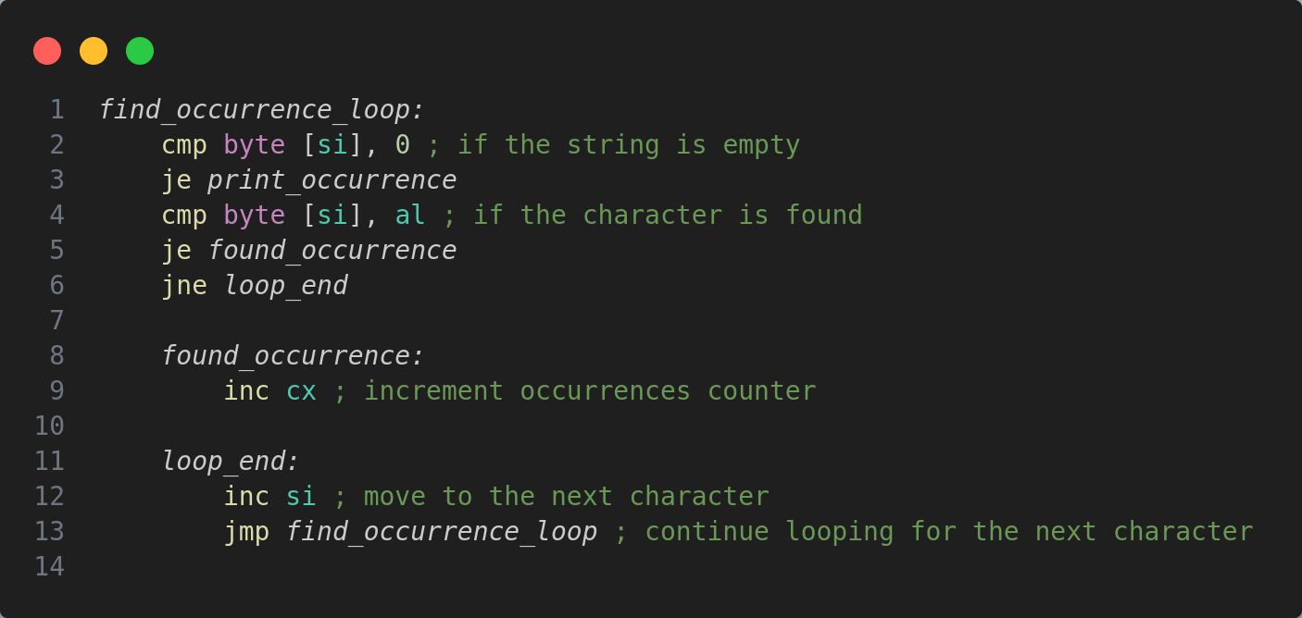

When the loop ends, the number of occurrences is printed:

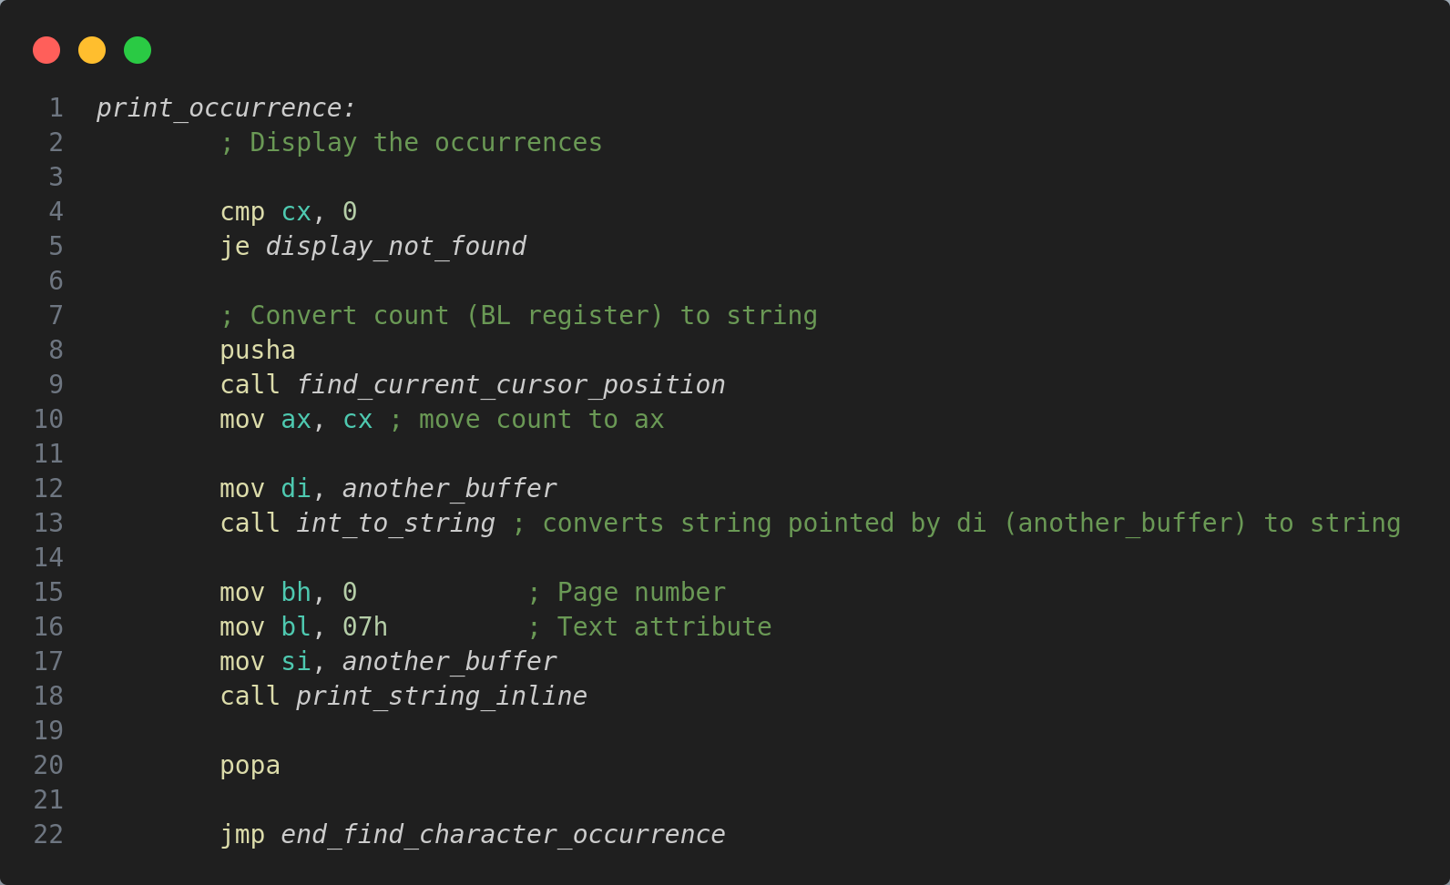
Another helper function is used here: a function to convert the integer value of occurrences in a string value, for it to be displayed on the screen:
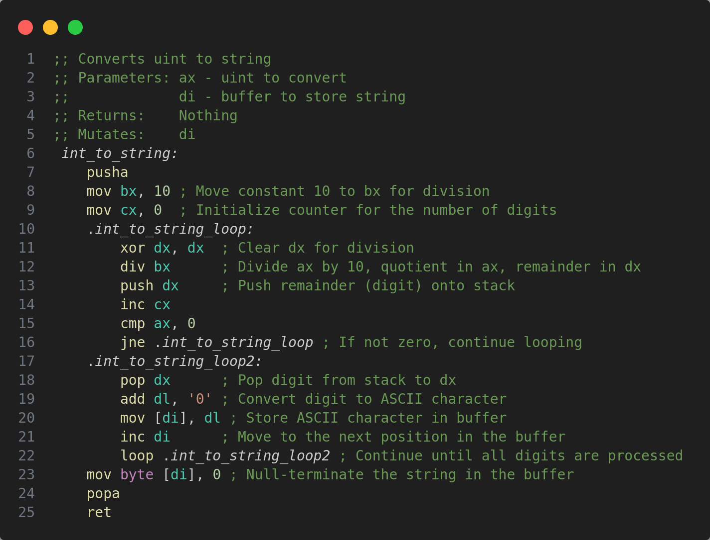

This function mutates the value pointed by the `di` register, and converts the value from an integer to a string. When the number of occurrences is printed, the function waits for any key to be pressed, to load the menu again.

Running the code

In order to create a bootable image for the virtual machine, first of all we need to assemble the program from the file with the individual task , using the command `nasm task.asm`. This command creates a binary file. After that, we need to execute the script `boot_floppy_script.sh`, passing it three parameters – the binary file, the bootloader (`bootloader.asm`) and the second bootloader (`mini_boot.asm`): `../boot_floppy_script.sh rainbow bootloader.asm mini_boot.asm`. The script is the following:
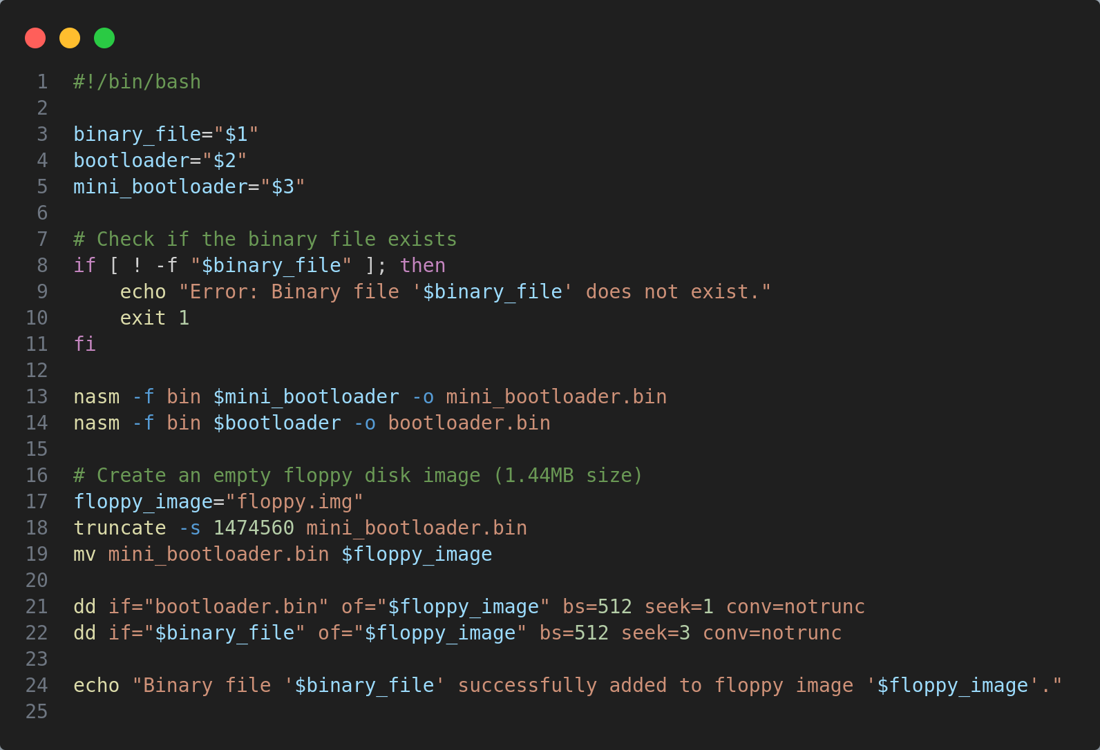
The script takes three arguments from the command line: $1 (binary_file), $2 (bootloader), and $3 (mini_bootloader). It checks if the binary file provided as $1 exists. If it doesn’t exist, it displays an error message and exits the script with a non-zero status. It uses NASM with the `-f bin` option to assemble the `mini_bootloader` file into `mini_bootloader.bin`. Similarly, it assembles the `bootloader` file into `bootloader.bin`.
After that, the script creates an empty floppy disk image named `floppy.img` with a size of 1.44MB using the truncate command. It then is essentially moving the `mini_bootloader.bin` file and renaming it to the name stored in the variable `$floppy_image` (which is `floppy.img` as per the script).
Using dd (data duplicator), it writes the `bootloader.bin` content to the created floppy image starting at the second block (512 bytes per block) using `seek=1`. This places the bootloader in the boot sector. Similarly, it writes the content of the binary file (`$binary_file`) to the floppy image starting at the fourth block (`seek=3`). This presumably adds the program or kernel to the floppy image.
Finally, it prints a message indicating that the binary file provided (`$binary_file`) has been successfully added to the floppy image (`$floppy_image`).

CONCLUSIONS
During this laboratory work, we worked together to create a flexible assembly program with different functions. The program starts with a menu where users can choose operations involving the keyboard, floppy disk, or RAM. It asks for various inputs like the number of operations, head, track, sector, data, segment, offset, and memory address.
The program handles user input effectively and performs tasks like writing from the keyboard to the floppy disk, reading from the floppy disk to RAM, and writing from RAM to the floppy disk. It shows error messages and can repeat operations.
For hexadecimal input, the program converts it into numbers and adjusts its behavior based on user choices. Users can easily move through different prompts, and the display updates accordingly.

Repository: https://github.com/alya1007/Labs-semester-5/tree/master/OS/lab4

