

**UNIVERSITATEA TEHNICĂ A MOLDOVEI**

**FACULTATEA: CALCULATOARE, INFORMATICĂ ŞI MICROELECTRONICĂ**

**DEPARTAMENTUL: INGINERIA SOFTWARE ȘI AUTOMATICA**

# **Laboratory work NR. 2.1**

# **Sequential Operating Systems**

**Executed by: Konjevic Alexandra, gr. FAF-213**

**Verified: University Lector Moraru Dumitru**

**Chișinău – 2024**

**1 TASK OF THE LABORATORY WORK**

Implementation of an Application for MCU Running at Least 3 Tasks Sequentially

This project aims to develop an application for a microcontroller (MCU) that executes at least three tasks sequentially. The tasks are as follows:

1. Button LED: Changes the LED state upon detecting a button press.
2. Intermittent LED: Flashes the LED while the LED from the first task is off.
3. Variable Increment/Decrement: Increments or decrements a variable upon pressing two buttons. This variable represents the number of repetitions or the time the LED from the second task will be in a certain state.
4. Idle Task: Displays program statuses, such as LED state and a message upon detecting button presses. One implementation could be to set a variable when a button is pressed and reset it when displaying the message, using a provider/consumer mechanism.

The objectives are the following:

* Implement producer-consumer communication between tasks using shared memory
* Find a reasonable interval between tasks
* For a bonus point, implement an extra functional

# **2 PROGRES OF THE WORK**

**2.1 Description**

In this laboratory work, I created an Arduino sketch that implements a simple scheduler to manage and execute tasks in a cooperative multitasking fashion. The tasks are related to controlling LEDs based on button presses and managing the flickering of a yellow LED. Here's a breakdown of the code:

* **Global Variables:** YELLOW_LED and RED_LED are constants representing the pin numbers for LEDs. TOGGLE_BUTTON, INC_BUTTON, and DEC_BUTTON are constants representing the pin numbers for buttons. Various variables for managing the state of button presses, flickering, and timing intervals.
* **Functions:** pressedButtonTask(): Checks if the toggle button is pressed and prints a message if it has been pressed. checkFlickerYellowTask(): Manages the flickering of the yellow LED. It toggles the state of the isFlicker variable based on a flickering interval. The flickering interval can be adjusted using the increment and decrement buttons. uiTask(): Updates the state of LEDs based on the values of isFlicker and isButtonPressed.
* **Scheduler Class:** Scheduler is a simple cooperative multitasking scheduler class. It has a constructor that takes the maximum number of tasks allowed and dynamically allocates an array for the tasks. addTask(Task task): Adds a task to the scheduler. advanceTick(): Advances the scheduler's internal tick, checks the elapsed time, and executes the current task if the elapsed time exceeds a maximum limit.
* **Setup and Loop:** setup(): Initializes serial communication, sets pin modes, and adds tasks to the scheduler. loop(): Calls advanceTick() on the scheduler in the main loop.

In summary, the code uses a scheduler to organize and execute tasks related to LED control and button presses in an Arduino environment. The tasks are managed in a cooperative multitasking manner to allow for concurrent execution of different functionalities.

**2.2 Flow Chart**

Next, I will present all the flow chart diagrams for every function in the program, and also, for the Scheduler class.

First of all, above you can see the Scheduler diagram:

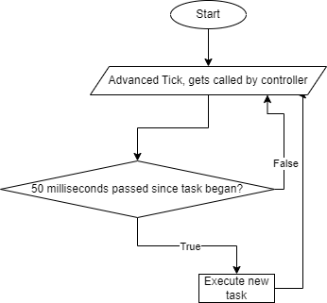

**Figure 1.** Scheduler loop diagram

The following is the diagram for the flicker LED task

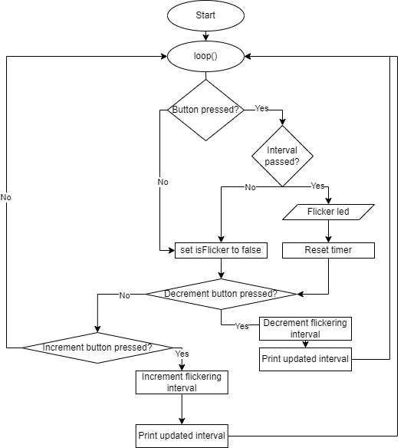

**Figure 2.** Flicker task diagram

Next, there is the diagram of the function responsible for changing the state of the button that toggles the first led (the red one).

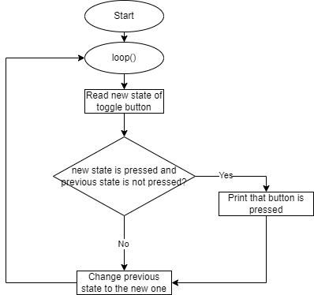

**Figure 3.** Toggle button task

And next, we have the last diagram - the one that shows the UI task:

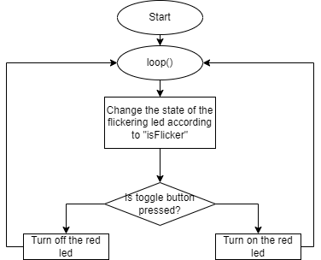

**Figure 4.** UI task

## 2.3 Circuit

For achieving the goals set, the components described in section 1.1 needed to be connected to the microcontroller.

Given with the necessary circuitry, the following is the diagram I made using wokwi:

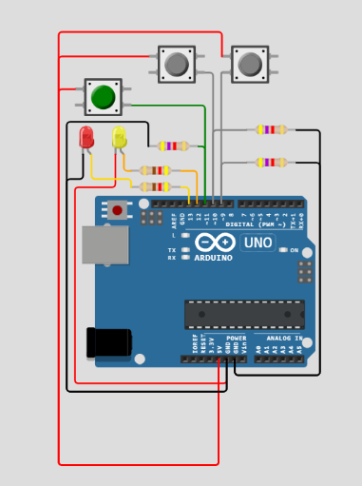

**Figure 5.** Simulated circuit

**2.4 Simulation:**

First of all, this is the state of the circuit when only the toggle button is pressed:

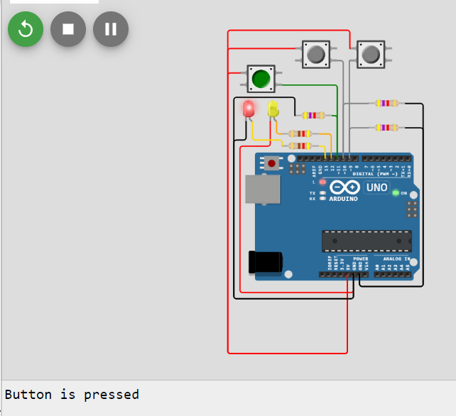

**Figure 6.** Toggle button pressed

And when the another led is flickering, this is the circuit:

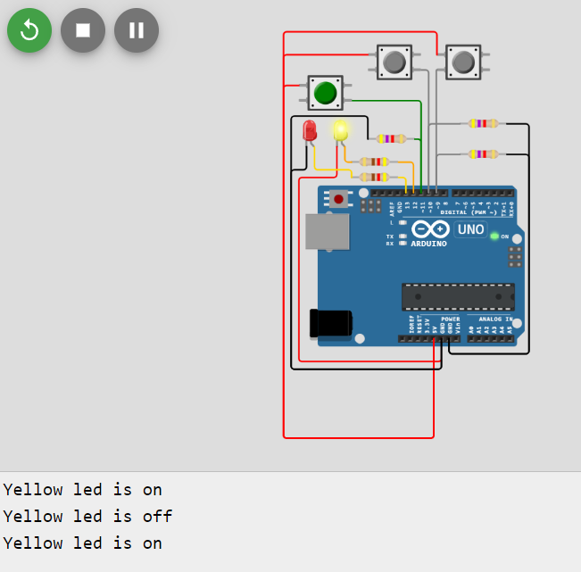

**Figure 7.** Yellow led flickering

# **CONCLUSION**

# This project demonstrates the implementation of a multi-tasking application on an MCU. The application includes multiple tasks that interact with each other and with the user. The project can be further extended by adding more tasks, implementing a more complex user interface, and using advanced programming techniques.

**BIBLIOGRAPHY**

1. Arduino: Arduino UNO R3. Arduino official site, ©2024 [quote 2024]. Access link: <https://docs.arduino.cc/hardware/uno-rev3/>
2. Serial Monitor: Using the Serial Monitor tool. Arduino official site, ©2024 [quote 2024]. Access link: <https://docs.arduino.cc/software/ide-v2/tutorials/ide-v2-serial-monitor/>
3. Buttons in Arduino. Arduino official site, ©2024 [quote 2024]. Access link: https://docs.arduino.cc/built-in-examples/digital/Button/