**TECHNICAL UNIVERSITY OF MOLDOVA FACULTY OF COMPUTERS INFORMATICS AND MICROELECTRONICS**

**DEPARTMENT OF SOFTWARE ENGINEERING AND AUTOMATION**

**Laboratory work 4**

**Subject: Linear digital image processing methods**

# **Done by: Konjevic Alexandra,**

# **st. gr. FAF-213**

# **Verified by: Railean Serghei,**

# **university lecturer**

**CHIŞINĂU, 2024**

**TASK OF THE LABORATORY WORK**

The purpose of this lab work is to explore various aspects of Fourier Transform and signal processing techniques. It involves tasks such as generating discrete signals, performing Fourier Transform, analyzing frequency spectra, determining magnitudes and phases, modeling rectangular pulses, filtering noise signals, and examining continuous Fourier Transform. The tasks cover practical applications of Fourier analysis in signal processing and aim to deepen understanding of frequency domain representations of signals.

**THEORETICAL CONSIDERATIONS**

Arithmetic operations on images involve applying a simple function to each pixel value. This function maps the range of pixel values (usually 0 to 255) onto itself. Simple functions include adding or subtracting a constant value from each pixel or multiplying each pixel by a constant. In each case, rounding might be necessary to ensure the results are integers within the 0 to 255 range. This can be achieved by rounding the result first (if necessary) to obtain an integer and then "clipping" the values by setting: pixel value = min(max(0,rounded value),255)

We can gain understanding of how these operations affect an image by visualizing the old grayscale values versus the new values. For instance, adding or subtracting 128 from each pixel brightens or darkens the image, respectively.

Histogram Equalization:

Histogram equalization enhances the contrast of an image by spreading out the intensity levels. It adjusts the intensity distribution of an image by transforming its histogram. A histogram represents the frequency of occurrence of each intensity level in an image. Histogram equalization can be visualized using the imhist function in MATLAB.

Spatial Filtering:

Spatial filtering is an extension of arithmetic operations, where a function is applied to a neighborhood of each pixel. It involves moving a "mask" or a rectangle (usually with odd-length sides) or another shape over the given image. As we do this, we create a new image whose pixel values are calculated from the grayscale values under the mask. The combination of the mask and the function is called a filter. If the function is a linear function of all the grayscale values in the mask, the filter is called a linear filter. We can implement a linear filter by multiplying all elements in the mask by the corresponding elements in the neighborhood and summing all these products.

Low-Pass and High-Pass Filters:

Low-pass filters reduce or eliminate high-frequency components, while high-pass filters reduce or eliminate low-frequency components. For example, a median filter is a low-pass filter as it tends to blur edges, while the Laplacian filter is a high-pass filter.

1. Gamma curve manipulations

# 1.1 Show an image from your file system.

**from** PIL **import** Image

**import** matplotlib.pyplot **as** plt

**import** numpy **as** np

original_image_path **=** './images/img.jpg' saved_image_path **=** './images/my_image.tif'

image **=** Image**.**open(original_image_path) image**.**save(saved_image_path)

image **=** Image**.**open(saved_image_path)

plt**.**figure() plt**.**imshow(image) plt**.**title('Original Image') plt**.**axis('off')

plt**.**show()

In [1]:

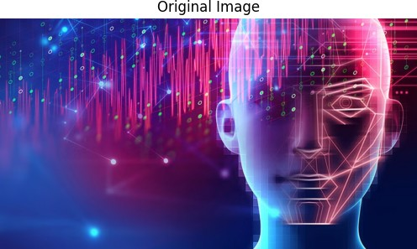

# 1.2 Add 128 to each pixel of the image.

cc **=** np**.**array(image) c1 **=** cc **+** 128

modified_image_c1 **=** Image**.**fromarray(c1**.**astype(np**.**uint8)) plt**.**figure()

plt**.**imshow(modified_image_c1)

plt**.**title('Image with 128 Added to Each Pixel') plt**.**axis('off')

plt**.**show()

In [2]:

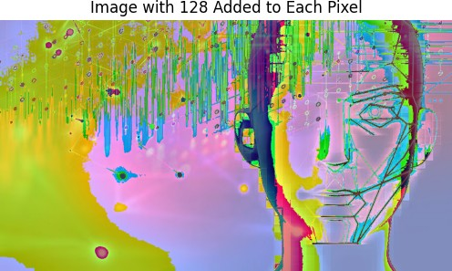

# 1.3 Subtract 128 from each pixel of the image.

c2 **=** cc **-** 128

modified_image_c2 **=** Image**.**fromarray(c2**.**astype(np**.**uint8)) plt**.**figure()

plt**.**imshow(modified_image_c2)

plt**.**title('Image with 128 Subtracted from Each Pixel')

plt**.**axis('off') plt**.**show()

In [3]:

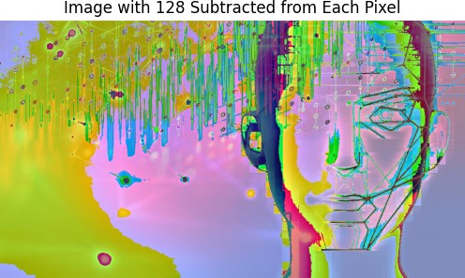

1.4 Divide each pixel of the image by 2

c3 = cc / 2

modified_image_c3 = Image.fromarray(c3.astype(np.uint8))

plot()

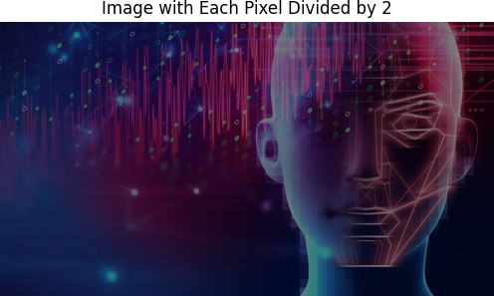

# 1.5 Multiply each pixel of the image by 2.

c4 **=** cc **\*** 2

modified_image_c4 **=** Image**.**fromarray(c4**.**astype(np**.**uint8)) plt**.**figure()

plt**.**imshow(modified_image_c4)

plt**.**title('Image with Each Pixel Multiplied by 2') plt**.**axis('off')

plt**.**show()

In [5]:

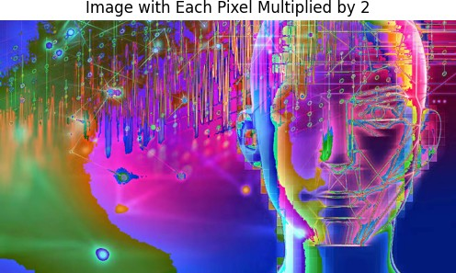

# 1.6 Divide each pixel of the image by half then add 128

In [6]:

c5 **=** cc **\*** 0.5 **+** 128

modified_image_c4 **=** Image**.**fromarray(c5**.**astype(np**.**uint8))

plt**.**figure() plt**.**imshow(modified_image_c4)

plt**.**title('Image with Each Pixel Multiplied by 0.5 and 128 Added') plt**.**axis('off')

plt**.**show()

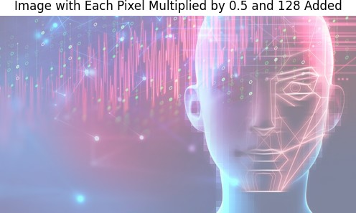

# 2.1 Show an image from your file system and its histogram

In [7]:

gray_image **=** image**.**convert('L') cc_gray **=** np**.**array(gray_image)

*# Display the grayscale image and its histogram*

plt**.**figure(figsize**=**(12, 6))

*# Grayscale Image and its histogram* plt**.**subplot(2, 2, 1) plt**.**imshow(gray_image, cmap**=**'gray') plt**.**title('Grayscale Image') plt**.**axis('off')

plt**.**subplot(2, 2, 2)

plt**.**hist(cc_gray**.**ravel(), bins**=**256, color**=**'k', alpha**=**0.7) plt**.**title('Grayscale Histogram')

plt**.**xlabel('Pixel Intensity') plt**.**ylabel('Frequency')

*# Color Image and its histogram* plt**.**subplot(2, 2, 3) plt**.**imshow(image) plt**.**title('Color Image') plt**.**axis('off')

plt**.**subplot(2, 2, 4)

R **=** np**.**histogram(cc[:,:,0], bins**=**256, range**=**[0,256])[0]

G **=** np**.**histogram(cc[:,:,1], bins**=**256, range**=**[0,256])[0]

B **=** np**.**histogram(cc[:,:,2], bins**=**256, range**=**[0,256])[0] plt**.**plot(R, color**=**'r')

plt**.**plot(G, color**=**'g') plt**.**plot(B, color**=**'b') plt**.**title('Color Histogram') plt**.**xlabel('Pixel Intensity') plt**.**ylabel('Frequency')

plt**.**legend(['Red channel', 'Green channel', 'Blue channel'])

plt**.**tight_layout() plt**.**show()

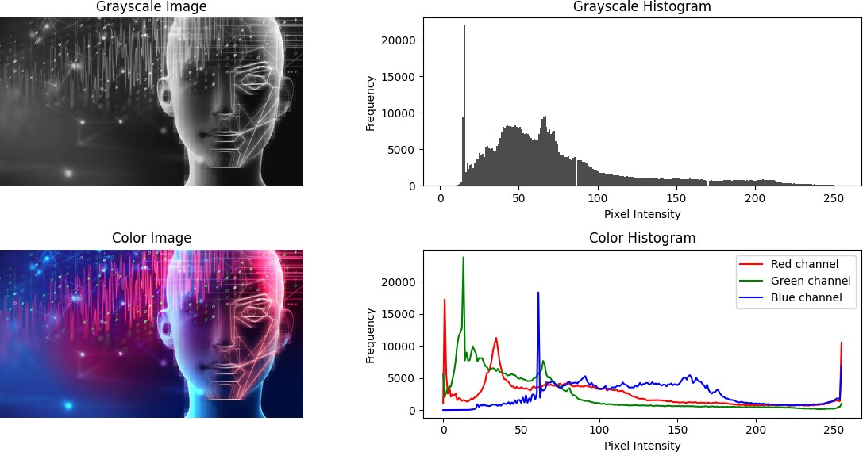

# 2.2 Equalize the histogram of the image and show the result.

In [13]:

**from** skimage **import** exposure

*# Perform histogram equalization for grayscale image*

h_gray **=** exposure**.**equalize_hist(cc_gray)

*# Perform histogram equalization for color image*

I2 **=** exposure**.**equalize_hist(cc)

*# Display the equalized grayscale image and its histogram*

plt**.**figure(figsize**=**(12, 6))

*# Equalized grayscale image* plt**.**subplot(2, 2, 1) plt**.**imshow(h_gray, cmap**=**'gray') plt**.**title('Equalized Grayscale Image') plt**.**axis('off')

*# Grayscale histogram after equalization*

plt**.**subplot(2, 2, 2)

plt**.**hist(h_gray**.**ravel(), bins**=**256, color**=**'k', alpha**=**0.7) plt**.**title('Grayscale Histogram (Equalized)') plt**.**xlabel('Pixel Intensity')

plt**.**ylabel('Frequency')

*# Display the equalized color image and its histogram*

plt**.**subplot(2, 2, 3) plt**.**imshow(I2) plt**.**title('Equalized Color Image') plt**.**axis('off')

*# Color histogram after equalization*

plt**.**subplot(2, 2, 4)

R **=** np**.**histogram(I2[:,:,0], bins**=**256, range**=**[0,1])[0]

G **=** np**.**histogram(I2[:,:,1], bins**=**256, range**=**[0,1])[0]

B **=** np**.**histogram(I2[:,:,2], bins**=**256, range**=**[0,1])[0] plt**.**plot(R, color**=**'r')

plt**.**plot(G, color**=**'g') plt**.**plot(B, color**=**'b')

plt**.**title('Color Histogram (Equalized)') plt**.**xlabel('Pixel Intensity') plt**.**ylabel('Frequency')

plt**.**legend(['Red channel', 'Green channel', 'Blue channel'])

plt**.**tight_layout() plt**.**show()

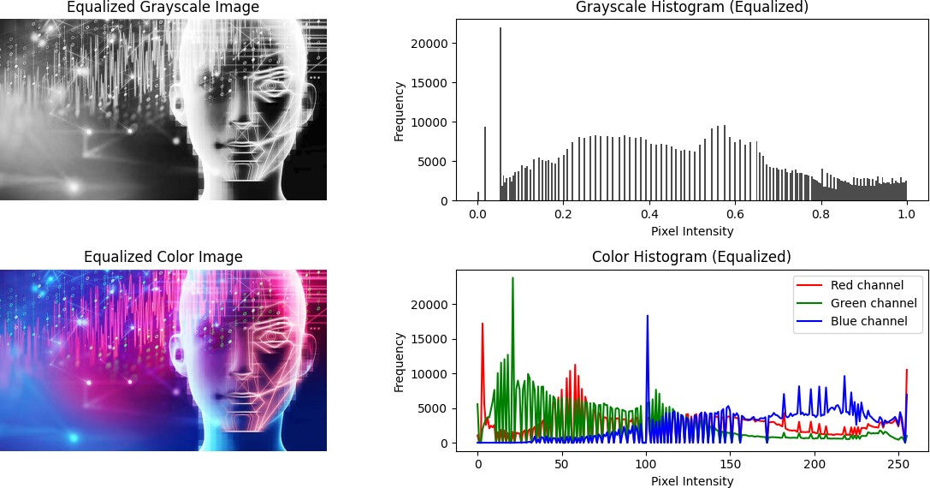

# 3.1 Apply a 3x3 filter to the image and show the result.

In [21]:

**from** scipy.signal **import** convolve2d

*# Perform filtering for grayscale image*

f1 **=** np**.**ones((3, 3)) **/** 9.0

cf1_gray **=** convolve2d(cc_gray, f1, mode**=**'same')

*# Separate channels for the color image*

R **=** cc[:,:,0]

G **=** cc[:,:,1]

B **=** cc[:,:,2]

*# Convolve each channel separately* cf1_color_R **=** convolve2d(R, f1, mode**=**'same') cf1_color_G **=** convolve2d(G, f1, mode**=**'same') cf1_color_B **=** convolve2d(B, f1, mode**=**'same')

*# Stack the filtered channels back into a color image*

cf1_color **=** np**.**stack([cf1_color_R, cf1_color_G, cf1_color_B], axis**=**2)

*# Display original and filtered images*

plt**.**figure(figsize**=**(16, 8))

*# Original grayscale image* plt**.**subplot(2, 2, 1) plt**.**imshow(cc_gray, cmap**=**'gray')

plt**.**title('Original Grayscale Image') plt**.**axis('off')

*# Filtered grayscale image* plt**.**subplot(2, 2, 2) plt**.**imshow(cf1_gray, cmap**=**'gray') plt**.**title('Filtered Grayscale Image') plt**.**axis('off')

*# Original color image* plt**.**subplot(2, 2, 3) plt**.**imshow(cc) plt**.**title('Original Color Image') plt**.**axis('off')

*# Filtered color image*

plt**.**subplot(2, 2, 4) plt**.**imshow(cf1_color**.**astype(np**.**uint8)) plt**.**title('Filtered Color Image') plt**.**axis('off')

plt**.**tight_layout() plt**.**show()

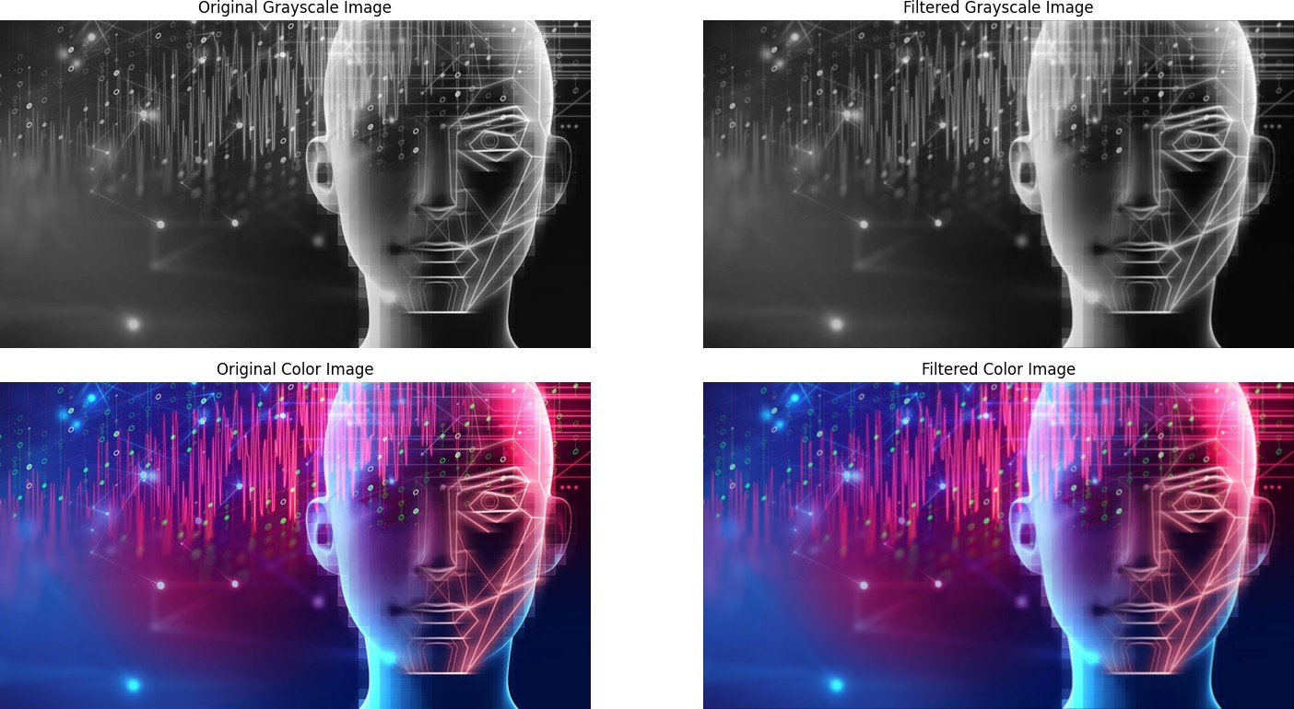

# 3.2 a Apply a 5x7 filter to the image and show the result

In [29]:

**def** filter(x, y):

*# Perform filtering for grayscale image*

f1_gray **=** np**.**ones((x, y)) **/** (x **\*** y)

cf1_gray **=** convolve2d(cc_gray, f1_gray, mode**=**'same')

*# Perform filtering for color image* f1_color **=** np**.**ones((5, 7)) **/** (5 **\*** 7) cf1_color **=** np**.**zeros_like(cc, dtype**=**float)

**for** i **in** range(3): *# Apply filter to each color channel separately*

cf1_color[:,:,i] **=** convolve2d(cc[:,:,i], f1_color, mode**=**'same')

*# Display original and filtered images*

plt**.**figure(figsize**=**(16, 8))

*# Original grayscale image* plt**.**subplot(2, 2, 1) plt**.**imshow(cc_gray, cmap**=**'gray') plt**.**title('Original Grayscale Image') plt**.**axis('off')

*# Filtered grayscale image* plt**.**subplot(2, 2, 2) plt**.**imshow(cf1_gray, cmap**=**'gray') plt**.**title('Filtered Grayscale Image') plt**.**axis('off')

plt**.**tight_layout() plt**.**show()

*# Display filtered color image*

plt**.**figure(figsize**=**(12, 6))

*# Original color image* plt**.**subplot(1, 2, 1) plt**.**imshow(cc) plt**.**title('Original Color Image') plt**.**axis('off')

*# Filtered color image*

plt**.**subplot(1, 2, 2) plt**.**imshow(cf1_color**.**astype(np**.**uint8)) plt**.**title('Filtered Color Image') plt**.**axis('off')

plt**.**tight_layout() plt**.**show()

filter(5, 7)

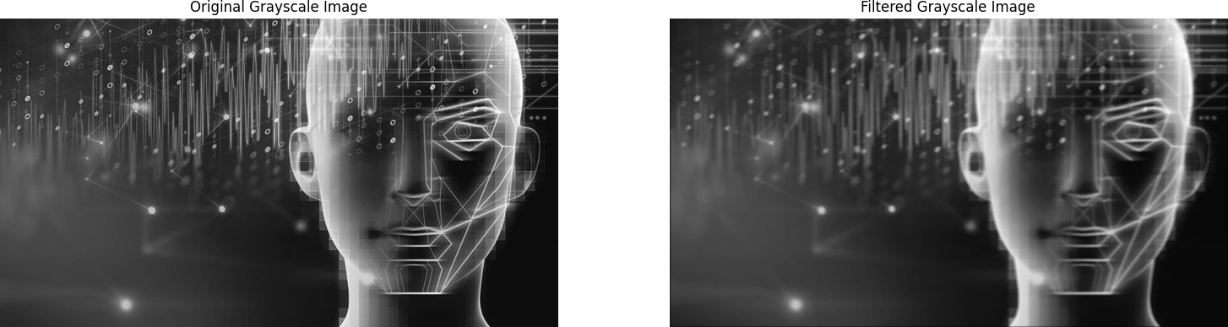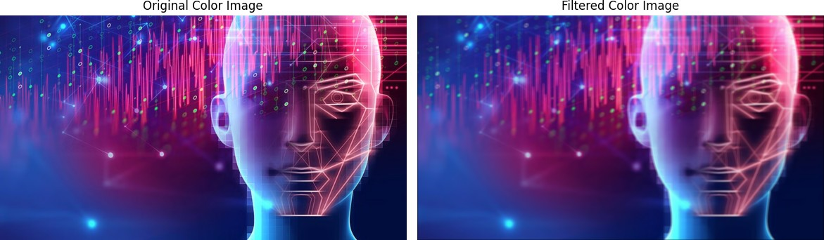

# 3.2 b Apply a 11x11 filter to the image and show the result

filter(11, 11)

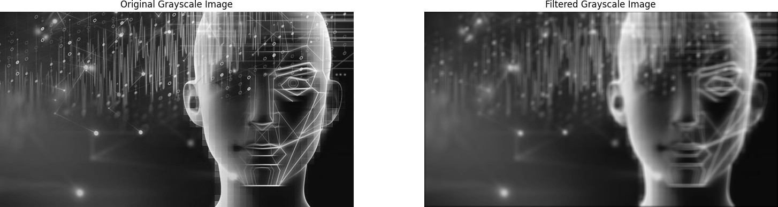



# 3.3 Detect the edges of the images using a Laplacian and then a logarithmic Gaussian filter

from skimage import color

# Perform edge detection for grayscale image

f_laplacian = np.array([[0, 1, 0], [1, -4, 1], [0, 1, 0]])

cf2_gray = convolve2d(cc_gray, f_laplacian, mode='same')

# Perform Laplacian of Gaussian for grayscale image

f_log = np.array([[0, 0, 1, 0, 0],

[0, 1, 2, 1, 0],

[1, 2, -16, 2, 1],

[0, 1, 2, 1, 0],

[0, 0, 1, 0, 0]])

cf3_gray = convolve2d(cc_gray, f_log, mode='same')

# Convert the color image to grayscale

IG = color.rgb2gray(cc)

# Perform edge detection for color image

cf2_color = convolve2d(IG, f_laplacian, mode='same')

# Perform Laplacian of Gaussian for color image

cf3_color = convolve2d(IG, f_log, mode='same')

# Display edge detection results

plt.figure(figsize=(12, 6))

# Edge detection for grayscale image

plt.subplot(2, 2, 1)

plt.imshow(cf2_gray / 155, cmap='gray')

plt.title('Edge Detection (Laplacian) - Grayscale')

plt.axis('off')

plt.subplot(2, 2, 2)

plt.imshow(cf3_gray / 155, cmap='gray')

plt.title('Edge Detection (LoG) - Grayscale')

plt.axis('off')

# Edge detection for color image

plt.subplot(2, 2, 3)

plt.imshow(cf2_color / 155, cmap='gray')

plt.title('Edge Detection (Laplacian) - Color')

plt.axis('off')

plt.subplot(2, 2, 4)

plt.imshow(cf3_color / 155, cmap='gray')

plt.title('Edge Detection (LoG) - Color')

plt.axis('off')

plt.tight_layout()

plt.show()

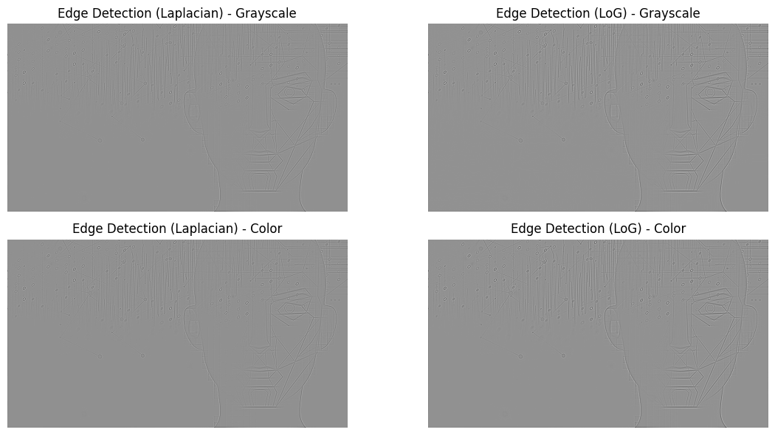

# 3.4 Add salt and pepper noise to the image and show the difference.

**from** skimage.util **import** random_noise

*# Add "salt and pepper" noise to grayscale image*

c_sp_gray **=** random_noise(cc_gray, mode**=**'s&p')

*# Convert the color image to grayscale*

IG **=** color**.**rgb2gray(cc)

*# Add "salt and pepper" noise to grayscale image*

c_sp_color **=** random_noise(IG, mode**=**'s&p')

*# Display images with "salt and pepper" noise*

plt**.**figure(figsize**=**(12, 6))

*# Image with "salt and pepper" noise - grayscale*

plt**.**subplot(1, 2, 1) plt**.**imshow(c_sp_gray, cmap**=**'gray')

plt**.**title('Grayscale Image with "Salt and Pepper" Noise')

In [32]:

plt**.**axis('off')

*# Image with "salt and pepper" noise - color*

plt**.**subplot(1, 2, 2) plt**.**imshow(c_sp_color, cmap**=**'gray')

plt**.**title('Color Image with "Salt and Pepper" Noise') plt**.**axis('off')

plt**.**tight_layout() plt**.**show()

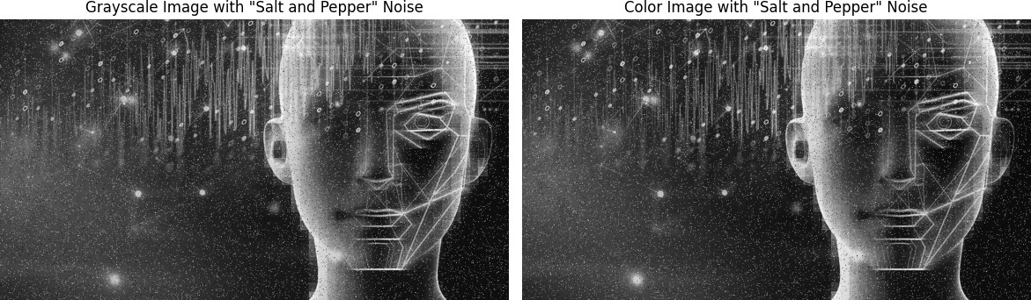

# 3.5 Apply a 3x3 median filter to the image and show the result.

*# Add "salt and pepper" noise to grayscale image*

c_sp_gray **=** random_noise(cc_gray, mode**=**'s&p')

*# Convert the color image to grayscale*

IG **=** color**.**rgb2gray(cc)

*# Add "salt and pepper" noise to grayscale image*

c_sp_color **=** random_noise(IG, mode**=**'s&p')

*# Define 3x3 and 5x7 average filters*

a3 **=** np**.**ones((3, 3)) **/** 9

a4 **=** np**.**ones((5, 7)) **/** 35 *# Adjusted to maintain sum of 1*

*# Filter the noisy images with the average filters* c_sp_f3 **=** convolve2d(c_sp_gray, a3, mode**=**'same') c_sp_f4 **=** convolve2d(c_sp_gray, a4, mode**=**'same')

*# Display filtered images*

plt**.**figure(figsize**=**(12, 6))

*# Filtered image with 3x3 average filter*

plt**.**subplot(1, 2, 1) plt**.**imshow(c_sp_f3 **/** 255, cmap**=**'gray')

plt**.**title('Filtered Image with 3x3 Average Filter') plt**.**axis('off')

*# Filtered image with 5x7 average filter*

plt**.**subplot(1, 2, 2) plt**.**imshow(c_sp_f4 **/** 255, cmap**=**'gray')

plt**.**title('Filtered Image with 5x7 Average Filter') plt**.**axis('off')

plt**.**tight_layout() plt**.**show()

In [34]:

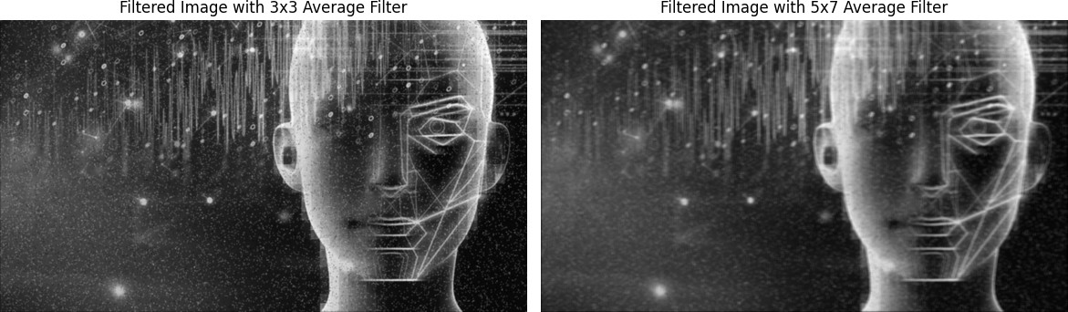

# 4.1 Generate a geometric pattern and apply a Fourier transform to it.

In [42]:

**from** scipy.fft **import** fftshift, fft2

*# Generate the geometric figure image*

a **=** np**.**zeros((256, 256)) a[78:178, 78:178] **=** 1

*# Compute the Fourier transform and shift it*

af **=** fftshift(fft2(a))

*# Plot the original image*

plt**.**figure(figsize**=**(10, 5))

plt**.**subplot(1, 2, 1) plt**.**imshow(a, cmap**=**'gray')

plt**.**title('Geometric Figure Image') plt**.**axis('off')

*# Plot the Fourier spectrum using heatmap for a colored representation*

plt**.**subplot(1, 2, 2)

plt**.**title('Fourier Spectrum of the Geometric Figure Image') plt**.**xlabel('Frequency (kx)')

plt**.**ylabel('Frequency (ky)') plt**.**imshow(np**.**log(np**.**abs(af)), cmap**=**'inferno') plt**.**colorbar(label**=**'Log Magnitude')

plt**.**tight_layout() plt**.**show()

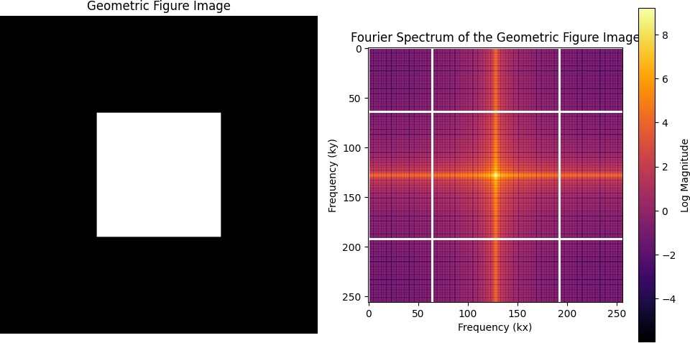

# 4.2 Add salt and pepper noise to the image and show the fft.

*# Add "salt and pepper" noise to the image*

c_sp **=** random_noise(a, mode**=**'s&p')

*# Compute the Fourier transform and shift it*

cf **=** fftshift(fft2(c_sp))

*# Plot the image with "salt and pepper" noise*

plt**.**figure(figsize**=**(10, 5))

plt**.**subplot(1, 2, 1) plt**.**imshow(c_sp, cmap**=**'gray')

plt**.**title('Geometric Figure Image with "Salt and Pepper" Noise') plt**.**axis('off')

*# Plot the Fourier spectrum using heatmap for a colored representation*

plt**.**subplot(1, 2, 2)

plt**.**title('Fourier Spectrum of the Image with "Salt and Pepper" Noise') plt**.**xlabel('Frequency (kx)')

plt**.**ylabel('Frequency (ky)') plt**.**imshow(np**.**log(np**.**abs(cf)), cmap**=**'inferno') plt**.**colorbar(label**=**'Log Magnitude')

plt**.**tight_layout() plt**.**show()

In [44]:

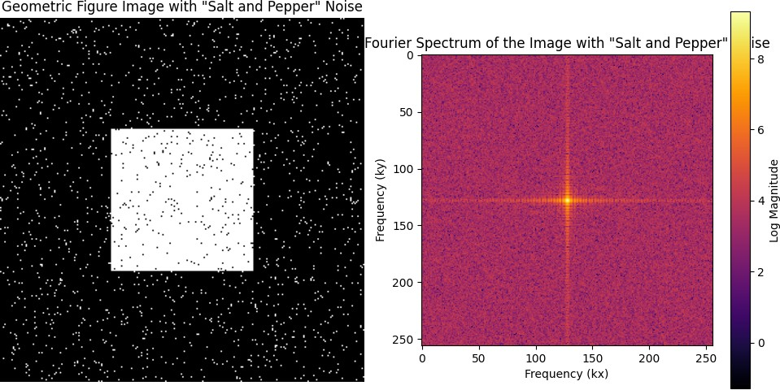

# 4.3 Apply a low-pass filter to the image and show the spectrum

In [46]:

**from** scipy.fft **import** ifft2

*# Compute the absolute values of the Fourier coefficients*

abs_cf **=** np**.**abs(cf)

*# Perform frequency domain filtering by eliminating high frequencies*

threshold **=** 100

filtered_cf **=** cf **\*** (abs_cf **>** threshold)

*# Shift the filtered Fourier spectrum back and compute the inverse Fourier transform*

filtered_cf_shifted **=** fftshift(filtered_cf) c_filtered **=** np**.**abs(ifft2(filtered_cf_shifted))

*# Plot the filtered image and its Fourier spectrum*

plt**.**figure(figsize**=**(12, 6))

*# Plot the original image with "salt and pepper" noise*

plt**.**subplot(1, 3, 1) plt**.**imshow(c_sp, cmap**=**'gray')

plt**.**title('Image with "Salt and Pepper" Noise') plt**.**axis('off')

*# Plot the filtered image*

plt**.**subplot(1, 3, 2) plt**.**imshow(c_filtered **/** 255, cmap**=**'gray')

plt**.**title('Filtered Image (Low-pass Filter)') plt**.**axis('off')

*# Plot the Fourier spectrum of the noisy image* plt**.**subplot(1, 3, 3) plt**.**imshow(np**.**log(abs_cf), cmap**=**'inferno') plt**.**title('Fourier Spectrum of Noisy Image') plt**.**axis('off')

plt**.**tight_layout() plt**.**show()

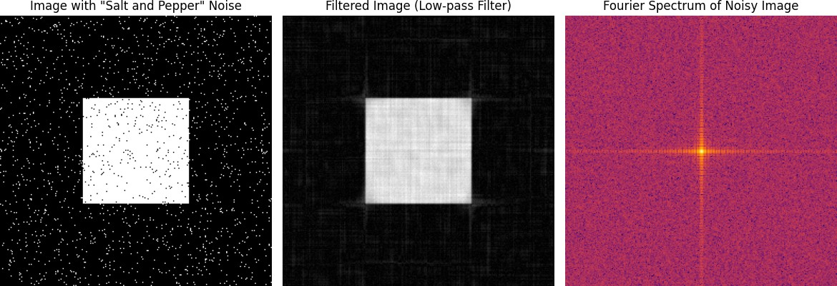

# 4.4 Perform the inverse Fourier transform and show the result.

In [47]:

*# Compute the Fourier transform of the noisy image and shift it*

cf **=** fftshift(fft2(c_sp))

*# Perform frequency domain filtering by eliminating high frequencies*

threshold **=** 100

filtered_cf **=** cf **\*** (np**.**abs(cf) **>** threshold)

*# Perform inverse Fourier transform of the truncated spectrum*

cf2 **=** ifft2(filtered_cf)

*# Plot the inverse Fourier transformed image* plt**.**imshow(np**.**abs(cf2) **/** 155, cmap**=**'gray') plt**.**title('Inverse Fourier Transformed Image') plt**.**axis('off')

plt**.**show()

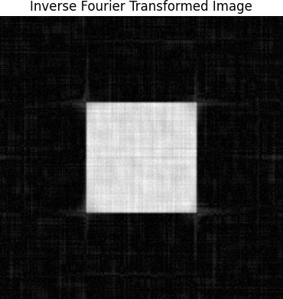

1.7 Analyze the gamma curve transform using the following tool: <https://demonstrations.wolfram.com/TransformationsOfGrayLevelsInAnImage/>

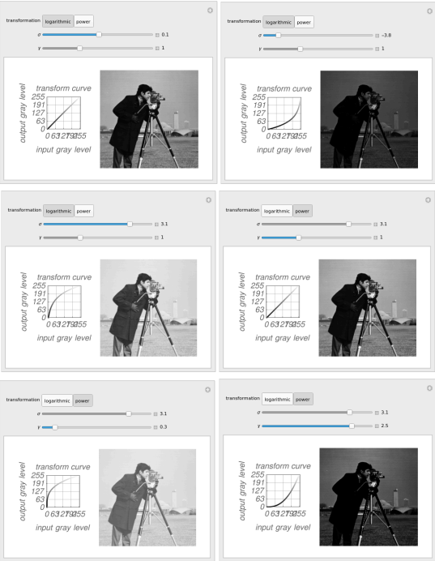

**CONCLUSION**

In conclusion, image processing involves a variety of techniques aimed at enhancing, analyzing, and manipulating digital images. Arithmetic operations allow for simple modifications of pixel values, such as adjusting brightness and contrast. Histogram equalization enhances image contrast by redistributing intensity levels. Spatial filtering extends these operations by applying functions to neighborhoods of pixels, allowing for tasks like blurring or edge detection.

Frequency domain filtering involves transforming images into the frequency domain via the Fourier transform, where operations such as filtering out high frequencies can be performed to remove noise or enhance specific features. Combining both spatial and frequency domain techniques provides a powerful toolkit for image enhancement and analysis.

Understanding these fundamental concepts and techniques equips us with the necessary tools to process images for a wide range of applications, from medical imaging to satellite imagery analysis and beyond.