THE ACCEPTANCE OF ARTIFICIAL INTELLIGENCE AMONG UNDERGRADUATE STUDENTS

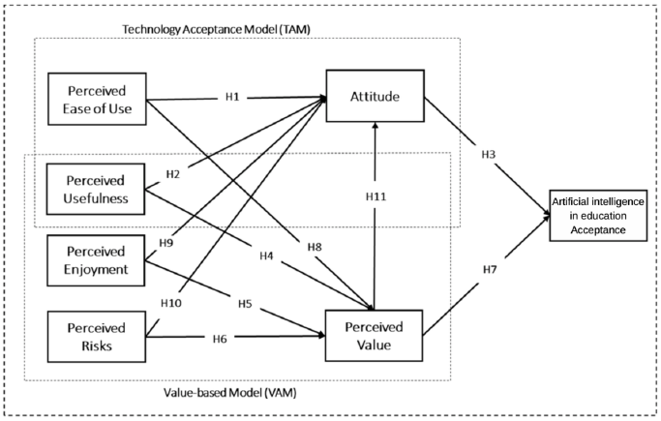

DEMOGRAPHIC PROFILE

Gender
- Male
- Female

Age
• ≤18
• 19-20
• 21-22
• 23-24
• ≥25

Family Income
- Below RM999
- RM1000 – RM4999
- RM5000 – RM9999
- Above RM10000

Please indicate to which extend you agree with the statement on the scale from 1 to 5, where:
1 Strongly disagree
2 Slightly disagree
3 Nether agree nor disagree
4 Slightly agree
5 Strongly agree

Perceived Ease of Use
PEU1: Learning how to use artificial intelligence in education is easy for me.
PEU2: My interaction with the artificial intelligence in education is clear and simple.
PEU3: I find artificial intelligence in education easy to use for my learning.
PEU4: It is easy for me to become skilled in using artificial intelligence in education.

Perceived Usefulness
PU1: I find artificial intelligence in education useful for performing my learning tasks.
PU2: Using artificial intelligence in education increases my chances of achieving high performance.
PU3: Using artificial intelligence in education helps me accomplish my learning tasks effortlessly.
PU4: Using artificial intelligence in education increases my productivity.

Perceived Enjoyment
PE1: I have fun interacting with artificial intelligence in education.
PE2: Using artificial intelligence in education provides me with a lot of enjoyment.
PE3: I enjoy using artificial intelligence in education for learning.

Perceived Risk
PR1: I feel unsafe when using artificial intelligence in education.
PR2: I am worried that personal information would be leaked when using artificial intelligence in education.
PR3: I am worried about personal information suffering from unauthorized use when using artificial intelligence in education.

Attitude
A1: Using artificial intelligence in education makes learning more interesting.
A2: Using artificial intelligence in education has a positive influence on my learning.
A3: I think learning with artificial intelligence in education is valuable.
A4: I think it is a trend to use artificial intelligence in education in learning.

Perceived Value
PV1: I believe that using artificial intelligence in education is a valuable idea.
PV2: Artificial intelligence in education is advantageous to me due to the general amount of effort I need to put in.
PV3: Artificial intelligence in education is worthwhile for me based on the amount of time I need to spend.
PV4: Artificial intelligence in education provides me with good value in general.

Artificial intelligence Acceptance
AIA1: I look forward to using artificial intelligence in education in my learning.
AIA2: I intend to use artificial intelligence in education in my future learning.
AIA3: I plan to use artificial intelligence in education in my future learning.
AIA4: I think using artificial intelligence in education will increase my future learning.
AIA5: I support the adoption of artificial intelligence in education in higher education.

