UML class diagram:

|  |
| --- |
| Employee |
| -department: str  -jobTitle: str  -basicSalary: int |
| Beth yw Diagram UML: Gan gynnwys Saeth a Symbol Diagram UML+displayDetails(): str |

|  |
| --- |
| Person |
| -id: int  -name: str  -dob: datetime  -age: int  -passportDetails: str |
| +displayDetails(): str |

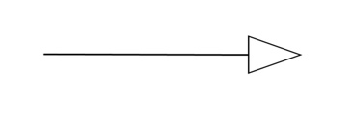

|  |
| --- |
| Manager |
| -salespersons: List[Salesperson] |
| +addSalesperson(salesperson: Salesperson)  +removeSalesperson(salesperson: Salesperson)  +displayDetails(): str |

|  |
| --- |
| Salesperson |
| -sales: List[Sale] |
| +addSale(sale: Sale)  +calculateCommission(): int  +displayDetails(): str |

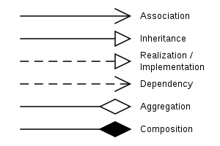



|  |
| --- |
| Car |
| -id: int  -name: str  -price: int  -type: str  -fuelCapacity: int  -maxSpeed: int  -color: str |
| +displayDetails(): str |

|  |
| --- |
| Sale |
| -salesperson: Salesperson  -car: Car  -salePrice: int  -saleDate: datetime.date |
| +__str__(): str |



|  |
| --- |
| Application |
| -employees  -cars |
| +showEmployeeDetails  +showCarDetails  +showSalesDetails |