Teacher Assist: Automating OBE Compliance, Accreditation Support and Learning Outcome Management Using Artificial Intelligence

Abstract
Outcome-Based Education requires teachers to manage assessment generation, learning outcome mapping, marksheet analysis, gap identification, and student improvement tasks in a structured and measurable way. The key outcomes of Outcome Based Education are the tasks for teachers in relation to generating assessments, mapping learning outcomes, analyzing marksheets, identifying gaps and designing tasks for student improvement, all of which must be done in a structured, measurable and systematic manner. In most universities, however, these activities remain manual, using documents and spreadsheets, which lead to more workload, take more time and can lead to less uniformity in academic assessments. This paper introduces Teacher Assist, an academic support system and assessment management system with AI capabilities that streamlines and enhances the core workflows of major OBE tasks for teachers, chairperson, admins and students. The proposed approach involves the document processing, retrieval of the AI assistant, and structured academic data, which will create quizzes, assignments, mid-term papers, and final exam questions from the uploaded course material. Furthermore, it provides for CLO based gap analysis, conversion of academic records, assignment of tasks to students, and monitoring of teacher-wise and course-wise academic performance on HOD level. Teacher Assist has been created to offer a structured and user-friendly approach to minimizing repetitive academic tasks and enhance learning outcome control. The system enables teachers to create an efficient assessment process, identify weak CLOs, facilitate academic decision making with a centralized platform, assign task to improve the CLOs to students, etc. The proposed system shows the potential of an integrated AI-based system to streamline academic workflows, facilitate OBE implementation, and ensure that the course content aligns with assessment and student performance in institutions.
Keywords: Outcome-Based Education, CLO Mapping, Bloom’s Taxonomy, NLP, Learning Outcome Management
- Introduction
In higher education, measuring student learning outcomes is of great importance and has been gaining momentum in recent years from the implementation of Outcome Based Education (OBE). In Universities, particularly in Pakistan, the responsibility of developing the tests lies with the teachers, matching the questions to Course Learning Outcomes,

analyzing the outcome of the test and keeping the academic record for the quality assurance and accreditation process in universities.
In case of OBE in Pakistani Universities, teachers need to be constantly involved in the CLO mapping, development of assessment, analyze marksheet and identify weak students. Another duty of the teacher is to look at the students' marks after the assessment, and define the learning gaps and the students who show poor performance in some CLO. If the class size is large, or multiple courses are being processed at once, it will be more challenging. Similarly, the Head of Department (HOD) would need to have a record of the academic performance of the teachers, courses as well as of the HOD himself/herself; however, manual records are not very helpful in providing a good snapshot of academic performance.
Previously several aspects of curriculum mapping have been discussed, including aspects of the evaluation and management of learning outcomes. In higher education, Arafeh [1] suggested using a curriculum mapping approach to get to know the structure and alignment of the curriculum in courses. Chowdhury et al. [2] discussed the need of automation in academic assessment system and evaluation in a bachelor course. Zaki et al. [3] elaborated on the automation of education programs mapping to ensure their accurate evaluation, while Jayalath et al. [4] spoke about generative AI's contribution to scaling curriculum mapping and curriculum analytics. Furthermore, Akber et al. [5] pointed out that students' achievement is affected by OBE, suggesting the importance of outcome measurement in education.
While these studies have played a significant role in mapping a curriculum and evaluating OBE, there are many systems available today that can't offer one-stop shopping for assessment generation, CLO tracking, gap analysis and academic monitoring. Some institutions have teachers creating their own assessment, manually tracking CLOs, and manually marking and identifying students that still need to improve even if not using AI for marking purposes. This gives rise to the need for a system which can decrease manual efforts and facilitate the implementation of OBE in real application in the university setting.
To meet this demand, the idea of Teacher Assist a system powered by AI for academic support for teachers, HODs, administrators, and students—is proposed. Assessment can be generated from uploaded content, a gap analysis can be carried out based on the course level objective, the marksheet can be transformed to another format, those who are weak students can be identified, and improvement activities can be assigned. The key goal of Teacher Assist is to minimize manual workload, enhance uniformity in academic documentation, and facilitate informed judgments by both educators and HODs within the university setting, by integrating AI with OBE-driven workflows.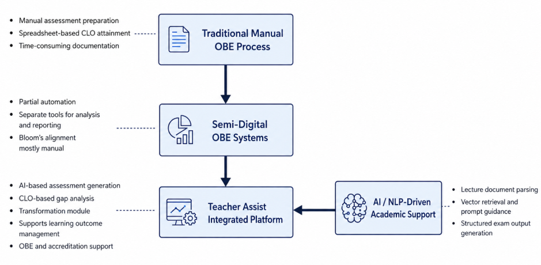
Figure 1. Process Flow for OBE System Design
The conceptual framework of the proposed Teacher Assist system is given in Figure 1. The traditional manual OBE processes are depicted and then moved towards semi-digital OBE systems, and then to an integrated AI-supported academic platform. Teacher Assist integrates the four components of AI-based assessment generation, CLO-based gap analysis, transformation support and learning outcome management in a single workflow. The support layer helps users with lecture parsing, finding vectors, suggestions for prompts, and assessment output in a structured format, with the help of AI/NLP features. This frame demonstrates the following benefits that will be provided in this proposed system: Academic support of OBE, Documentation for academic purposes for accreditation.

- Literature Review

A. Outcome-Based Education and CLO/GA Mapping
Outcome Based Education (OBE) is driven by the learning outcomes to be measured, which are then used to drive the teaching, assessment, and performance evaluation. In higher education, curriculum mapping is applied to structure learning, to sequence topics and to ensure that learning activities contribute to the learning outcomes. Arafeh [1] highlighted the importance of using curriculum mapping as a useful tool for supporting curriculum alignment, but this type of curriculum mapping primarily helps to organize the course and does not calculate the attainment or learning gap of students.
Chowdhury et al. [2] came up with an automated assessment and evaluation procedure for a bachelor program, demonstrating the possibility of computing the CLO and GA in a structured manner. Likewise, Shaheen [3] and Zaki et al. [4] studied data-driven and NLP-based approaches to learning outcome mapping. The studies indicate that the process of OBE can be automated; however, most of the existing approaches are still driven by mapping or calculating attainment, and do not provide a comprehensive teacher-centered academic process.

B. AI-Based Assessment Generation Using LLMs and RAG
The recent advancement of LLMs and RAG has opened up opportunities for automatic generation of academic assessment. The RAG framework by Lewis et al. [12] merges retrieved document context with a generative model to achieve more precise and relevant responses. What this means for Teacher Assist is that the questions for the assessment need to be formulated based on the lecture content uploaded, and not on general AI content.
Using LLMs to create tests can save time and allow test writers to release their creativity, as Fiesta et al. [16] presented, and structuring the prompts can help produce a set of academically relevant test questions, as Elallam et al. [17] showed. Imran and Almusharraf [20] also pointed out the educational opportunities that Google Gemini offers in creating quizzes, customized learning plans, and graded assessment content. These research studies help to provide the foundation for how AI can be applied to TeachAssist to create quizzes, assignments, mid-term papers and final exams from course materials.

C. Bloom’s Taxonomy in Assessment Design
Bloom's Taxonomy has been utilized in the area of assessment design in the context of OBE due to the use of classification of questions based on cognitive levels of (Remembering, Understanding, Applying, Analyzing, Evaluating, and Creating) [5]. Manual assessment preparation may involve teachers to set the levels of Bloom themselves, causing the blurring of assessment question structure and problems related to employing appropriate levels regarding the alignment of question, CLO, and assessment objectives.
The use of AI-powered assessment generation can enhance this process by using structured prompts to assist with creating assessments that follow a specific set of Bloom's levels. Elallam et al. [17] validated the fact that with proper guidance, questions generated by LLM can be related to various cognitive domains in the Bloom's taxonomies. With regard to Teacher Assist, Bloom's Taxonomy helps to facilitate the generation of more well-balanced and outcome-based assessments with control over the type/mode and level of cognition of the assessment.

D. CLO-Based Gap Analysis and Student Performance Evaluation
There are a number of key components of OBE, one of which is CLO-based gap analysis to determine if students are learning poorly in certain CLOs and if there are any teachers that would like academic support in certain parts of their teaching. OBE systems have basically computed attainment value or created reports post manual-mark entry, up to date. The mapping approaches based on NLP, e.g., approach developed by Zaki et al. [4] can significantly decrease manual mapping work, but still cannot fully cover the whole mapping process from marksheet analysis to marksheet analysis of weak CLOs and remedial tasks assignment.
Learning analytics research also serves as a basis to implement data driven systems to detect student performance issues. AI prediction of learning outcomes and learning analytics could aid in delivering timely feedback to boost students' learning outcomes, as demonstrated by Ouyang et al. [22]. In an OBE setting, Teacher Assist takes this concept further by writing computer-alised marksheets and question papers, computing CLO achievement levels based on teachers' benchmarks, pinpointing students who are not performing up to the required level and students who have not achieved the CLOs defined by the teacher, and recommending targeted tasks to help students improve.

E. Academic Workflow Automation and Accreditation Support
The reason why Academic workflow automation is required is that teachers maintain assessment papers, their CLO records, marksheets, attainment calculations, and accreditation papers in separate documents and spreadsheets. Many automation systems need the manual entry of information and dealing with academic records separately, but Chowdhury et al. [2] demonstrated how automation can support assessment and evaluation. This results in repeated tasks and potential inaccuracies in documentation.
The research on generative AI in higher education also indicates that there is a need to re-think assessment and documentation processes [23], if institutions want to be flexible and adaptable with the growing prevalence of generative AI in the academic setting. To meet this requirement, Teacher Assist provides an integrated solution to create, customize, and transform academic records, offers CLO-based gaps analysis, reviews and advises students on academic task performance and allows for monitoring by the Higher Education Director (HOD). This allows the system to be used by teacher, for institutional quality assurance, and for institutional accreditation support.

F. Summary of Related Work
From the literature reviewed, it is seen that the existing systems generally cater to a single aspect of the academic process. There are some studies that involve a curriculum mapping approach, some that involve calculating attainment scores, some that involve mapping onto curriculum CLO/GA by means of AI or NLP, and some that involve generation of AI-based assessments. Few, however, want to consider integrating these features into an actual platform that will help the teachers, HODs and admins, and students to work practically and efficiently together in the classroom. The mix of LLM (LLM/RA) based assessment generation, support for Bloom's level, CLO based gaps and improvement tasks, mark sheet/Document Transformation and academic monitoring comes together in one OBE focused system to fill in part of this void by envisaging being taught by an Assistant. Teacher Assist bridges part of this void by enabling the envisioning of being taught with the assistance of an LLM (LLM/RA), support by Bloom's level, CLO based gap and improvement tasks, mark sheet/Document Transformation and academic monitoring within one OBE oriented system.

Table 1. Comparison of TeachAssist with Prior OBE and AI-Based Systems
System / Study | CLO/GA Mapping | Assessment Generation | Bloom’s Support | Gap Analysis | AI / NLP
Arafeh [1] | ✓ | ✗ | ✗ | ✗ | ✗
Chowdhury et al. [2] | ✓ | ✗ | ✗ | Partial | ✗
Shaheen [3] | ✓ | ✗ | ✗ | ✗ | Decision Tree
Zaki et al. [4] | ✓ | ✗ | ✗ | ✗ | NLP / Cosine
Rojas et al. [16] / Elallam et al. [17] | ✗ | ✓ | ✓ | ✗ | LLM
TeachAssist (Ours) | ✓ | ✓ | ✓ | ✓ | LLM + RAG

Table 1 summarizes that most prior systems support either outcome mapping, attainment calculation, or AI-based question generation separately. TeachAssist combines these functions into a single workflow, which makes it more suitable for OBE-based academic management and accreditation support.

- Methodology
A. System Design Approach
This system is built solve the problem that many of the teachers encounter, that they have to manually do a lot of work when making academic results or assessing the student reports An educational organization that follows outcome based education. This system not only supports the teachers but also supports head of department and administrators. The methodology adopted in this work combines software engineering practices, modular system design, database-driven architecture, and artificial intelligence integration to solve real academic workflow problems.
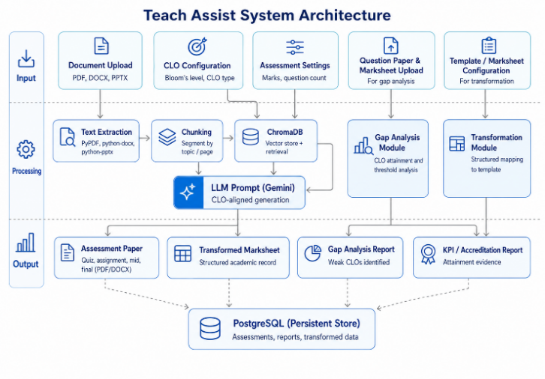
Figure 2. System Diagram for Teacher Assist
B. System Architecture and Workflow
With reference to Figure 2, the AI educational assessment system in this study adopts a three-layer architecture consisting of an input layer, a server layer, and an output layer. This section sorts out the tasks of the first two layers along the data flow, while content related to the output layer will be elaborated in subsequent discussions. The input layer is operated by teachers, who are required to upload lecture handouts, set the assessment type, select the relevant Bloom's Taxonomy level, upload documents to be converted, and submit the exam score sheet used for gap analysis. The server layer sequentially completes the following tasks: identity verification, file storage, integration with LLM, conversion of assessment materials, generation and storage of assessment content, and provision of export services.

C. Stakeholder and Role Identification
In the first phase of the education support system built for this study, we first completed the foundational work of identifying all stakeholders, including students, teachers, department heads, and administrative staff, and clarifying the system role of each actor. We then sorted out the functions for the teacher-side: teachers can generate assignments, quizzes, and exams, input grades via the transform module, analyze performance gaps by integrating course learning outputs, and push supplementary learning tasks to students who fail to meet the standards of specific CLOs.

D. Requirement Analysis
Besides functional requirements, non-functional requirements like responsiveness, usability, modularity, security of credentials, consistency of user interface etc. were also considered.

E. Database Design and Academic Data Management
This study carried out the development of a campus management system. The database design module belonging to this system constructed multiple relational data tables, and collected 8 categories of system data to cover all scenarios of campus operations. The student table stores 7 fields of student information, while the teacher table stores 4 items of business information.
F. Technology Stack and Development Tools
In the methodology of this research project, the technology stack is organized by functional layers. The core architecture layer specifies a full-stack toolset covering front-end development, back-end development, storage, hosting, and AI invocation. Multiple third-party Python libraries are adopted to process multi-format office documents. All technologies are aligned with their corresponding application scenarios, and a downloadable PDF file is ultimately generated.

- Implementation :
A. Modular Implementation Strategy
The system was adopted in a “modular” approach, developing, testing and improving each major system separately before integrating it into the system. This was useful because there were a number of roles and processes in the realm of the project.

B. Authentication and Role-Based Access Control
The first module to be implemented was the authentication system which allowed for the separate login for teacher, student, HOD and admin users. Each role is only allowed to access what he/she can in the system. For instance, students have access to their tasks only and teachers have access to academic records and assessment related features only.

C. Teacher Profile and Course Setup
The teacher profile module is created to enable the teacher to handle their teaching record in a well-structured manner. This module is used to configure the semester, batch, department, section, course code and threshold percentage, in which a teacher is teaching a specific course. These records are then shared with other modules of the system, especially the transform and gap analysis modules.

D. AI-Based Assessment Generation Implementation
The generation module was then integrated and the teachers were able to upload course material files and generate prompts that they could use on any AI tools that would generate highly structured and course relevant assessments. Besides, the teachers will also have access to an in-built system exam generator by leveraging Gemini's AI model via an API key. During the teacher's upload of the file, the parser is triggered depending on the detected file type. For each format, text is extracted from the new document using python libraries. PDF files are parsed using a PDF parsing library, Word files are read from using a document parsing library, and PowerPoint files are parsed, one page at a time to retrieve the text. For some cases, the image content from a file is also taken into account in the processing. Hybrid method of processing content for the system. For some generation processes, they use a RAG-like method, dividing documents into chunks and utilizing Chroma DB to fetch content from the documents. In other use cases, the file content is simply extracted and in other workflows, without having a complete retrieval loop, is passed to the AI model. The course module has been designed to accommodate new resources such as PDFs, PowerPoint presentations and other resources used for prompt and paper generation which need to be processed.
E. Transformation Module Implementation
Another important area of implementation was the transform module. This module was developed to automate the procedure of creating the transcript which enables teacher to choose the registered course and automatically load the list of students pertaining to the selected course. Then, the teacher can use a more systematic approach to filling in the structure and the marks and the system will generate a structured record of the marks on a marksheet that can then be used again.

F. Gap Analysis and KPI Evaluation Implementation
The gap analysis module was then designed to analyze question papers along with the marksheet simultaneously to identify the weaker CLOs and understand if the student's scores were below the set threshold. This turned the system into more than a marks management system, it also provided support for the diagnosis of performance and academic intervention.

G. Student Task and Review Implementation
In addition, a student task module was used to deal with the poor performance. In this module teachers can create and share questions directly from that specific CLO where their student is struggling. These tasks will be available in each student's dashboard and can be responded to with a text response, or a file upload. Once submitted the teacher receives the submission in the notification and review interface, and is able to view and grade it as pass/fail and provide feedback and marks.

- Results
To demonstrate the working of the proposed TeachAssist system, the Digital Image Processing course was used as an example case study. The course chosen was “Digital Image Processing” (CSC-321) and the posted material was the course material from this class. The full workflow of the system has been demonstrated with this example, which involved the development of a marksheet based assessment, mapping of CLOs, analysis of the marksheet, and evaluation of the student performance using CLO gap analysis.

A. Assessment Generation Results
The Generate module was piloted with the Digital Image Processing course, CSC-321. The teacher added the input source of lecture file “Lecture Series 1-Spring 2025.ppt”. This file was used by the system to create assessment items out of real course material.
For this module, the teacher has chosen the type of the Mid-Term assessment. The assessment had four of the theory based questions, each with five marks. Multiple choice questions were not allowed for and short, descriptive, and case-study questions were chosen. In addition, Bloom's taxonomy levels were also assigned by the teacher; L1 Remember, L2 Understand, and L5 Evaluate.
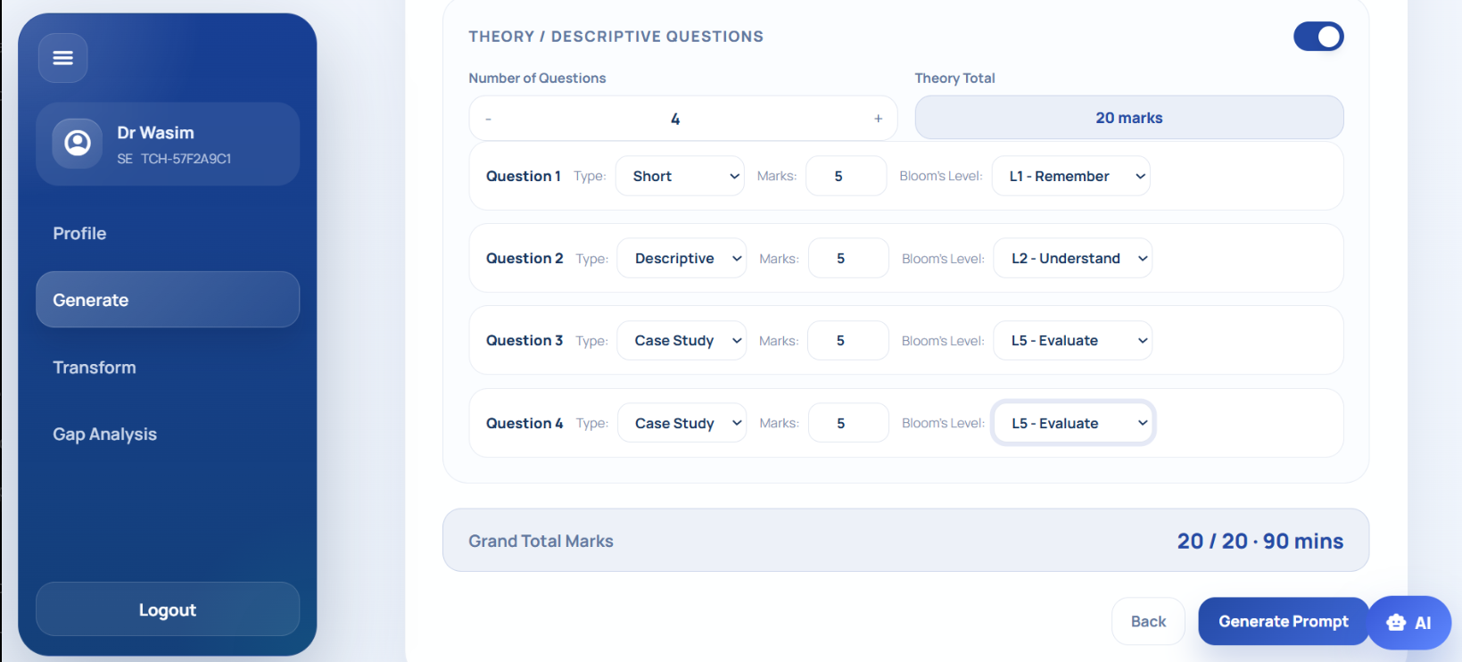
Figure 3 Assesment Generation

The system configured and created an AI prompt from the file uploaded, selected the question type, mark distribution, Bloom's level and the exam settings. A midterm paper was then created using Digital Image Processing by the system. The questions that were created ranged from computer vision, medical image analysis, computer graphics, 3D modeling, etc. The results also presented are CLO mapping including CLO-3 and CLO-4, which validates that the output assessment is aligned with the Course Learning Outcomes.

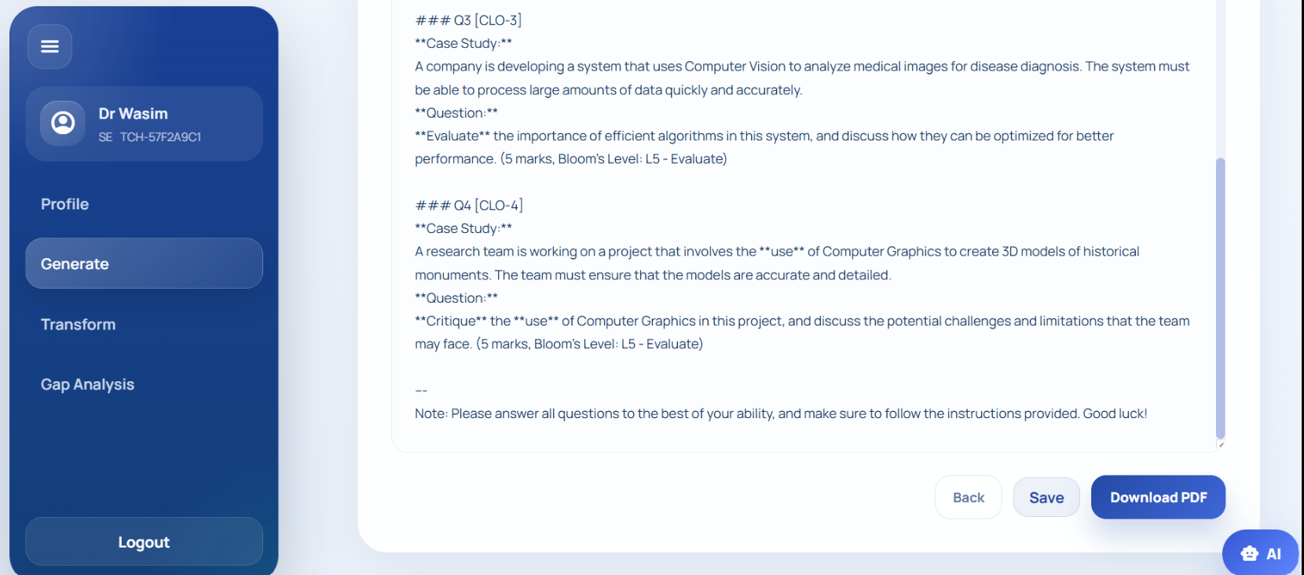
Figure 4 generated prompt
C. Gap Analysis and KPI Evaluation Results
The Gap Analysis module was tested by uploading two files: the Digital Image Processing question paper in PDF format and the student marksheet in Excel format. These files were used to compare student marks with the question-wise CLO mapping.
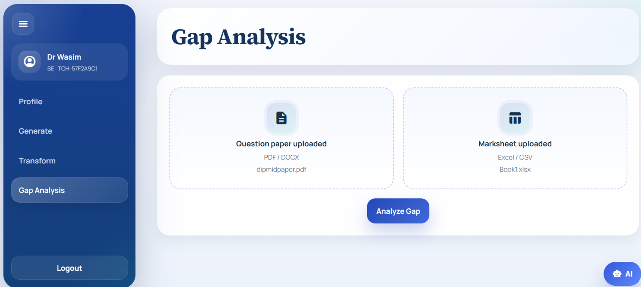
Figure 5 question paper and marksheet
The system applied a 50% threshold to classify student performance. Students scoring below the threshold were marked as weak, while students scoring equal to or above the threshold were marked as passed.
The result was displayed in two forms: a question-wise performance graph and a student-wise performance table. The graph showed passed and below-threshold percentages for each question. The result showed that students performed better in Q1, while Q3 and Q4 had higher learning gaps.
The student-wise table used color indicators to make the result easy to understand. Red showed weak performance, yellow showed near-threshold performance, green showed pass, and dark green showed strong performance. This helped the teacher quickly identify weak students and the specific CLOs where improvement was needed.
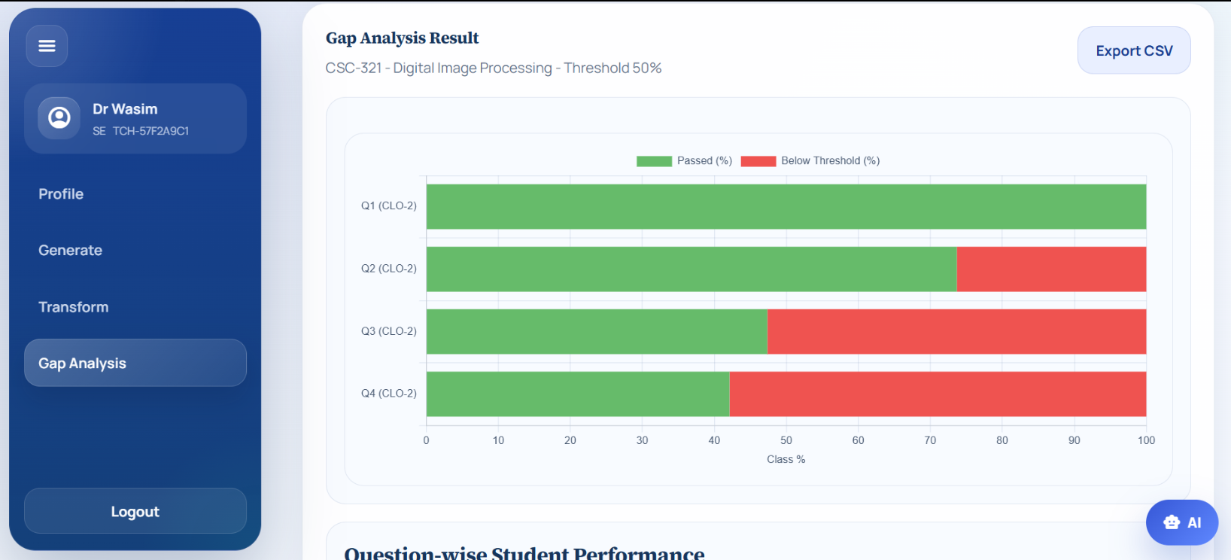
Figure 6. Visual Representation of Analysis Respective To Threshold
D. Recommendation and Remedial Task Results
The Recommendation Engine has been used after the gap analysis result has been obtained. The system detected the weak students, and the questions in which they failed to reach the threshold level, based on the student-wise and CLO-wise performance.
The engine recommended improvement tasks based on the weak CLOs, after determining the learning gaps. For instance, if a student was weak in Q3 or Q4, the system associated the weakness with the CLO and proposed practice/revision tasks to address that specific CLO.
This module supports teachers to limit manual analysis and task planning. The teacher can directly see which student(s) need support and give them relevant improvement activities instead of examining each student's marking report individually. This not only speeds up the feedback process, but also targets it more accurately to the outcome of the learning. 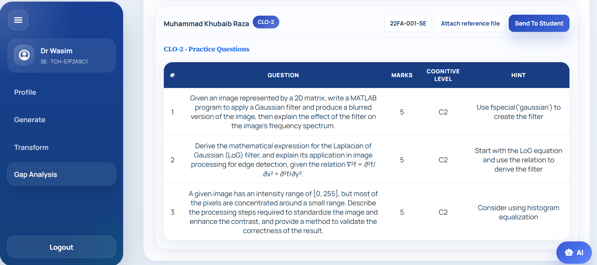
Figure 7. Recommendation For Students For Weak CLOS

F. Document Transformation Results
The Marksheet module was used to prepare the marksheet for the generated Digital Image Processing assessment. The teacher entered course details such as course name, course code, assessment type, batch, section, semester, and total marks.
The marksheet was structured question-wise. Each question was mapped with a specific CLO, such as Q1 with CLO-1, Q2 with CLO-2, Q3 with CLO-3, and Q4 with CLO-4. The teacher then entered student marks against each question. This created a structured dataset for analyzing student performance according to CLOs.

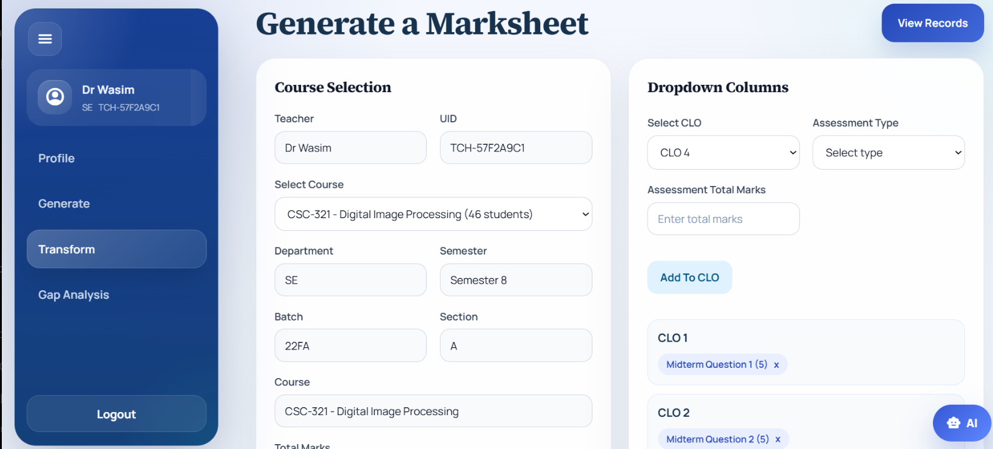
Figure 8. Transformation Module to Generate Marksheet

- Conclusion
In this research, a system named Teacher Assist which is an academic automation system based on artificial intelligence for help to the implementation of the Outcome Based Education for Higher Education Institutions is presented. The system was developed to address some of the issues teachers and administrators face with manual CLO mapping, tracking KPI, making assessments and preparing reports.
The proposed solution is to integrate AI, NLP, RAG, and cloud technologies into one platform that will allow automating critical academic tasks. The system enhances the effectiveness, reduces manual work, increases the reliability of data reporting and helps fulfill the quality assurance needs of the institutions.
The system was tested and the feedback from the faculty was received to prove its capability to develop assessment items based on Bloom's Taxonomy, conduct gap analysis for CLOs and generate meaningful KPI reports for academic monitoring and continuous improvement. The modular client-server design will also allow the system to be scaled up and configured to accommodate additional improvement.

- References

[1] Arafeh, S. (2015). Curriculum mapping in higher education: a case study and proposed content scope and sequence mapping tool. Journal of Further and Higher Education, 40(5), 585 611. https://doi.org/10.1080/0309877X.2014.1000278.

[2] M. A. Chowdhury, K. K. S. Chisty, H. Tushar, K. M. F. Ahmed, and S. A. Waliullah, “Automating assessment and evaluation for a bachelor’s degree program,” International Journal of Evaluation and Research in Education (IJERE), vol. 12, no. 4, pp. 2037– 2044, Dec. 2023, http://doi.org/10.11591/ijere.v12i4.25479

[3] N. Zaki, S. Turaev, K. Shuaib, A. Krishnan, and E. Mohamed, “Automating the mapping of s to using for accurate educational program evaluation,” Education and Information Technologies, vol. 28, pp. 16723–16742, May 2023, https://doi.org/10.1007/s10639-023-11877-

[4] Jayalath, Vimukthini & Barthakur, Abhinava & Dawson, Shane & Tingey, Joanne & Crase, Lin & Kovanovic, Vitomir. (2025). Scaling Curriculum Mapping in Higher Education: Evaluating Generative AI’s Role in Curriculum Analytics. https://doi.org/10.1007/978-3-031-98414-3_21

[5] Akber, s & Roy, Ashutosh & Saha, Professor Gopal. (2023). IMPACT OF OUTCOME-BASED EDUCATION (OBE) ON LEARNERS' PERFORMANCE IN BUSINESS COURSES. International Journal of Professional Business Review. https://doi.org/10.26668/BUSINESSREVIEW/2023.V8I8.2394

[6] Okoye, K., Arrona-Palacios, A., Camacho-Zuñiga, C. et al. Towards teaching analytics: a contextual model for analysis of students’ evaluation of teaching through text mining and machine learning classification. Educ Inf Technol 27, 3891–3933 (2022). https://doi.org/10.1007/s10639-021-10751-5

[7] Abu Zohair, L. M. (2019). Prediction of Student’s performance by modelling small dataset size. International Journal of Educational Technology in Higher Education. https://doi.org/10.1186/s41239-019-0160-3

[8] Ngoc, P.P., Do Thi, P., Xuan, L.D. (2026). Automated Content Generation and Distribution. In: Chien Thang, P., Prasanth, A. (eds) AI-Assisted Journalism and Media: Opportunities and Challenges. Studies in Computational Intelligence, vol 1277. Springer, Cham.
[9] Chen, J., Lu, H., Zhou, H., & Zhou, Y. (2019, August). ExGAsration on curriculum teaching based on OBE and AI. In 2019 10th International Conference on Information Technology in Medicine and Education (ITME) (pp. 385-389). IEEE. 10.1109/ITME.2019.00093
[10] Shaheen, M. (2023). Decision tree for GAs of undergraduate computing program based on CLO of computer programming. Interactive Learning Environments, 31(4), 2452-2470. https://doi.org/10.1080/10494820.2021.1890621
[11] V. R. Tewari and M. N. Tiwari, “Impact assessment of outcome based approach in engineering education in India,” Procedia Computer Science, vol. 172, pp. 791-796, 2020, doi: 10.1016/j.procs.2020.05.113. https://www.sciencedirect.com/science/article/pii/S1877050920314423
[12] P. Lewis, E. Perez, A. Piktus, F. Petroni, V. Karpukhin, N. Goyal, H. Kuttler, M. Lewis, W.-t. Yih, T. Rocktaschel, S. Riedel, and D. Kiela, “Retrieval-Augmented Generation for Knowledge-Intensive NLP Tasks,” in Advances in Neural Information Processing Systems (NeurIPS), vol. 33, 2020, pp. 9459-9474. https://arxiv.org/abs/2005.11401

[13] Google, “Gemini API Reference,” Google AI for Developers. https://ai.google.dev/api.

[14] Render, “Web Services,” Render Documentation. https://render.com/docs/web-services

[15] B. S. Bloom, M. D. Engelhart, E. J. Furst, W. H. Hill, and D. R. Krathwohl, Taxonomy of Educational Objectives: The Classification of Educational Goals, Handbook I: Cognitive Domain. New York, NY, USA: Longmans, Green, 1956. 10.4236/ce.2014.518180

[16] Rojas, M.P., et al., "Automated Test Creation Using Large Language Models: A Practical Application," Applied Sciences, vol. 14, no. 19, p. 9125, MDPI, 2024. https://www.mdpi.com/2076-3417/14/19/9125

[17] Elallam, M., et al., "Automated Educational Question Generation at Different Bloom's Skill Levels using Large Language Models: Strategies and Evaluation," arXiv preprint arXiv:2408.04394, Aug. 2024. https://arxiv.org/abs/2408.04394
[18]S. Es, J. James, L. Espinosa Anke, and S. Schockaert, "RAGAs: Automated Evaluation of Retrieval Augmented Generation," in Proceedings of the 18th Conference of the European Chapter of the Association for Computational Linguistics (EACL): System Demonstrations, pp. 150–158, Mar. 2024. https://aclanthology.org/2024.eacl-demo.16/

[19] P. Lewis, E. Perez, A. Piktus, F. Petroni, V. Karpukhin, N. Goyal, H. Küttler, M. Lewis, W. Yih, T. Rocktäschel, S. Riedel, and D. Kiela, "Retrieval-Augmented Generation for Knowledge-Intensive NLP Tasks," in Advances in Neural Information Processing Systems (NeurIPS), vol. 33, pp. 9459–9474, 2020. https://arxiv.org/abs/2005.11401

[20]M. Imran and N. Almusharraf, "Google Gemini as a Next Generation AI Educational Tool: A Review of Emerging Educational Technology," Smart Learning Environments, Springer, 2024. https://link.springer.com/article/10.1186/s40561-024-00310-z

[21] Ouyang, F., Wu, M., Zheng, L., Zhang, L., and Jiao, P., "Integration of Artificial Intelligence Performance Prediction and Learning Analytics to Improve Student Learning in Online Engineering Course," International Journal of Educational Technology in Higher Education, vol. 20, no. 4, Springer, 2023. https://doi.org/10.1186/s41239-022-00372-4
[22]Chiu, T. K. F., et al., "A Scoping Review on How Generative Artificial Intelligence Transforms Assessment in Higher Education," International Journal of Educational Technology in Higher Education, Springer, 2024. https://doi.org/10.1186/s41239-024-00468-z
[23] Lan, Y., et al., "Survey of Natural Language Processing for Education: Taxonomy, Systematic Review, and Future Trends," arXiv preprint arXiv:2401.07518, 2024. https://arxiv.org/abs/2401.07518

