1- VLAN Table :
Branch | VLAN Number | VLAN Name | IP Address / Prefix | Subnet Mask | No. usable Host
Muscat | 10 | Staff | 192.168.10.0 /25 | 255.255.255.128 | 126
Muscat | 20 | Customer Service | 192.168.10.128 /26 | 255.255.255.192 | 62
Muscat | 88 | Native / Management | 192.168.88.0 /27 | 255.255.255.224 | 30
Nizwa | 30 | HR | 192.168.20.0 /26 | 255.255.255.192 | 62
Nizwa | 40 | Sales | 192.168.20.64 /27 | 255.255.255.224 | 30
Nizwa | 99 | Native / Management | 192.168.99.0 /27 | 255.255.255.224 | 30
Salalah | 50 | Operations | 192.168.30.0 /26 | 255.255.255.192 | 62
Salalah | 60 | Support | 192.168.30.64 /27 | 255.255.255.224 | 30
Salalah | 77 | Native / Management | 192.168.77.0 /27 | 255.255.255.224 | 30
2- Network Topology (Muscat, Nizwa, Salalah) :
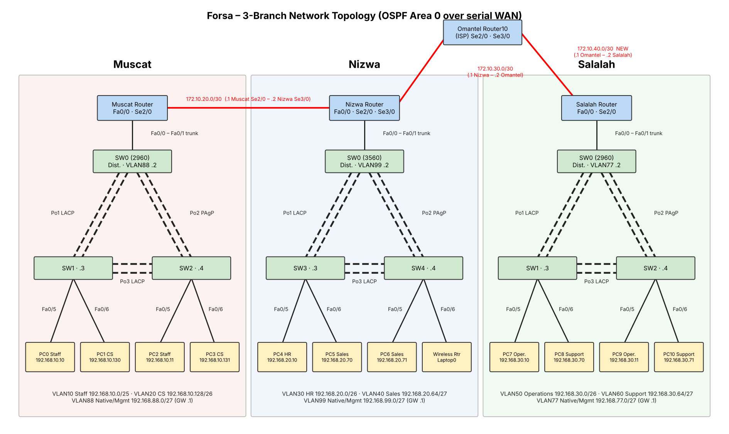
WAN: Muscat–Nizwa 172.10.20.0/30, Nizwa–Omantel 172.10.30.0/30, Omantel–Salalah 172.10.40.0/30 (new). All routers run OSPF area 0.
Router gateways use the first usable address of each VLAN subnet (router-on-a-stick sub-interfaces on Fa0/0). Management VLANs are /27 (no /24 used).
Port-Channel 1 and 3: LACP; Port-Channel 2: PAgP (same design in every branch).

