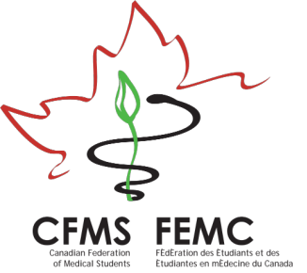
Student Initiative Grant Program

Project Funding Application

Supporting local CFMS initiatives

Name(s):

School:

School Address:

Email/Phone:

Date:

Proposed Initiative:

Funding Requested: please provide a detailed budget on page 3

Eligibility Criteria:
- Enhancement of the educational experience of Canadian Medical Students
- Enhancement of the Canadian Healthcare System
- Enhancement of your local or national community
- Potential for sustainability
- Practicality and level of planning invested in the proposal, including transparency of an itemized budget

Bonus Point:
- A bonus point will be awarded to proposals for projects that have a significant impact to the CFMS Member Students.

Terms & Conditions:
- Projects will NOT be considered if they have been recipients of the CFMS SIGs in the past 5 years (since the 2010 cycle)
- In order to fund the most projects possible, the CFMS will place cap on the maximum financial amount awarded per SIG at $3000. If the budget is larger than this amount, please submit the budget in full, state that you are requesting the maximum amount, and search for additional funding sources such that your project can be completed with partial funding from the CFMS
- The Student Initiative Grants are NOT meant to fund academic research or travel funding to conferences for individual medical students
- The CFMS cannot use SIGs to support individual travel funding to conferences or research events, or support individual academic medical student research
- The CFMS cannot support events that involve alcohol or gambling
- Applications will be accepted until the entire pool of funding has been exhausted
- All submissions will be assessed at one application deadline: October 23rd, 2015.
- Application review and final decisions will be made in the 8 weeks following the application deadline
- Funds for accepted projects will be disbursed within the subsequent 4 weeks, upon receipt of a project progress update/summary (250 words)
- The CFMS supports activities that involve students from faculties and disciplines outside of the CFMS – however applications for funding should come from CFMS members
- The CFMS will grant retroactive funding for projects within the 2014-2015 academic year upon presentation of receipts
- Requests will be reviewed using a standardized assessment template focusing on interaction between CFMS member schools, CFMS visibility, project feasibility, etc.

Notable Points:
- Successful acquisition of CFMS regional funding does not denote CFMS endorsement of the project
- Members should consult official CFMS policy statements or consult their regional representative for guidance if they have concerns regarding a potentially controversial issue or event
- The CFMS generally supports events inclusive of different viewpoints and attitudes
Project Funding Application

Supporting local CFMS initiatives

Please detail how the initiative proposed above will promote interaction between member schools, enhance the medical student experience, improve the Canadian health care system or help improve your community: (max 500 words)

Due date: October 23rd, 2015
For more information or to submit your completed application,
please contact us at sigs.cfms@gmail.com
CFMS Project Funding Request
Itemized Budget*

Item | Description | Resources | Expenses

Total amount of funding requested (expenses – resources) =

*Please indicate any alternate sources of funding for events such as fundraising, external sponsors, etc.

Due date: October 23rd, 2015
For more information or to submit your completed application,
please contact us at sigs.cfms@gmail.com

