Deliverable No. 4 — Mini Systematic Review
Aly Gallo López · PhD in Deep Tech, FISI-UNMSM · Doctoral Seminar (R6S10714) · Session 4
Thesis project: ChroniCare-AI · Search conducted on October 1, 2026

1. Research Question and Search Strategy
Guiding question: What evidence exists on multimodal-temporal AI architectures, using electronic health record (EHR) data, to predict adverse clinical events in chronic disease (obesity, type 2 diabetes, ¿cardiovascular disease)?
Database: Scopus (Elsevier), with institutional access via SISBIB-UNMSM. A single database was used, per the deliverable's specification.
Search string (advanced search):
TITLE-ABS-KEY (multimodal AND (“electronic health records" OR "electronic medical records" OR EHR) AND prediction AND (diabetes OR obesity OR cardiovascular OR "heart failure" OR hypertension)) AND PUBYEAR > 2019
Result: 174 records exported as CSV on October 1, 2026. The search was not restricted by document type or language; the file includes articles, conference papers, reviews, book chapters, and other types, which were screened in the screening phase. No duplicates were found (0 repeated titles and 0 repeated DOIs).
Inclusion criteria (PICOS):
- Population: adults with obesity, type 2 diabetes, or cardiovascular disease (including heart failure and hypertension) and their complications.
- Intervention: a predictive model combining at least two data modalities, one of which is the EHR or clinical record.
- Comparator: unimodal models, conventional scores, or machine-learning baselines.
- Outcome: prediction of a clinical outcome (disease onset, complication, readmission, or mortality).
- Design: primary study (journal article or conference paper), published since 2020.
Exclusion criteria: reviews, surveys, perspectives, book chapters, editorials, letters, and conference proceedings volumes; other diseases or populations; data limited to public, simulated, or unverifiable benchmarks in the abstract; diagnosis or detection studies with no future event; multimodality reduced to tabular variables or codes.

2. Screening Methodology
Title/abstract screening of the 174 records was performed by a single reviewer. Each record has a decision (Include, Exclude, or Maybe), a coded reason (R1-R6), and, for included records, a domain label. The full record is in the annex Cribado_Scopus_174.xlsx.
Twenty-three records advanced to detailed abstract evaluation. Of these, 10 were selected using a prioritization rule: (1) real clinical data with a described cohort, (2) a clinical outcome in a target disease, (3) distinct, clearly described modalities, and (4) validation information. The other 13 met the criteria and are listed in Appendix A.
Table 3 data come from the abstracts indexed in Scopus. No full-text extraction or formal risk-of-bias assessment was performed; this is declared as a limitation in Section 6.

3. PRISMA 2020 Flow Diagram
The diagram was generated using the official tool (estech.shinyapps.io/PRISMA_2020, database and register template) with the values from Table 1. The numbers satisfy exact consistency: 174 − 151 − 13 = 10.
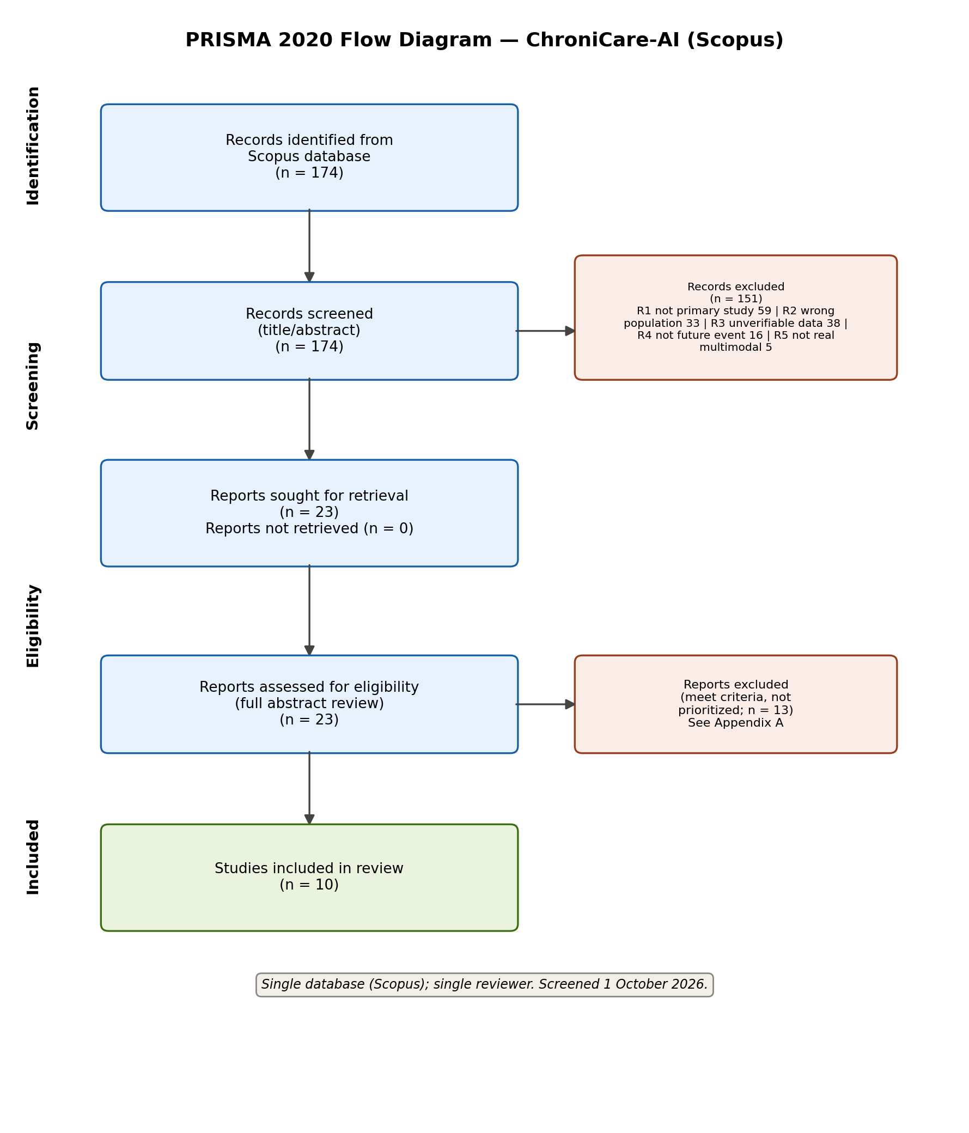
Table 1. Values for the PRISMA 2020 generator.
Phase and cell | n
Identification: records identified through databases (Scopus) | 174
Identification: records identified through registers or other methods | 0
Records removed before screening (duplicates / automation / other) | 0 / 0 / 0
Screening: records screened (title and abstract) | 174
Screening: records excluded | 151
Reports sought for retrieval | 23
Reports not retrieved | 0
Eligibility: reports assessed (detailed abstract) | 23
Eligibility: reports excluded (meet criteria, not selected among the 10) | 13
Inclusion: studies included in the review | 10
Inclusion: reports of included studies | 10
Table 2. Reasons for exclusion at screening (n = 151).
Code | Reason | n
R1 | Not a primary study (review, survey, perspective, chapter, editorial, letter, or conference proceedings volume) | 59
R2 | Population or disease out of scope | 33
R3 | Real data or multimodality not verifiable in the abstract (public benchmark, simulated, or unspecified) | 38
R4 | Diagnosis, detection, or classification; outcome is not a future event | 16
R5 | Not genuinely multimodal (codes or tabular variables only) | 5

4. Included Studies (Qualitative Synthesis, n = 10)
Table 3. Characteristics of included studies. Data taken from abstracts indexed in Scopus.
# | Study | Data and modalities | Population / setting | Outcome | Main result | Main limitation
1 | Sivarajkumar et al. (2026) npj Health Systems, 3(1), 46 | Structured EHR time series + clinical notes; CNN-Transformer encoder, cross-attention, and LLaMA-based decoder | MIMIC-IV (ICU, USA) | Heart failure, T2D, and 30-day readmission | AUROC 0.923 (HF), 0.817 (T2D), and 0.627 (readmission) | Single database (MIMIC-IV); abstract does not describe external validation; readmission discriminates poorly
2 | Li et al. (2025) Int J Cardiovasc Imaging, 41(3), e9936 | Longitudinal chest X-rays + structured EHR; spatio-temporal Transformer (MN-STDT) | MIMIC-IV and MIMIC-CXR; patients with heart failure | In-hospital all-cause mortality | AUC-ROC 0.8620 (multimodal) vs 0.8166 (EHR only) and 0.7479 (X-ray only) | Single US center; in-hospital horizon; abstract does not describe external validation
3 | Gao et al. (2024) J Med Internet Res, 26, e54363 | Admission clinical notes + tabular EHR variables; deep learning with SHAP | MIMIC-III/IV and eICU (208 hospitals, USA); critical heart failure | In-hospital mortality | AUROC 0.838 (internal), 0.849 (prospective), and 0.767 (external); multimodal outperformed unimodal models | Drop in discrimination on external validation; US critical-care patients only
4 | Bhattacharya et al. (2022) Physiol Meas, 43(12), 124004 | 12-lead ECG + clinical EMR variables; joint two-branch fusion | Mayo Clinic Health System (4 sites); 17,356 patients after percutaneous coronary intervention | All-cause mortality, HF hospitalization, and ischemic stroke | AUROC 0.91 at 6 months for mortality (clinical model); fusion outperformed on HF hospitalization and stroke | Fusion did not improve mortality; outcomes evaluated separately; single US health system
5 | Fei et al. (2026) J Am Heart Assoc, 15(12), e048151 | Clinical variables and EHR outcomes + proteomics (Olink); Random Forest with SHAP | UK Biobank; 502,166 participants; risk of hypertensive complications | Cardiac (1232), cerebral (166), and renal (549) complications | AUC 0.73 (heart), 0.83 (brain), and 0.79 (kidney) | Moderate cardiac AUC; UK biobank cohort; abstract does not describe external validation
6 | Khan & Shah (2026) Eng Appl Artif Intell, 181, 115678 | Proteomics + DXA body composition + EHR; TabNet with SHAP | Qatar Biobank, longitudinal cohort | Risk and progression of T2D | TabNet outperformed GBM, SVM, and Random Forest; proteomic markers and visceral adiposity as early indicators | Abstract does not report metrics; single Middle Eastern biobank
7 | Ding et al. (2024) Sci Rep, 14, 20774 | Clinical notes + lab results converted to text; multimodal language model | EHR 2017-2021 from a Taiwanese hospital (1,420,596 notes; 387,392 lab results) | New-onset T2D | AUC > 0.70 | Moderate discrimination; single hospital; both modalities are textual; shares cohort and hospital with Dao et al. (2026)
8 | Dao et al. (2026) Health Inf Sci Syst, 14(1), 7 | Unstructured notes + lab tests + visit time series; LLM and Transformer encoders (CURENet) | MIMIC-III (public) and FEMH (private hospital, Taiwan) | Prediction of the 10 most frequent chronic multi-label conditions | Accuracy > 94% | Accuracy only (no AUROC or calibration in the abstract); outcome is diagnosis, not an adverse event; shares cohort with Ding et al. (2024)
9 | Wang et al. (2025) J Med Internet Res, 27, e78402 | Clinical, laboratory, and imaging variables extracted from the EMR; 33 survival models (best: XGBoost-Cox) with SHAP | 4,459 patients with HFpEF and unstable angina, 7 hospitals in China (derivation n=2923; external validation n=1536) | MACE at 40 months (composite outcome) | External validation: C-index 0.788 and dynamic AUC 0.81; satisfactory calibration; online calculator | Multimodality described as EMR variable groups, without a fusion architecture in the abstract; Chinese population only
10 | Kang et al. (2026) Prog Cardiovasc Dis, 95 | Wearable sleep (Fitbit) + EHR + laboratory; LightGBM and XGBoost ensemble | All of Us (USA); 23,413 adults | Incident cardiovascular disease at 6 years | AUROC 0.748 (non-invasive) and 0.782 (invasive) vs 0.649-0.685 for SCORE2, Framingham, AutoPrognosis 2.0, and Pooled Cohort | Moderate discrimination; abstract does not specify validation type; tabular models without deep temporal architecture

5. Gap Analysis Table
Each gap is supported by citations from the corpus of 10 studies. Statements of the type “no study” refer to what the abstracts describe and should be confirmed in the full text.
Category | Identified gap | Evidence from the corpus | Implication for ChroniCare-AI
Population | No study in the corpus reports a Latin American population, and none targets obesity as the index disease; moreover, 4 of 10 reuse the MIMIC database. | US data: Sivarajkumar et al. (2026), Li et al. (2025), Gao et al. (2024), Bhattacharya et al. (2022), and Kang et al. (2026). United Kingdom: Fei et al. (2026). Qatar: Khan & Shah (2026). Taiwan: Ding et al. (2024) and Dao et al. (2026). China: Wang et al. (2025). MIMIC appears in Sivarajkumar, Li, Gao, and Dao. Obesity appears only as a predictor (DXA visceral adiposity in Khan & Shah; TyG-BMI index in Wang et al.). | ChroniCare-AI contributes Peruvian hospital EHR (Hospital Rebagliati) and addresses obesity within the cardiometabolic spectrum.
Methodological (1) | No study isolates, as a primary test, whether the predictive gain comes from summing modalities or from coordination between them. | Reported comparisons are unimodal vs. multimodal (Li et al.: 0.8620 vs 0.8166 vs 0.7479; Gao et al.), multimodal vs. conventional scores (Kang et al.), or fusion vs. single source (Bhattacharya et al.: fusion did not improve mortality). No abstract contrasts summation/concatenation against cross-attention. | Design with the additive-vs-fusion comparison as the primary confirmatory contrast.
Methodological (2) | External validation and calibration are scarce, and discrimination drops outside the development sample. | Only Gao et al. (2024) and Wang et al. (2025) describe external validation, and only Wang et al. reports calibration. In Gao et al., AUROC drops from 0.849 (prospective validation) to 0.767 (external). Sivarajkumar, Li, Bhattacharya, Fei, Khan, and Ding do not describe it in the abstract. | External validation in an independent Peruvian hospital, with discrimination, calibration, and clinical utility.
Methodological (3) | No study measures Adaptive Capacity as an intermediate preventive construct (physiological response and recovery to a perturbation); all predict disease or the event directly, with no prior functional step. | Only Wang et al. uses a composite (MACE at 40 months). The rest predict single or separate events: in-hospital mortality (Li, Gao); mortality, HF hospitalization, and stroke evaluated separately (Bhattacharya et al.); cardiac, cerebral, and renal complications evaluated separately (Fei et al.). Declared horizons are in-hospital, 30 days (Sivarajkumar et al.), 6 months (Bhattacharya et al.), 40 months (Wang et al.), and 6 years (Kang et al.). None of the 10 operates on a response-recovery phase following a documented perturbation; all proceed directly from a baseline state to the disease outcome. | BSI recovery differential following a documented physiological perturbation, as a functional measure of Adaptive Capacity (primary analysis), with NCD progression as a secondary, distal outcome on the same cohort.
Theoretical / conceptual | No study starts from a prior, integrative, falsifiable biological framework; predictors are chosen by statistical selection, or a single isolated factor is tested. | Wang et al. (LASSO and Boruta), Fei et al. (Cox and LightGBM), and Khan & Shah (integrated selection within TabNet) choose predictors by statistical criteria. Kang et al. tests a single isolated factor (REM sleep). Li, Gao, Sivarajkumar, Ding, and Dao present performance-oriented architecture development. Contrast: the thesis's Biological State Hypothesis, BS = f(SR, M, BP | E), organizes variables a priori and is falsifiable. | ChroniCare-AI anchors its architecture in a prior falsifiable hypothesis.
Technological | The corpus does not include the combination of 3 or more modalities with deep temporal modeling and an adverse-event outcome. | Only 4 of 10 describe 3 or more sources: Khan & Shah (proteomics, DXA, EHR), Dao et al. (notes, laboratory, time series), Wang et al. (clinical, laboratory, imaging), and Kang et al. (wearable, clinical, laboratory). The only one with a deep temporal model on hospital EHR (Dao et al.) predicts diagnoses and reports accuracy. Wang and Kang use classic tabular models, and the deep architectures with adverse events (Li, Gao, Bhattacharya, Sivarajkumar) integrate only two modalities. | Multimodal-temporal architecture with 3 or more real modalities from EHR, laboratory, and signal or imaging data for adverse events.

6. Conclusion and Limitations
The 10 studies support ChroniCare-AI's architectural premise: in most reported comparisons, integrating EHR with other modalities improves discrimination over unimodal models or conventional scores (Li et al., 2025; Gao et al., 2024; Kang et al., 2026), though not in all cases (Bhattacharya et al., 2022, for mortality). Gains are moderate, with AUC between 0.70 and 0.92 across abstracts, and deteriorate outside the development sample (Gao et al., 2024).
No study addresses all of the identified gaps at once: a Latin American population with obesity as the target condition, an explicit test of cross-modality coordination versus additive summation, anchoring in a prior falsifiable biological hypothesis, a functional measure of Adaptive Capacity anchored in physiological response-recovery to a perturbation, with external validation and calibration, and NCD progression as a secondary outcome on the same cohort, plus an architecture with 3 or more real modalities on hospital EHR. That intersection is the thesis's contribution.
Limitations of this review:
- Single database (Scopus) and a single reviewer for screening.
- Screening and extraction are based on title and abstract; full text was not read, and risk of bias was not formally assessed.
- Ding et al. (2024) and Dao et al. (2026) share research group and hospital, and four studies use MIMIC, so the evidence is not fully independent.
- Dao et al. (2026) predicts chronic diagnoses rather than an adverse event; it was included as the only temporal architecture with 3 modalities on hospital EHR.

7. References
Sivarajkumar, S., Zhang, H., Ji, Y., Bilalpur, M., Wu, X., Li, C., et al. (2026). A multimodal generative model for structured and unstructured electronic health records. npj Health Systems, 3(1), 46. https://doi.org/10.1038/s44401-026-00095-y
Li, D., Xing, W., Zhao, J., Shi, C., Wang, F. (2025). Multimodal deep learning for predicting in-hospital mortality in heart failure patients using longitudinal chest X-rays and electronic health records. International Journal of Cardiovascular Imaging, 41(3), e9936. https://doi.org/10.1007/s10554-025-03322-z
Gao, Z., Liu, X., Kang, Y., Hu, P., Zhang, X., Yan, W., et al. (2024). Improving the Prognostic Evaluation Precision of Hospital Outcomes for Heart Failure Using Admission Notes and Clinical Tabular Data: Multimodal Deep Learning Model. Journal of Medical Internet Research, 26, e54363. https://doi.org/10.2196/54363
Bhattacharya, A., Sadasivuni, S., Chao, C.-J., Agasthi, P., Ayoub, C., Holmes, D.R., et al. (2022). Multi-modal fusion model for predicting adverse cardiovascular outcome post percutaneous coronary intervention. Physiological Measurement, 43(12), 124004. https://doi.org/10.1088/1361-6579/ac9e8a
Fei, Y., Liu, S., Tong, T., Zhang, X., Wang, H., Liu, J., et al. (2026). Multimodal Machine Learning Integrating Clinical and Proteomic Data for Early Prediction of Hypertensive Complications: A UKB Longitudinal Study. Journal of the American Heart Association, 15(12), e048151. https://doi.org/10.1161/JAHA.125.048151
Khan, S., Shah, Z. (2026). Multimodal attention fusion: Integrating proteomics and body composition for longitudinal type 2 diabetes risk prediction. Engineering Applications of Artificial Intelligence, 181, 115678. https://doi.org/10.1016/j.engappai.2026.115678
Ding, J.-E., Thao, P.N.M., Peng, W.-C., Wang, J.-Z., Chug, C.-C., Hsieh, M.-C., et al. (2024). Large language multimodal models for new-onset type 2 diabetes prediction using five-year cohort electronic health records. Scientific Reports, 14(1), 20774. https://doi.org/10.1038/s41598-024-71020-2
Dao, C.-T., Phan, N.M.T., Ding, J.-E., Wu, C., Restrepo, D., Luo, D., et al. (2026). CURENet: combining unified representations for efficient chronic disease prediction. Health Information Science and Systems, 14(1), 7. https://doi.org/10.1007/s13755-025-00396-w
Wang, Y., Wang, Y., Luan, Y., Hao, M., Yin, W., Wu, B., et al. (2025). Multimodal Data-Driven Explainable Prognostic Model for Major Adverse Cardiovascular Events Prediction in Patients With Unstable Angina and Heart Failure With Preserved Ejection Fraction: Multicenter, Cross-Regional Cohort Study. Journal of Medical Internet Research, 27, e78402. https://doi.org/10.2196/78402
Kang, J., Kim, H.J., Yim, Y., Kim, M.S., Park, J., Son, Y., et al. (2026). Wearable-derived REM sleep as a modifiable risk factor for cardiovascular disease: A multimodal prediction model in the All of Us Research Program. Progress in Cardiovascular Diseases, 95. https://doi.org/10.1016/j.pcad.2026.03.002
Page, M.J., McKenzie, J.E., Bossuyt, P.M., et al. (2021). The PRISMA 2020 statement: an updated guideline for reporting systematic reviews. BMJ, 372, n71. https://doi.org/10.1136/bmj.n71

Appendix A. Records Meeting Criteria but Not Selected (n = 13)
Excluded from the 10 by the prioritization rule in Section 2. May replace an included study if full-text reading requires it.
No. | First author and year | Title | Source and type
6 | Rabinovici-Cohen S. (2026) | Multimodal predictions of end stage chronic kidney disease from asymptomatic individuals for discovery of genomic biomarkers | BMC Nephrology (article)
20 | Feng W. (2025) | Deep learning based prediction of depression and anxiety in patients with type 2 diabetes mellitus using regional electronic health records | International Journal of Medical Informatics (article)
79 | Zhu T. (2026) | Empowering digital health management with on-device large language models for glucose prediction: a model development and validation study | eBioMedicine (article)
92 | Bagheri A. (2021) | Automatic Prediction of Recurrence of Major Cardiovascular Events: A Text Mining Study Using Chest X-Ray Reports | Journal of Healthcare Engineering (article)
46 | Thakur A. (2025) | Joint fusion of EHR and ECG data using attention-based CNN and ViT for predicting adverse clinical endpoints in percutaneous coronary intervention patients | Computers in Biology and Medicine (article)
110 | Farias Cacao G. (2026) | Pre-implant echocardiography plus EHR for post-LVAD risk stratification for survival: Single-center exploratory study | International Journal of Artificial Organs (article)
122 | Zheng Y. (2026) | A Multimodal Deep Learning Framework for Predicting Cardiovascular Deterioration Based on MIMIC-IV Dataset | Proceedings of 2025 6th International Symposium on Artificial Intelligence for Medical Sciences, ISAIMS 2025 (conference paper)
52 | Victor O.A. (2025) | TS-GraphNet: Fusing ECG, PPG, and EHR via Temporal-Spatial Graphs for Cardiogenic Shock Prediction | 2025 8th International Conference on Information Communication and Signal Processing, ICICSP 2025 (conference paper)
40 | Ma H. (2024) | Heart failure prognosis prediction: Let's start with the MDL-HFP model | Information Systems (article)
80 | Cahan N. (2023) | Multimodal fusion models for pulmonary embolism mortality prediction | Scientific Reports (article)
81 | Zhang Z. (2025) | Heart failure prognosis risk assessment model based on multimodal data fusion and IoT device monitoring | Alexandria Engineering Journal (article)
149 | Khan S. (2025) | Early Prediction of Type 2 Diabetes Using Multimodal data and Tabular Transformers | 2025 3rd International Conference on Foundation and Large Language Models, FLLM 2025 (conference paper)
119 | Ma M. (2023) | Prediction of coronary heart disease risk based on multimodal EHRs | 2023 2nd International Conference on Health Big Data and Intelligent Healthcare, ICHIH 2023 (conference paper)

