INVENTORY MANAGEMENT SYSTEM

1.ERD DIGRAM
supplier
Location
Employee

BY Aly Hassan, Ahmed Sameh, Yehia Hazem

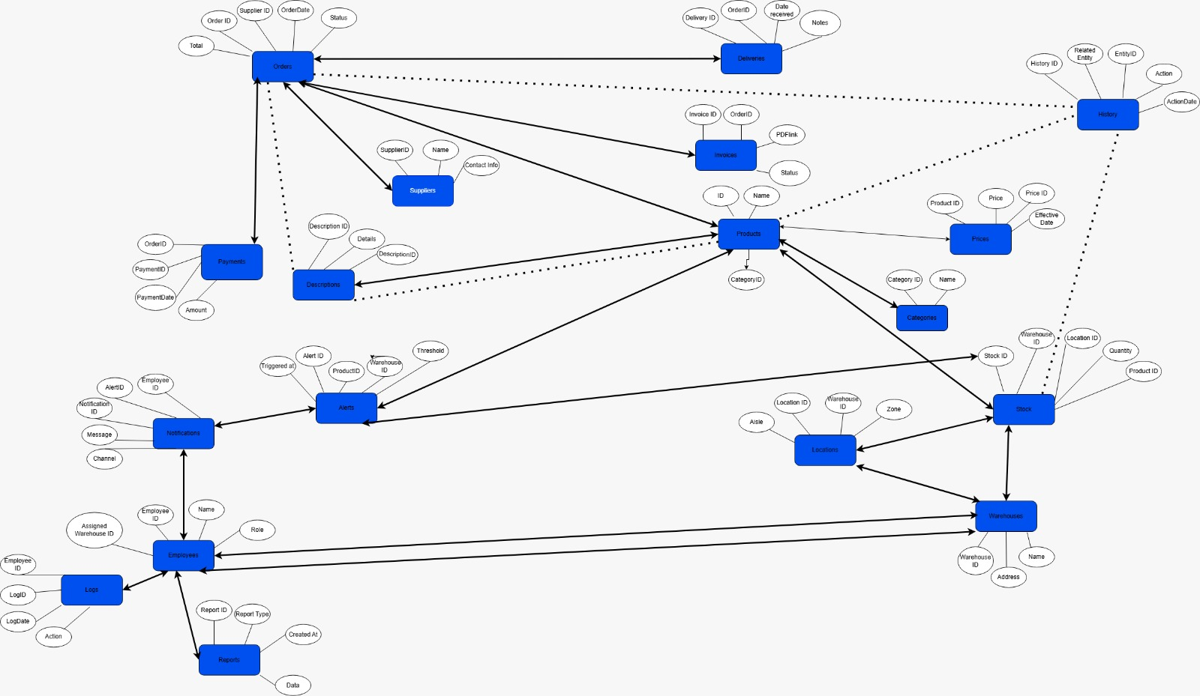

2.NORMALIZATION
delv

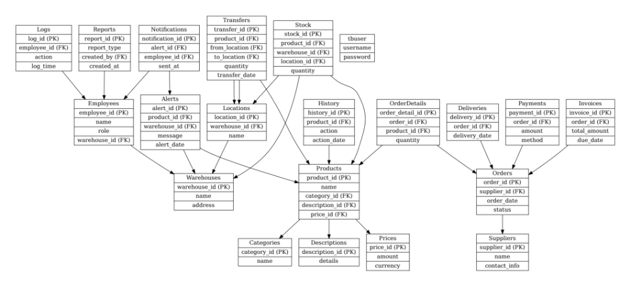

1. Product ➝ Category / Description / Price
- Product.category_id → Category.category_id (Many-to-One)
- Product.description_id → Description.description_id (Many-to-One)
- Product.product_id → Price.product_id (One-to-Many)

2. Product ➝ Stock
- Stock.product_id → Product.product_id (Many-to-One)

3. Stock ➝ Warehouse / Location
- Stock.warehouse_id → Warehouse.warehouse_id (Many-to-One)
- Stock.location_id → Location.location_id (Many-to-One)

4. Warehouse ➝ Location / Employee / Transfer
- Location.warehouse_id → Warehouse.warehouse_id (Many-to-One)
- Employee.warehouse_id → Warehouse.warehouse_id (Many-to-One)
- Transfer.from_warehouse_id / Transfer.to_warehouse_id → Warehouse.warehouse_id (Many-to-One)

5. Supplier ➝ Orders / Deliveries / Payments / Invoices
- Order.supplier_id → Supplier.supplier_id (Many-to-One)
- Delivery.order_id → Order.order_id (Many-to-One)
- Payment.order_id → Order.order_id (Many-to-One)
- Invoice.order_id → Order.order_id (Many-to-One)

6. Order ➝ Product (via OrderDetails)
- OrderDetails.order_id → Order.order_id (Many-to-One)
- OrderDetails.product_id → Product.product_id (Many-to-One)

7. Employee ➝ Logs / Transfers / Notifications
- Log.employee_id → Employee.employee_id (Many-to-One)
- Transfer.employee_id → Employee.employee_id (Many-to-One)
- Notification.employee_id → Employee.employee_id (Many-to-One)

8. Alert ➝ Product / Stock / Employee (via Notification)
- Alert.product_id → Product.product_id (Many-to-One)
- Alert.stock_id → Stock.stock_id (Many-to-One)
- Notification.alert_id → Alert.alert_id (Many-to-One)

9. History ➝ Product
- History.product_id → Product.product_id (Many-to-One)

10. Invoice ➝ Status
- Invoice.status_id → Status.status_id (Many-to-One)

11. Reports ➝ History / Status
- Reports.report_id → History.report_id (One-to-One or Many-to-One, optional)
- Reports.status_id → Status.status_id (Many-to-One)

