
Info@AllWindowDoorParts.com in the deep blue color

replace above image with image below

The Right Part. Right The First Time.

With over 40 Years of industry experience, we are America’s trusted source for replacement window and door hardware. If they made it, we can find it – if we can’t you probably never will.
Change wording to….The Right Part. Right The First Time.
With over 40 Years of industry experience, we are America’s trusted source for replacement window and door hardware. If they made it, we can find it – if we can’t you probably never will.

Not Sure What Part You Need?
Send us a picture of your broken part. Our experts with decades of experience will identify it and send you a link to buy the exact replacement—completely free.
Change to: Send us pictures of your needed parts. Our team with decades of industry experience will identify it and send you a link to buy the exact replacement parts or upgrade – completely free.
- Enjoy a risk-free preview.
- Timely responses you can count on.
- Expert identification of obsolete parts.

Featured Hardware
High-quality replacement parts trusted by industry professionals.
Browse by Category
Find the exact replacement part you need from our extensive catalog of hardware. Replace with:
Quality parts proven and preferred by industry specialists.

Still can't find what you're looking for?
Window and door hardware can be notoriously difficult to identify. Many parts look similar but have microscopic differences. Let our experts with 40+ years of experience find the exact match for you—for free.
Replace with:
Don’t waste time guessing which window or door part you need. Many look alike but have tiny, critical differences. Our seasoned experts (40+ years in the field) will do the hard work and find your exact match or upgrade—for free.

Our Story
Our AllWindowDoorParts GROUP USA was built by industry veterans—not executives in a boardroom. With over 40 years of hands-on experience in construction, remodeling and fenestration, we’ve dealt with every kind of window and door hardware challenge.
We have helped D.I.Y. homeowners, contractors big and small wasting precious time searching for parts that were discontinued, redesigned, or impossible to find in hardware stores and big box stores. So, we created a company dedicated to solving that problem.
If a part exists, we can get it. If it doesn’t, we know the right modern replacement—or can confirm and save you time wasted when something is truly no longer available.


Our team has over 40 years of hands-on experience. We know Casement, Awning, Single/Double Hung and slider windows inside and out.

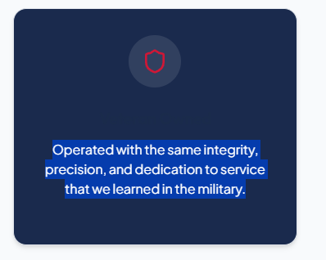
Our standards come from years of experience built on trust, consistency, and respect

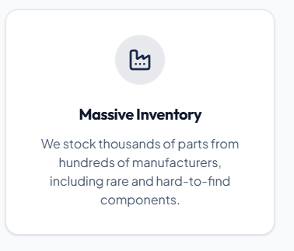
We’ve always believed in doing things the right way, with attention to detail. That’s why we’ve built a distribution network that keeps thousands of parts in stock from hundreds of manufacturers, making it easier to track down even the rarest components.

Remove catalog database statistics


Make parts ID button RED

Remove any distributor information from the products.. customers don’t need to see that.

Products:
Change names / link etc. to be set up for AllWindowDoorParts.com
Upload PDF- customized to All window door parts
AllWindowDoorParts-PDF-Catalog.pdf Rollers and Wheels PDF

Research PDFs | BiltBest Window Parts - PDF Pages Brand References / schematics etc.

