Name:mohammad Ali

Rol number:25k-0850

Section: A

<https://github.com/alylateef/pfweek5.git>

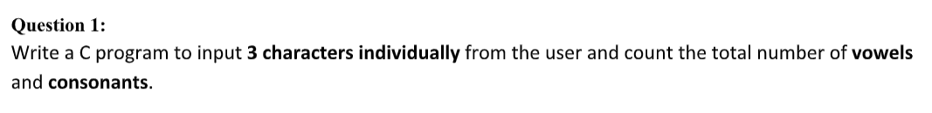

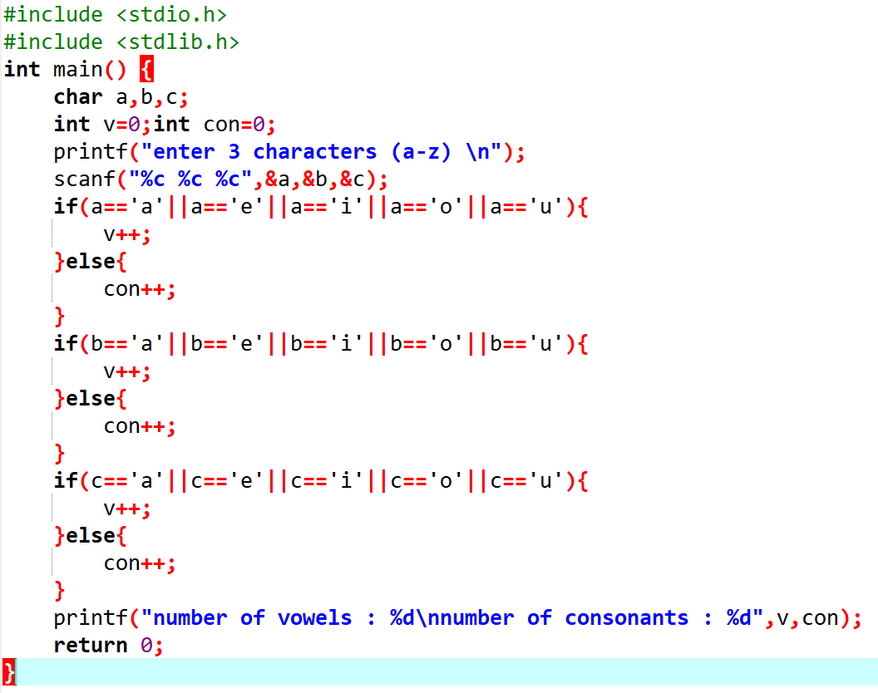

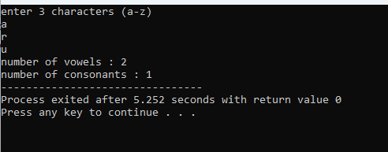

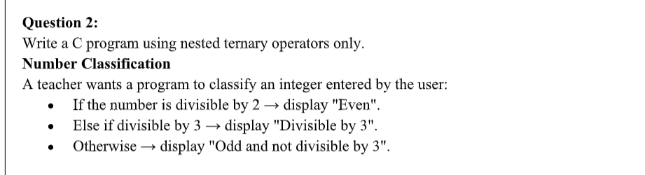

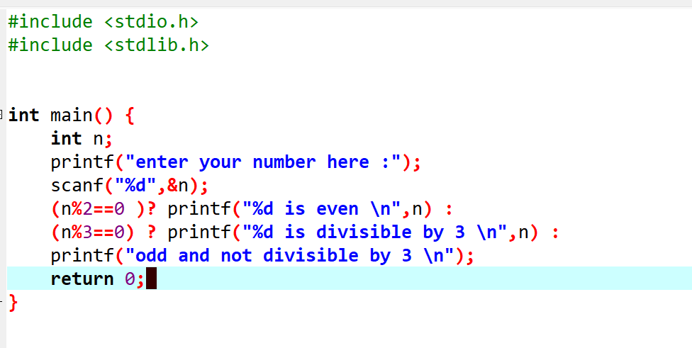



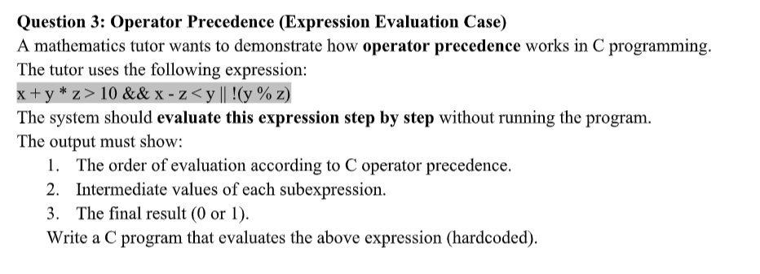

DRY RUN:

1. We have assumed x=2.y=6, z=4.
2. Calculate y times z: 6 times 4 equals 24
3. Add x to the result: 2 plus 24 equals 26
4. Check if 26 is greater than 10: yes, true
5. Calculate x minus z: 2 minus 4 equals -2
6. Check if -2 is less than y: yes, true
7. Calculate y modulo z: 6 modulo 4 equals 2
8. Negate the modulo result: not 2 means false
9. Logical AND of step 3 and step 5: true and true equals true

10.Logical OR of step 8 and step 7: true or false equals true

11.Final output will be 1 which is true.

