**Chapter 1**

**THE PROBLEM**

**Introduction**

The “Gamified Android Learning Application” is a specialized educational platform for Bachelor of Science in Computer Science 4th year students at Osmeña Colleges, designed to enrich learning through interactive and engaging methods. Targeted at fourth-year students, it covers core subjects like Practicum, Social Issues & Professional Practice, Professional Ethics for Filipino IT, and CS Thesis Writing I & II. Each subject is explored through multiple stories or topics that dive into real-world scenarios related to the course material, with each culminating in a quiz that reinforces students’ understanding of complex topics. Additional features, including levels, and achievement badges, further enhance this gamified learning experience, making it both enjoyable and impactful. By transforming essential course material into interactive game, this system develops a unique and engaging approach to learning, preparing students for both academic and professional success.

Globally, digital and automated learning systems are recognized for transforming education by providing interactive learning environments. Gamified learning, in particular, has been shown to reduce stress, improve comprehension, and support collaborative learning across diverse fields. This aligns with the study by Demir and Akpinar (2018) titled “The Effect of Mobile Learning Applications on Students' Academic Achievement and Attitudes Toward Mobile Learning” finds that mobile learning can positively influence academic achievement, with participants exhibiting significantly high attitude scores toward mobile learning. Furthermore, students recognize mobile learning as an effective approach to enhance their motivation. Additionally, the findings of Alsawaier (2018), who emphasizes that gamification can significantly enhance motivation and engagement among students in his study titled “The Effect of Gamification on Motivation and Engagement”. By integrating game elements into the learning process, educators can create a more engaging experience that gives deeper understanding among students. This connection highlights the potential of gamification as an effective strategy to enhance educational outcomes and adapt to the evolving needs of learners in today's digital landscape. These insights suggest that mobile learning applications can have a positive impact on students' academic performance.

In the Philippines, the educational system has increasingly focused on equipping Filipino students to compete globally. Technology has become instrumental in helping educators enhance students' conceptual understanding, enabling them to apply their skills in real-life contexts. However, motivating students remains a significant challenge for teachers, as learners' engagement varies from one generation to another. Addressing students' conceptual understanding, particularly in science education, is crucial and can be achieved through effective motivational strategies. Gamification has emerged as a promising approach to integrate technology, aiming to improve students' conceptual understanding and enhance their motivation in learning science. A study by Furio (2019) investigates the effects of gamification on Grade 7 students' conceptual understanding and motivation in a Junior High School in Valenzuela City. The research employs an experiment with two groups: one receiving conventional teaching and the other engaging in a gamified teaching approach. The findings reveal that while students in the conventional group exhibit better conceptual understanding, those in the gamified group demonstrate higher levels of motivation. The study identifies specific gamification elements, such as points and teamwork that significantly influence students' motivation to learn. The results underscore the need for collaboration among students, educators, and school administrators to implement gamification strategies effectively. Further research is encouraged to develop systematic methodologies for instructional design in gamified learning environments (Furio, 2019).

Locally developed, indigenized game-based instructional materials have shown promising results in enhancing student engagement and comprehension, especially in public school settings. A study by Lotivio and Bercasio (2022) developed the Portable Science Playhouse (PSP) as a game-based tool tailored for Grade VI Science students in Albay, Philippines. This instructional material incorporated recyclable and local resources to present lessons on mixtures through interactive and culturally relevant activities. The study found that PSP significantly improved students' understanding of different mixtures compared to conventional methods. The integration of gamified strategies within the lesson phases fostered a collaborative, learner-centered environment, demonstrating the effectiveness of game-based learning. Results suggested that the game-based approach had a greater impact on students’ proficiency than traditional techniques, supporting the value of indigenized, interactive materials in science education.

In conclusion, this study highlights the powerful potential of gamified and mobile learning in transforming educational outcomes for students. As evidenced by various studies, incorporating game-based and mobile learning strategies can improve academic achievement, motivation, and engagement across a range of educational fields, including science, technology, and social issues. “Gamified Android Learning Application” seeks to build on these insights by offering an interactive learning experience tailored to the core subjects of Bachelor of Science in Computer Science 4th year students at Osmeña Colleges. This approach not only give a more dynamic and immersive learning environment but also aligns with global and local trends in educational technology by addressing the evolving learning preferences and needs of students. Ultimately, by combining motivational elements, real-world scenario-based learning, and indigenized content, this application aims to enhance students’ conceptual understanding and prepare them for success in both academic and professional settings.

**General Objective** To develop “Gamified Android Learning Application”, designed to enhance learning engagement and comprehension for 4th year BSCS students at Osmeña Colleges. The app aims to provide a gamified approach to various subjects, making learning both interactive and effective.

Specifically, the study aims to:

1. Develop a system with the following functionalities and features:

1.1. Create a Gamified Android Learning Application specifically designed for fourth-year BSCS students at Osmeña Colleges

1.2. Ensure the app will include with 10 questions per difficulty with a total of 4 difficulties for the each of following subjects:

1.2.1. Practicum

1.2.2. Social Issues & Professional Practice

1.2.3. Professional Ethics for Filipino IT

1.2.4. CS Thesis Writing I & II

1.3. Implement an Achievements button that redirects users to a page showcasing the badges earned for completing levels in each subject

2. Implement a Subjects Page:

2.1. When a user clicks on any subject card button, they will navigate to a list of difficulties associated with that specific subject.

2.2. Each difficulty should represent a different story or topic within that subject.

2.3. At the end of each story or topic, players will encounter quizzes to test their understanding and reinforce learning.

3. Design the Profile page to include:

3.1. Display user information such as profile avatar, username, and rank. Ensure that this user information is editable, except for the rank.

3.2. Flash Card button that directs users to a page where they can access flashcards featuring key terms, definitions, and concepts from each subject.

4. Evaluate the system using ISO 25010 of

5.1 Functional Suitability

5.2 Performance Efficiency

5.3 Usability

5.4 Reliability

5.5 Maintainability

5.6 Security

**Scope and Delimitation**

This study focuses on developing an educational tool specifically for fourth-year Bachelor of Science in Computer Science (BSCS) students at Osmeña Colleges. The application covers key subjects relevant to these students, including Practicum, Social Issues & Professional Practice, Professional Ethics for Filipino IT, and CS Thesis Writing I & II. Designed to enhance students’ knowledge of the course, the app delivers course content through interactive stories and topics.

Each subject in the app consists of four difficulties, with each difficulty presenting a unique topic or story and ending with 10 questions. A passing score of 80% is required to proceed to the next difficulty. The difficulties and quizzes are predefined by the developers, and the application does not include an administrative panel to modify or update the content. As a result, the content, including the difficulties and quizzes, is fixed, with each subject containing four difficulties and 10 questions per difficulty, totaling 40 questions per subject. Any expansion or modification of the content would require future research or additional development, as the predefined material cannot be altered within the app.

The system is limited to Android devices, excluding compatibility with other operating systems such as iOS, Windows, and Linux. It is not designed for desktop or remote use. The app supports only the four specified subjects within the BSCS curriculum, excluding other computer science courses offered at Osmeña Colleges. Additionally, the application is restricted to single-player gameplay and does not include multiplayer interaction or online database connectivity, as all user data is stored locally within the application.

**Locale of the Study**

The study was conducted at Osmeña Colleges, located in Masbate City, Masbate, Philippines. Masbate is strategically positioned at the center of the Philippines, bridging the two major island groups of Luzon and Visayas. Administratively, it is part of Region V, also known as the Bicol Region, and politically associated with the Luzon island group. However, from a biogeographical and sociolinguistic perspective, Masbate has strong affiliations with the Visayas.

Figure 1 shows the map of Province of Masbate, Figure 2 shows the map of Masbate City, Figure 3 shows the map of Osmeña Colleges.

Figure 1

MAP OF MASBATE PROVINCE

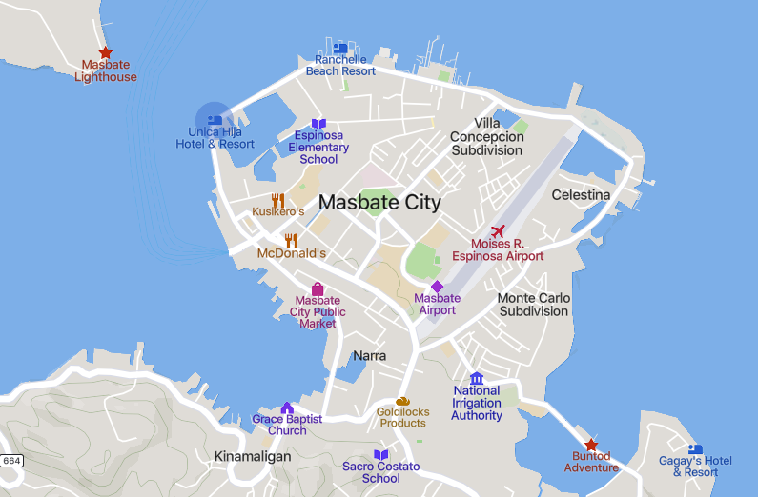

Figure 2

MAP OF MASBATE CITY

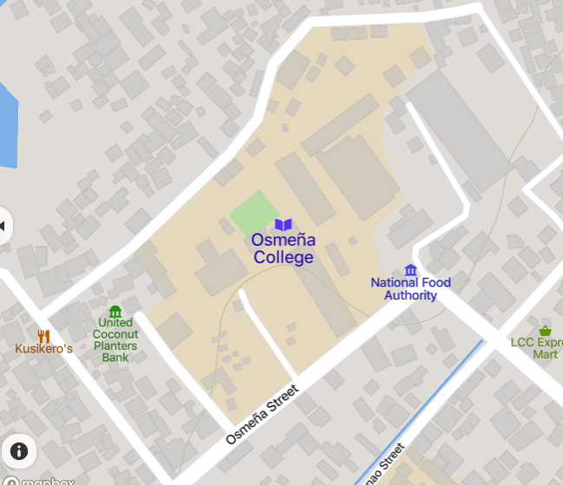

Figure 3

MAP OF OSMEÑA COLLEGES

**Significance of the study**

The study deemed significant for the following:

**Osmeña Colleges**. This project enhances the institution's educational offerings by showcasing technology-driven learning resources that align with global standards.

**BSCS Students**. The project provides an engaging and interactive approach to learning core computer science concepts. This helps improve conceptual understanding and readiness for real-world applications, thereby supporting academic and professional success.

**Educational Institutions**. As the country strives to improve its educational standards, this study provides a model for integrating gamification in learning applications. This may encourage them to explore similar learning solutions to foster better academic outcomes.

**Researchers**. This study contributes to the expanding field of educational technology, particularly within gamified learning and computer science education. Researchers can use insights from VirtuLearn as a basis for further studies, potentially exploring gamification’s impact in other academic fields and educational settings.

**Operational Definition of Terms**

The following terms related to the research are conceptually and operationally defined to enhance the reader's understanding:

**Gamified Learning**. An approach to education that applies game-design elements and principles to non-game contexts to enhance user engagement, motivation, and learning outcomes.

**In-App Database**. A database embedded within a mobile or desktop application that allows for the local storage, retrieval, and management of data directly on the user's device. This type of database enables the application to operate offline, ensuring that users can access and interact with their data without requiring a continuous internet connection.

**Educational Tool**. Any resource or tool designed to enhance the teaching and learning process, providing support for knowledge acquisition and skill development in various subjects or fields.

**Functional Suitability**. A measure of how well a system's functions and features meet the needs and requirements of users, ensuring that the intended tasks can be effectively accomplished.

**Gamification**. The integration of game mechanics, dynamics, and aesthetics into non-gaming applications to drive user participation, improve engagement, and promote specific behaviors or outcomes.

**Game-Based Instructional Materials**. Learning resources that utilize game principles, mechanics, and narratives to facilitate education, making the learning experience interactive and enjoyable.

**Achievement Badge**. A digital symbol or icon awarded to users for accomplishing specific tasks or reaching milestones within a game or application. These badges often serve as motivators and indicators of progress.

**Flash Card**. A study aid that consists of a card bearing information, such as a question on one side and the answer on the other. Flash cards are commonly used for learning and memorization, particularly in educational settings.

**Operating System**. Software that manages computer hardware and software resources and provides services for computer programs. The operating system acts as an intermediary between users and the computer hardware, enabling users to perform tasks and run applications.

**Windows**. A series of operating systems developed by Microsoft, designed for personal computers, tablets, and other devices. Windows provides a graphical user interface (GUI) that allows users to interact with the system through windows, icons, and menus. It supports a wide range of software applications and hardware, making it one of the most popular operating systems worldwide. Windows is known for its user-friendly experience, extensive software compatibility, and regular updates, which enhance security and performance.

**Linux**. An open-source operating system kernel that serves as the foundation for various operating systems (distributions). Known for its stability and flexibility, Linux is widely used in server environments, embedded systems, and as a desktop operating system by enthusiasts.

**iOS**. A mobile operating system developed by Apple Inc. for its hardware, including the iPhone, iPad, and iPod Touch. iOS is known for its user-friendly interface, high security, and seamless integration with other Apple products.

**Single-Player Gameplay**. A mode of play in video games where a single player engages with the game, usually completing missions or challenges without the involvement of other players. This mode focuses on the individual player's experience and progression.

**Biogeographical**. Pertaining to the study of the distribution of species and ecosystems in geographical space and through geological time. It examines how biological diversity is distributed across different regions and how environmental factors influence this distribution.

**Sociolinguistic**. Referring to the study of how language varies and changes in social contexts. It examines the relationship between language and society, focusing on aspects such as dialects, sociolects, language attitudes, and the impact of social factors like ethnicity, class, and gender on language use. Sociolinguistics explores how language functions in different communities, how it reflects and shapes social identities, and how social interactions influence linguistic behavior. This field is essential for understanding the complexities of communication within diverse cultural settings.

**Maintainability**. The ease with which a system or application can be updated, modified, or repaired, ensuring that it remains functional and effective over time.

**Performance Efficiency**. The ability of a system to deliver results effectively while utilizing resources optimally, ensuring minimal delays and maximizing output quality.

**Professional Ethics for Filipino IT**. A subject in computer science that emphasizes the ethical responsibilities and professional conduct expected of IT practitioners in the Philippines.

**Practicum**. A hands-on subject for computer science students, typically offered during the summer semester, where students gain practical experience through on-the-job training (OJT).

**Real-World Scenarios**. Situations that reflect actual challenges or problems encountered in everyday life or professional practice, used as examples or case studies to enhance learning and critical thinking.

**Social Issues & Professional Practice**. A subject within the computer science curriculum that explores the impact of technology on society and the professional responsibilities of IT practitioners, providing context for discussions in the application.

**Acronym**

**BSCS**. Bachelor of Science in Computer Science

**CS**. Computer Science

**IT**. Information Technology

**OS**. Operating System

**PSP**.Portable Science Playhouse

**RAM**. Random Access Memory

**ROM**. Read-Only Memoryvs

**Notes**

Alsawaier, R.S. (2018), "The effect of gamification on motivation and engagement", International Journal of Information and Learning Technology, Vol. 35 No. 1, pp. 56-79. <https://doi.org/10.1108/IJILT-02-2017-0009>

Demir, K., & Akpinar, E. (2018). The effect of mobile learning applications on students' academic achievement and attitudes toward mobile learning. Malaysian Online Journal of Educational Technology, 6(2), 48-59. <https://eric.ed.gov/?id=EJ1174817>

Furio, G. A., Que, E. N., Abesamis, G. M., Olegario, L. C., Yangco, R. T., & Maligalig, J. P. F. (2019). Using classcraft to develop students conceptual understanding and motivation to learn. College of Education, University of the Philippines Diliman. <https://tuklas.up.edu.ph/Record/UP-99796217613547364>

Lotivio, W. S., & Bercasio, R. R. O. (2022). Game-based learning using indigenized instructional material in Grade VI science. BU R&D Journal, 25(2), 60-73. https://doi.org/10.47789/burdj.mbtcbbgs.20222502.06