Sampling Distributions and Estimations
The purpose of sampling is to select a set of units, or elements, from a population that we can use to estimate the parameters of the population. Random sampling is one special type of probability sampling. Random sampling erases the danger of a researcher consciously or unconsciously introducing bias when selecting a sample. In addition, random sampling allows us to use tools from probability theory that provide the basis for estimating the characteristics of the population, as well as for estimating the accuracy of the samples.
Probability theory is the branch of mathematics that provides the tools researchers need to make statistical conclusions about sets of data based on samples. As previously stated, it also helps statisticians estimate the parameters of a population. A parameter is a summary description of a given variable in a population. A population mean is an example of a parameter. When researchers generalize from a sample, they’re using sample observations to estimate population parameters. Probability theory enables them to both make these estimates and to judge how likely it is that the estimates accurately represent the actual parameters of the population.
Probability theory accomplishes this by way of the concept of sampling distributions. A single sample selected from a population will give an estimate of the population parameters. Other samples would give the same, or slightly different, estimates. Probability theory helps us understand how to make estimates of the actual population parameters based on such samples.
Estimating Population Parameters from a Small Sample
Suppose you were to randomly select a sample of only one person from the ten. How close will this sample be to the population mean?
The ten possible samples are represented in the diagram below, which shows the peso bills possessed by each sample. Since samples of one are being taken, they also represent the means you would get as estimates of the population.
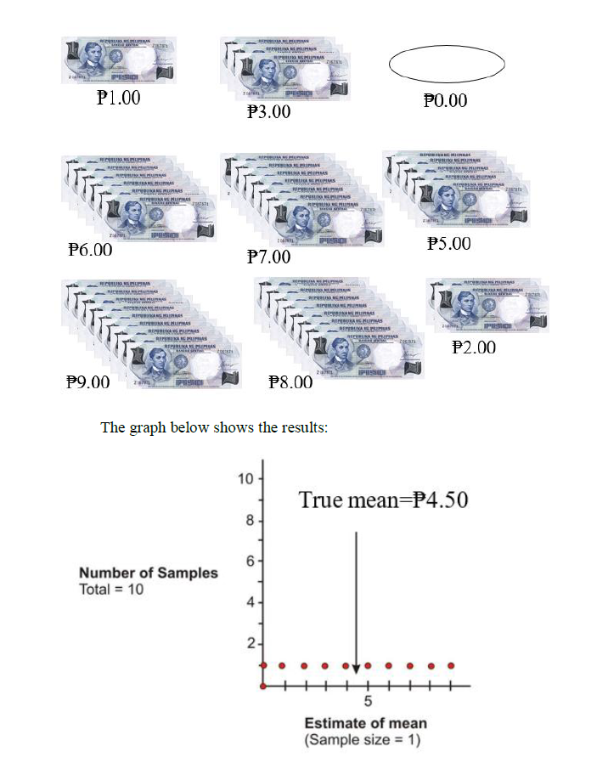

The distribution of the dots on the graph is an example of a sampling distribution. As can be seen, selecting a sample of one is not very good, since the group’s mean can be estimated to be anywhere from ₱0.00to ₱9.00, and the true mean of ₱4.50 could be missed by quite a bit.

Estimating Population Parameters from a Larger Sample
What happens if we take samples of two or more?
First let's look at samples of size two. From a population of 10, in how many ways can two be selected if the order of the two does not matter? The answer, which is 45, can be found by using a graphing calculator as shown in the figure below. When selecting samples of size two from the population, the sampling distribution is as follows:
Increasing the sample size has improved your estimates. There are now 45 possible samples, such as (₱0, ₱1), (₱0, ₱2), (₱7, ₱8), (₱8, ₱9), and so on, and some of these samples produce the same means. For example, (₱0, ₱6), (₱1, ₱5), and (₱2, ₱4) all produce means of ₱3. The three dots above the mean of 3 represent these three samples. In addition, the 45 means are not evenly distributed, as they were when the sample size was one. Instead, they are more clustered around the true mean of ₱4.50. (₱0, ₱1) and (₱8, ₱9) are the only two samples whose means deviate by as much as ₱4.00. Also, five of the samples yield the true estimate of ₱4.50, and another eight deviate by only plus or minus 50 cents.
If three people are randomly selected from the population of 10 for each sample, there are 120 possible samples, which can be calculated with a graphing calculator as shown below. The sampling distribution in this case is as follows:

Here are screen shots from a graphing calculator for the results of randomly selecting 1, 2, and 3 people from the population of 10. The 10, 45, and 120 represent the total number of possible samples that are generated by increasing the sample size by 1 each time

Next, the sampling distributions for sample sizes of 4, 5, and 6 are shown:

From the graphs above, it is obvious that increasing the size of the samples chosen from the population of size 10 resulted in a distribution of the means that was more closely clustered around the true mean. If a sample of size 10 were selected, there would be only one possible sample, and it would yield the true mean of ₱4.50. Also, the sampling distribution of the sample means is approximately normal, as can be seen by the bell shape in each of the graphs.
Now that you have been introduced to sampling distributions and how the sample size affects the distribution of the sample means, it is time to investigate a more realistic sampling situation.
Studying a Population through Sampling
Assume you want to study the student population of a university to determine approval or disapproval of a student dress code proposed by the administration. The study's population will be the 18,000 students who attend the school, and the elements will be the individual students. A random sample of 100 students will be selected for the purpose of estimating the opinion of the entire student body, and attitudes toward the dress code will be the variable under consideration. For simplicity's sake, assume that the attitude variable has two variations: approve and disapprove. As you know from the last chapter, a scenario such as this in which a variable has two attributes is called binomial.
The following figure shows the range of possible sample study results. It presents all possible values of the parameter in question by representing a range of 0 percent to 100 percent of students approving of the dress code. The number 50 represents the midpoint, or 50 percent of the students approving of the dress code and 50 percent disapproving. Since the sample size is 100, at the midpoint,
half of the students would be approving of the dress code, and the other half would be disapproving.
To randomly select the sample of 100 students, every student is presented with a number from 1 to 18,000, and the sample is randomly chosen from a drum containing all of the numbers. Each member of the sample is then asked whether he or she approves or disapproves of the dress code. If this procedure gives 48 students who approve of the dress code and 52 who disapprove, the result would be recorded on the figure by placing a dot at 48%. This statistic is the sample proportion. Let’s assume that the process was repeated, and it resulted in 52 students approving of the dress code. Let's also assume that a third sample of 100 resulted in 51 students approving of the dress code. The results are shown in the figure below.
In this figure, the three different sample statistics representing the percentages of students who approved of the dress code are shown. The three random samples chosen from the population give estimates of the parameter that exists for the entire population. In particular, each of the random samples gives an estimate of the percentage of students in the total student body of 18,000 who approve of the dress code. Assume for simplicity's sake that the true proportion for the population is 50%. This would mean that the estimates are close to the true proportion. To more precisely estimate the true proportion, it would be necessary to continue choosing samples of 100 students and to record all of the results in a summary graph as shown:

Sampling Error
Notice that the statistics resulting from the samples are distributed around the population parameter. Although there is a wide range of estimates, most of them lie close to the 50% area of the graph. Therefore, the true value is likely to be in the vicinity of 50%. In addition, probability theory gives a formula for estimating how closely the sample statistics are clustered around the true value. In other words, it is possible to estimate the sampling error, or the degree of error expected for a given sample design. The formula 𝑠=√𝑝(1−𝑝)𝑛 contains three variables: the parameter,𝑝, the sample size, 𝑛, and the standard error, 𝑠.
The symbols 𝑝 and 1−𝑝 in the formula represent the population parameters.
Calculating Standard Error
If 60 percent of the student body approves of the dress code and 40% disapproves, 𝑝 and 1−𝑝 would be 0.6 and 0.4, respectively. The square root of the product of 𝑝 and 1−𝑝 is the population standard deviation. As previously stated, the symbol n represents the number of cases in each sample, and s is the standard error.
If the assumption is made that the true population parameters are 0.50 approving of the dress code and 0.50 disapproving of the dress code, when selecting samples of 100, the standard error obtained from the formula equals 0.05:
S = (0.5)(0.5)100=0.05
This calculation indicates how tightly the sample estimates are distributed around the population parameter. In this case, the standard error is the standard deviation of the sampling distribution.
The Empirical Rule states that certain proportions of the sample estimates will fall within defined increments, each increment being one standard error from the population parameter. According to this rule, 34% of the sample estimates will fall within one standard error above the population parameter, and another 34% will fall within one standard error below the population parameter. In the above example, you have calculated the standard error to be 0.05, so you know that 34% of the samples will yield estimates of student approval between 0.50 (the population parameter) and 0.55 (one standard error above the population parameter). Likewise, another 34% of the samples will give estimates between 0.5 and 0.45 (one standard error below the population parameter). Therefore, you know that 68% of the samples will give estimates between 0.45 and 0.55. In addition, probability theory says that 95% of the samples will fall within two standard errors of the true value, and 99.7% will fall within three standard errors. In this example, you can say that only three samples out of one thousand would give an estimate of student approval below 0.35 or above 0.65.
The size of the standard error is a function of the population parameter. By looking at the formula 𝑠=√𝑝(1−𝑝)𝑛, it is obvious that the standard error will increase as the quantity 𝑝(1−𝑝) increases. Referring back to our example, the maximum for this product occurred when there was an even split in the population. When𝑝=0.5, 𝑝(1−𝑝)=(0.5)(0.5)=0.25. If 𝑝=0.6, then 𝑝(1−𝑝)=(0.6)(0.4)=0.24. Likewise, if p=0.8, then 𝑝(1−𝑝)=(0.8)(0.2)=0.16. If 𝑝 were either 0 or 1 (none or all of the student body approves of the dress code), then the standard error would be 0. This means that there would be no variation, and every sample would give the same estimate.
The standard error is also a function of the sample size. In other words, as the sample size increases, the standard error decreases, or the bigger the sample size, the more closely the samples will be clustered around the true value. Therefore, this is an inverse relationship. The last point about that formula that is obvious is emphasized by the square root operation. That is, the standard error will be reduced by one-half as the sample size is quadrupled.

