**INTRODUCTION TO PROBABILITY**

**Sample Spaces and Events**   
**Basic Terminology and Probability Rules**

An **event** is something that occurs, or happens.

For example, flipping a coin is an event, and so is walking in the park and passing by a bench. Anything that could possibly happen is an event.

* Suppose a coin is tossed once. There are two possible outcomes, either heads, H, or tails, T. Notice that if the experiment is conducted only once, you will observe only one of the two possible outcomes.
* An **experiment** is the process of taking a measurement or making an observation.
* These individual outcomes for an experiment are each called **simple events**.
* A die has six possible outcomes: 1, 2, 3, 4, 5, or 6. When we toss it once, only one of the six outcomes of this experiment will occur. The one that does occur is called a simple event.

The **sample space** is the set of all possible outcomes of an experiment, or the collection of all the possible simple events of an experiment.

We will denote a sample space by **S**. As we know, there are 6 possible outcomes for throwing a die. We may get 1, 2, 3, 4, 5, or 6, so we write the sample space as the set of all possible outcomes:

S = {1,2,3,4,5,6}

Similarly, the sample space of tossing a coin is either heads, H, or tails, T, so we write S={H,T}.

Probability is usually denoted by P, and the respective elements of the sample space (the outcomes) are denoted by A,B,C, etc.

The mathematical notation that indicates the probability that an outcome, A, happens is P(A). We use the following formula to calculate the probability of an outcome occurring:



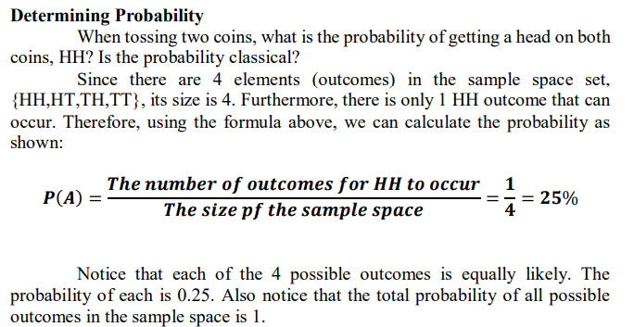

**Operations with Sets**   
**Union and Intersection**

The **union of events** A and B occurs if either event A, event B, or both occur in a single performance of an experiment.

We denote the union of the two events by the symbol A∪B. You read this as either **“A union B” or “A or B.” A∪B** means everything that is in set A or in set B or in both sets.

* The **intersection of events A and B** occurs if both event A and event B occur in a single performance of an experiment.
* It is where the two events overlap. We denote the intersection of two events by the symbol A∩B. You read this as either “**A intersection B” or “A and B.” A∩B** means everything that is in set A and in set B.
* That is, when looking at the intersection of two sets, we are looking for where the sets overlap.
* Describing and Finding the Probabilities of Unions and Intersections Suppose you have a standard deck of 52 cards.

Let:

A: draw a 5

B: draw a Jack

1. Describe A∪B for this experiment, and find the probability, P, of A∪B.

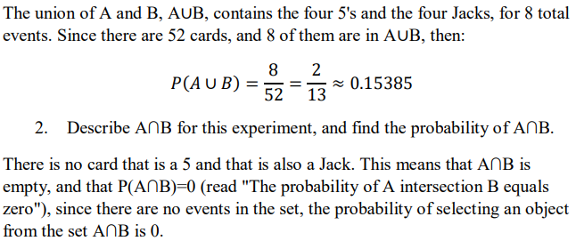

**Counting Techniques**

* Probability is primarily concerned with predicting chances, especially the occurrence of an event

Any probability activity, called an experiment, gives results which are known as outcomes.

Tree diagram – is a graphic organizer that makes use of branching connecting lines to represent a certain relationship between events.

**Example no. 1**

You are driving down McArthur Highway where you encounter two intersections. In each intersection, there are traffic lights installed displaying green, red, and yellow lights. How many different sequences of lights could you encounter after passing through the two intersections?

**Fundamental Counting Principle**

General counting principle: Multiplication rule

If k choices are made in which there are $m_{1}$ ways for the first choice, $m_{2}$ ways for the second choice, $m_{3}$ ways for the third, and so on, there are $m_{1}$ x $m_{2}$ x $m_{3}$ x……. $m_{k }$ number of possible outcomes.

**Example no. 2**

When three dice are thrown, how many different outcomes are possible?

Since there are 6 possible outcomes for each die, then the total number of outcomes as given by the general principle of counting is 6x6x6= $6^{3}$ = 216

**General Counting Principle: Addition Rule**

If a choice can be done in $m_{1}$ ways and another in $m_{2}$ ways such that the two choices cannot be made at the same time, then the total number of possible outcomes is $m_{1}$ + $m_{2}$.

**Example no. 3**

A student, either a junior or a senior, is to be chosen as the school’s representative for an extemporaneous speech contest. If there are 50 juniors and 70 seniors, in how many ways can the selection be done?

Since only one student is to be chosen and it is technically impossible to have a student that is both a junior and a senior at the same time, by the addition rule, there are 50+70= 120 ways to choose a representative for the contest.

**Permutations of n Distinct Objects**

Taken r at a time: n $Pr$ = $\frac{n!}{\left(n-r\right)!}$

Taken n at a time: nPn = n!

**Example 1:**

In how many ways can you arrange 8 books on a shelf if only 5 books can fit at a time?

Since there are 8 books in all, then n=8. the books are to be arranged on a shelf at a time, thus r=5. Thus, there are ₈P₅ ways.

₈P₅ = $\frac{8!}{\left(8-5\right)!}$ = 6 720 ways

**Permutations with repeated objects**

The total number of permutations of n objects of which n₁ are similar, n₂ are similar……nₖ are similar is given by the expression

$$\frac{n!}{\text{n₁}!\text{n₂}……\text{nₖ}}$$

**Example 3.**

How many distinct permutations are there for the word PHILIPPINES?

The word PHILIPPINES has 11 letters and 3 of which are Ps, 3 are I’s, and the rest of the letters appear only once.

$\frac{11!}{3!3!}$ = 1 108 800 permutations

**Circular Permutation**

If n objects are arranged in a circle, then there is a total of (n-1)! Permutations.

**Example 4**.

In how many ways can you sit 8 people in a round table with 8 seats?

(8-1)! = 7! = 5 040 ways

**COMBINATION**

* Unlike permutations, there are certain selections which do not take into consideration the arrangement of the objects; thus, order is not important.
* These unordered selections are called combinations.

Combinations of n Objects Taken r at a time

If a choice of several objects involves selections that regard order as significant, the total number of selections, called combinations, is given by

nCr= $\frac{n!}{r!\left(n-r\right)!}$

**Example 5.**

Four children are chosen from a class of 30 for a survey. How many ways can this be done?

₃₀C₄= $\frac{30!}{4!\left(30-4\right)!}$ = 27 405 ways

**Example 6.**

A committee of 5 consisting of 3 girls and 2 boys is to be chosen from a class with 15 girls and 10 boys. How many distinct committees are possible to form?

Using the multiplication rule and the combination formula, the total number of committees is:

₁₅C₃x ₁₀C₂= $\frac{15!}{3!12!}$ x $\frac{10!}{2!8!}$ = 20 475 committees