**VISUALIZATIONS OF DATA**

**Histograms**   
**Creating Frequency Tables**

**Frequency tables** simply display each value of the variable, and the number of occurrences (the frequency) of each of those values. In this example, the variable is the number of plastic beverage bottles of water consumed each week.

Consider the following raw data: 6, 4, 7, 7, 8, 5, 3, 6, 8, 6, 5, 7, 7, 5, 2, 6, 1, 3, 5, 4, 7, 4, 6, 7, 6, 6, 7, 5, 4, 6, 5, 3

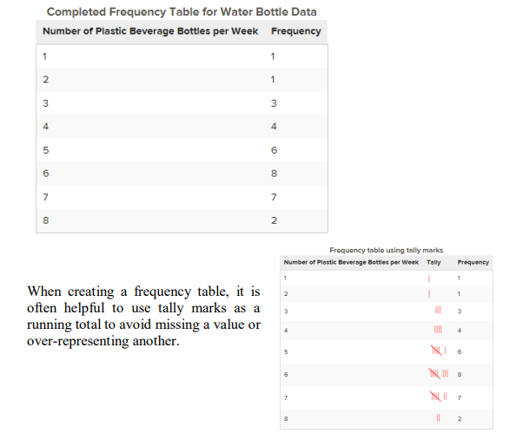

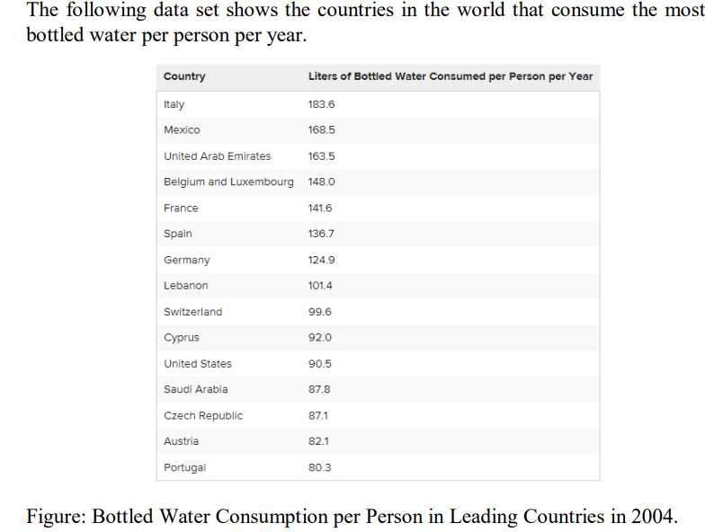

* A **bracket, '[' or ']',** indicates that the endpoint of the interval is included in the class.
* A **parenthesis, '(' or ')',** indicates that the endpoint is not included. It is common practice in statistics to include a number that borders two classes as the larger of the two numbers in an interval.
* For example, [80−90) means this classification includes everything from 80 and gets infinitely close to, but not equal to, 90. 90 is included in the next class, [90−100).

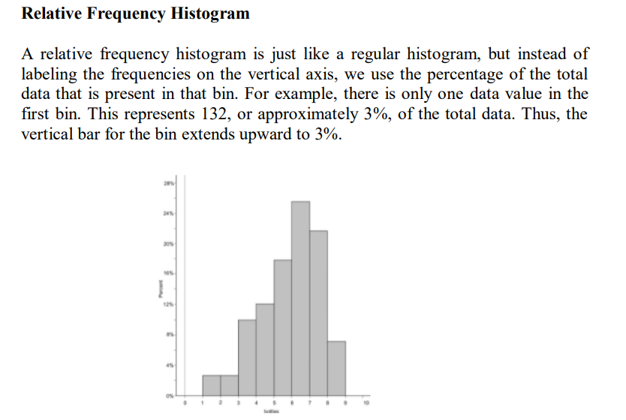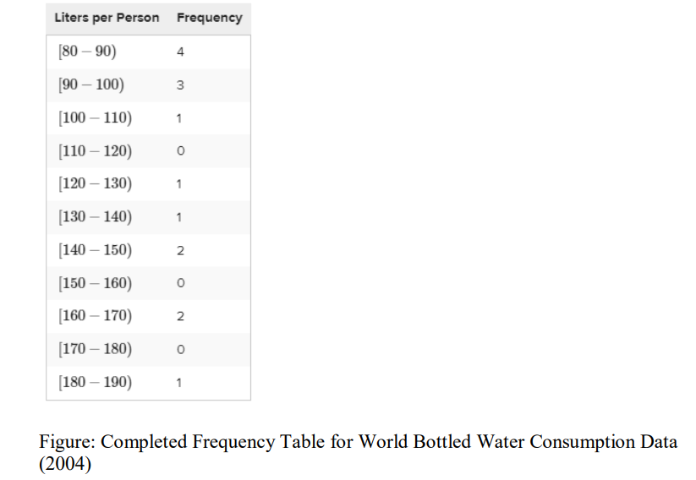

**Frequency Polygons**

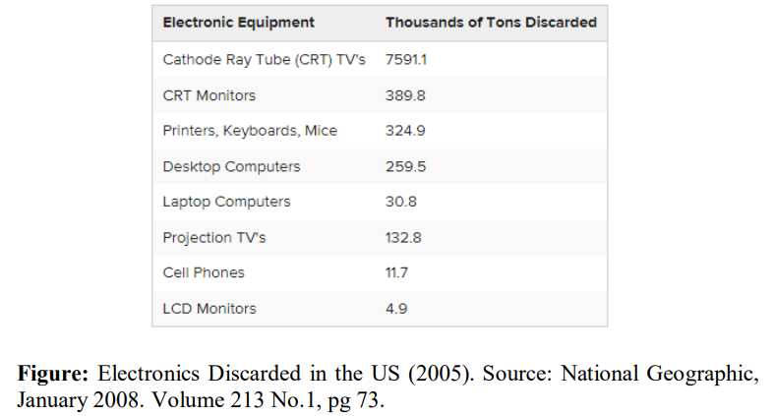A **frequency polygon** is like a histogram, but instead of using bins, a polygon is created by plotting the frequencies and connecting those points with a series of line segments.

**Using Frequency Polygons   
Graphs for Categorical Data**

E-Waste and Bar Graphs

The following table shows the amount of tonnage of the most common types of electronic equipment discarded in the United States in 2005.

The type of electronic equipment is a categorical variable, and therefore, this data can easily be represented using a bar graph.

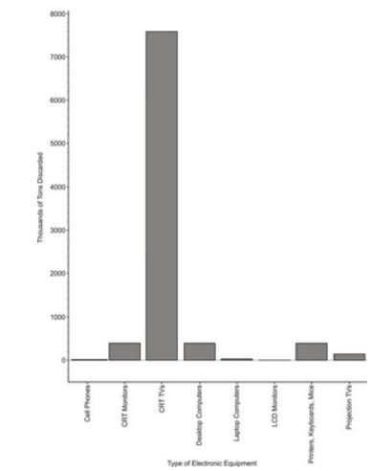

**Creating a Bar Graph**

Make a bar graph for the E-waste data

* The graph is just a series of disjoint categories.

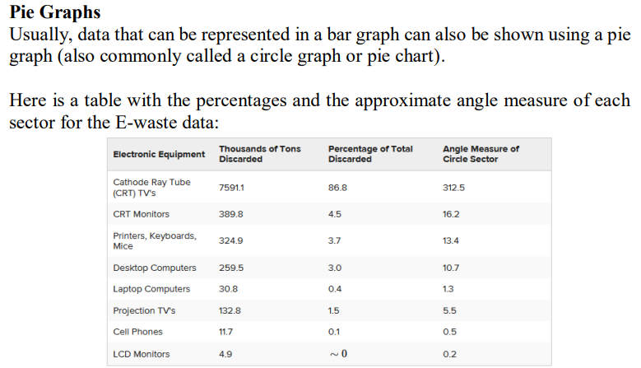

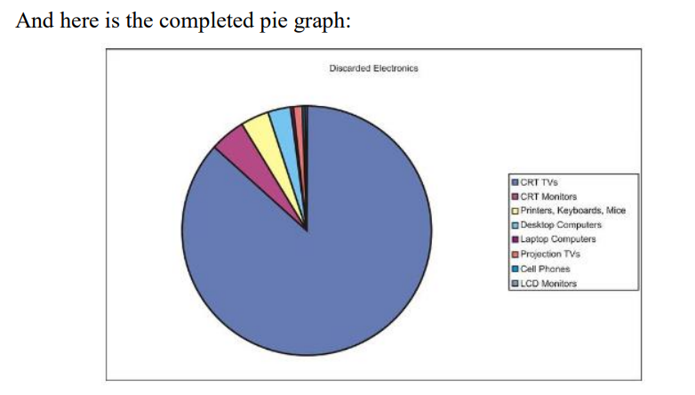

**Displaying Univariate Data**   
**Graphs for Univariate Data**

* **Univariate Data** is composed of single numerical variables.
* A dot plot is one of the simplest ways to represent numerical data. After choosing an appropriate scale on the axes, each data point is plotted as a single dot. Multiple points at the same value are stacked on top of each other using equal spacing to help convey the shape and center.

**Constructing a Dot Plot**

The following is a data set representing the percentage of paper packaging manufactured from recycled materials for a select group of countries.

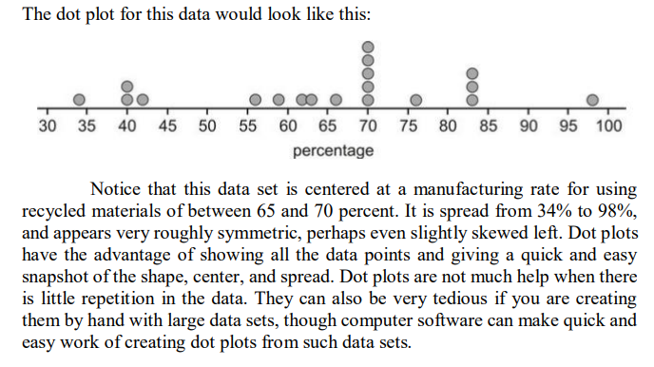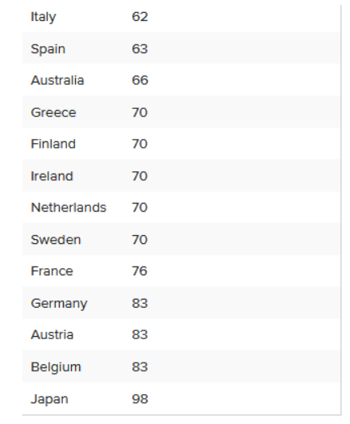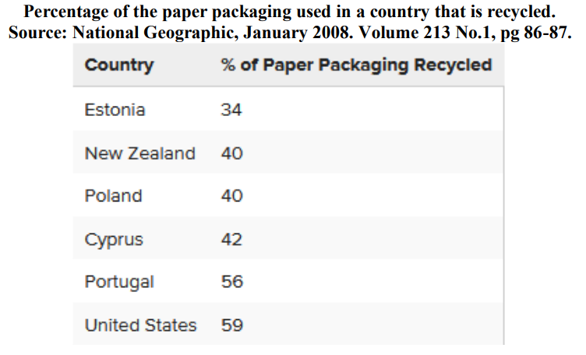

**Stem-and-Leaf Plots**

* A **stem-and-leaf plot** is a similar plot in which it is much easier to read the actual data values.
* In a stem-and-leaf plot, each data value is represented by two digits: the stem and the leaf.

**Displaying Bivariate**   
**Data Scatterplots and Line Plots**

**Bivariate** simply means two variables. The goal of examining bivariate data is usually to show some sort of relationship or association between the two variables.

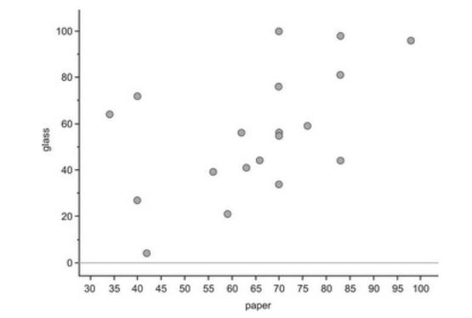 **Scatterplots**

We will place the paper recycling rates on the horizontal axis and those for glass on the vertical axis. Next, we will plot a point that shows each country's rate of recycling for the two materials. This series of disconnected points is referred to as a **scatterplot.**

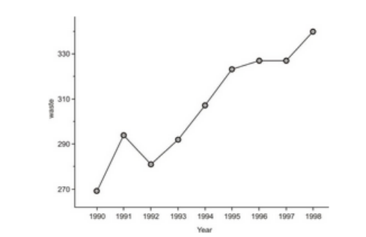

**LINE PLOTS**

A **line plot** is simply a scatterplot in which we connect successive chronological observations with a line segment to give more information about how the data values are changing over a period of time.

