**Lesson 4: Computing Weighted Mean**

The **weighted mean** is used when **different values in a dataset contribute unequally** to the average. It is especially useful in research when certain data points carry more importance or frequency.

**Formula for Weighted Mean:**

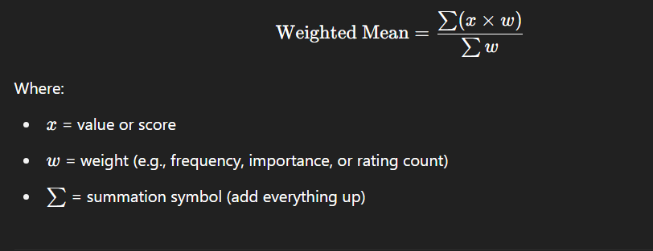

**When to Use It in Research:**

* Calculating average **student performance** when tests have different weights
* Analyzing **Likert scale data** where responses (Strongly Agree to Strongly Disagree) are weighted numerically
* Determining **overall customer satisfaction** from weighted survey items

**Step-by-Step Example:**

Let’s say a survey asked students to rate their satisfaction on a **5-point Likert scale**:

|  |  |  |
| --- | --- | --- |
| **Rating (x)** | **Description** | **Frequency (w)** |
| 5 | Very Satisfied | 10 |
| 4 | Satisfied | 15 |
| 3 | Neutral | 8 |
| 2 | Dissatisfied | 5 |
| 1 | Very Dissatisfied | 2 |

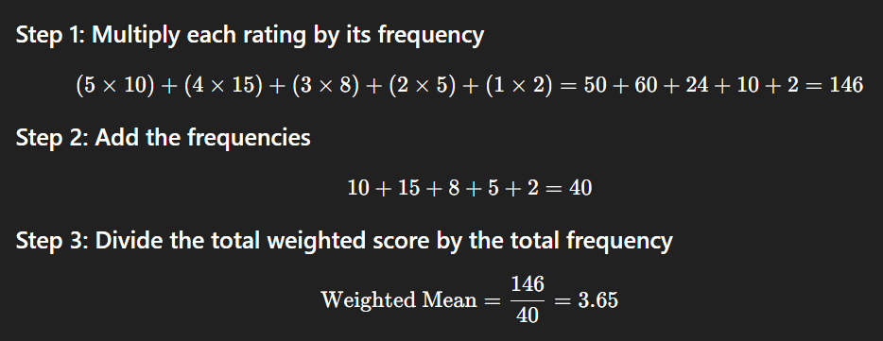

**Interpretation:**  
The **average satisfaction rating** is **3.65**, which falls between **Neutral** and **Satisfied**.