# 1000 Objects Classifier Based on GoogleNet

# Project Overview:

This project is object classification using GoogleNet pre-trained model. It is based on the tutorial found in the below link:

<https://docs.opencv.org/master/d5/de7/tutorial_dnn_googlenet.html>

Download any photo with an object that needs to be classified and then modify the following line of code:



# Example:

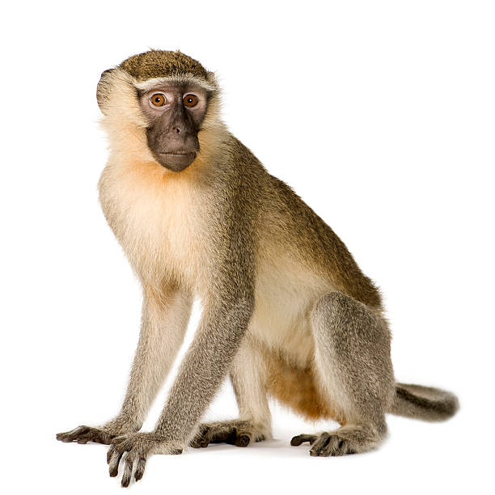

**Input Output**

# Model Classes:

The 1000 class that the model can predict are found in: *classification_classes_ILSVRC2012.txt*