**Analyzing The Median House Income**

# Assignment:

This assignment requires that you to find **at least** two datasets on the web which are related, and that you visualize these datasets to answer a question with the broad topic of **economic activity or measures** for the region of **Ann Arbor, Michigan, United States**, or **United States** more broadly.

# Project overview:

How the median house income in Michigan changed from 1985 till 2017 compared to the median income in the US and the minimum national wage?

# Project Description:

The graphs describe the median household income in Michigan compared to the median income in the US and the minimum average wage at the US from the period between 1985 to 2017. The median was chosen to describe the household income to avoid the outliers in the data and the units were adjusted to 2018 CPI-U-RS. It can be noticed that the minimum wage over the whole period only changed a few times. There is a period where the median income at Michigan was obviously higher than the median of the US like the period between 1991 till 2002. Then there were multiple overlaps between Michigan and the US median income which indicates that the mean income for a household in Michigan wasn’t always above the US median and wasn’t always below it and ends in 2014 with both medians way higher than the minimum wage. There is also a sudden decrease in Michigan as well as the US income near 2007 this was due to the financial crisis. But its noticed that the minimum wage kept constant throughout this period.

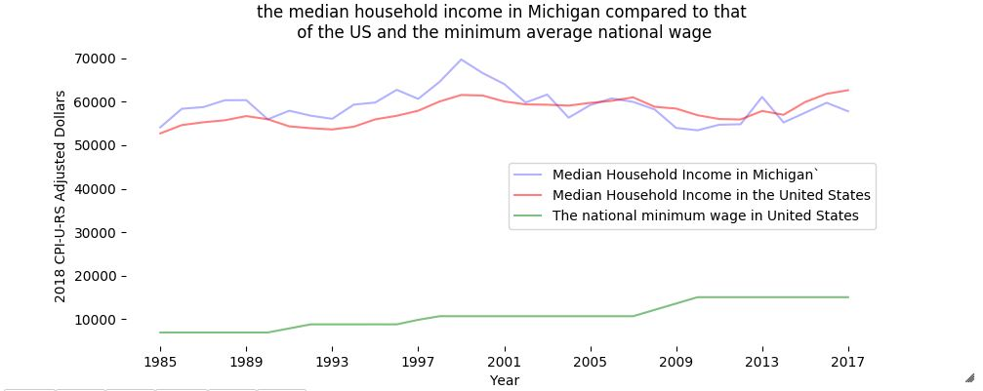

# Data Sources:

1. Real Median Household Income in the United States:

<https://fred.stlouisfed.org/series/MEHOINUSA672N#0>

1. Real Median Household Income in Michigan:

<https://fred.stlouisfed.org/series/MEHOINUSMIA672N>

1. United States (USA) National Minimum Wage – NMW:

<https://countryeconomy.com/national-minimum-wage/usa>