# Sound Classification Using MFCC Spectrogram and CNN

# Project Overview:

This project classifies sound signals from different environmental classes in the ESC-10 dataset. the above photo summarizes the model steps:

1. The model read all the signals of different classes and assign a label number to each class.
2. The Mel Frequency Cepstral Coefficients (MFCC) are extracted from the time domain.
3. Full Convolutional Neural Network (CNN) is defined and used to classify 10 different classes of ESC-10 dataset

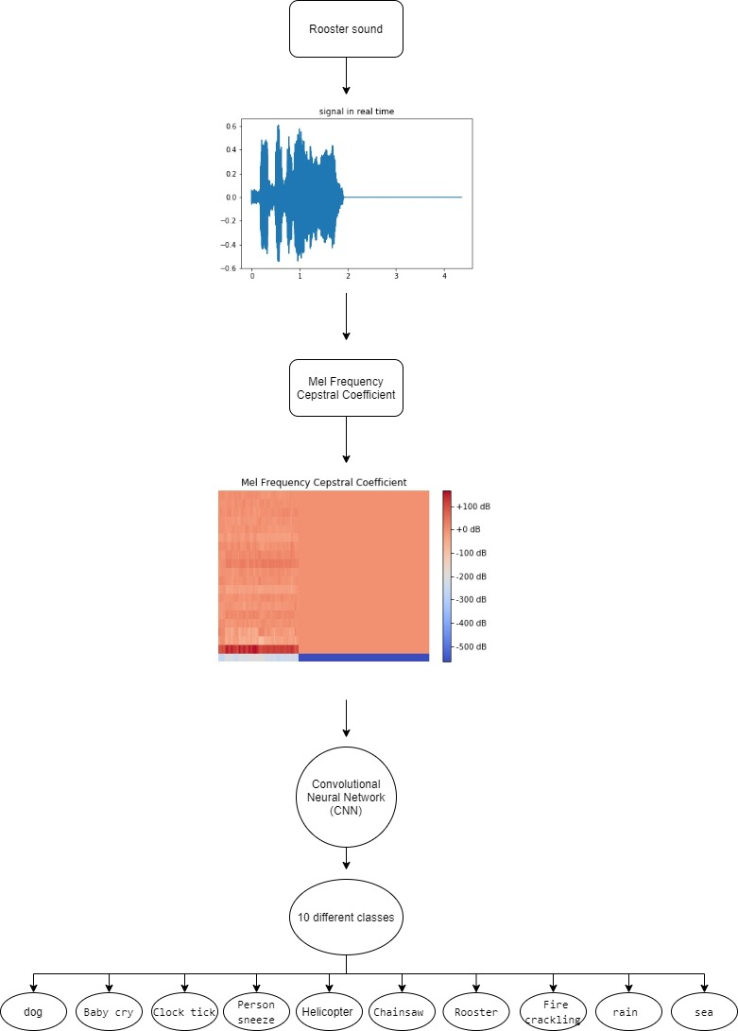

# Dateset:

The dataset can be found in:

<https://dataverse.harvard.edu/dataset.xhtml?persistentId=doi:10.7910/DVN/YDEPUT>