Differential gene expression analysis
1. Summary of significant genes
Thresholds used:
- adjusted p-value < 0.05
- log2FoldChange > 1 → up-regulated
- log2FoldChange < −1 → down-regulated
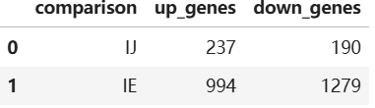
IE has many more significant genes than IJ, so IE condition shows stronger gene expression changes.
2. Volcano Plots
I made volcano plots for both comparisons.
The colours show three groups:
- red = up-regulated
- green = down-regulated
- grey = not significant
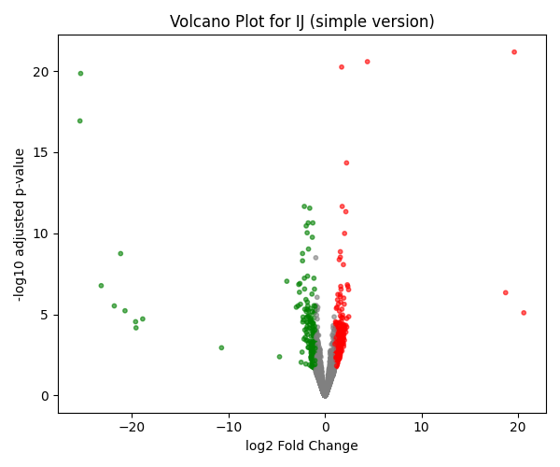
The IJ comparison shows fewer significant genes. Most points are close to log2FC = 0.
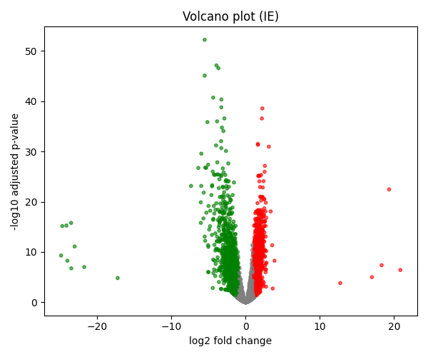
IE has a lot more significant changes. Many genes have large fold changes.
3. Histogram of p-values
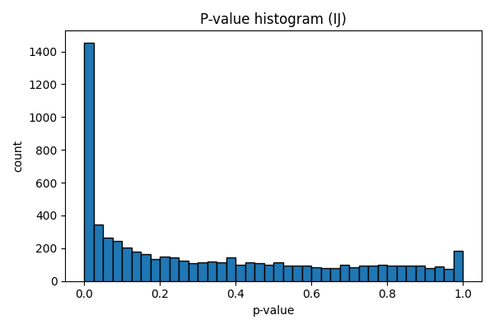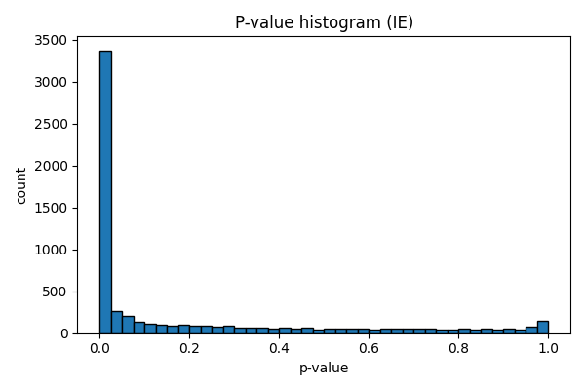Most small p-values appear more in IE, which matches the larger number of DE genes.
4. MA Plots
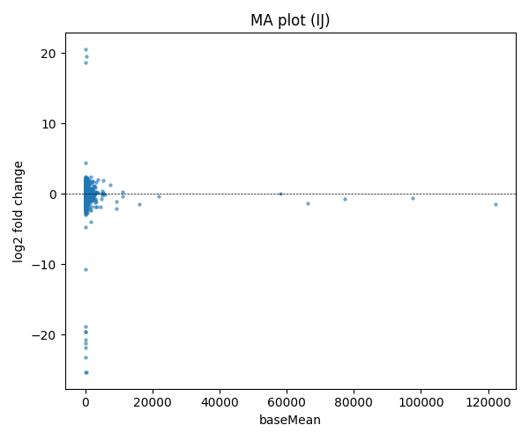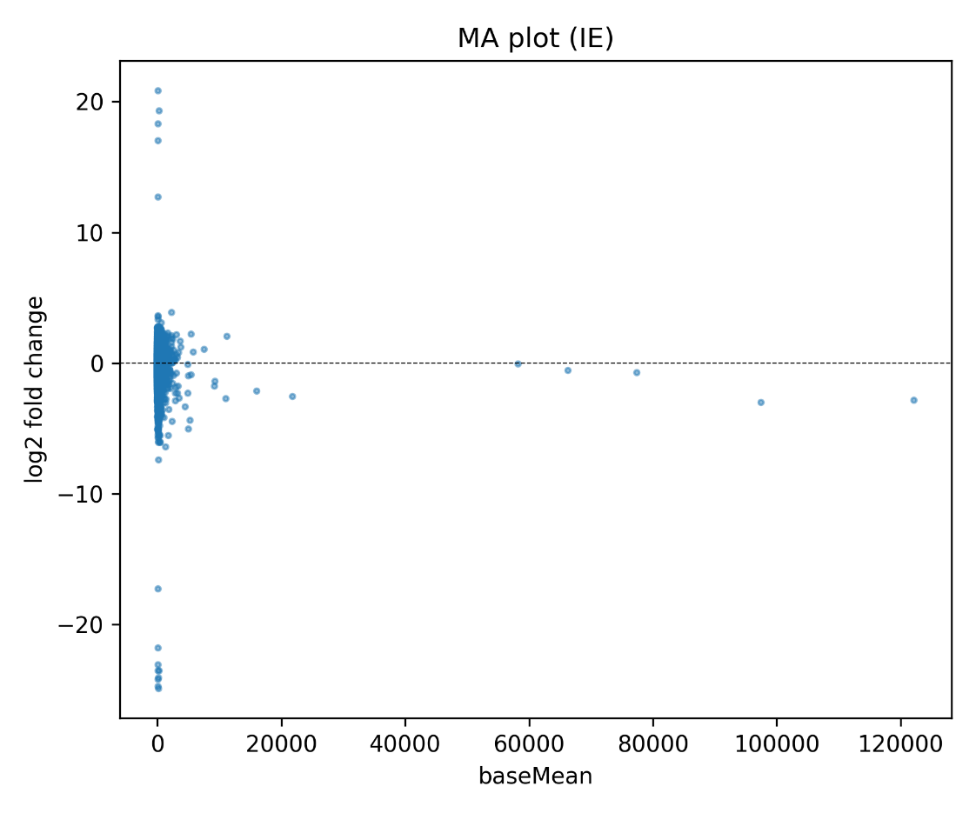Each point is one gene. The x-axis is baseMean, and the y-axis is log2 fold change.
IE looks like it has more genes with strong changes than IJ.
5. Heatmap of top differentially expressed genes
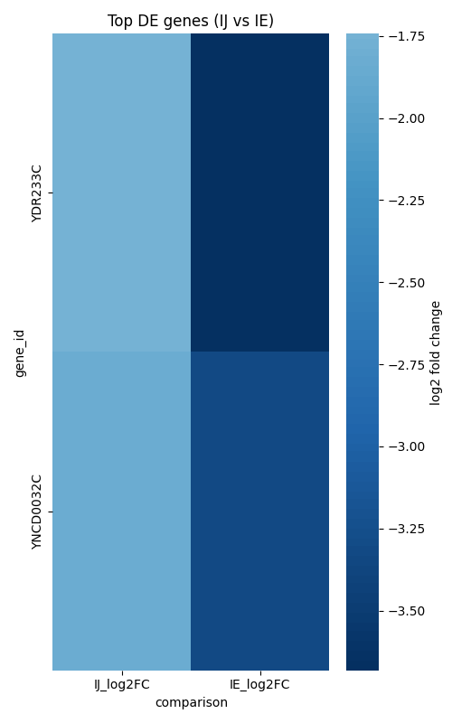
I selected the top genes by adjusted p-value.

