Output for Pumpkins Coding Challenge (R)

1. Reading the pumpkins.csv data
I loaded the pumpkins.csv file into R using read_csv().
The dataset contains pumpkin competition records, including weight, country, variety, and other information.

2. Heaviest pumpkin
I checked the whole dataset and found the heaviest pumpkin.
Here are the key details from the row with the maximum weight (lbs):
Year: 2016
Variety: Atlantic Giant
Country: Belgium
City: Deurle
Weight (lbs): 2772.458

3. Converting weight from lbs to kg
I added a new column called weight_kg.
The formula is simple:
1 pound = 0.453592 kilograms

4.Weight classes
I created a column called weight_class to roughly group pumpkins:
light: < 200 kg
medium: 200–500 kg
heavy: > 500 kg

5.Plot 1 – Estimated vs actual weight
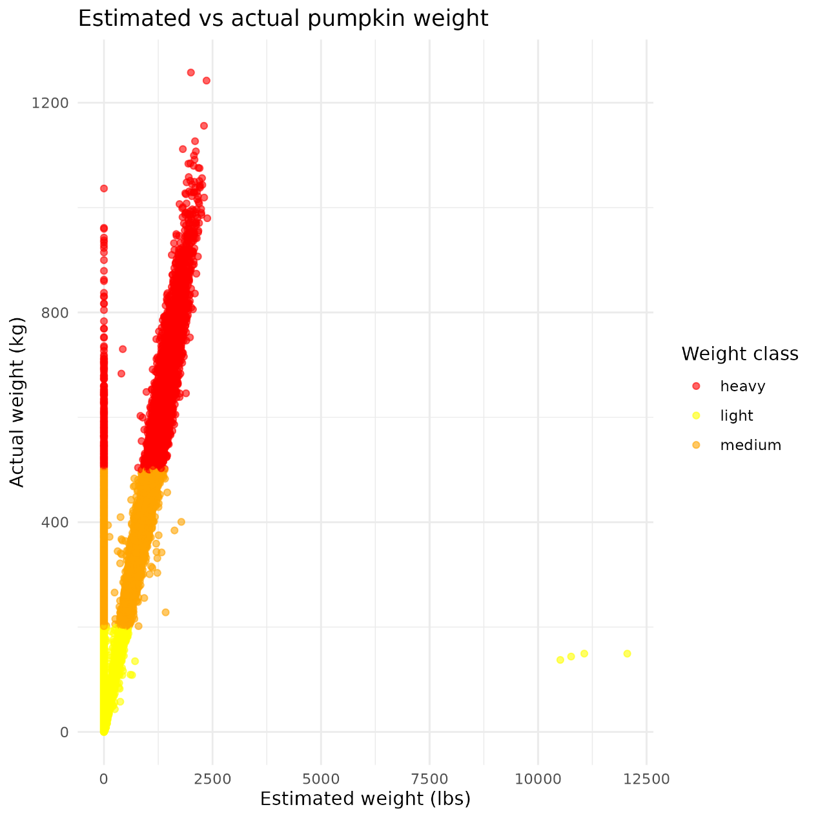
This scatter plot shows how the estimated weight compares with the actual weight (kg).
Most points follow a general trend, but there are also some clear differences, especially for heavier pumpkins.
This means the estimation is not always accurate.

6. Filtering three countries
I selected pumpkins from three countries:
- Canada
- Japan
- Italy
I saved this filtered dataset as pumpkins_filtered.csv.

7. Summary of the filtered data
Mean weight by country：I calculated the mean pumpkin weight (in kg) for the three selected countries.
Mean weight by country + variety：I also calculated the mean weight for each pumpkin variety within each of the three countries.

8.Plot 2 – Boxplot for three countries
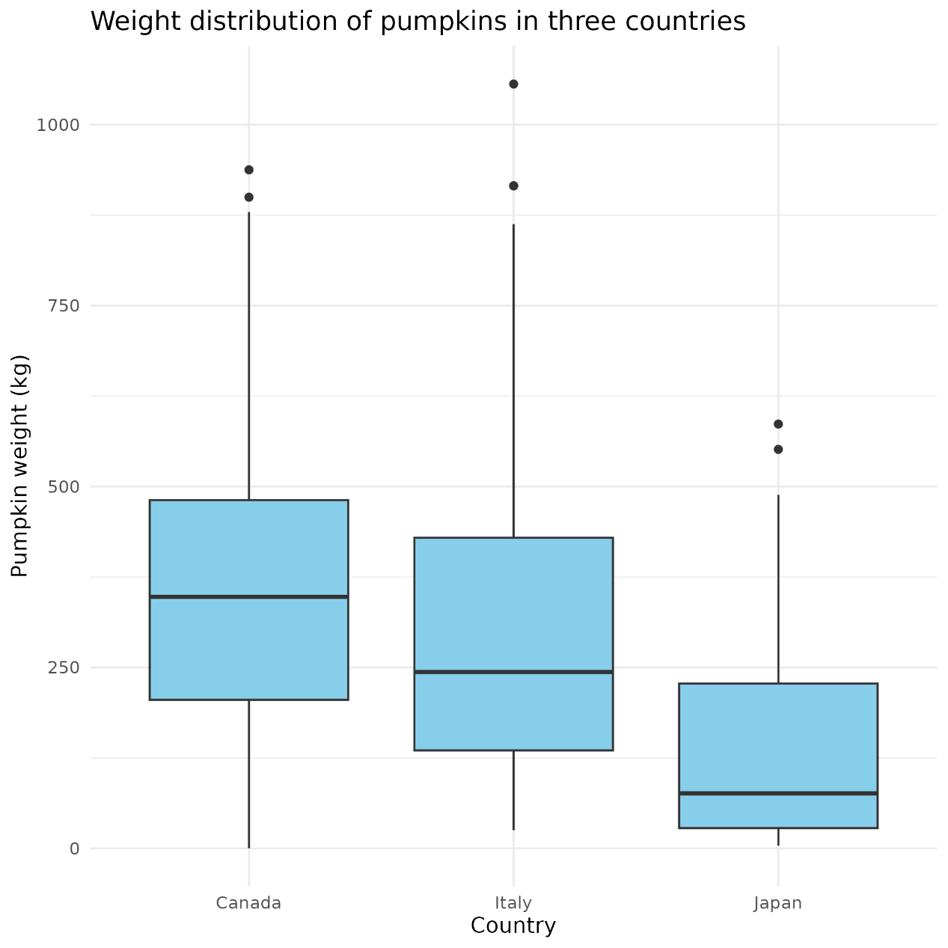
The spread of pumpkin weights looks different between the three countries.
Some countries have wider ranges, meaning more variation.
9.Plot 3 – Facet plot by variety
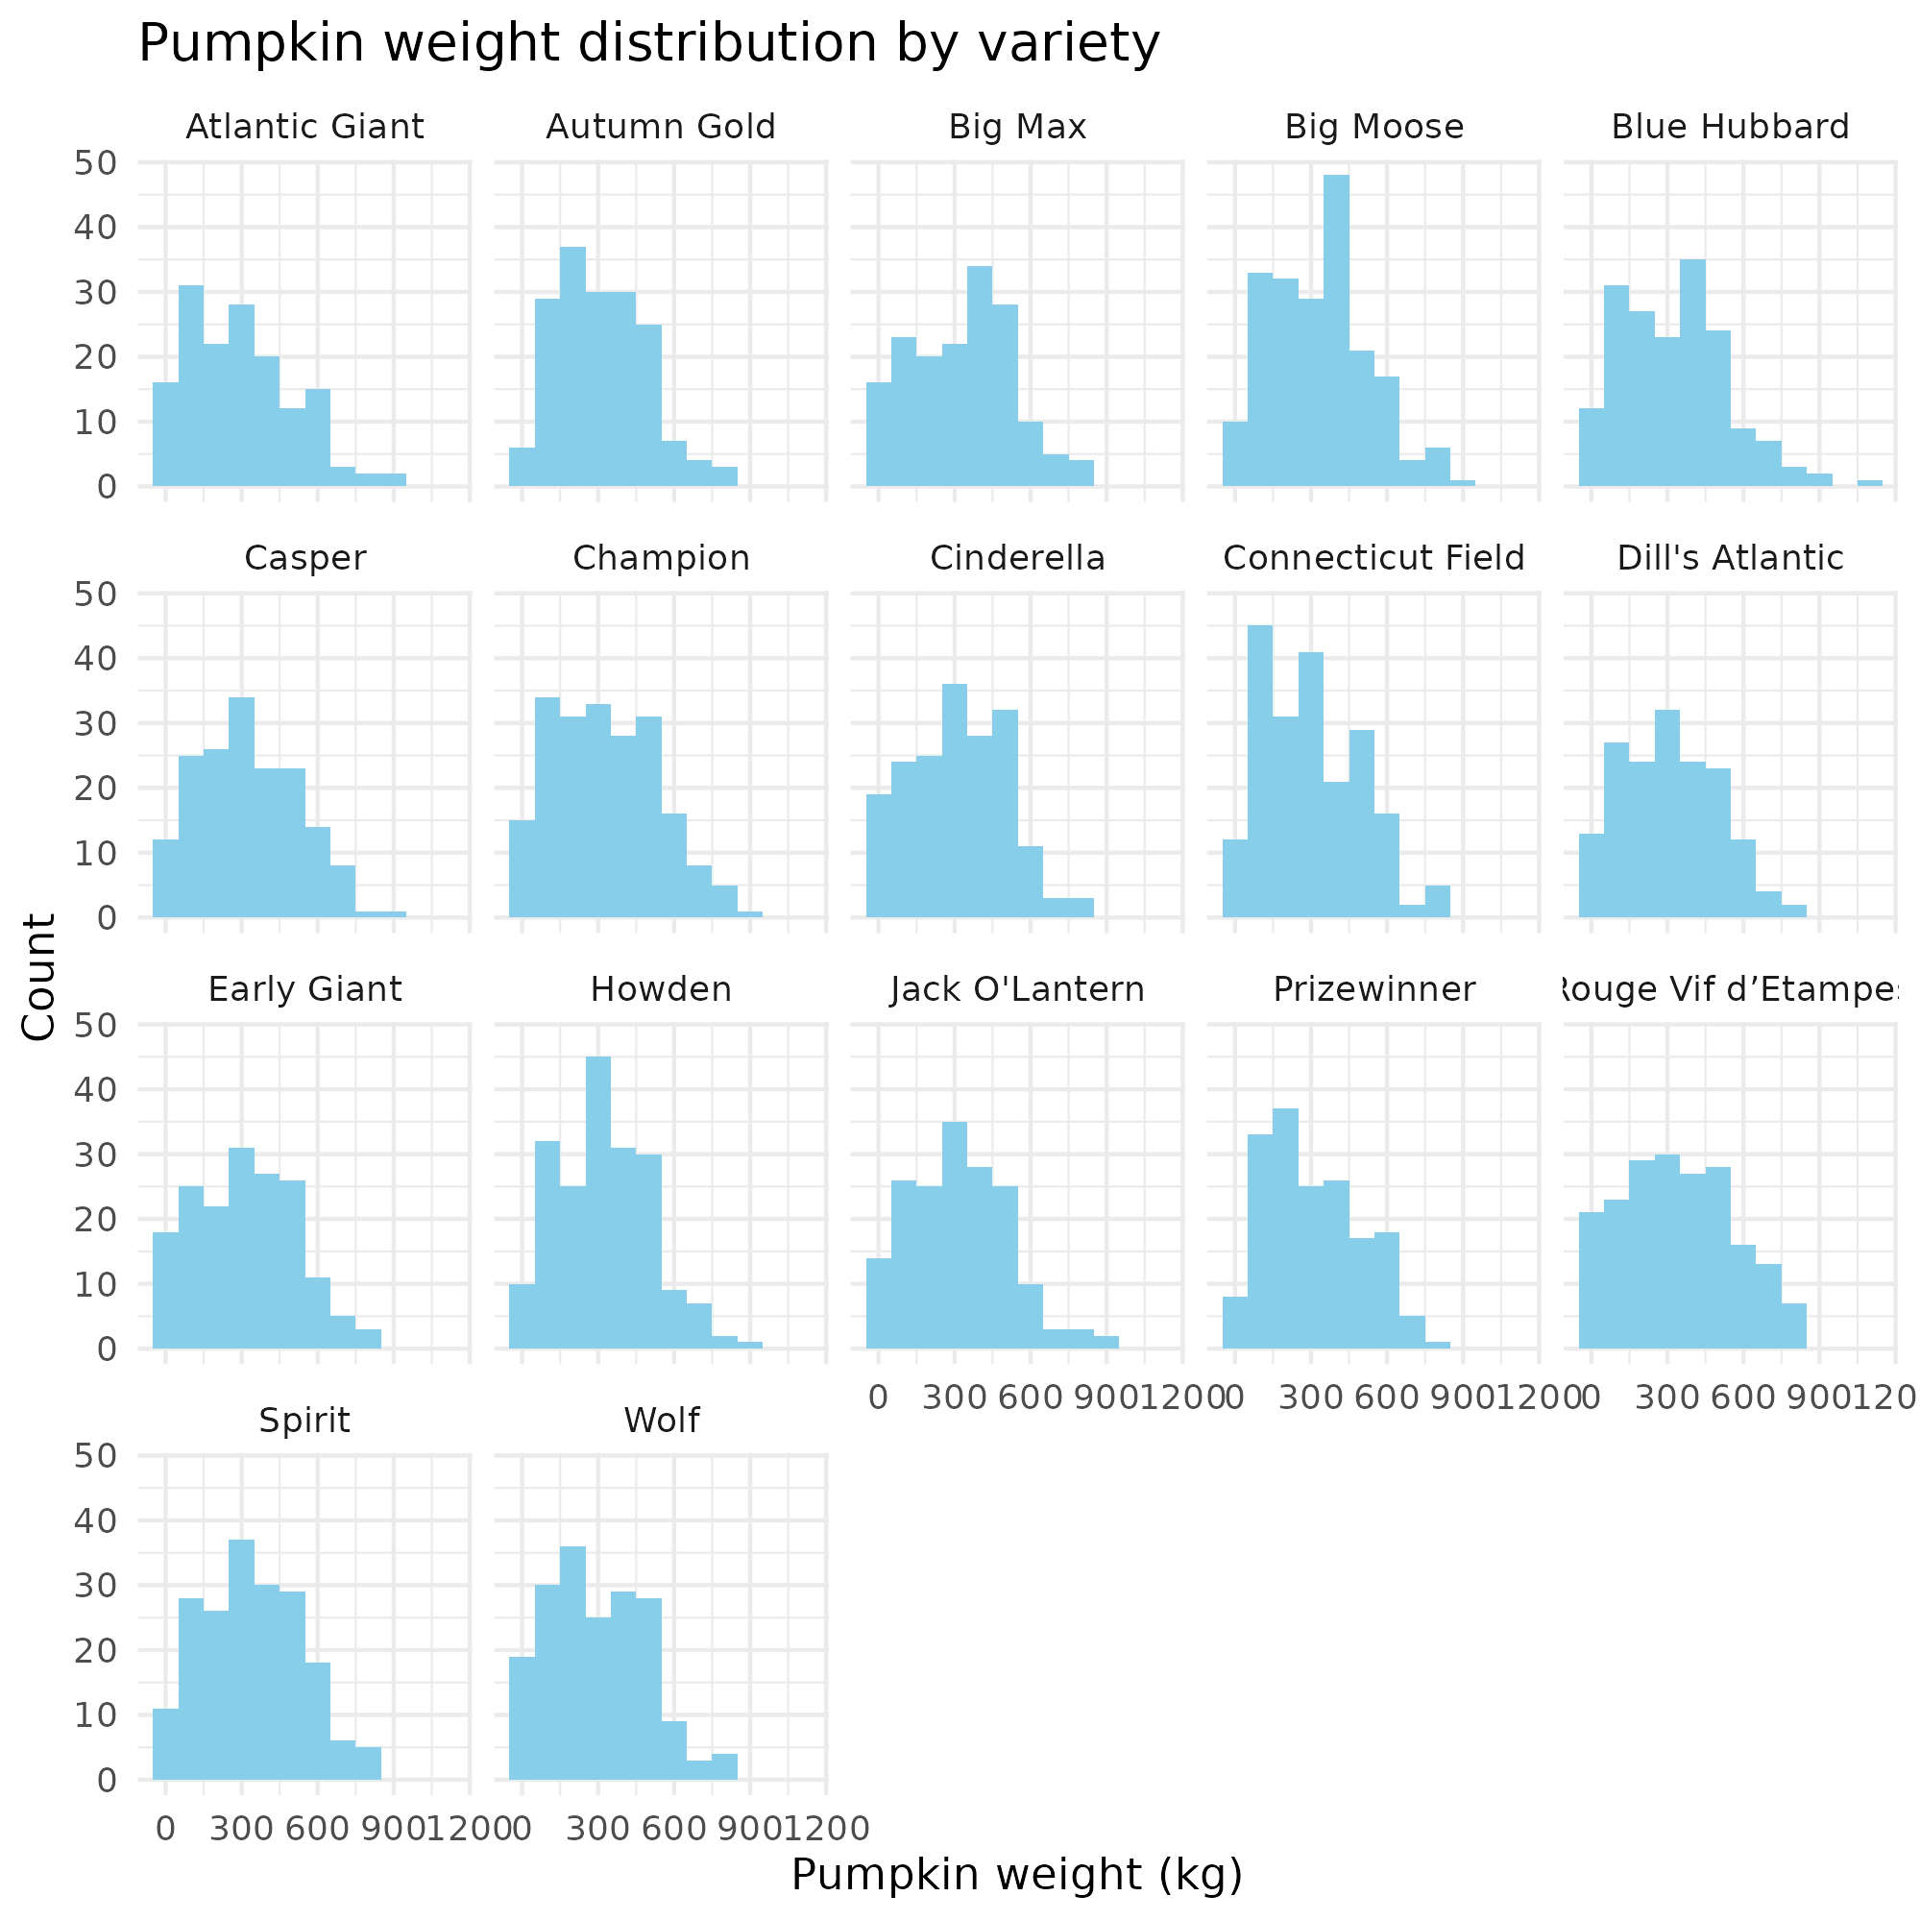
Different varieties clearly have different weight ranges.
Some varieties appear much more frequently than others.
It is easier to compare how pumpkin varieties differ across the three countries.

