

MINOR DEFECT RECORD SYSTEM
Version 3.0.0
Work Instruction
IT | System Group – Ally Maranan

TABLE OF CONTENTS
- SYSTEM OVERVIEW | 2
- VIEWER INTERFACE  Viewer Page  Search Record  Export Record | 3
- DASHBOARD INTERFACE  Daily Monitoring  Overall Monitoring | 3
- QC INTERFACE  New Record Authorization  Add Record | 6
- ADMIN INTERFACE  Login  Defect Details  Car Model  Process  Admin Account  Authorized Account  Defect Record List | 8

- SYSTEM OVERVIEW
- Live System Link:
http://172.25.116.188:3000/minor_defect_record_system/

- Process Flow
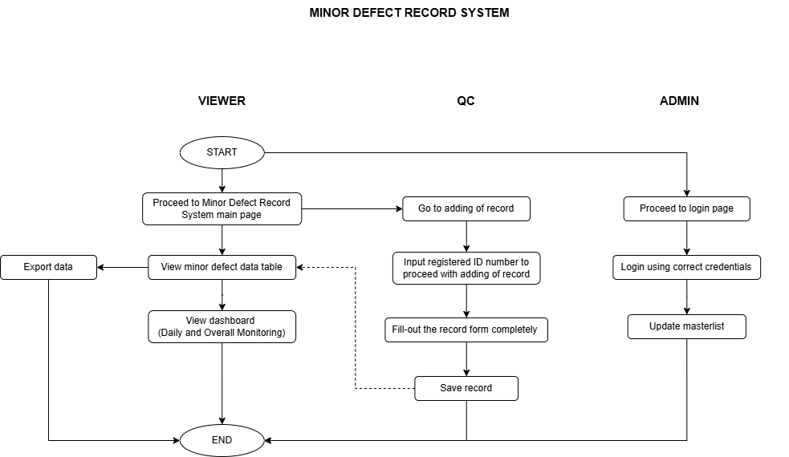
Figure 1. System Process Flow

A web application that provides comprehensive functionality for managing and analyzing minor defects on production lines. Key features include:

- Defect Tracking: Efficiently record and monitor defects per production line.
- Data Management: Capture essential details such as date detected, car maker and model, line number, process, product number, lot number, serial number, defect category, defect details, treatment content, sequence and connector numbers, and personnel involved in repair and verification.
- Trend Analysis: Utilize recorded data to analyze trends and visualize performance metrics.
- Reporting: Generate insightful reports to aid in decision-making and quality control.

This system is designed to streamline defect management and enhance data-driven decision-making through effective tracking and analysis.

- VIEWER INTERFACE
- Viewer Page
1.1 At the top of the page, the user will find a set of search fields designed to help them quickly locate specific records. These fields allow them to filter data based on various criteria, making it easier to find relevant defect records based on above parameters. By default, the date from and date to is set to current date. See Figure 2

1.2 Below the search fields, the main section of the page features a detailed table displaying the defect records that match the search criteria. This table is organized to provide a clear and concise view of all added defect records.

The table also includes load more to help users to navigate through large sets of records efficiently.

In the lower left of the table, it displays the total count of records. These changes based on the data shown in the table. See Figure 2

1.3 To extract the data, click on the Export button. The file will contain the filtered data from the table. The downloaded file will be named based on the date of download. See Figure 2

1.4 The Add Record button is accessible only to authorized QC personnel. See Figure 2

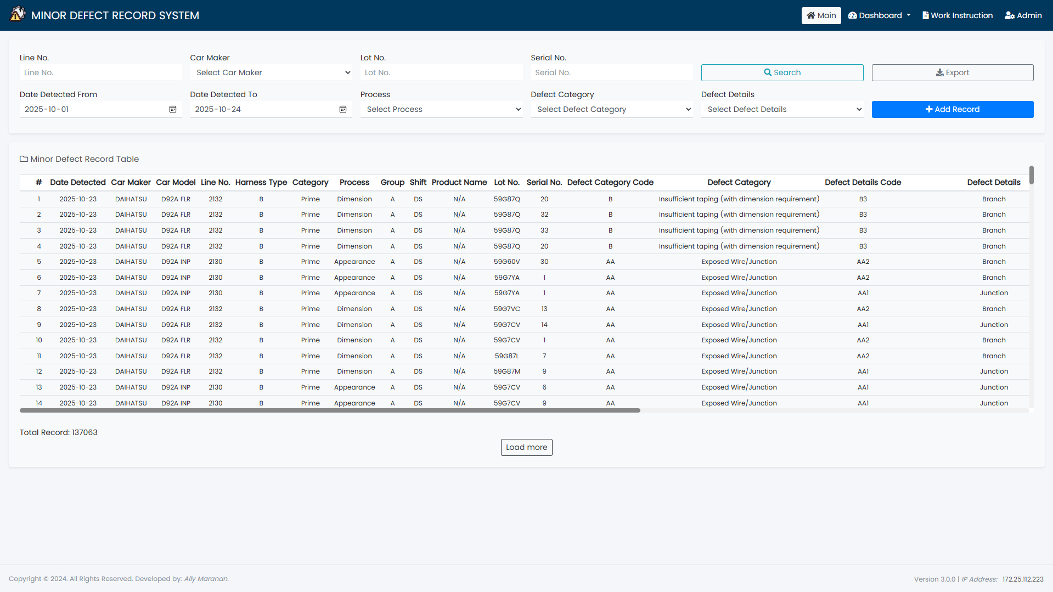
1.2
1.4
1.3
1.1
Figure 2. Viewer Page

- DASHBOARD INTERFACE
- Daily Monitoring
1.1 The daily monitoring dashboard includes the following chart analysis. The data is filtered by month, and default view displays data for the current month. See Figure 3
- Defect Category Record – this shows the overall defect record sorted by the defect categories.
- Defect Details – this shows the defect details of the selected defect category.
- Top 10 Lines based on the selected defected category.
- Top 10 Lot No. – this shows the top 10 lot no.
- Top 10 Sequence No. – this shows the top 10 sequence no.
- Top 10 Connector No. – this shows the top 10 connector no.
- Top 5 Defect Categories per Section – this shows the top 5 defect categories sorted by section.
- Defect Records per Section – this shows the overall record sorted by section.
- Top 10 Lines based on the selection section.
- Daily Defect Record Trend – this shows the daily trend of defect records based on the filtered month.
- Defect Category Record based on the selected day from Daily Defect Trend.
- Top 10 Lines with defect record based on the selected day from the Daily Defect Trend.

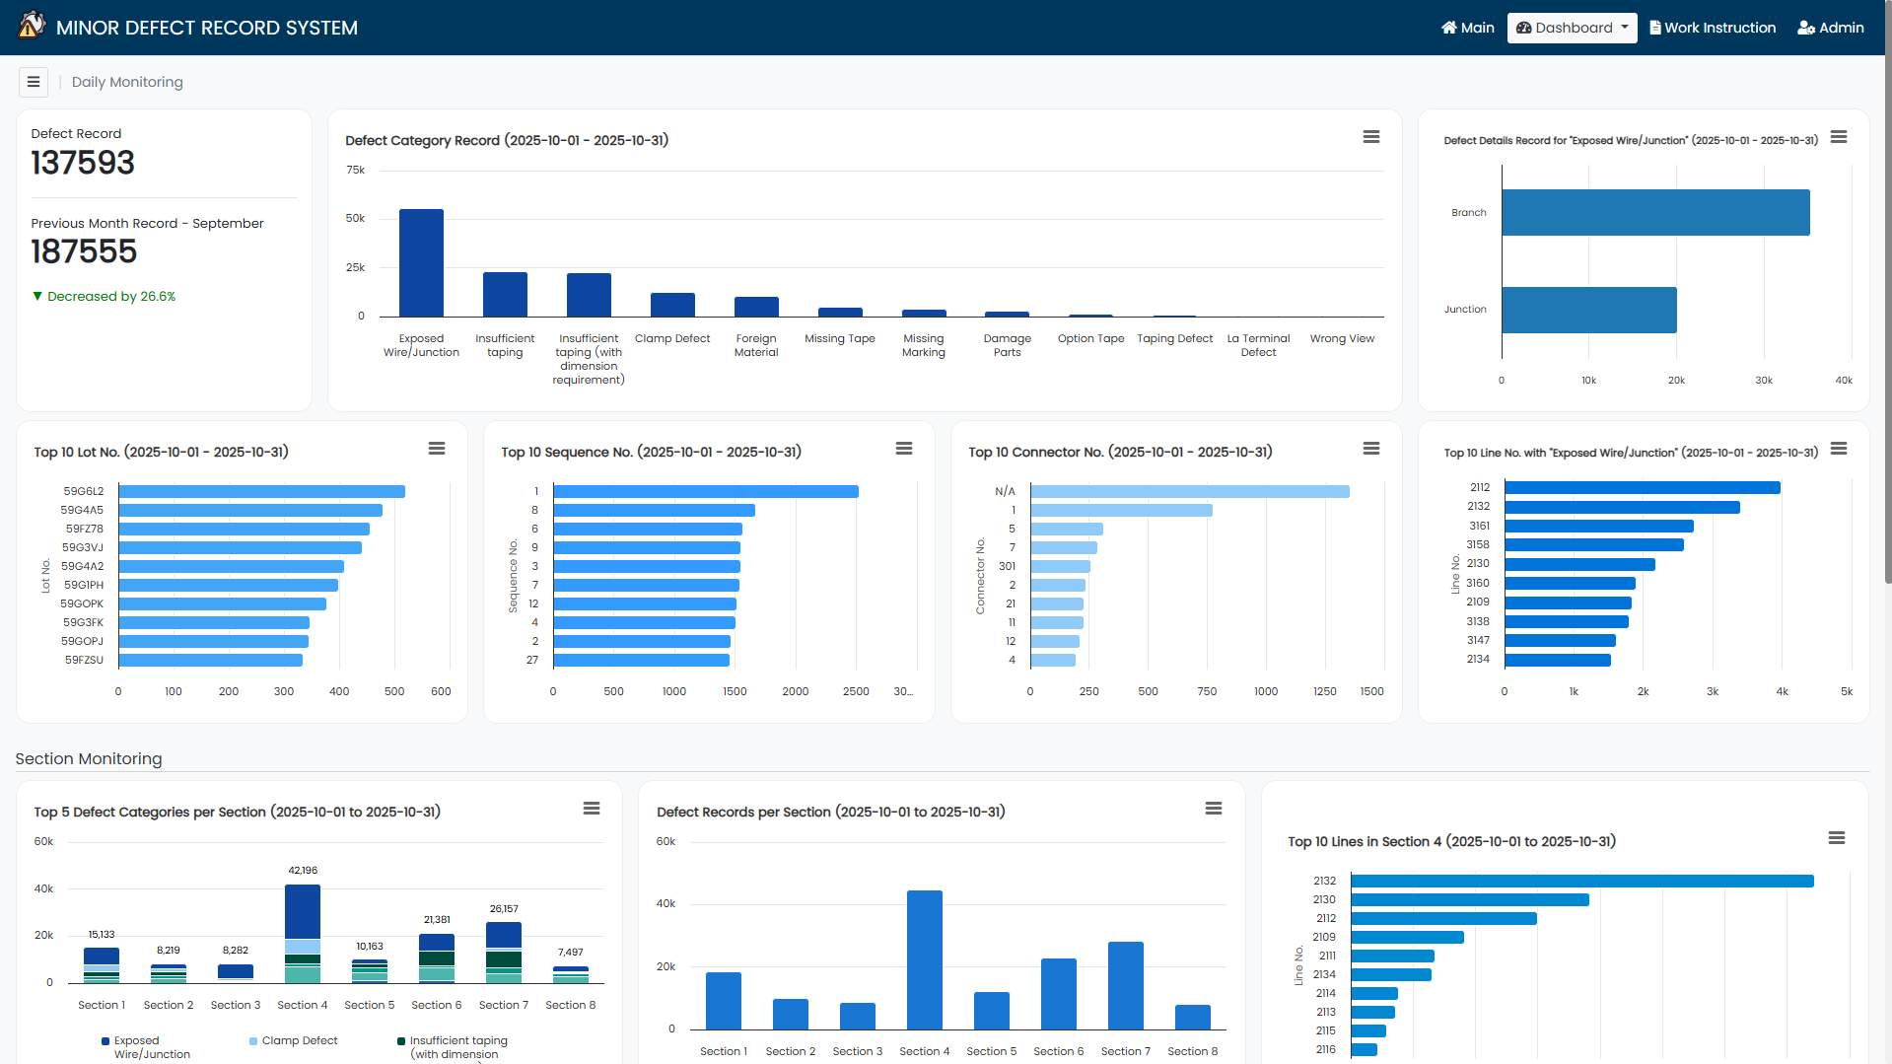
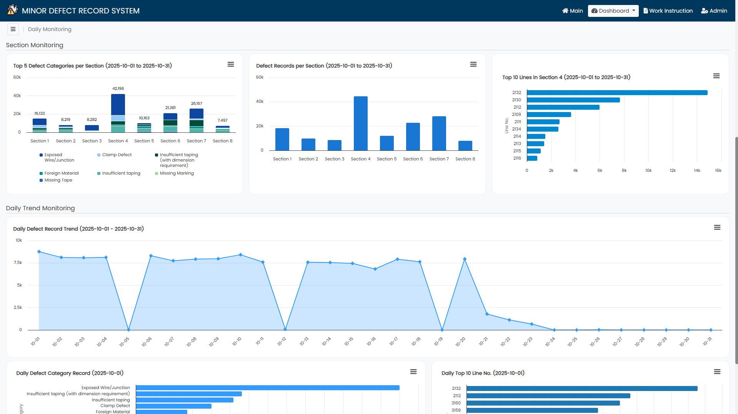
Figure #.
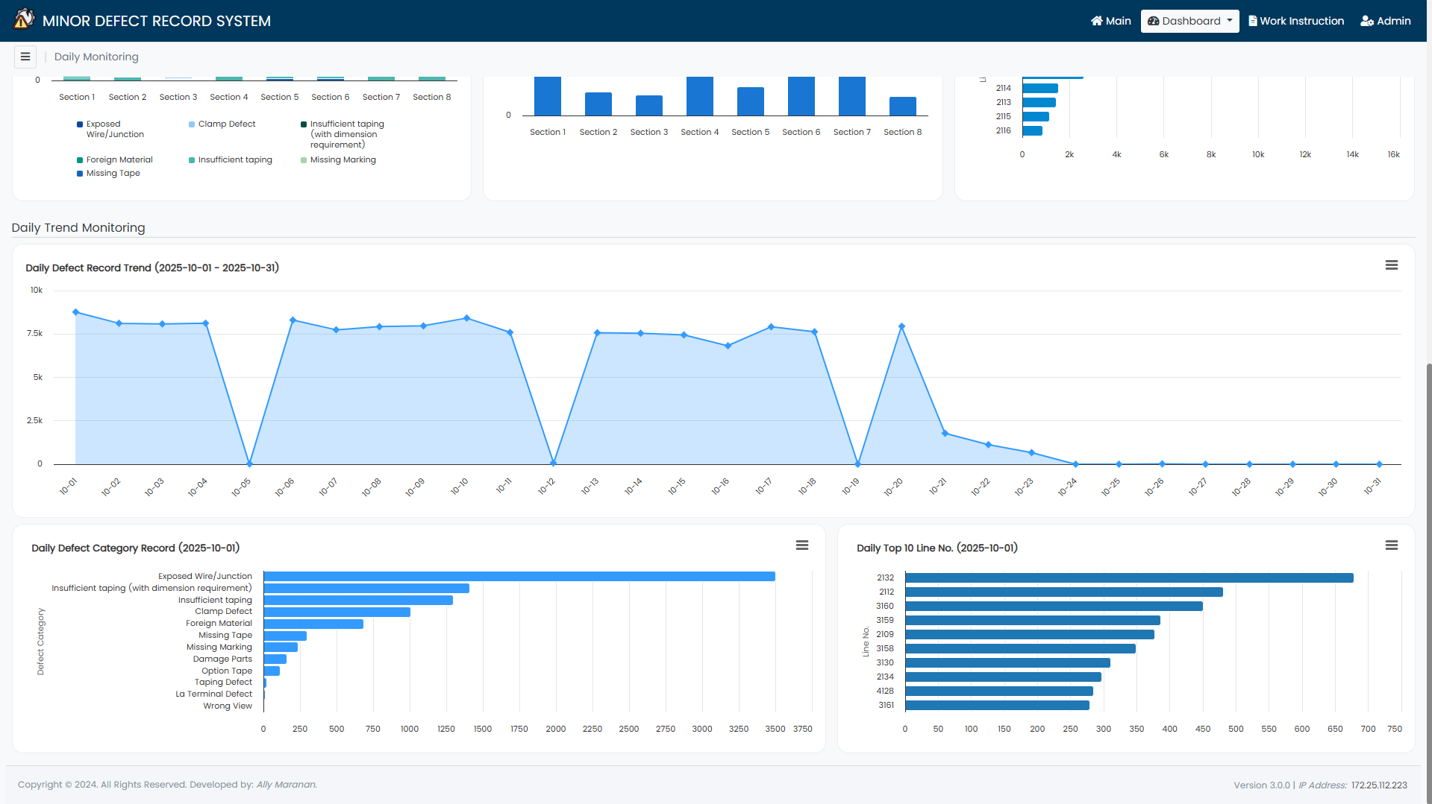
Figure 3. Daily Monitoring Dashboard

- Overall Monitoring
2.1 The overall monitoring dashboard includes the following chart analysis. The data can be filtered by year, month, defect category, and section. See Figure 4
- Overall Monthly-Weekly Defect Records – this shows the defect records sorted by week based on the filters.
- Harness Type Breakdown – this shows the percentage of big and small harness based on the filters.
- Summary per Detection – this shows the top process with most defects were detected based on the filters.
- Overall Defect Record per Section – this shows the weekly breakdown of defects sorted by weeks and filters.
- Top 10 Lines – this shows the top lines per week based on the filters.
- Defect Category Weekly Breakdown – this shows the weekly record of the selected defect category.
- Defect Details by Category Weekly Breakdown – this shows the weekly record of the defect details based on the filtered defect category.
- Top Sequence No. by Process – this shows the top 5 sequence no. by process detected.
- Top Connector No. by Process – this shows the top 5 connector no. by process detected.
- Weekly Breakdown per Line Category – this shows the line category record result sorted by weeks.

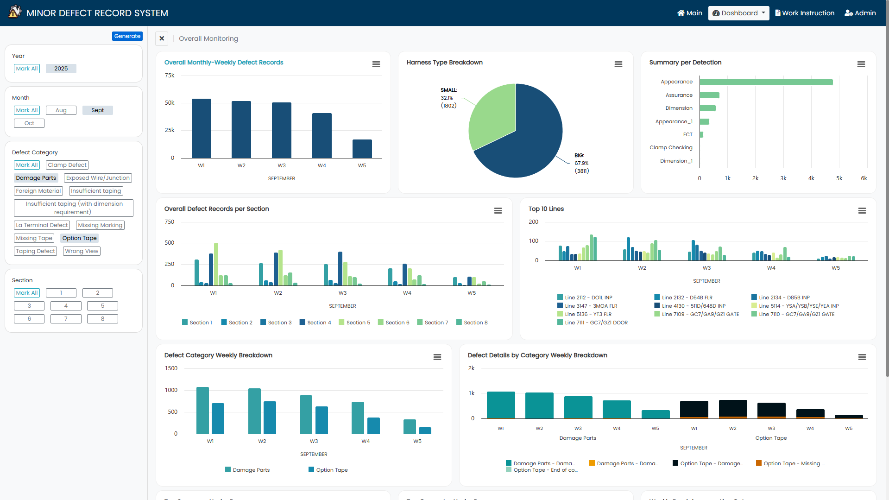
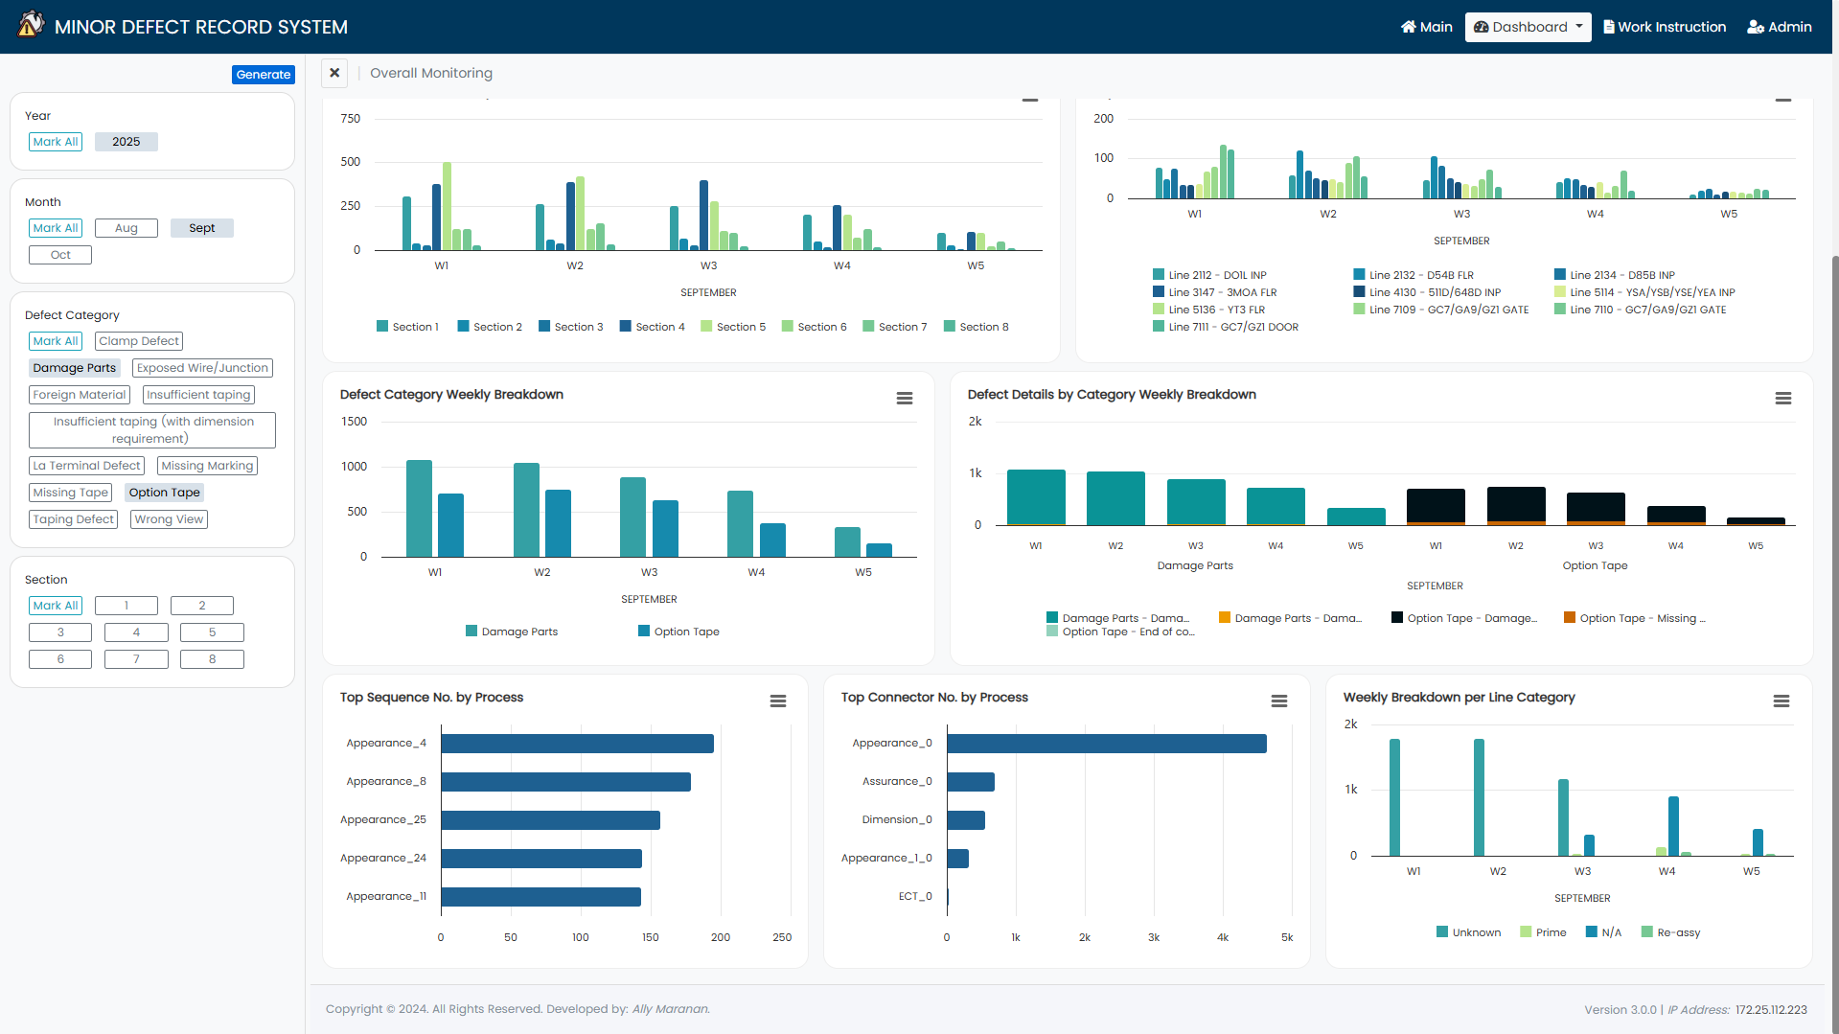
Figure 4. Overall Monitoring Dashboard

- QC INTERFACE
  - New Record Authorization
1.1 Upon clicking on the Add Record button, the access authorization will show. This is to ensure that only registered QC personnel will add defect records.

The user must enter their registered ID number to be able to proceed with adding of record/s. Then, click on the Enter button. See Figure 5

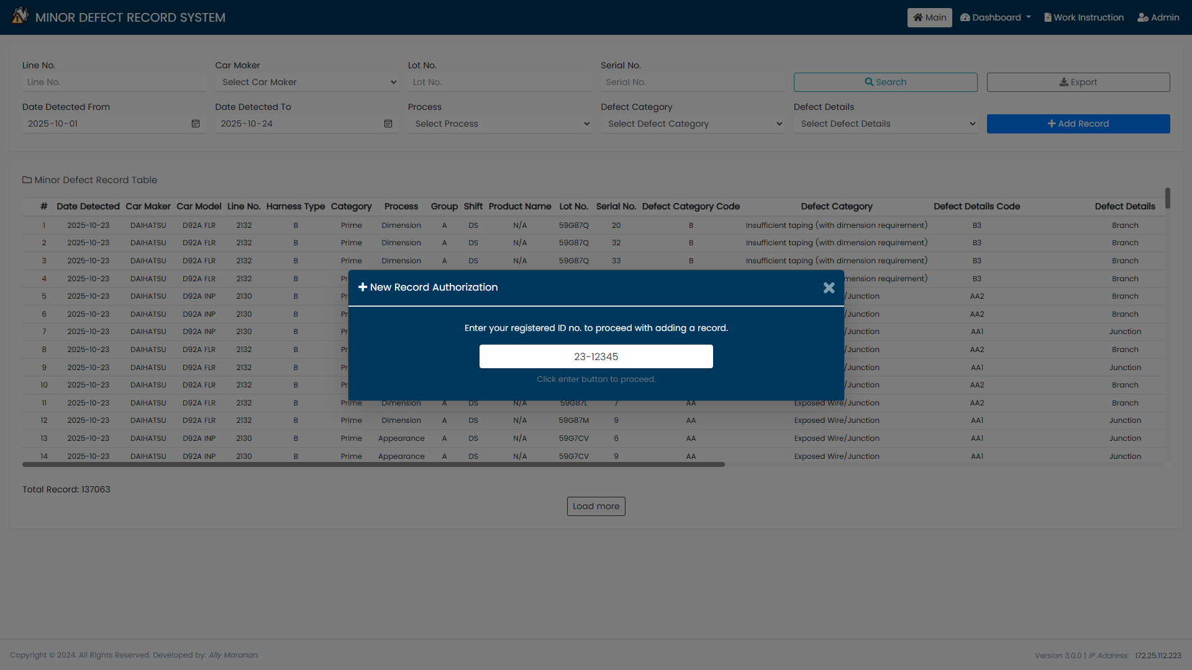
1.1
1.1
Figure 5. New Record Authorization Access

1.2 Otherwise, an alert will pop notifying that the ID number entered is not registered. If ID number is needed to be registered, contact IT – System Group for the account registration. See Figure 6
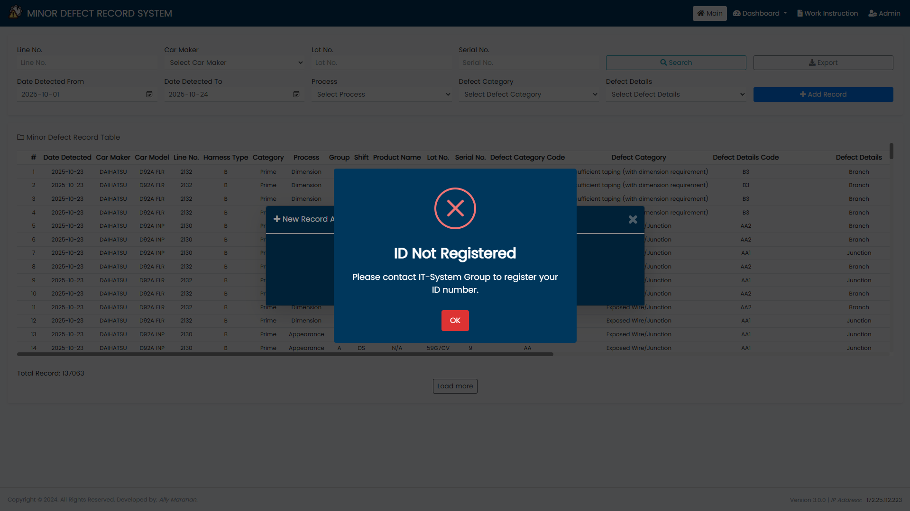
1.2
Figure 6. ID Not Registered Alert

  - Add Record
2.1 After successful access, the Add Record form will be displayed. See below data type. See table below.

INPUT FIELD | TYPE/CONDITION | DEPENDENT FIELDS
Date Detected | Manual selection
Line No. | Manual input | Car Maker, Car Model, Process
Group | Dropdown selection
Shift | Dropdown selection (default to N/A)
Product, Lot, and Serial No. | Manual input
Defect Details Code | Manual input | Defect Category, Defect Details, Treatment Content of Defect
Total Minutes | Manual Input
Sequence No. and Connector No. | Manual input
Repaired By and Verified By | Manual input (default to N/A)

2.2 All fields are required to be filled out; otherwise, the record will not be saved.

In the upper right corner, the name of the user is displayed, indicating that all added records will be attributed to the currently logged-in user. See Figure 7

Note: When the user closes the form, the authorization access modal will prompt again.

2.3 For adding records, the QC personnel may add either a single record or multiple records.

When all fields are filled and the user clicks the Add Record button, the values for Date Detected, Line No., Car Maker, Car Model, Process, Group, Shift, Product, Lot, and Serial No. will be retained. This allows the user to add new records under the same nameplate information.

Note: Upon entering the Line No., the associated Car Maker, Car Model, and Process will be fetched automatically. Similarly, upon entering the Defect Details Code, the corresponding Defect Category, Defect Details, and Treatment Content of Defect will be fetched automatically.

To reset the form, the user must click the Clear All button. See Figure 8
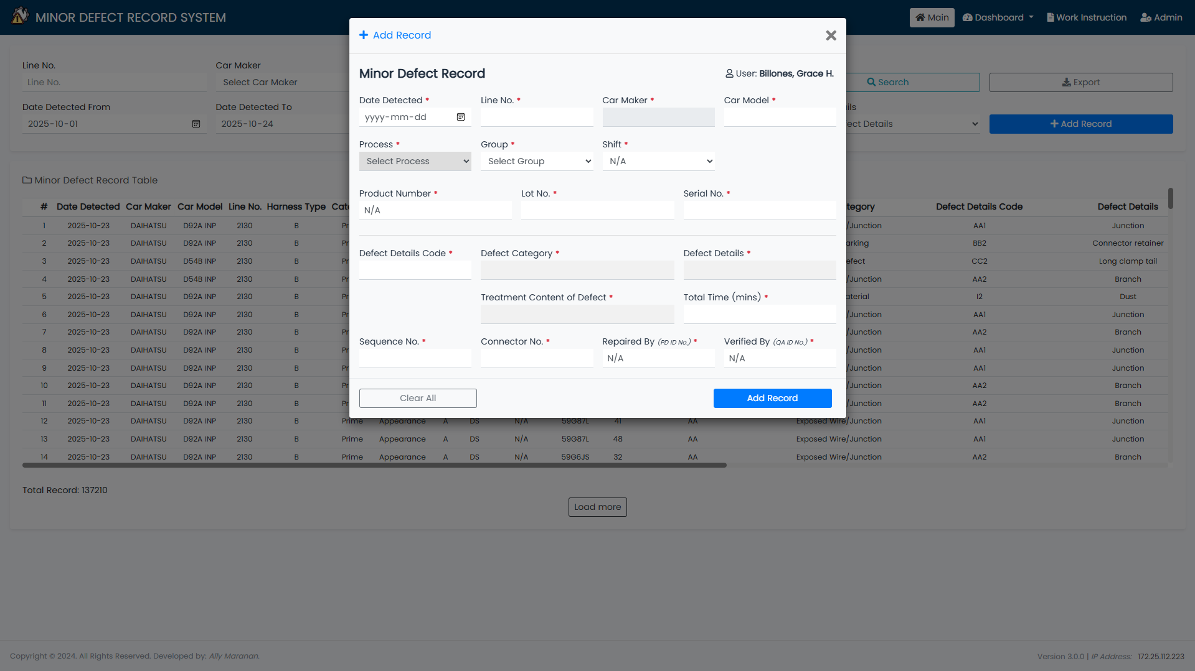
2.2
Figure 7. Add Record Form (with complete fill-out)

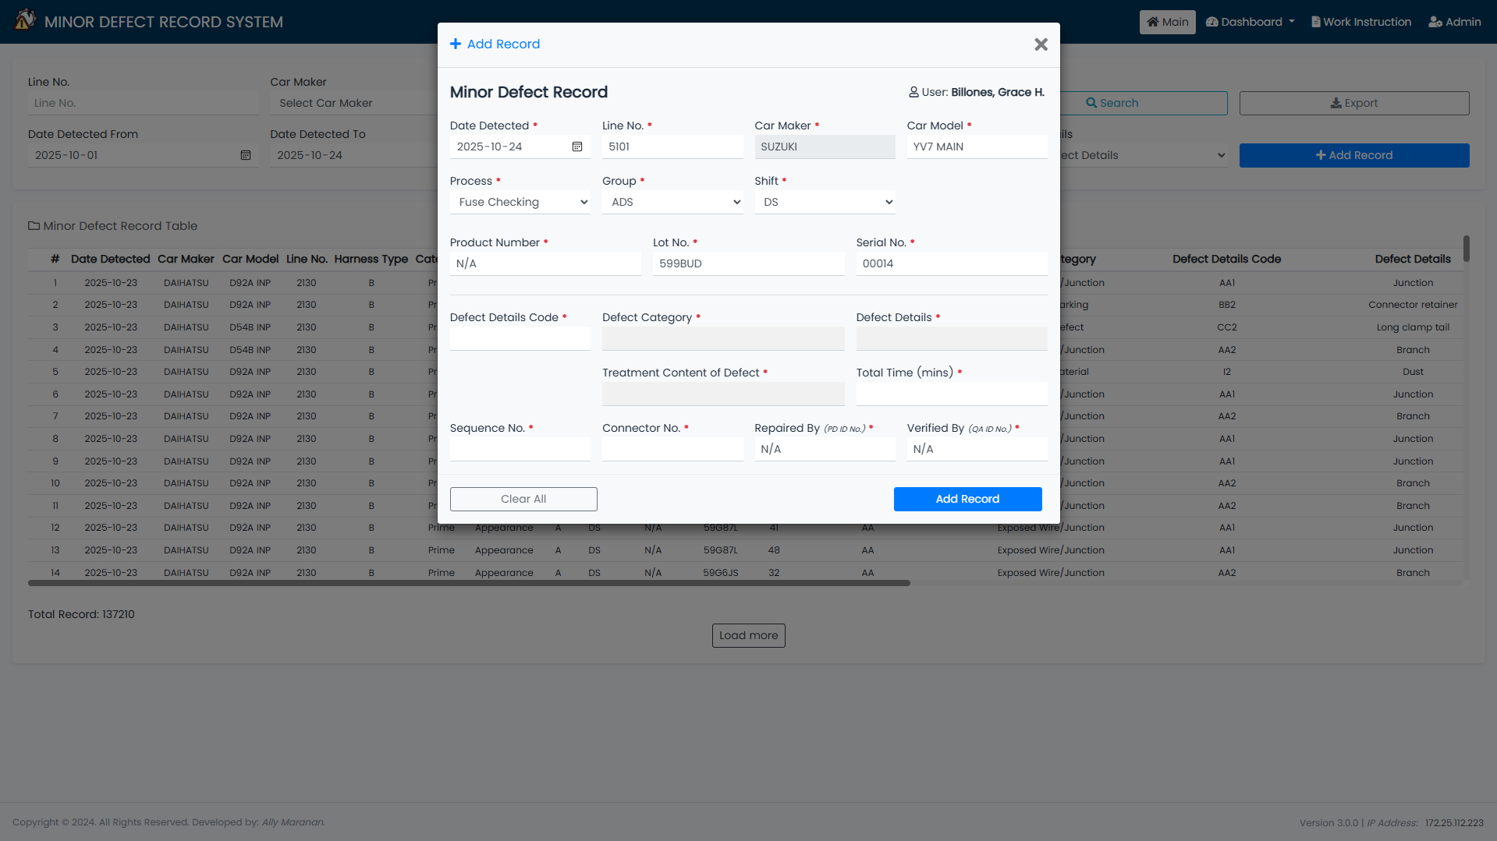
2.3
Figure 8. Add Record Form (values retained, for multiple record)

- ADMIN INTERFACE
- Login
1.1 Input the correct credentials to access the master list. See Figure 9

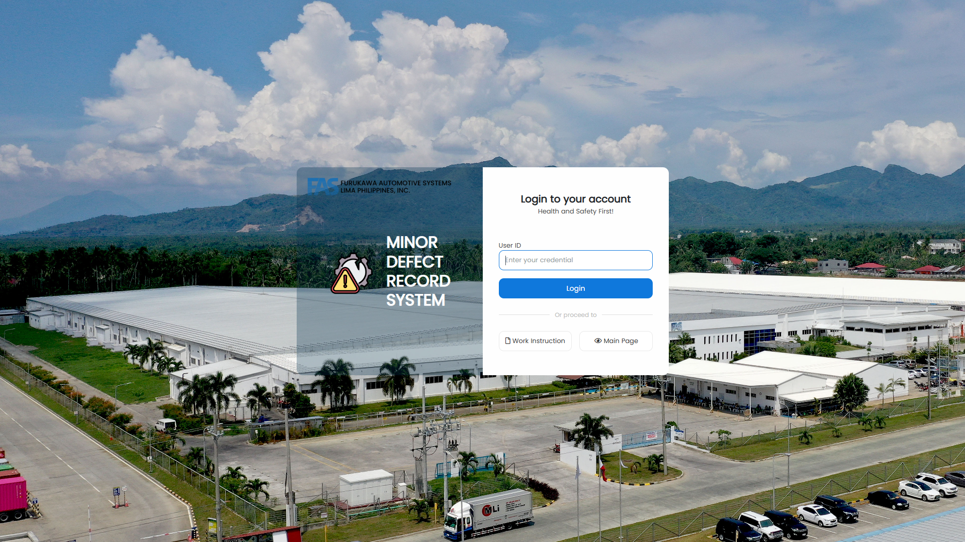
1.1
Figure 9. Login Page

- Defect Details
2.1 Click on the Defect Details tab to view the defect category and details.

To add defect details, click on the Add Defect Details button. Fill-out the needed details (defect code, defect category, defect sub code, defect details, and defect treatment), then save the record. See Figure 10
2.1

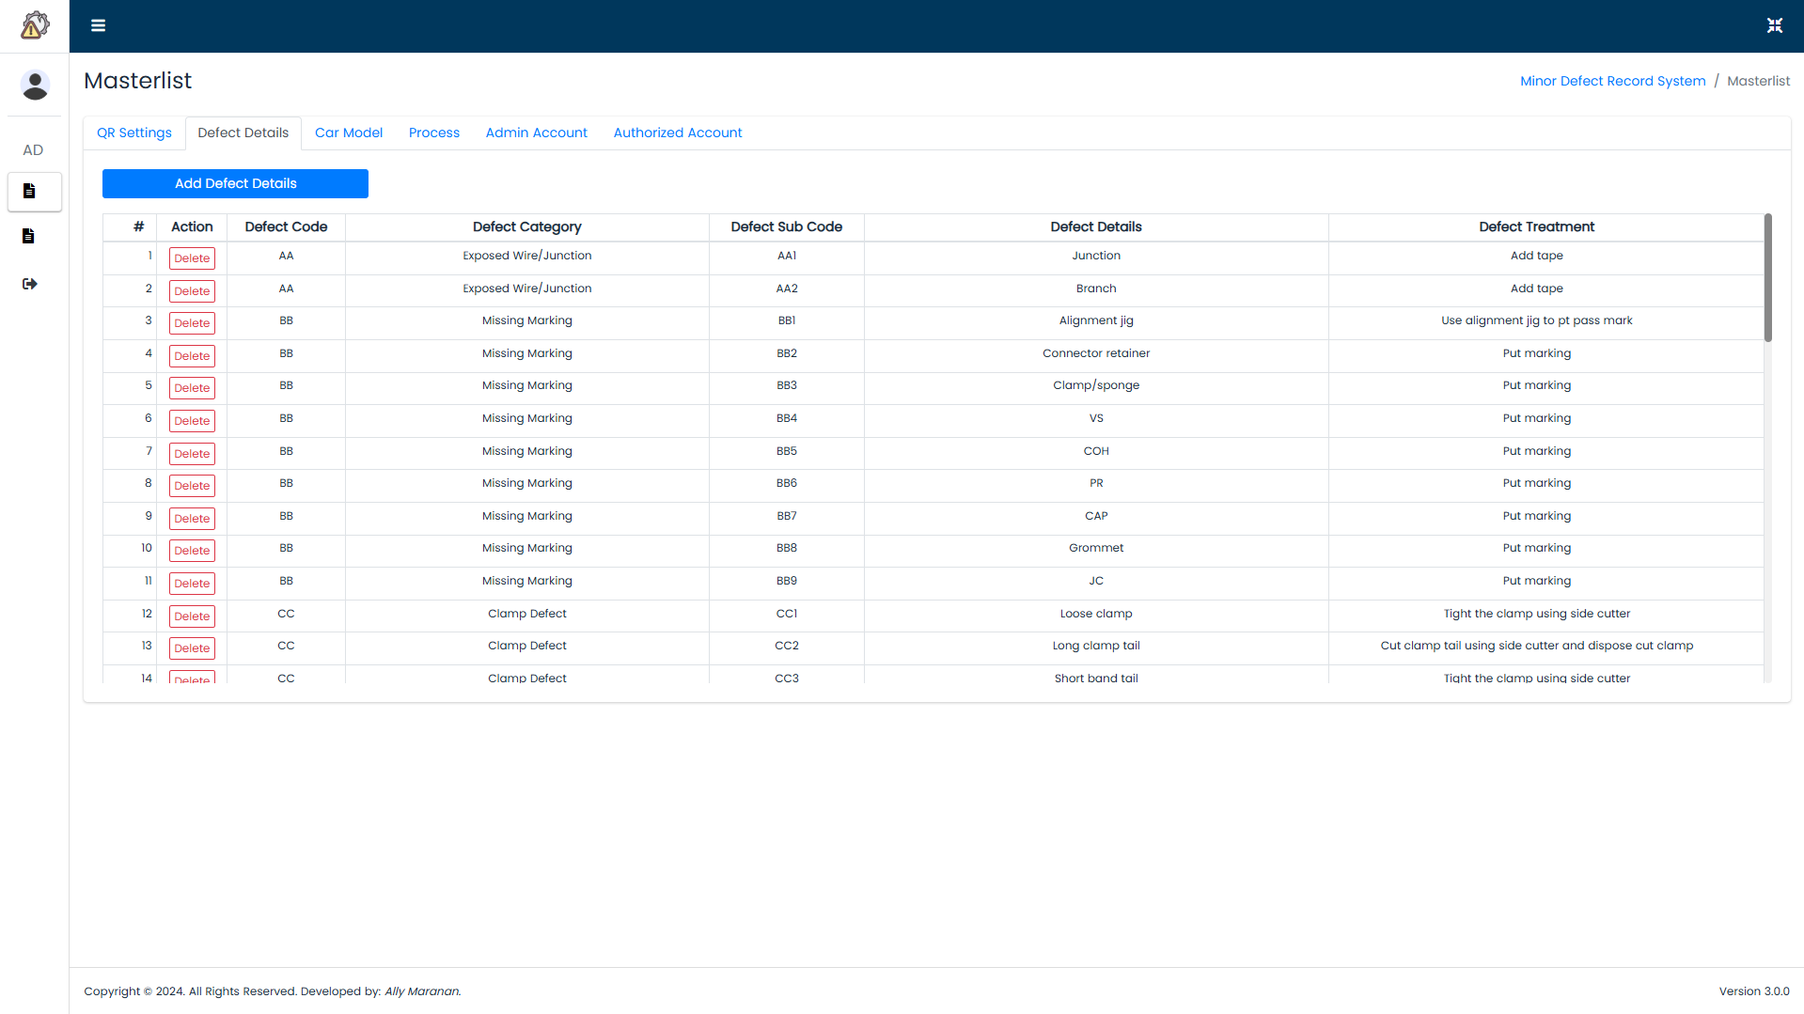
Figure 10. Defect Content Master List

- Car Model
3.1 Click on the Car Model tab to view the list of lines and its section, car maker, car model, and harness type.

To add car model, click on the Add Car Model button. Fill-out the needed details (line no., section, car maker, car model, and harness type), then save the record. See Figure 11
3.1
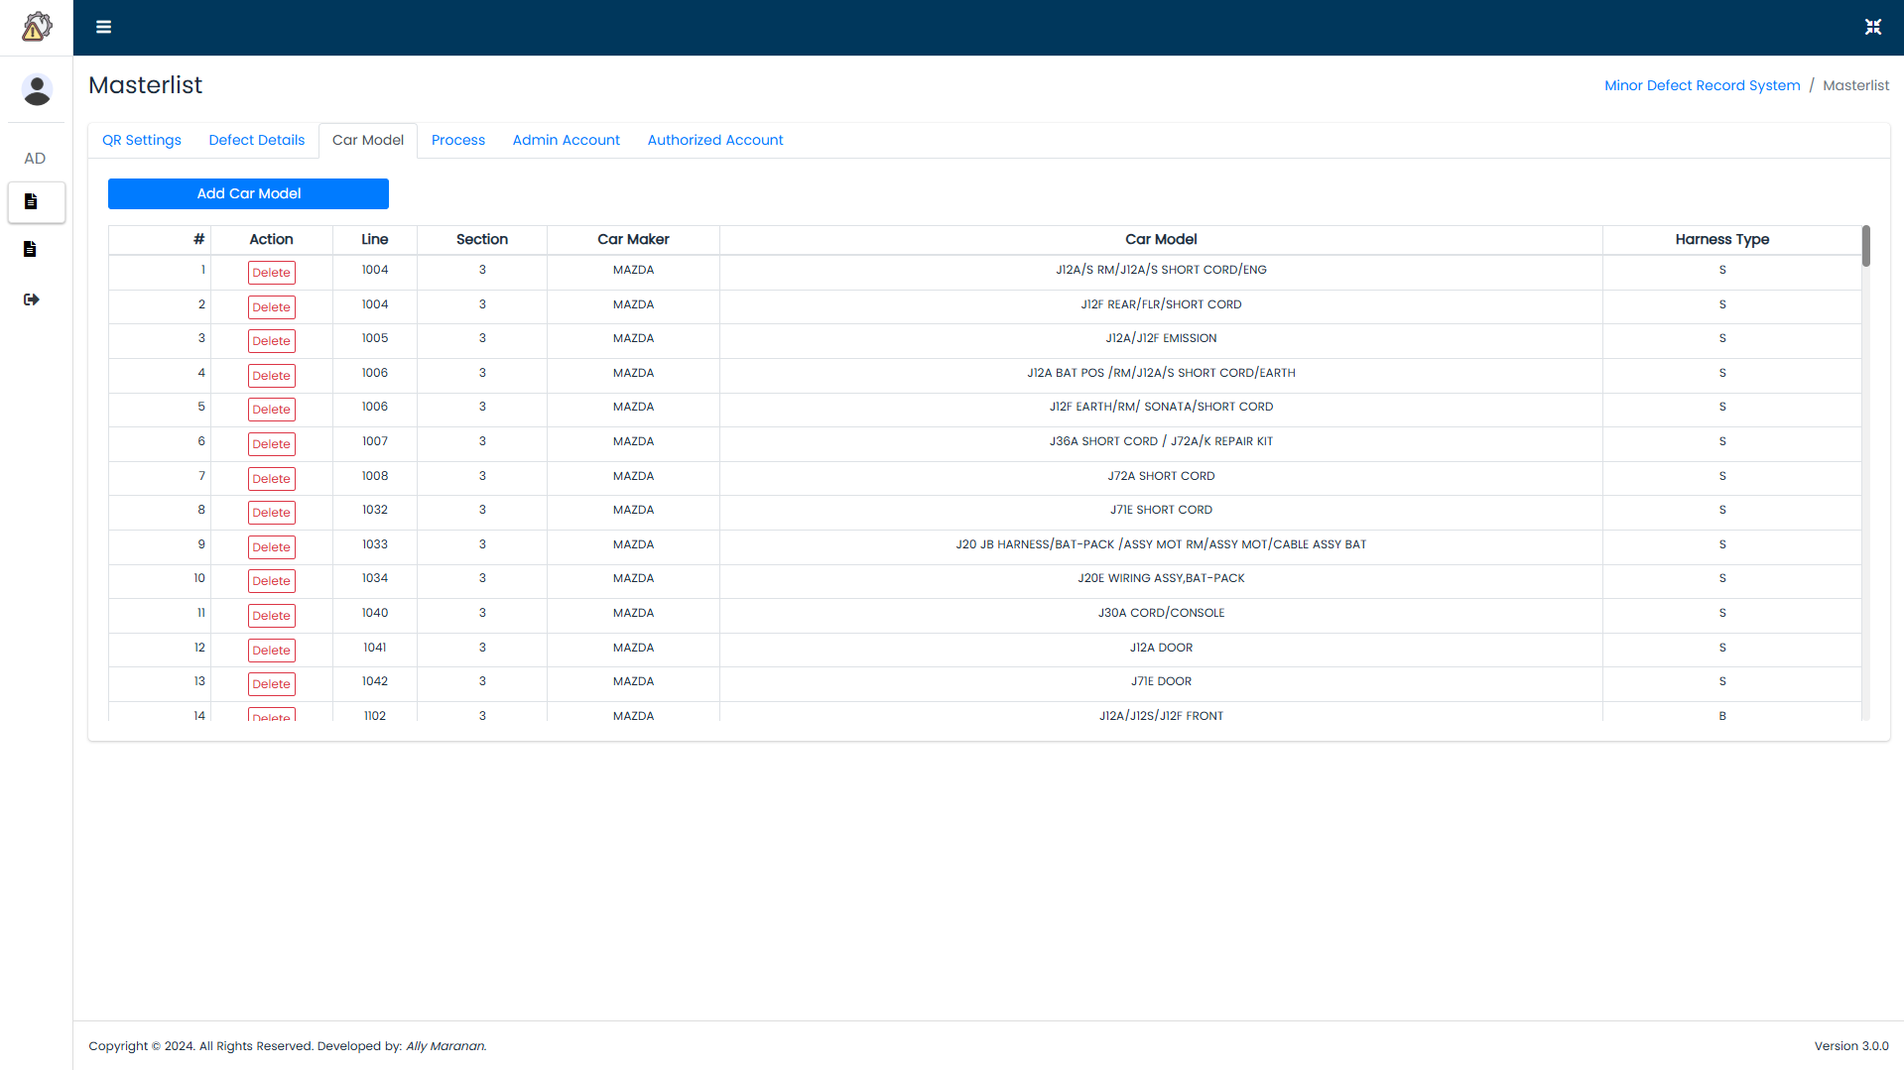
Figure 11. Car Model Master List

- Process
4.1 Click on the Process tab to view the list of applicable processes per line no.

To add process, click on the Add Process button. Fill-out the needed details (line no. and process), then save the record. See Figure 12

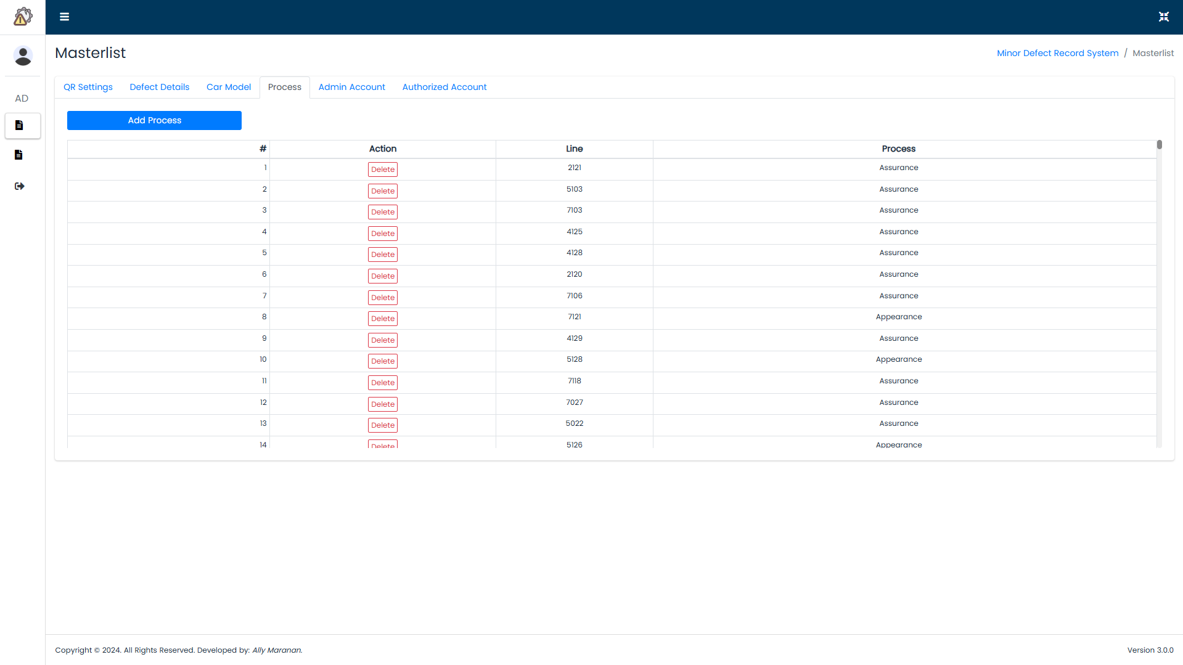
4.1
Figure 12. Processes Master List

- Admin Account
5.1 Click on the Admin Account tab to view the list of admin accounts who are allowed to alter or update the master list or records.

To add account, click on the add account button. Fill-out the needed details (username and role), then save the record. See Figure 13

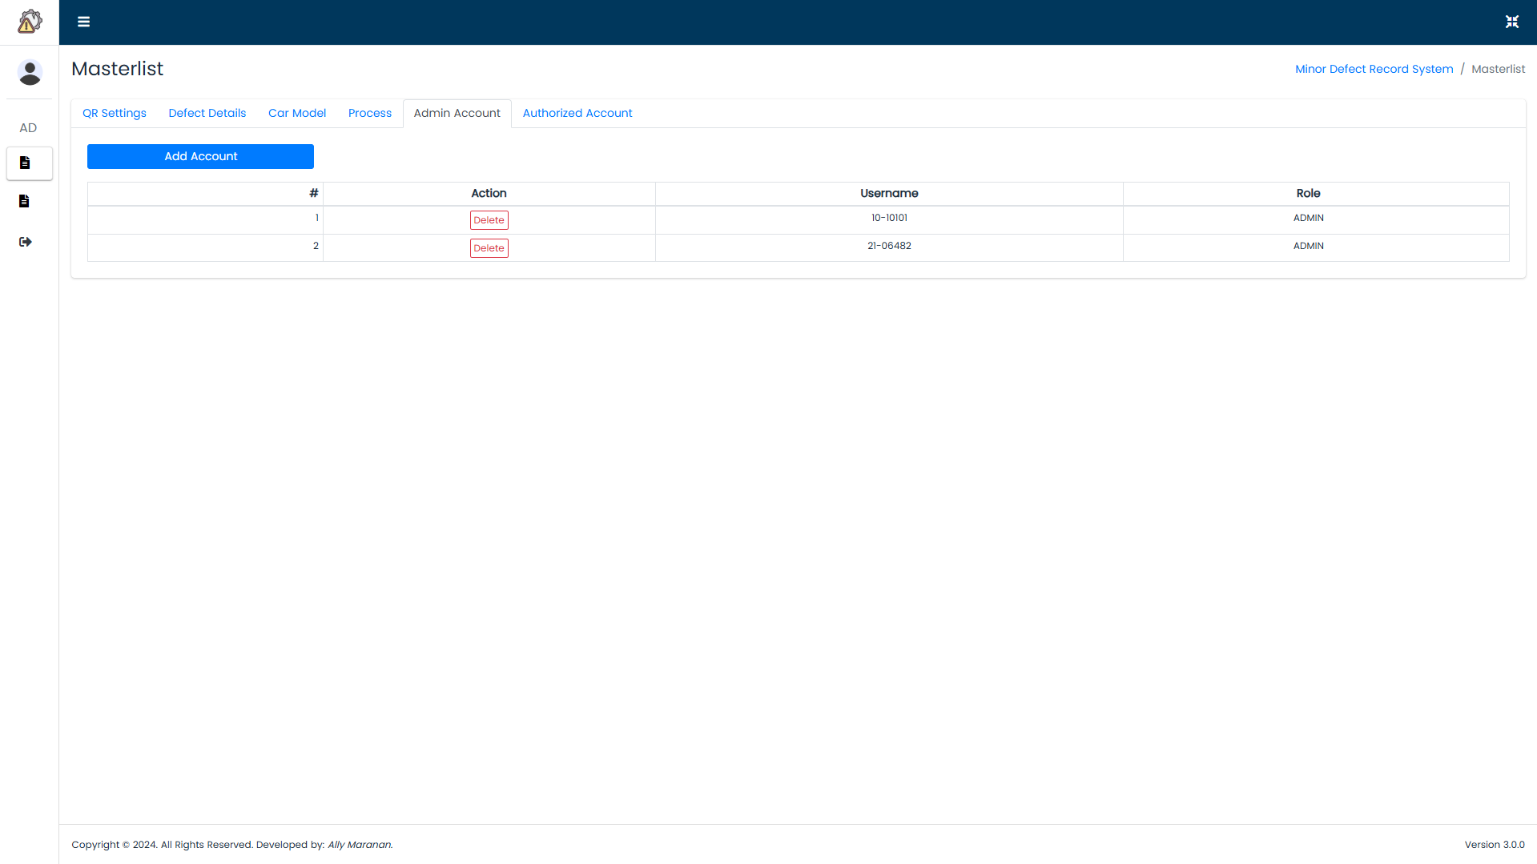
5.1
Figure 13. Admin Account Master List

- Authorized Account
6.1 Click on the Account Management tab to view the list of registered accounts.

To add account, click on the Add Account button. Fill-out the needed details (username and role), then save the record. See Figure 14

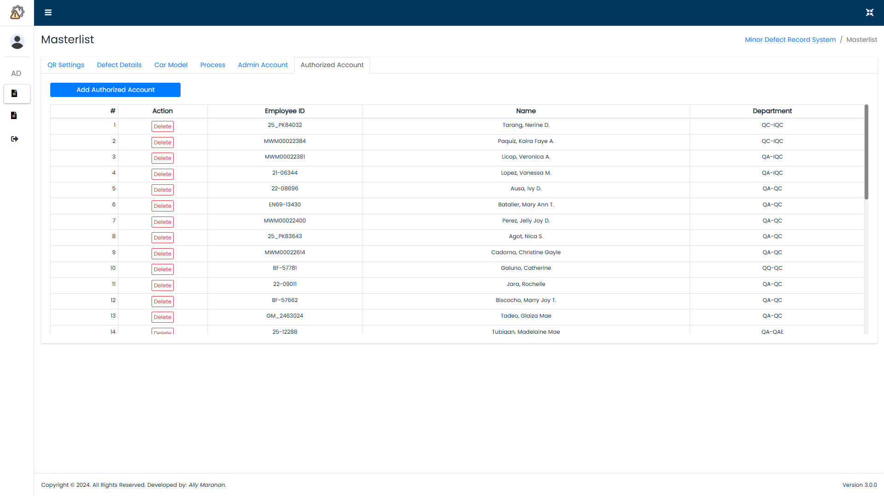
6.1
Figure 14. Authorized Account Master List

- Defect Record List
7.1 Proceed to minor record list tab. See Figure 15
7.2 Use the available search fields (date detected from, date detected to, line no., and process) to filter the desired data. See Figure 15
7.3 The table displays the overall record of the minor defect system. See Figure 15
7.4 The edit function enables to retrieve the existing data and allow the authorized user to modify or update the record. See Figure 16
7.5 All fields can be edited. After modification, click on the Update Record button to save the changes. See Figure 16

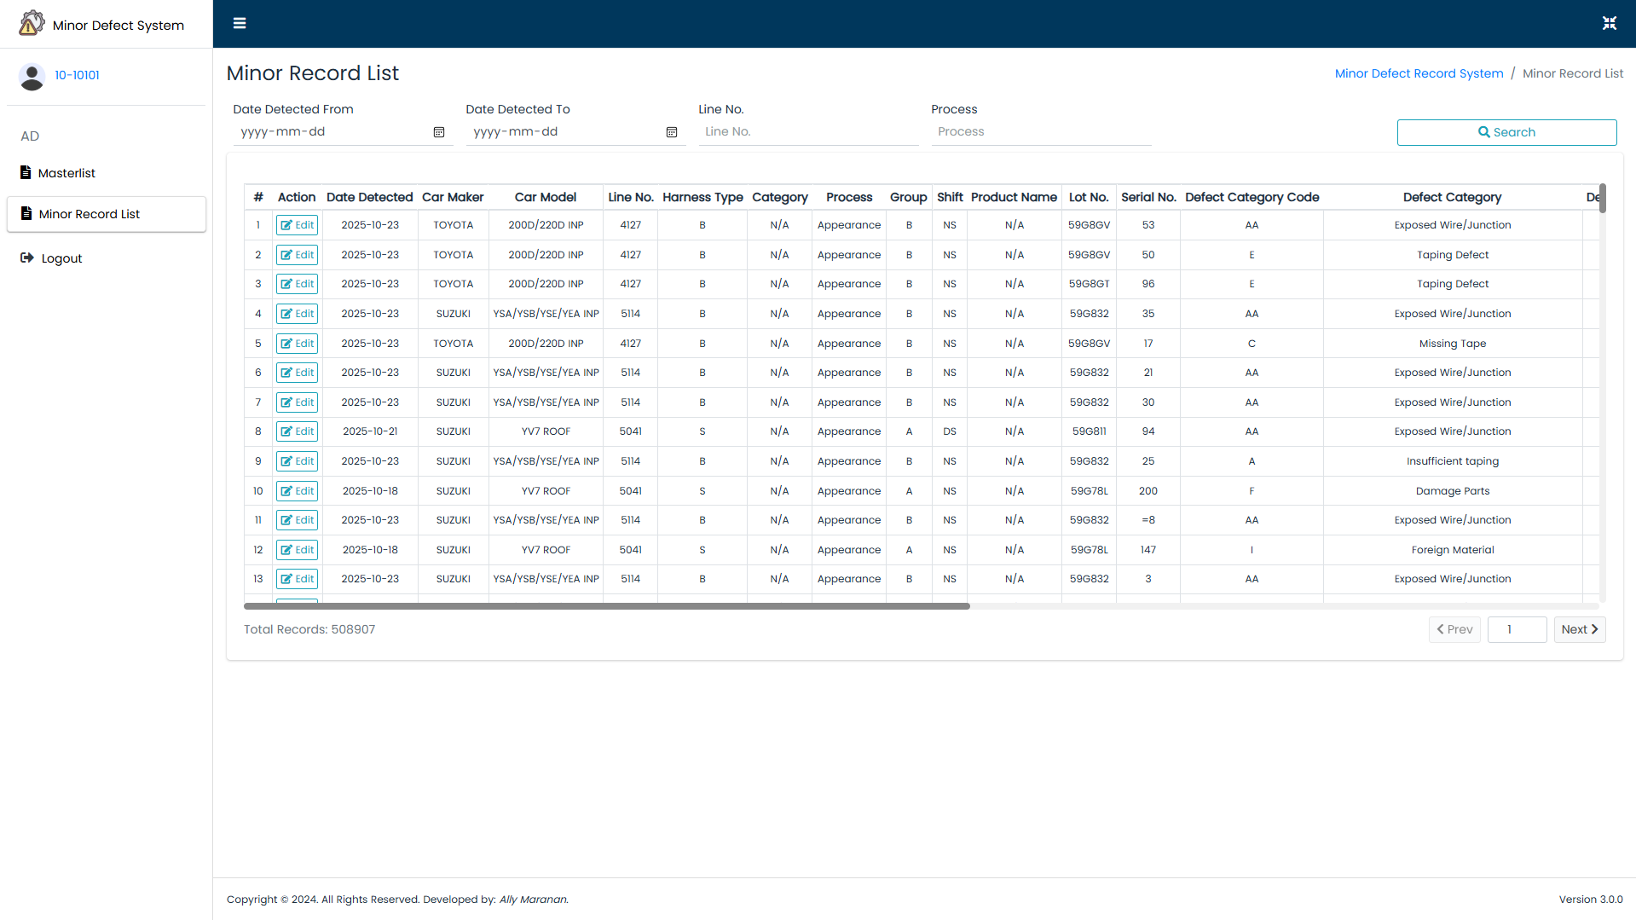
7.4
7.3
7.1
7.2
Figure 15. Minor Defect Record Master List

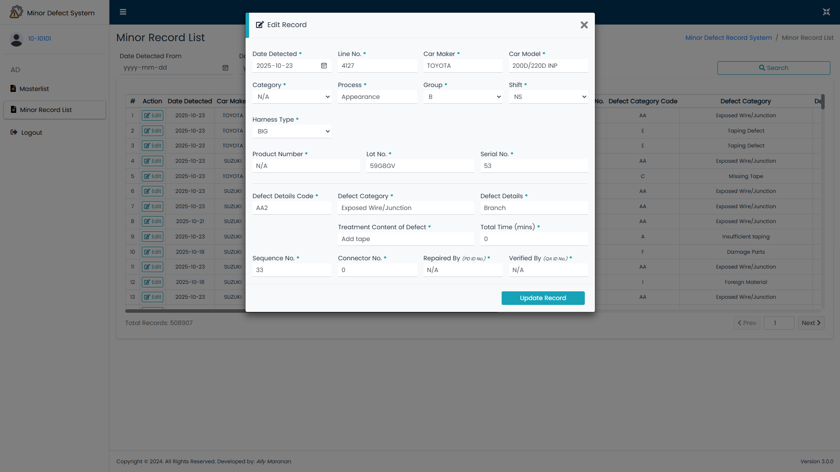
7.5
Figure 16. Edit Defect Details

- END -

