

**Minor Defect Record System**

Work Instruction

IT | System Group

A web application that provides comprehensive functionality for managing and analyzing minor defects on production lines. Key features include:

* Defect Tracking: Efficiently record and monitor defects per production line.
* Data Management: Capture essential details such as date detected, car maker and model, line number, process, product number, lot number, serial number, defect category, defect details, treatment content, sequence and connector numbers, and personnel involved in repair and verification.
* Trend Analysis: Utilize recorded data to analyze trends and visualize performance metrics.
* Reporting: Generate insightful reports to aid in decision-making and quality control.

This system is designed to streamline defect management and enhance data-driven decision-making through effective tracking and analysis.

1. **Viewing Page**

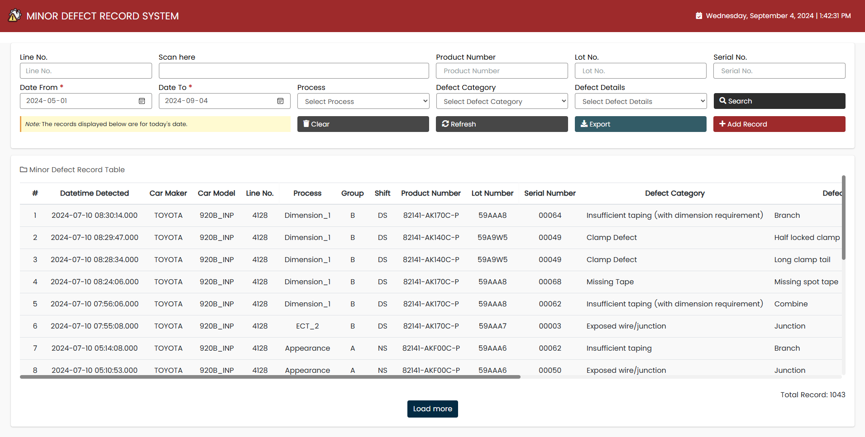

C

B

A

*Figure 1.* Viewer Page

This page offers a comprehensive overview of the system, structured to enhance usability and efficiency:

**1.A.** At the top of the page, the user will find a set of search fields designed to help them quickly locate specific records. These fields allow them to filter data based on various criteria, making it easier to find relevant defect records based on above parameters. By default, the date from and date to is set to current date.

**1.B.** Below the search fields, the main section of the page features a detailed table displaying the defect records that match the search criteria. This table is organized to provide a clear and concise view of all added defect records. The table also includes load more to help users to navigate through large sets of records efficiently.

**1.C.** In the lower right of the table, it displays the total count of records. These changes based on the data shown in the table.

1. **Adding of Record**

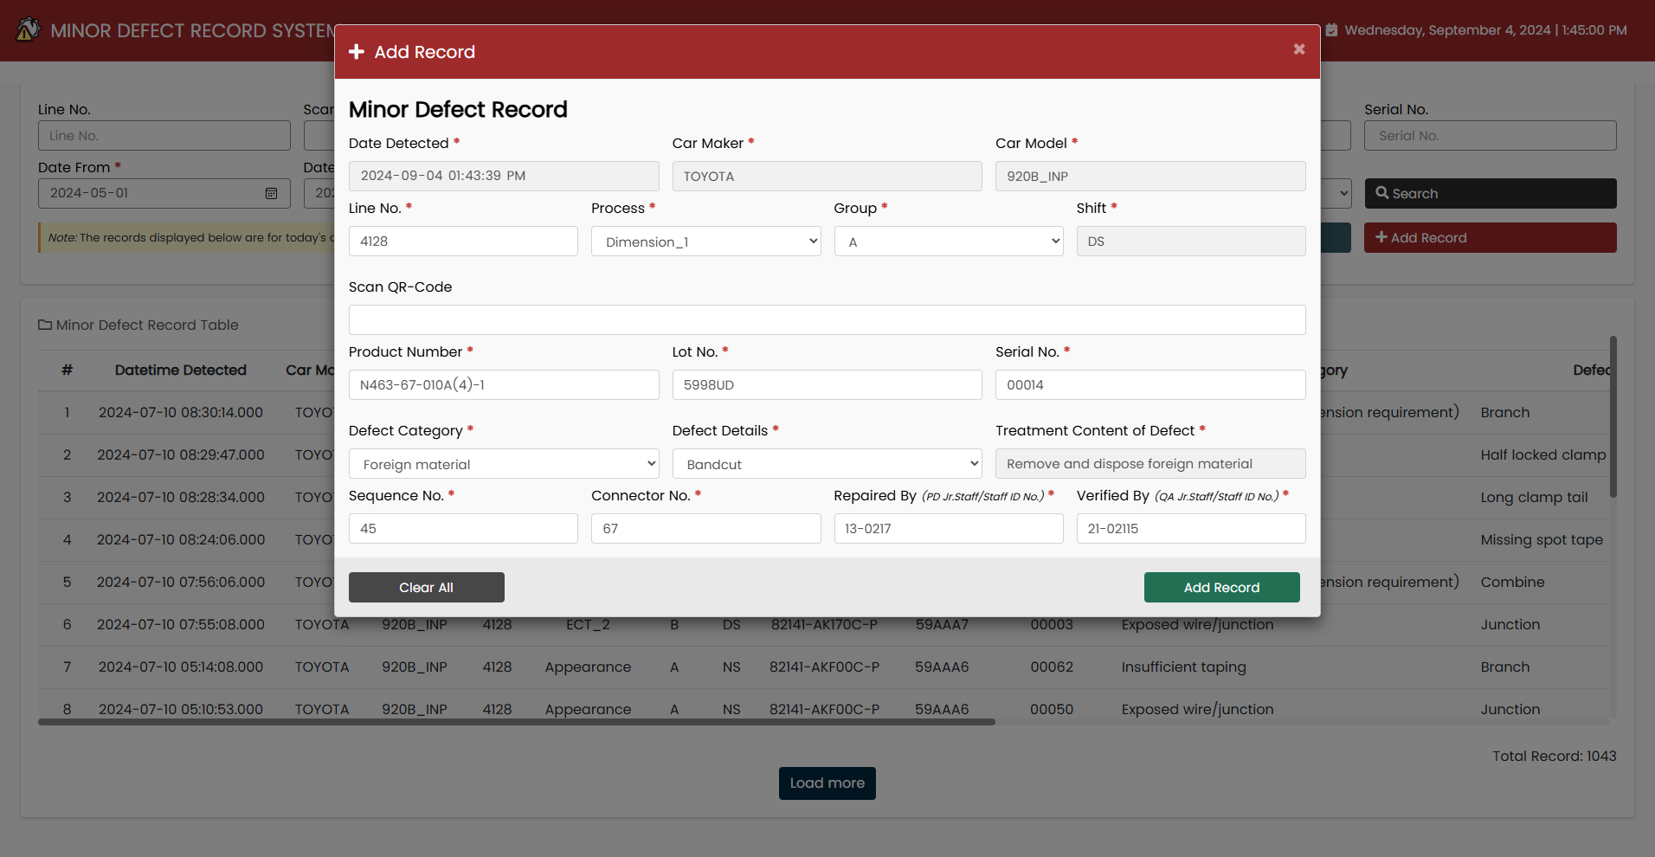

C

B

A

*Figure 2.* Add Record

 Upon clicking the add record button [ ], the add record form will appear. This contains the following:

**2.A.** The datetime detected is auto-generated. The car maker and model are automatically fetched based on the selected line number. The list of processes is based on the processes associated with the selected line number. The shift is also automated.

**2.B.** When a harness is barcoded, its product name, lot number, and serial number will be fetched automatically and displayed in their designated input fields.

**2.C.** When a defect category is selected, the corresponding defect details will be displayed in the dropdown menu. Similarly, the treatment content for the defect will be based on the selected defect details.

1. **Search Fields**

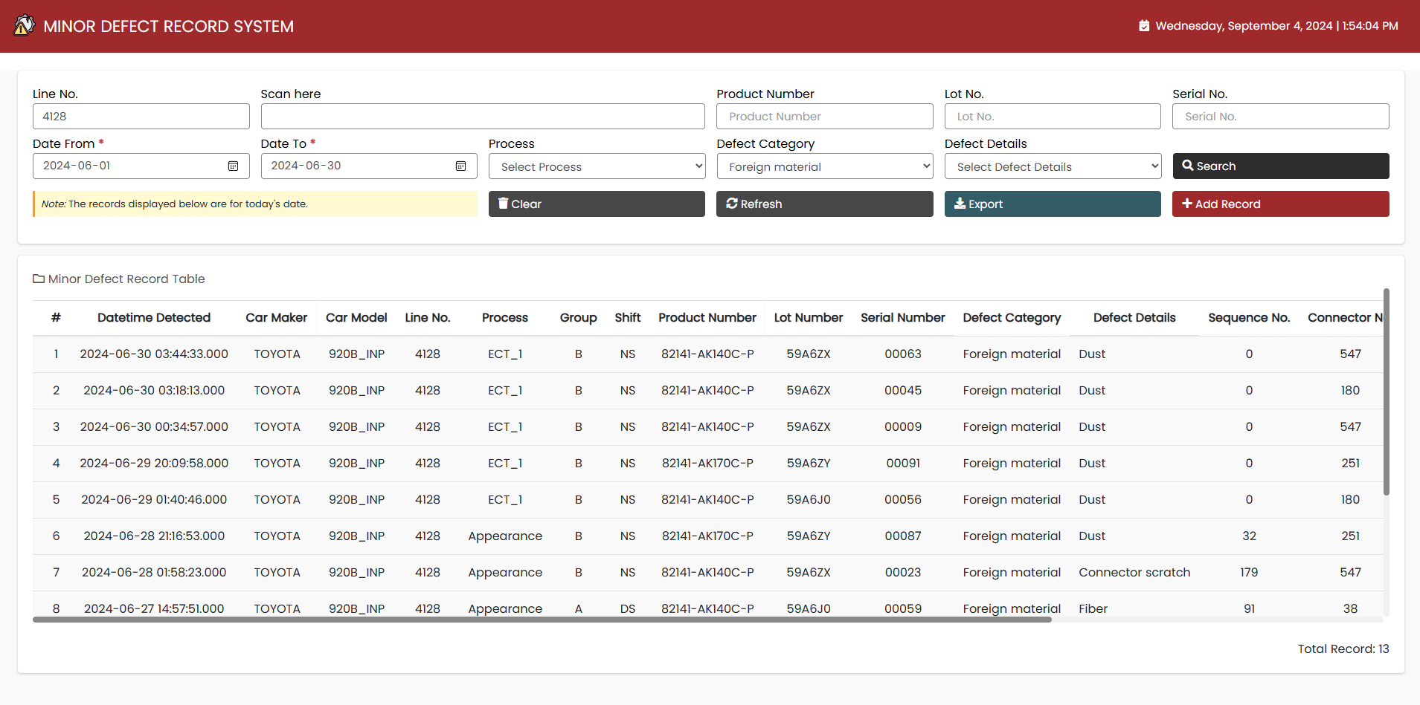

A

*Figure 3.* Search

**3.A.** In the highlighted part, the user will find a range of search fields designed to help them efficiently locate specific records. These fields enable the user to filter data by various criteria, allowing them to swiftly find relevant defect records based on parameters such as line no., product name, lot no., serial no. (these can be done manually or scan harness and it will search automatically), date from, date to, process, defect category, and defect details. By default, the date from and date to is set to current date.

1. **Export Record**



B

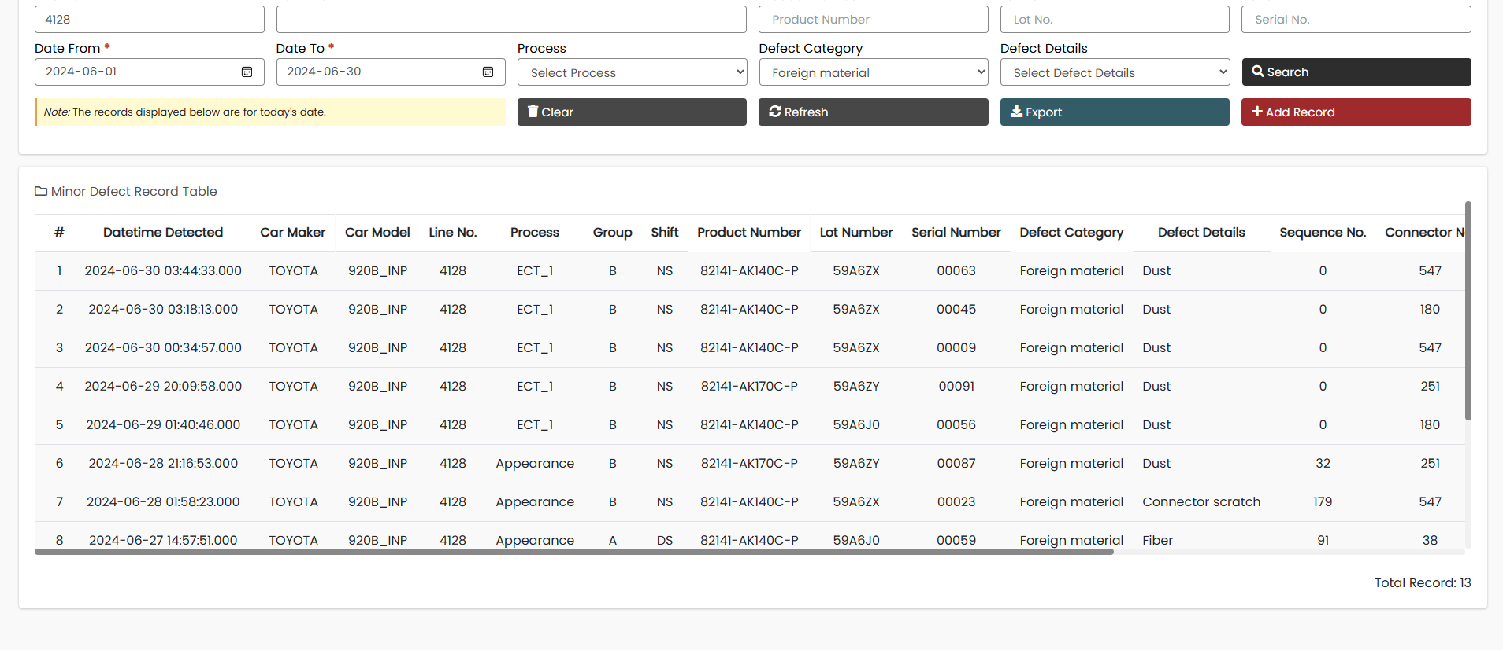

A

*Figure 4.* Export

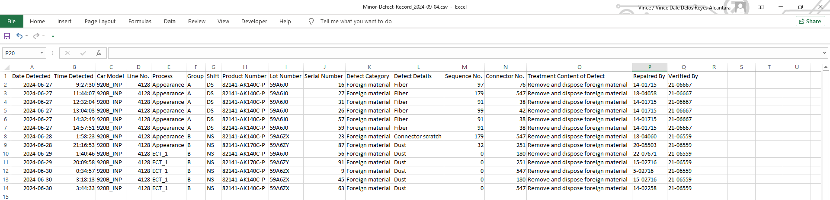

*Figure 5.* Exported Data

**4.A.** Once the user has filtered the data as needed, click the export button to download the file. The file will contain the filtered data from the table.

**4.B.** The downloaded file will be named based on the date of download, indicating the time it was saved.