S&P 500 Index: Datasource – <https://datahub.io/core/s-and-p-500#readme>

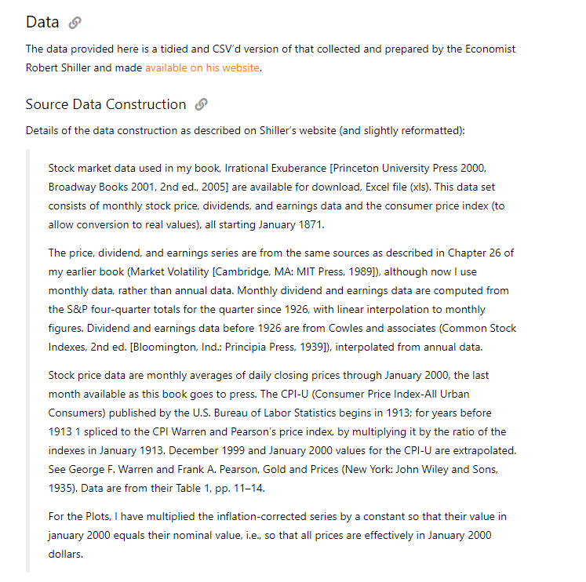

Natural Disaster Data - <https://public.emdat.be/data>

