Pabalinas, Joey
ICS 122 #21
11/18/17
- B
- G, C, M, H, D, E, J, F
- N, I, O, K, G
- D
- J, F
- D, C, B
- J, F, O, J, G
- J, O, K
- F, G
- 3
- 5
- Yes; each node has at most two children. No, because lexicographically ‘G’ comes after ‘B’.
- No, because the height of the right and left subtrees differ by more than one.
- B, G, M, N, H, I, C, D, E, J, O, K, F, G
- M, N, G, H, I, B, C, D, O, J, K, E, F, G
- N, M, I, H, G, O, K, J, G, F, E, D, C, B
- Diagram:
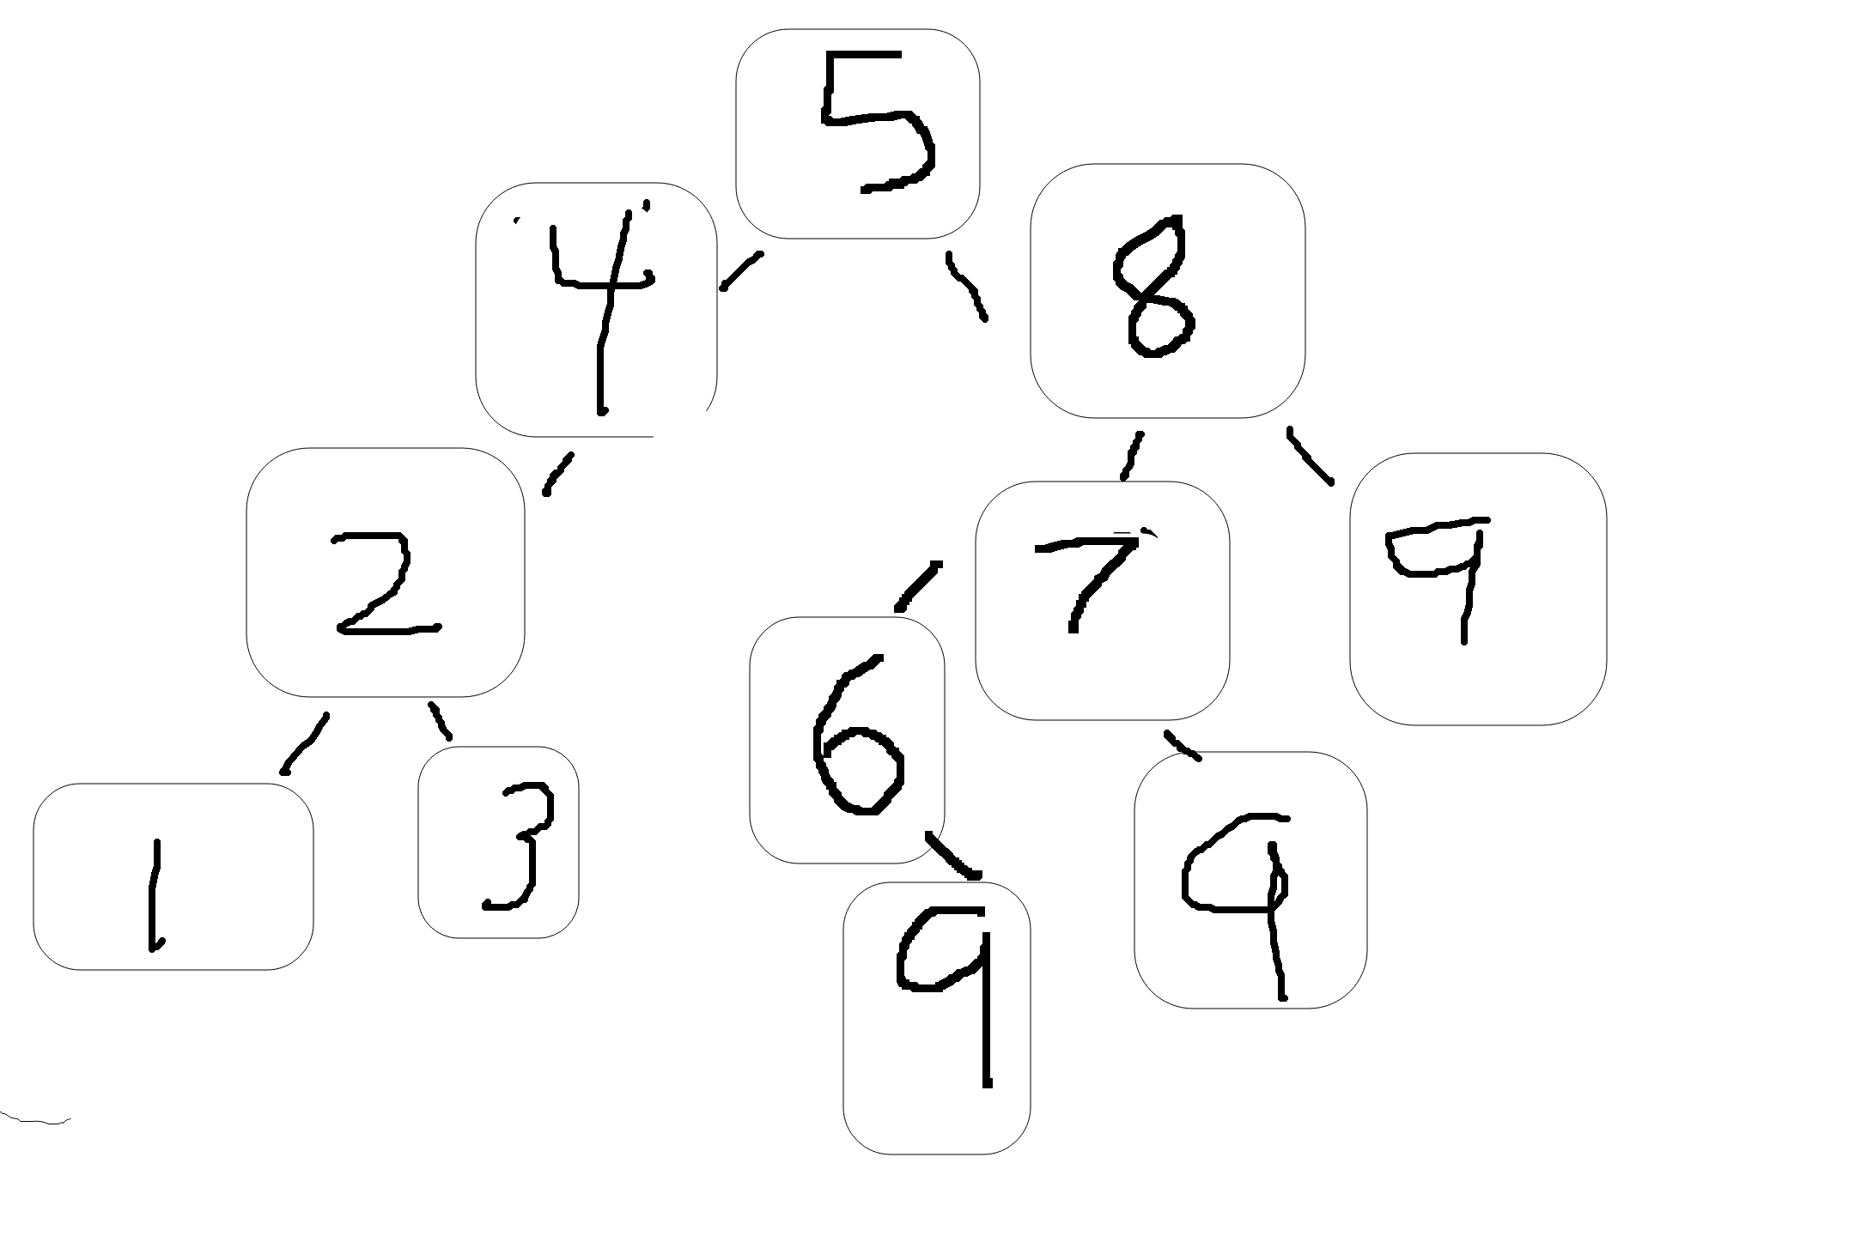
- Diagram:
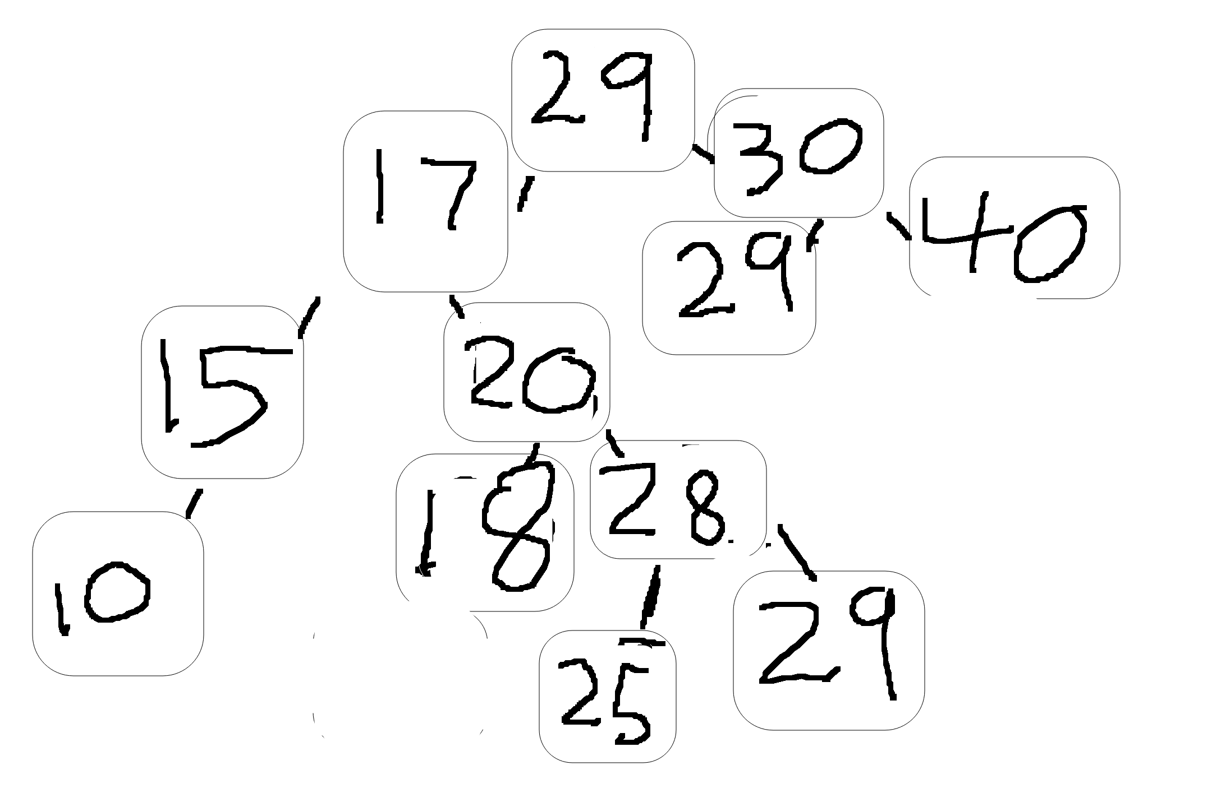
- Diagram:
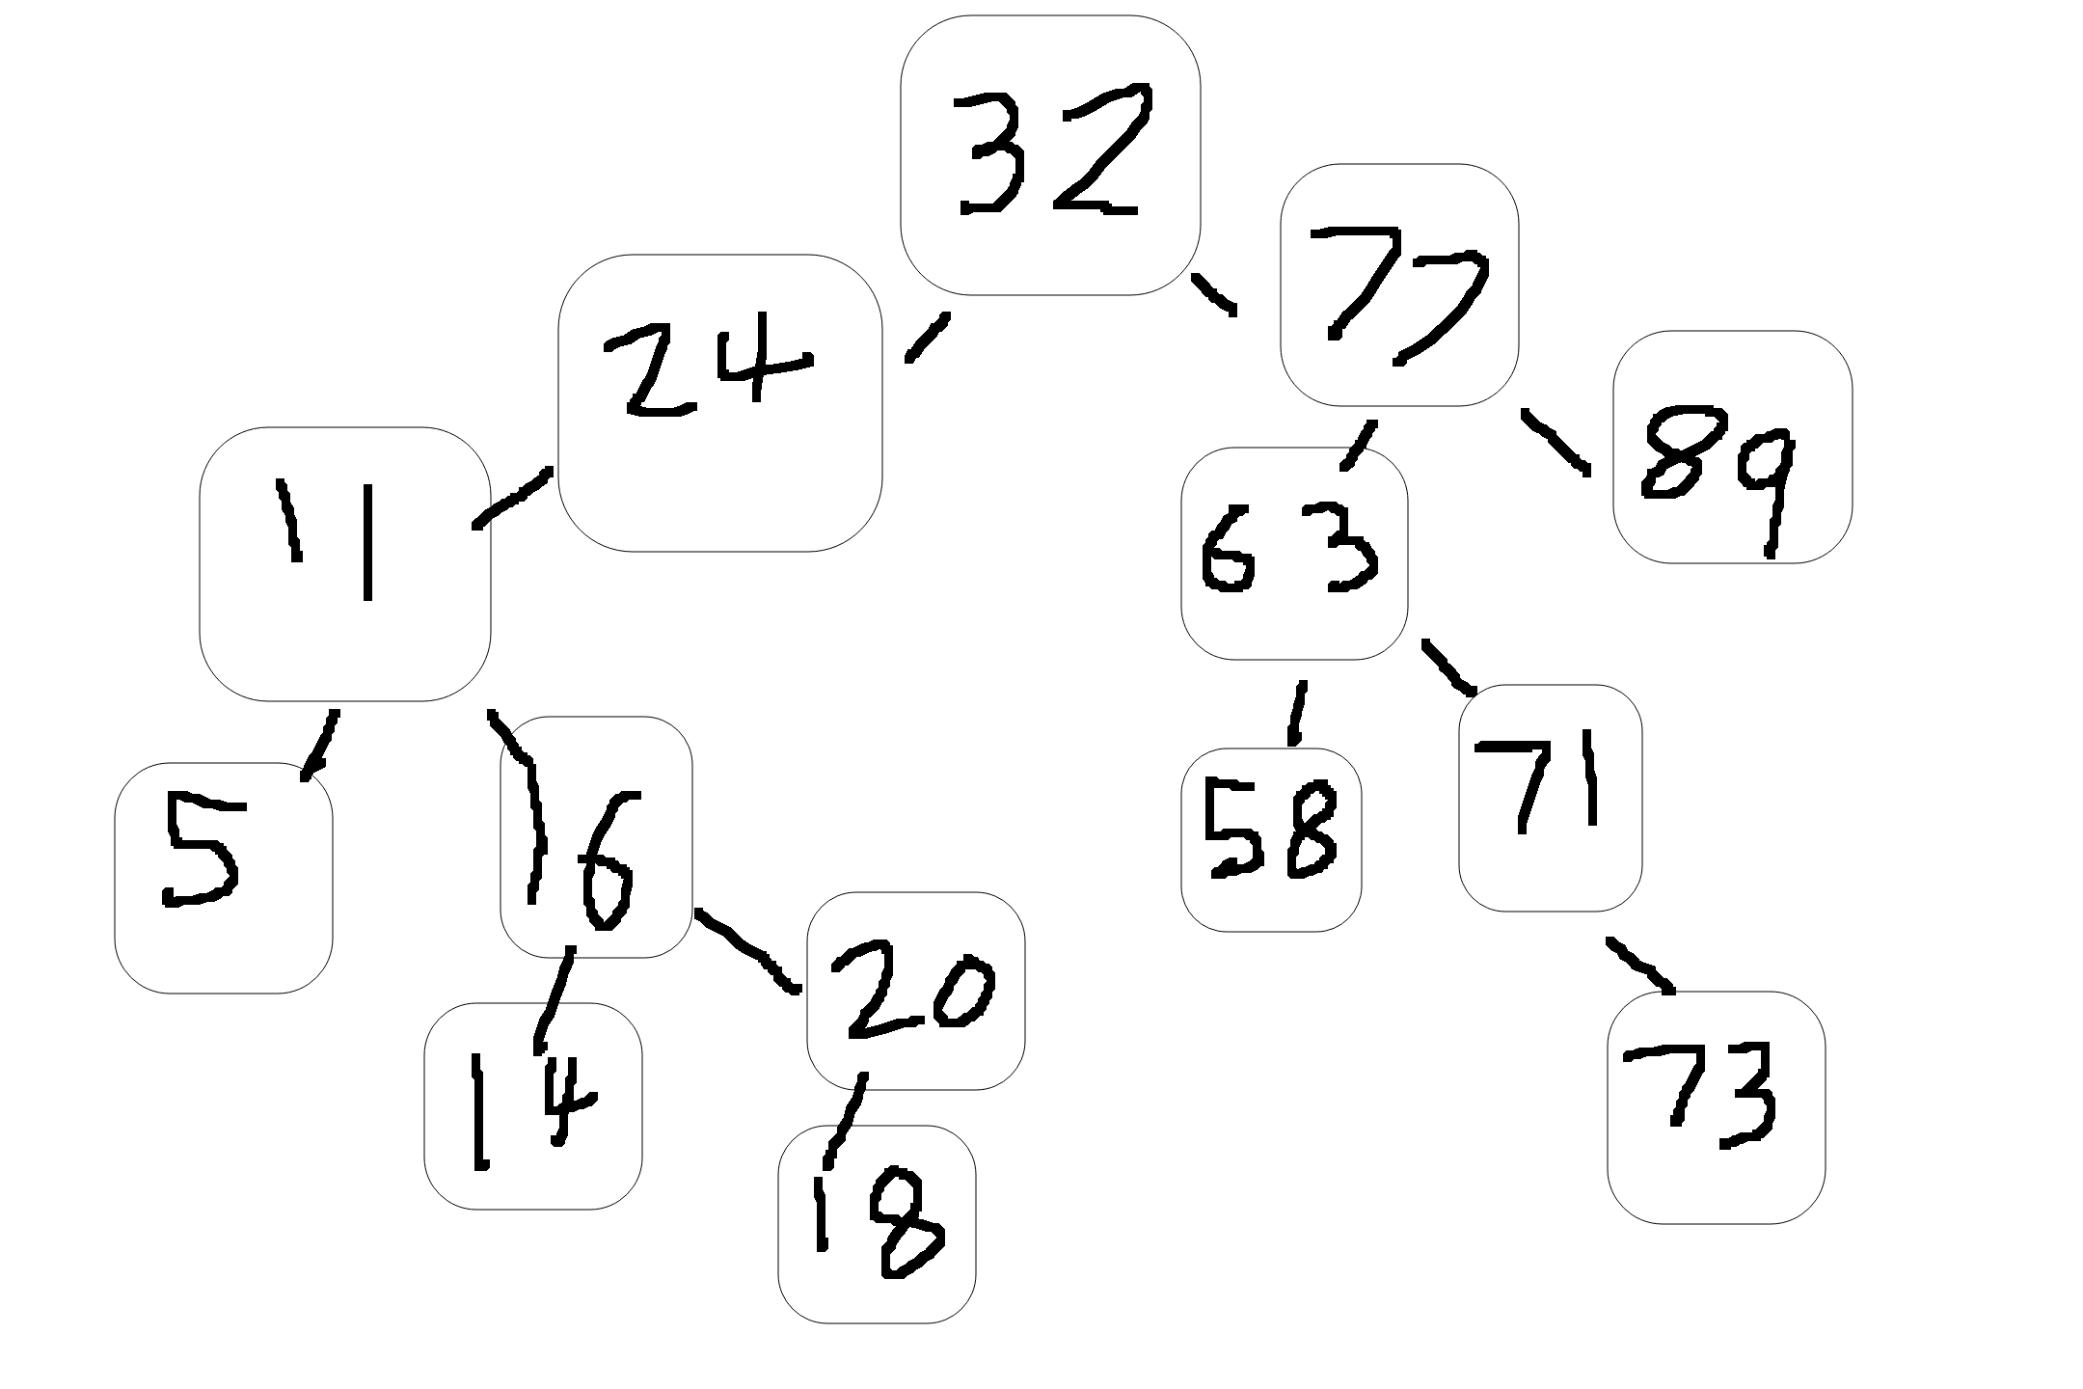
- Diagram:
