VEDIC ASTROLOGY PLATFORM
Phase 1: AI Core &
Credit System SRS

Software Requirement Specification -- Phase 1 of 3

Document Type | Software Requirement Specification
Phase | Phase 1 of 3
Version | 1.0
Date | May 2, 2026
Classification | Personal / Confidential

CONFIDENTIAL -- FOR PERSONAL USE ONLY

Table of Contents

1. Introduction

1.1 Purpose
This document specifies the software requirements for Phase 1 of the Vedic Astrology Platform. Phase 1 delivers the core AI-powered astrological engine, the credit-based access system, and multi-language support for English, Hindi, and Tamil.
This SRS is intended for the development team, project owner, and technical reviewers responsible for designing, building, and testing the Phase 1 deliverable.

1.2 Scope -- Phase 1 Deliverables
Phase 1 delivers the following capabilities:
- Kundli Generation: Nirayan (Sidereal) birth chart computation using precise ephemeris data.
- Dasha Analysis: All major Dasha systems (Vimshottari, Yogini, Chara, Kalachakra, Narayana, Moola Dasha).
- AI Interpretation: LLM-driven natural-language reports for Personal Astrology, Compatibility Matchmaking, and Career & Finance -- gated behind the credit system.
- Credit Wallet System: Users purchase platform credits (Card / UPI) and spend them per AI report. Geo-based pricing applies (India: INR minimum; USA/Canada: USD minimum).
- Report Export: PDF and shareable link export of generated interpretations.
- Super Admin Analytics: Built-in dashboard tracking user traffic, feature usage, revenue, and system health.
- Multi-Language Support: English, Hindi, and Tamil -- dynamically applied to all UI forms and AI outputs.
- Cross-Platform: Web Application and Mobile Application (iOS + Android).

? Note: Phase 2 adds Russian, German, Finnish, and Spanish language support. Phase 3 introduces the Astrologer Consultation Marketplace. Both are covered in separate SRS documents.

1.3 Definitions, Acronyms & Abbreviations
Term | Definition
Kundli | A Vedic birth chart (Janam Patrika) showing planetary positions at the time of birth.
Nirayan / Sidereal | Zodiac system used in Vedic astrology that accounts for the precession of equinoxes (Ayanamsa correction).
Dasha | A planetary period system in Vedic astrology that governs timing of events.
Ayanamsa | The angular offset between the Tropical and Sidereal zodiac, used to convert Western chart positions to Vedic.
LLM | Large Language Model -- the AI component used to generate natural-language astrological interpretations.
Credit | A platform-specific unit of currency used to purchase AI-generated reports.
SRS | Software Requirement Specification.
FR | Functional Requirement.
NFR | Non-Functional Requirement.
UPI | Unified Payments Interface -- an Indian real-time payment system.
API | Application Programming Interface.
RBAC | Role-Based Access Control.

1.4 Document Overview
Section 2 describes the product overview and user classes. Section 3 covers all Phase 1 functional requirements. Section 4 details multi-language support. Sections 5-8 cover non-functional requirements, architecture, platform requirements, and constraints.

2. Overall Description

2.1 Product Overview
The Vedic Astrology Platform Phase 1 is an AI-powered astrological engine delivered as a Web Application and Mobile Application. Users enter their birth data to generate a Nirayan Kundli, compute Dasha timelines, and receive detailed AI-generated interpretations in their preferred language. Access to AI reports is governed by a credit wallet system -- users purchase platform credits and spend them per interpretation.

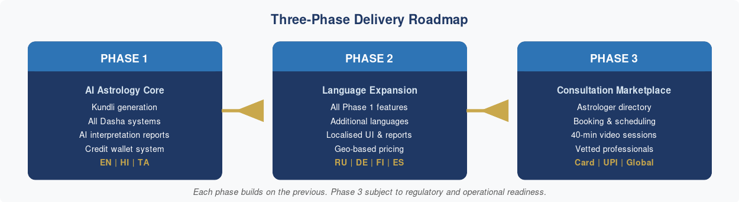
Figure 1 -- Three-Phase Delivery Roadmap

2.2 User Classes & Characteristics

2.2.1 General Users
Characteristic | Description
Technical Proficiency | Low to moderate -- minimal knowledge of astrological concepts.
Primary Activities | Personal AI interpretations, Kundli generation, Dasha analysis, Matchmaking compatibility reports, Credit purchase and management.
Interface Preference | Clean, guided wizard-style forms; visual infographics; plain-language descriptions.
Language | Served in English, Hindi, or Tamil (Phase 1). Language is selectable at registration and changeable in profile settings.

2.2.2 Super Admin
Characteristic | Description
Access Level | Highest privilege. Manages platform settings, approves content, and monitors analytics.
Primary Activities | View analytics dashboard (traffic, usage, revenue, system health), issue promotional credits, manage user accounts.
Privacy Constraint | Analytics views must never expose Personally Identifiable Information (PII) for individual users.

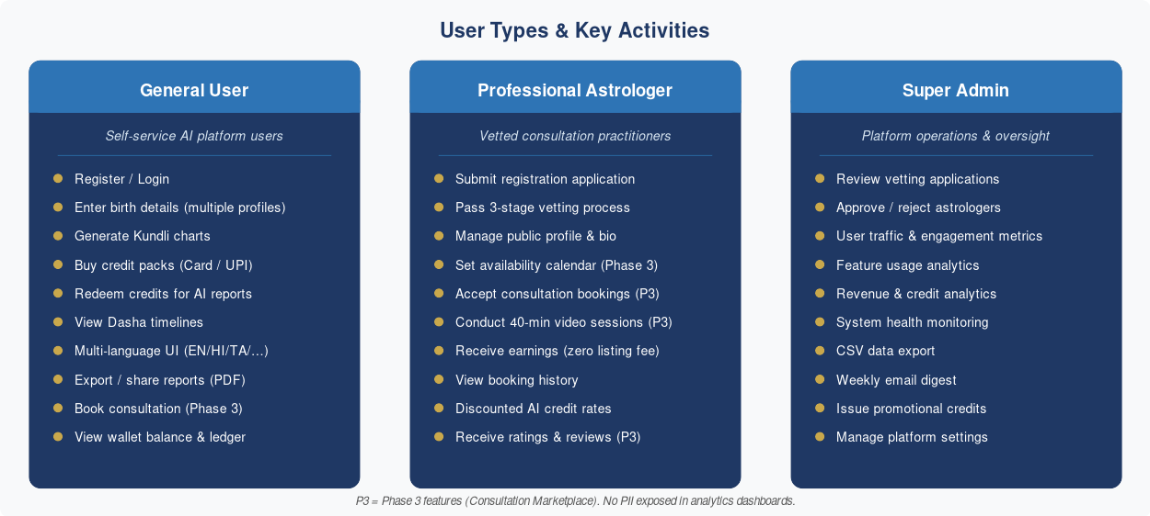
Figure 2 -- User Types & Key Activities

2.3 Operating Environment
- Web Application: Modern browsers (Chrome 110+, Firefox 110+, Safari 16+, Edge 110+).
- Mobile Application: iOS 15+ and Android 10+.
- Backend: Cloud-hosted microservices. Deployment platform to be decided during system design.
- Connectivity: Requires active internet connection. No offline mode in Phase 1.

2.4 Design & Implementation Constraints
- Must use Nirayan (Sidereal) zodiac with configurable Ayanamsa.
- AI interpretation calls are made to a third-party LLM provider. Provider selection is an architectural decision.
- All AI output must be language-aware (English, Hindi, Tamil in Phase 1).
- Credit transactions must be atomic -- no partial deductions on failure.
- All payment processing must go through a certified PCI-DSS compliant gateway.

2.5 Assumptions & Dependencies
- A reliable third-party LLM API is available with sufficient rate limits for expected traffic.
- A payment gateway supporting Card and UPI is available and integrated.
- Ephemeris data source (Swiss Ephemeris or equivalent) is licensed and integrated.
- Translation assets for Hindi and Tamil are reviewed by a qualified linguist before launch.

3. Functional Requirements
This section covers all functional requirements delivered in Phase 1. Phase 3 consultation requirements (FR 3.6-3.8) are documented in the Phase 3 SRS.

3. Functional Requirements

3.1 User Onboarding & Profile Management

3.1.1 Registration & Login
- Users shall be able to register using email/password or social OAuth (Google, Apple).
- Two-factor authentication (2FA) shall be supported.
- Users shall select their preferred language during onboarding.

3.1.2 Profile Management
- Users may create and save multiple Kundli profiles (self, family, clients).
- Each profile stores: name, gender, date of birth, time of birth (with timezone), and place of birth.
- Professional astrologers may manage a client list and access profiles from a dedicated dashboard.

3.2 Kundli Generation Engine
The Kundli engine is the computational core of the system.

3.2.1 Core Chart Calculations
- Compute Lagna (Ascendant), Sun, Moon, Mars, Mercury, Jupiter, Venus, Saturn, Rahu, Ketu positions in degrees, signs, and houses using the Nirayan zodiac.
- Apply Lahiri Ayanamsa by default (configurable to Raman or KP by professional users).
- Calculate Navamsa (D9), Dashamsa (D10), Hora (D2), Dreshkana (D3), Saptamsa (D7), Ashtamsa (D8), and Shodashavarga (D16) divisional charts.
- Display charts in both North Indian (diamond) and South Indian (square) chart styles, selectable by the user.

3.2.2 House & Sign Analysis
- Determine house lordships, occupying planets, and aspecting planets for all 12 houses.
- Identify key yogas (auspicious and inauspicious planetary combinations): Raj Yoga, Dhana Yoga, Kemdrum Yoga, Kemadruma, Vipreet Raj Yoga, etc.
- Compute Shadbala (six-fold planetary strength) and Ashtakavarga (eight-source benefic point system).

3.3 Dasha System Engine
The system shall support all major Dasha systems as listed below.
Dasha System | Basis | Total Period
Vimshottari Dasha | Moon's Nakshatra at birth | 120 years
Yogini Dasha | Moon's Nakshatra (8 Yoginis) | 36 years
Chara Dasha (Jaimini) | Rashi (sign) based | Variable per sign
Kalachakra Dasha | Nakshatra Pada | Variable
Narayana Dasha | Rashi-based (Jaimini variant) | Variable
Moola Dasha | Nakshatra of Lagna | Variable

- Each Dasha system shall display Mahadasha (major period), Antardasha (sub-period), Pratyantardasha (sub-sub-period), and Sookshma Dasha (micro period).
- An interactive timeline view shall allow users to navigate past, present, and future Dasha periods.
- The current active Dasha shall be highlighted and a brief AI interpretation shall be displayed automatically.

3.4 AI Interpretation Module

3.4.1 Report Types by User Segment
Report Category | Professional Astrologers | General Users
Personality Profile | Full sign/house/nakshatra breakdown with classical shlokas (verses) | Plain-language personality summary
Life Areas Report | All 12 houses with lord, occupant, aspect, yoga analysis | Career, relationships, health, wealth highlights
Dasha Predictions | Full Mahadasha-Antardasha tables with technical commentary | Current period effects in simple language
Yearly Forecast | Gochara (transit) overlay with natal chart, strength analysis | Monthly highlights and guidance
Compatibility Report | Ashtakoot + Dashakoot guna matching with exception analysis | Compatibility score with narrative summary
Remedies | Detailed gemstone, mantra, yantra recommendations with rationale | Simple, actionable daily remedies

3.4.2 Credit Gate for AI Reports
All AI-generated report requests shall be gated behind the credit wallet. The following rules apply:
- Before generating any AI report, the system shall check the user's current credit balance.
- If the user has insufficient credits, report generation is blocked. The UI must display the current balance, the credits required, and a direct 'Buy Credits' call-to-action.
- Credits are deducted atomically at the moment report generation is confirmed -- not on viewing or downloading the completed report.
- If report generation fails (AI service error), consumed credits shall be automatically refunded to the user's wallet.
- Professional astrologers generating reports on behalf of clients consume credits from their own wallet, not the client's.

Report Type | General User (Credits) | Professional Astrologer (Credits)
Personality Profile | 2 credits | 1 credit
Life Areas Report (All 12 Houses) | 3 credits | 2 credits
Dasha Predictions (Current Period) | 2 credits | 1 credit
Yearly Forecast (Gochara + Dasha) | 3 credits | 2 credits
Matchmaking / Compatibility Report | 4 credits | 2 credits
Remedies Report | 1 credit | 1 credit
Full Comprehensive Report (All sections) | 8 credits | 5 credits

? Note: The credit values in the table above are indicative and shall be finalised during the product commercialisation phase. Professional astrologers receive discounted credit rates as they generate reports for client purposes.

3.4.3 AI Interpretation Behaviour
- The AI module shall receive structured astrological data (JSON schema) from the calculation engine and produce narrative interpretation text.
- Interpretations must be consistent with classical Vedic astrology texts (BPHS, Jataka Parijata, etc.) and must not contradict established principles.
- The AI must contextualise dasha periods with transits (Gochara) to provide time-sensitive predictions.
- Users may ask follow-up questions in a conversational interface ('Ask the Astrologer' feature) for deeper clarification.
- All AI responses must include a disclaimer: interpretations are for guidance only and should not replace professional advice in medical, legal, or financial matters.

3.5 Report Export & Sharing
- Reports shall be exportable as PDF (for both user types) and DOCX (for professional users).
- Professional users may export raw chart data in JSON or CSV format for external tools.
- Sharing via link (view-only, expirable) shall be supported.
- Print-optimised layouts must be available.

3.9 Credit Purchase & Wallet Management

3.9.1 Credit Wallet
- Every registered user (General and Professional Astrologer) shall have a credit wallet automatically created upon account registration.
- The wallet balance shall be prominently displayed in the app header and on the user dashboard at all times.
- The wallet shall maintain a complete, auditable ledger of all credit transactions: purchases, consumptions, refunds, and promotional credits awarded.
- Credits do not expire during Phase 1. Any expiry policy introduced in future must be communicated to users at least 30 days in advance.

3.9.2 Geo-Based Credit Pricing
Credit pack prices and minimum purchase values shall vary by the user's country of registration. The platform shall detect the user's country at registration (via IP geolocation, confirmed by the user) and display all prices in the appropriate local currency. The rules are:
Region / Countries | Currency | Minimum Pack Value | Phase Availability
India | INR (Indian Rupee) | INR 100 | Phase 1
USA, Canada | USD (US Dollar) | USD 10 | Phase 2
United Kingdom | GBP (British Pound) | GBP 8 | Phase 2
Germany, Finland & EU | EUR (Euro) | EUR 9 | Phase 2
Russia & CIS | USD / local TBD | USD 10 equiv. | Phase 2
Rest of World | USD (US Dollar) | USD 10 | Phase 2+

- The user's region is determined at registration. Users may update their region if they relocate; updated pricing applies to future purchases only.
- Credit quantity per pack is consistent across all regions -- only the monetary price is localised. A user in India and a user in the USA purchasing the 'Standard' pack both receive 20 credits.
- All displayed prices must include applicable local taxes (GST for India, VAT for EU/UK, sales tax for USA where applicable).

3.9.2a Per-Interpretation Charge & Cost Basis
The monetary cost charged to a user for a single AI astrological interpretation is determined by two factors: the underlying AI model inference cost and the platform margin. The following principles and indicative values apply:
Region | Underlying API Cost (per interpretation) | User Charge (per interpretation) | Notes
India | ~USD 0.20 per call | ~USD 0.60 (approx. INR 50) | 3x markup on API cost. INR equivalent to be set at launch based on prevailing exchange rate.
USA, Canada | ~USD 0.20 per call (assumed similar) | USD 1.00 -- USD 2.00 | 5x-10x markup. Final price within this band to be confirmed once actual API costs for international traffic are verified.
UK, EU, Russia & Other Regions | TBD -- to be measured at Phase 2 launch | To be set based on actual API costs | Pricing will follow the same cost-plus model once actual per-region API costs are confirmed.

? Note: The underlying AI model used for interpretations is Claude Sonnet (Anthropic). The per-call cost (~USD 0.20 for India) is the current known cost basis. If Anthropic adjusts its pricing, or if actual costs differ by region, the user-facing charge per interpretation will be revised proportionally. This pricing model applies to the standard Personality Profile / Dasha interpretation. Complex or composite reports consuming multiple AI calls will be priced accordingly.

- The credit system must map cleanly to the per-interpretation charge: the INR/USD value of one credit is derived by dividing the user charge per interpretation by the credits consumed for that report type (as defined in FR 3.4.2).
- The credit-to-currency conversion rate used in pack pricing must be reviewed and updated at each major platform release to keep it aligned with actual API costs.

3.9.3 Credit Packs
Credits shall be sold in predefined packs at tiered price points. The following structure is indicative and shall be finalised during the commercialisation phase:
Pack Name | Credits | Indicative Price (INR) | Best For
Starter | 5 credits | INR 99 | Casual / first-time users
Standard | 20 credits | INR 299 | Regular users
Value | 50 credits | INR 599 | Frequent users
Professional | 150 credits | INR 1,499 | Astrologers -- bulk report generation

3.9.4 Credit Purchase Flow
- User taps 'Buy Credits' (accessible from: wallet balance indicator, report generation gate screen, or dashboard).
- User selects a credit pack from the available tiers.
- Order summary is displayed: pack name, credits to be added, price, and applicable taxes.
- User selects payment method: Credit Card, Debit Card, or UPI.
- For Card: user enters details on the PCI-DSS compliant gateway form; 3D Secure OTP triggered as required.
- For UPI: user enters their VPA or scans the QR code in their UPI app.
- On successful payment: credits are instantly credited to the wallet. Updated balance reflected in UI within 5 seconds.
- On payment failure: no credits are added; user prompted to retry or choose an alternative method.
- An itemised receipt is emailed to the user and available in 'Purchase History'.

3.9.5 Wallet Management & Transparency
- Users shall view full credit transaction history: date, type (Purchase / Consumed / Refund / Promotional), report type for consumptions, credits affected, and running balance.
- Before any report is generated the UI shall clearly display: credits required, current balance, and balance after generation.
- If balance is insufficient, the system blocks generation and redirects the user to 'Buy Credits' with the recommended pack pre-selected.
- Post-Interpretation Balance Display: immediately after an AI report is generated and displayed, the UI shall show a prominent balance summary -- credits consumed for that report and the user's current remaining balance. This is visible on the report screen itself without any additional navigation.
- Low-balance alerts: an in-app notification (and optional email) is sent when the balance falls below 3 credits.

3.9.6 Credit Refund Policy
- Credits consumed for a successfully generated report are non-refundable.
- Credits consumed for a report that failed due to a platform or AI service error are automatically refunded to the wallet within 60 seconds.
- Purchased (unused) credits are non-refundable as cash. Transfer to a new account may be permitted in exceptional cases at platform discretion.

3.9.7 Promotional Credits
- The platform may issue promotional credits (e.g., welcome bonus on registration, referral rewards, campaign bonuses).
- Promotional credits are clearly labelled 'Promo' in the wallet ledger and may carry an expiry date set at issuance.
- Promotional credits are consumed before paid credits when a report is generated.

3.10 Super Admin Analytics Dashboard

3.10.1 Super Admin Role
A Super Admin is a privileged internal platform operator with access to a dedicated, secured administration portal. The Super Admin can view aggregated, anonymised analytics across the entire platform to support business decisions, monitor platform health, and identify usage patterns. The Super Admin role is distinct from general users and astrologers and must be provisioned only by the platform owner.

? Note: All analytics data presented to the Super Admin is aggregated and anonymised at the individual user level unless a specific compliance investigation requires individual-level data access, which must follow a documented internal process.

3.10.2 User Traffic & Engagement Analytics
The analytics dashboard shall provide real-time and historical metrics on how users interact with the platform across Web and Mobile:
Metric | Description
Total Visits | Total number of sessions initiated on Web and Mobile apps, shown as a daily/weekly/monthly trend. Breakdowns by platform (Web vs Mobile) and by country.
Unique Visitors | Count of distinct registered and guest users who accessed the platform in a given period. New vs returning visitor split.
Daily Active Users (DAU) | Number of unique users who performed at least one meaningful action (login, report generation, booking) in a day.
Monthly Active Users (MAU) | Unique active users over a rolling 30-day window. DAU/MAU ratio as an engagement health indicator.
Average Session Duration | Mean time a user spends on the platform per session, broken down by platform (Web vs Mobile) and user type (General vs Professional Astrologer).
Pages / Screens per Session | Average number of distinct screens or pages visited per session, indicating depth of engagement.
User Retention Rate | Percentage of users who return to the platform after their first visit -- tracked at Day 1, Day 7, Day 30 cohorts.
Bounce Rate (Web) | Percentage of web sessions where the user left after viewing only one page -- indicates landing page effectiveness.
Peak Usage Hours | Heatmap of usage by hour of day and day of week, to support infrastructure scaling decisions.
Geographic Distribution | Map view and table showing user distribution by country and region.

3.10.3 Feature Usage Analytics
The dashboard shall show how users are consuming platform features:
Metric | Description
Reports Generated | Total AI reports generated per day/week/month, broken down by report type (Personality, Dasha, Matchmaking, Yearly Forecast, etc.) and by user type (General vs Professional).
Dasha System Usage | Which Dasha systems are most frequently requested (Vimshottari, Yogini, Chara, etc.) -- useful for prioritising engine optimisation.
Language Usage | Distribution of reports and sessions by selected language. Tracks uptake of each language across phases.
Matchmaking Requests | Volume of compatibility reports generated, with regional distribution.
Report Completion Rate | Percentage of report requests that completed successfully vs failed (AI errors, timeouts). Tracks service reliability from the user perspective.
Credit Purchase Funnel | Drop-off analysis at each step of the credit purchase flow: Pack Selection > Order Summary > Payment Method > Payment Completion.
Time-to-Report | Average time from a user initiating a report to receiving the result -- tracks AI response performance over time.

3.10.4 Revenue & Credit Analytics
Metric | Description
Total Revenue | Gross revenue from credit pack purchases, broken down by region, currency, and time period (daily/weekly/monthly/yearly).
Revenue by Pack Tier | Sales volume and revenue contribution of each credit pack (Starter, Standard, Value, Professional).
Credits Purchased vs Consumed | Total credits purchased across all users vs total credits consumed -- the gap indicates unconsumed credit liability (deferred revenue).
Average Revenue per User (ARPU) | Total revenue divided by active users -- tracked monthly to measure monetisation effectiveness.
Payment Method Distribution | Split of transactions by payment method (Credit Card / Debit Card / UPI) and by region.
Refund Rate | Percentage of transactions resulting in a refund -- high rates may indicate AI service reliability issues.
Consultation Booking Revenue (Phase 3) | Revenue generated from consultation slot bookings by astrologer, region, and time period.

3.10.6 System Health & Performance Analytics
- API Response Times: p50, p95, and p99 latency for all key API endpoints, tracked over time to detect degradation.
- AI Interpretation Latency: average and peak time for the AI service to return a report, by report type.
- Error Rate Dashboard: real-time error rate by service (Calculation, AI, Payment, Booking) with alerting thresholds.
- Uptime & Availability: rolling uptime percentage per service component against the SLA targets defined in Section 5.3.
- Payment Gateway Success Rate: percentage of payment attempts that complete successfully, broken down by method (Card / UPI) and by gateway.
- Credit Refund Volume: volume and value of automatic credit refunds triggered by AI service failures -- used to track service reliability cost.

3.10.7 Dashboard Features & Access Controls
- The analytics dashboard shall be accessible only via a dedicated Super Admin portal, protected by MFA.
- The Super Admin may apply date-range filters (last 7 days, 30 days, 90 days, custom range) to all metrics.
- All charts and tables shall support CSV/Excel export for offline analysis.
- Key metrics shall support drill-down: e.g., clicking a country on the geographic map shows that country's user and revenue breakdown.
- An automated weekly summary report shall be emailed to the Super Admin every Monday, containing the prior week's key metrics across all categories.
- The dashboard must not expose any personally identifiable information (PII). Individual user records are not accessible from the analytics interface.

4. Multi-Language & Internationalisation

4.1 Language Support Phases
Phase | Languages | Notes
Phase 1 | English, Hindi, Tamil | Core languages targeting Indian domestic market. Hindi (Devanagari script), Tamil (Tamil script), English (Latin script).
Phase 2 | Russian, German, Finnish, Spanish | International expansion targeting European and CIS markets. All use Latin or Cyrillic scripts.

4.2 Language Selection
- A language selector shall be prominently displayed on the landing/login screen and accessible from any page.
- The selected language persists across sessions for registered users.
- Language change shall immediately re-render all UI elements without requiring a page reload (reactive i18n).

4.3 Dynamic UI Form Generation
All UI forms (birth data entry, settings, report request, etc.) shall be generated dynamically based on the active language selection. This means:
- Form labels, placeholders, validation messages, tooltips, and help text are served from language resource files (e.g., JSON/YAML i18n bundles).
- Text input direction shall adapt automatically -- left-to-right (LTR) for all Phase 1 and Phase 2 languages.
- Font rendering shall use Unicode-compliant web fonts supporting Devanagari (Hindi), Tamil, Latin, and Cyrillic scripts.
- Date and number formats shall follow locale conventions (e.g., DD/MM/YYYY for English-India, Tamil calendar integration for Tamil locale).
- All astrological terminology shall be translated using culturally appropriate terms -- not merely phonetic transliterations.

4.4 AI Output Localisation
- The AI interpretation engine shall generate report text natively in the selected language (not translate from English post-generation, where possible).
- For Phase 1 Hindi and Tamil outputs, the AI must be validated for grammatical accuracy, appropriate honorifics, and culturally resonant expressions.
- Sanskrit shloka (verse) citations in professional reports shall retain the original Sanskrit text alongside a translation in the selected language.
- Numerals shall display in the local script where applicable (e.g., Devanagari numerals for Hindi locale, if preferred by user).

5. Non-Functional Requirements

5.1 Performance
- Kundli chart generation (full calculation) shall complete in under 3 seconds for standard configurations on a mid-range device with a stable internet connection.
- AI interpretation generation (full personality + dasha report) shall complete in under 30 seconds.
- The availability calendar shall load and display slots within 2 seconds of the user opening an astrologer profile.
- Payment confirmation (post-gateway callback) shall update the booking status within 5 seconds.
- The application shall support a minimum of 1,000 concurrent users in Phase 1 without performance degradation.
- Page load time (first contentful paint) shall be under 2.5 seconds on a 4G mobile connection.

5.2 Security & Privacy
- All data transmission shall use TLS 1.3 or higher.
- Personally Identifiable Information (PII) -- name, date, time and place of birth -- shall be encrypted at rest using AES-256.
- Payment card data must never be stored on the platform's own servers. All card processing shall be delegated entirely to a PCI-DSS Level 1 compliant payment gateway.
- UPI transaction references shall be stored, but bank account details shall not be retained beyond the transaction lifecycle.
- The system shall comply with GDPR (European users, Phase 2) and applicable Indian data protection regulations (DPDP Act).
- Users shall be able to request full data export and account deletion (right to erasure).
- AI prompts sent to the underlying LLM provider shall be anonymised -- user PII must not appear in raw LLM calls.

5.3 Reliability & Availability
- Target system uptime: 99.5% monthly (Phase 1); 99.9% (Phase 2 and beyond).
- Automated database backups shall occur every 24 hours with a recovery point objective (RPO) of 24 hours and recovery time objective (RTO) of 4 hours.
- Graceful degradation: if the AI module is unavailable, the calculation engine shall continue to serve raw chart data.
- If the payment gateway is temporarily unreachable, the booking flow shall display a clear error and preserve the user's slot hold for the remaining hold duration.

5.4 Scalability
- The backend architecture shall be stateless and horizontally scalable via container orchestration (e.g., Kubernetes).
- The Booking & Scheduling Service shall handle concurrent slot-hold requests without race conditions -- slot locks must be atomic.
- The system shall be designed to add new languages without code changes to the core logic -- only new i18n resource files are required.
- New Dasha systems shall be pluggable via a modular calculation interface without modifying existing dasha engines.

5.5 Accessibility
- The application must conform to WCAG 2.1 Level AA.
- All form inputs must have associated labels and ARIA attributes.
- Chart visualisations must provide text alternatives for screen reader users.
- The booking calendar must be keyboard-navigable and screen-reader compatible.
- Minimum colour contrast ratio: 4.5:1 for normal text; 3:1 for large text.

5.6 Maintainability
- Code shall follow a defined style guide with inline documentation.
- Unit test coverage shall achieve a minimum of 80% for the astrological calculation engine.
- Astrological calculation logic shall be isolated in a standalone library (separate from UI and AI layers) to facilitate independent testing and reuse.
- The booking and payment modules shall have independent test suites covering success, failure, timeout, and refund scenarios.

5.7 CRITICAL: System Security Requirements
Security is a top-priority, non-negotiable requirement for this platform. The system handles sensitive personal data (birth information, financial transactions, health-adjacent astrological insights) and must be architected with a security-first mindset. The following requirements are CRITICAL and must be satisfied before any phase goes live.

5.7.1 Database Security
- All production databases must be hosted in a private network subnet with no direct public internet access. Database ports must not be exposed outside the VPC/VNET.
- All data at rest must be encrypted using AES-256 or equivalent. Encryption keys must be managed via a dedicated Key Management Service (KMS) -- never hard-coded or stored in application code.
- Role-based database access controls must be enforced: application services receive least-privilege credentials (read/write only on required tables); no service may have DDL or DROP permissions in production.
- All database queries must use parameterised statements or ORM-level query binding. Raw string concatenation in SQL queries is strictly prohibited to prevent SQL injection.
- Database activity monitoring must be enabled: all access, modifications, and failed login attempts must be logged to an immutable audit log retained for a minimum of 12 months.
- Regular automated database backups (minimum daily) with encryption. Backup restoration must be tested quarterly.
- No production data may be used in development or test environments. Synthetic or anonymised data sets must be used for testing.

5.7.2 Application Security
- The application must be designed and audited against the OWASP Top 10 vulnerabilities before each phase release. Any critical or high-severity findings must be resolved before go-live.
- All API endpoints must require authentication (JWT or equivalent). Unauthenticated endpoints are limited strictly to registration, login, and public astrologer directory browsing.
- API rate limiting must be enforced on all endpoints to prevent brute-force and denial-of-service attacks. Repeated authentication failures must trigger temporary account lockout and alert the security team.
- Input validation and sanitisation must be applied server-side on all user-supplied data. Client-side validation alone is insufficient.
- All secrets (API keys, database credentials, payment gateway keys) must be stored in a secrets management vault (e.g., HashiCorp Vault, AWS Secrets Manager). They must never appear in source code, configuration files committed to version control, or environment variables in plain text.
- Dependency scanning must be integrated into the CI/CD pipeline to detect and block builds containing known-vulnerable third-party libraries (CVE monitoring).

5.7.3 Network & Infrastructure Security
- All client-server communication must use TLS 1.3 minimum. TLS 1.0 and 1.1 must be disabled. HTTP (non-HTTPS) requests must be rejected or redirected.
- A Web Application Firewall (WAF) must be deployed in front of all public-facing services to detect and block common attack patterns (SQLi, XSS, CSRF, etc.).
- DDoS protection must be in place at the network edge (via cloud provider or CDN-level protection).
- Infrastructure must be segmented into security zones: public-facing (load balancers, CDN), application tier (API services), and data tier (databases, storage). Cross-zone communication must be explicitly whitelisted.
- All infrastructure changes must go through an Infrastructure-as-Code (IaC) review process. Ad-hoc manual changes to production infrastructure are prohibited.

5.7.4 Data Integrity & Corruption Prevention
- All astrological chart data and user records must be protected with checksums or hash verification to detect and alert on any unauthorised data modification.
- Critical write operations (booking confirmations, credit transactions, payment records) must be implemented as atomic database transactions. Partial writes that could result in data corruption must roll back automatically.
- An immutable audit trail must record every create, update, and delete operation on critical entities (user profiles, bookings, credit wallets, payment records). Audit records must be write-once and tamper-evident.
- Point-in-time recovery must be enabled on all production databases to allow restoration to any point within the last 7 days in the event of data corruption.

5.7.5 Identity & Access Management
- Multi-factor authentication (MFA) must be available to all users and mandatory for all administrative and astrologer accounts.
- Session tokens must be short-lived (access token: 15 minutes; refresh token: 7 days) and must be invalidated immediately upon logout or password change.
- An administrative access review must be conducted quarterly to revoke credentials for inactive or departing personnel.
- All privileged administrative actions (user data export, bulk operations, system configuration changes) must require a second-factor confirmation and generate an audit log entry.

5.7.6 Security Testing & Incident Response
- A third-party penetration test must be conducted before the Phase 1 go-live and after each subsequent major phase release. Critical and high findings must be remediated before launch.
- Automated vulnerability scanning must run on every production deployment.
- A documented security incident response plan must be in place before Phase 1 launch, covering: detection, containment, eradication, recovery, and user notification procedures.
- In the event of a confirmed data breach, affected users must be notified within 72 hours in compliance with GDPR (Phase 2+) and applicable Indian data protection regulations.
? Note: This section (5.7) constitutes the CRITICAL SECURITY REQUIREMENTS baseline. No phase may be released to production without a sign-off confirming all applicable requirements in this section are satisfied. Any waiver requires explicit written approval from the project owner.

6. High-Level System Architecture -- Phase 1

6.1 Architectural Overview
Phase 1 system architecture comprises the following service layers:

Layer | Description
Presentation Layer | Web frontend (React/Vue) and Mobile app (React Native/Flutter). Renders dynamic, language-driven UI. Communicates exclusively via the API gateway.
API Gateway | Single entry point for all client requests. Handles authentication, rate limiting, and routing to microservices.
Calculation Service | Core Vedic astrology engine. Performs all ephemeris-based computations: chart generation, Dasha calculations, yoga detection, Shadbala, Ashtakavarga.
AI Interpretation Service | Receives structured chart data; interfaces with the LLM provider to generate natural-language reports. Manages prompt construction, response parsing, and language routing.
User & Profile Service | Manages user accounts, Kundli profiles, authentication, and authorisation (RBAC).
Payment Service | Integrates with the third-party payment gateway for credit card, debit card, and UPI transactions for credit pack purchases.
Credit Wallet Service | Manages each user's credit balance ledger. Handles credit pack fulfilment, atomic credit deduction on report generation, automatic refunds on AI failures, and promotional credit issuance.
Analytics Service | Captures anonymised event data and aggregates it into the Super Admin dashboard. Provides real-time and historical metrics for traffic, usage, revenue, and system health.
i18n Service | Serves language resource bundles for English, Hindi, and Tamil.
Data Store | Relational database (user/profile/wallet data) + Object storage (generated reports, receipt PDFs). Encrypted at rest.

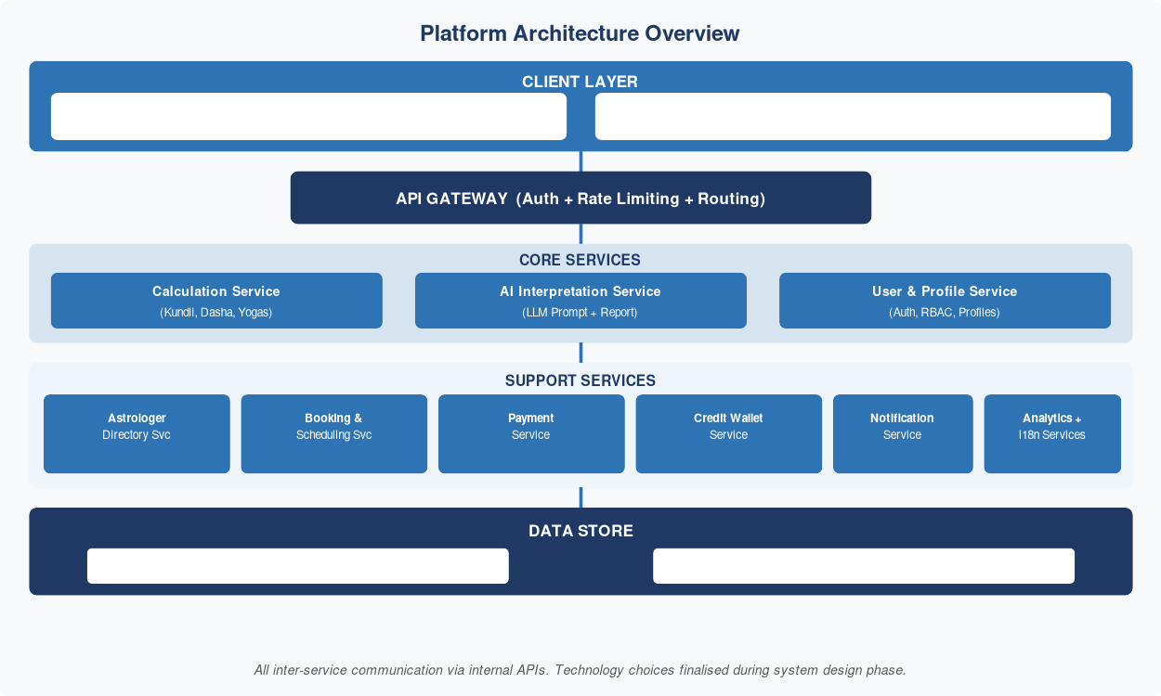
Figure 3 -- Phase 1 Platform Architecture

? Note: Astrologer Directory Service, Booking & Scheduling Service, and consultation-related infrastructure are NOT part of Phase 1. These are introduced in Phase 3.

6.2 Data Flow Summary

6.2.1 AI Interpretation Flow
- User submits birth data via the UI form in their chosen language.
- The API Gateway authenticates the request and routes it to the Calculation Service.
- The Calculation Service computes the Kundli and selected Dasha timelines, returning a structured JSON payload.
- The structured payload is forwarded to the AI Interpretation Service.
- The AI Interpretation Service constructs a locale-aware prompt, calls the LLM, and returns a formatted interpretation.
- The combined data (chart + interpretation) is returned to the frontend for rendering.

6.2.2 Credit Purchase & AI Report Generation Flow
- User selects a report type; the UI checks the Credit Wallet Service for current balance.
- If balance is sufficient: user confirms; Credit Wallet Service atomically deducts the required credits.
- If balance is insufficient: user is directed to Buy Credits. User selects a pack and pays via the Payment Service.
- Payment Service receives gateway confirmation and instructs the Credit Wallet Service to credit the purchased amount.
- Wallet balance updates instantly; user proceeds to generate the report.
- AI Interpretation Service generates the report and returns it to the frontend.
- If AI generation fails: Credit Wallet Service automatically refunds the deducted credits.

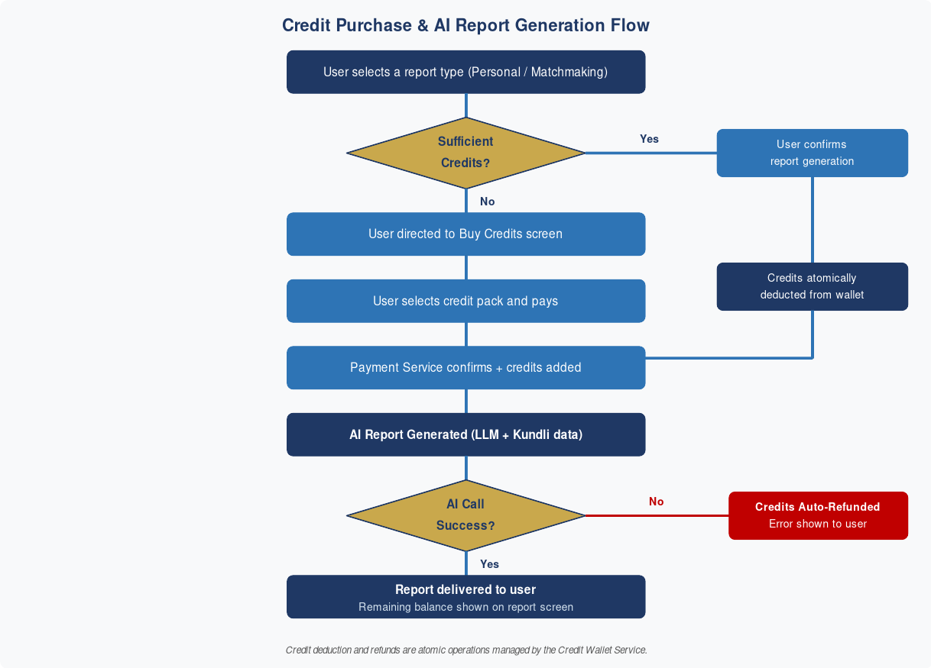
Figure 4 -- Credit Purchase & AI Report Generation Flow

7. Platform Requirements

7.1 Web Application
- Shall be a Single-Page Application (SPA) with server-side rendering (SSR) support for SEO.
- Responsive design: fully functional on screens from 360px (mobile) to 2560px (large desktop).
- Progressive Web App (PWA) support for offline access to previously generated reports.
- Chart rendering via SVG or Canvas for crisp display at all screen densities.
- All forms shall auto-save draft state to prevent data loss on accidental navigation.
- The astrologer directory and booking calendar shall be fully functional on tablet and desktop viewports.

7.2 Mobile Application
- Targets iOS 15+ and Android 10+.
- Push notifications for Dasha period transitions, booking confirmations, session reminders, and the reschedule-window closing alert.
- Biometric authentication (Face ID / Fingerprint) support.
- Offline mode: previously fetched charts and reports shall be accessible without connectivity.
- Device calendar integration for saving confirmed consultation session dates.
- UPI payment intent flow must integrate with installed UPI apps on the device (GPay, PhonePe, Paytm, BHIM, etc.) via deep-link or intent.

7.3 Shared Platform Standards
- Both platforms shall share a unified design system (colours, typography, component library).
- Session tokens shall be short-lived (access: 15 min; refresh: 7 days) with secure storage.
- Analytics instrumentation (anonymised) shall be consistent across both platforms.
- The booking UI, payment screens, and rescheduling flow must be identical in behaviour across Web and Mobile -- only layout may differ.

8. Constraints & Assumptions

8.1 Constraints
- The system must not use Tropical/Western zodiac calculations as the primary system. The Nirayan system is non-negotiable.
- AI-generated content must pass through a deterministic validation layer to check for internally inconsistent astrological claims before delivery to the user.
- Consultation slot duration is strictly fixed at 40 minutes in Phase 1. No variable-length slots are permitted.
- The platform must not charge astrologers any listing fee, commission, or transaction fee. All platform charges (if any) are levied on the user side only.
- A slot is only confirmed after successful payment. No slot may be blocked without a completed payment transaction.
- The reschedule cutoff of 12 hours before session start is enforced server-side and cannot be overridden via the client.
- Payment card data must never touch the platform's own servers -- PCI-DSS scope must be minimised via gateway-hosted or iframe-based card entry.

8.2 Assumptions
- Users are assumed to have access to their accurate birth data (date, time, place). The system will prompt for confirmation of birth time accuracy.
- Astrologers are responsible for maintaining accurate availability calendars. The platform is not liable for double-bookings caused by astrologer-side calendar mismanagement.
- Phase 2 language content (Russian, German, Finnish, Spanish) will require professional human review of AI translations for astrological terminology before launch.
- The Ayanamsa value will be updated programmatically each year as new ephemeris data becomes available.
- Payment gateway vendor selection (Razorpay, Stripe, PayU, or equivalent) and UPI aggregator agreements will be finalised during the architecture phase.
- The video/audio infrastructure for live consultation sessions (if required) is out of scope for this SRS and will be addressed in a separate technical specification.

7. Revision History
Version | Date | Author | Changes
1.0 | 02 May 2026 | Project Owner | Initial Phase 1 SRS: AI Core, Kundli, Dasha, AI Interpretation, Credit Wallet, Analytics, EN/HI/TA languages.

