Note:

I have not yet been able to compile all of my results and am working on more figures for comparative purposes.

References have not been compiled nor have they been referred to according to proper APA format

Great paper and project! You outlined the problem very well and justified your model in a way that was consistent with previous studies. I never felt lost when reading this, which is an indication of good writing. The only thing I would mention is to elaborate a bit more on the background material. But I see that you have a placeholder for this, so you’re on the right track already! The results are really cool. It’s fascinating how the Gov node has the lowest AI because it’s not an obvious result. Great job and great model!

**Abstract**

Economic systems such as stock markets, banks, small local and even entire economies of individual and representative firms have been modeled in a variety of ways in the past. Classical models such Balzano’s Intermediate and Extreme Value Theorem (5) have been replaced with Keynesian models that incorporate aggregate demand and endogenous technical change (6). Even these conventions have been superceeded by numerous new models based on empirical results and built upon the importance institutional framework in influencing actions such as the Cobbs-Douglas function (8) and the Coutts-Norman post Keynesian model (9). In these models firms interact with and react to other firms and consumers by producing products at an optimum level that maximizes profits and minimizes costs. Complexity science and network theory is breaking new ground in providing new ways to model these interactions and decisions. Although it’s applications thus far have been basic, network theory has the potential of describing complex economic mechanisms. In this paper we produce a simple model of firms which rely on each other's production as an input to create their own products. We utilize Boolean Delay Equations to track the propagation of damage sustained by an initial firm and observe how the economy of a small number of firms responds and reacts to the propagation of damage. The results derived suggest that small local economies cannot survive a man made or natural disaster without relief from an outside force. This paper serves as an example of how complexity science can be utilized to model economic systems.

**Introduction**

Major natural disasters can and do have severe negative short-run economic impacts. Disasters also appear to have adverse longer-term consequences for economic growth (1). Calculating the costs of these damages is an onerous and imprecise science. This is because damage does not only take the form of direct losses such as destroyed physical infrastructure but also has indirect effects which are the impairments that follow after physical damages. An example of an indirect effect is the subsequent detriment in the supply chain when a business cannot rely on established routes that have been broken due to a disaster.

Studies have shown that these indirect losses can be larger than direct ones. Furthermore, they have found that the implications of economic disasters are especially strong among small, local economies (1). This feature of natural disasters is illustrated in the cases of the small islands of Dominica and Monsterrat when Hurricane David hit Dominica and when Montserrat erupted. These disasters, whose effect would be minimized in a larger country had catastrophic consequences and disrupted the two islands’ entire economy when the events destroyed much of the transport, power, and communications networks, as well as the productive capacity and social infrastructure (1). “A loss that ‘would merely be a local transfer in a larger economy’—for example, the temporary or permanent displacement of markets for a country’s outputs—could be a devastating setback to a small island economy” (2). In the case of Hurricane David, the Dominican economy was almost totally destroyed; 86% of people lost their jobs, virtually the entire island was without electricity and around 76% of all crops were lost (3). It is important to understand the network topology of these economies in order to derive how and why they are able to recover.

Boolean Delay Equations on Networks in Economics and the Geosciences, the paper that our model economy is based on, realizes that network formalism is well adapted to study the cascading effects generated by exogenous events such as natural disasters (4). This is because introducing the role of networks in the economic system can lead to complex endogenous economic dynamics. Boolean variables allows us to analyze how a network’s connectivity and how varying time delays, for example, determine the total loss in a model economy due to an initial catastrophe (4). They allow us to characterize the causal structure of a model economy and therefore decipher the forces that determine the recovery of an impaired economy. In classical economic models the effects of exogenous events (such as a hurricane) have to be averaged over all firms or a set of representative firms. This has the implication of biasing the results obtained as exogenous events have many heterogenous effects and have varying implications for each firm. Boolean Delay Equations solve this problem as they represent a useful tool in modeling complex systems that are characterized by threshold behavior, multiple feedbacks, and distinct time delays (4). In our model we create a simple economy that allows damage to propagate from firm to firm representing a delay in production for the receiving firm and we observe how the economy reacts.

**The Model**

In order to track the propagation of damage within a model economy the proper framework must be laid out. It is the structure of the underlying network that determines its ability to survive failure. In this case we examine two models, one free and one forced. These models are the essentially the same besides the presence of a governmental role in the forced model. In the free model economy there are 14 nodes where each node represents a firm (labeled FirmA—FirmN) and in the forced economy there are 15 nodes with the addition representing a governmental force (labeled Gov). These nodes take on Boolean values to represent two things: In the free model if at a given time step Xi(t)=0 it means that the firm i is impaired at time t, otherwise Xi(t)=1 meaning the firm i is healthy at time t. The second Boolean variable is Aij which represents the idea that firm i is supplying to firm j (there is a directed edge from firm i to firm j), this occurs when Aij=1, otherwise Aij=0 and firm j does not need firm i’s production as an input to their own (there is no directed edge from firm i to firm j). Firms do not supply to themselves.

The structure of the free model is simplistic. It is a circular brain-chain where each Firm receives supplies from its preceding two neighbors and supplies product to the two neighbors ahead of it. A firm in the free model can thus only be in two states, either impaired or healthy. We start with the initial condition of FirmA being impaired and what determines the spread of the damage us is following the rule; if half of the individual production of a firm i’s preceding 2 neighbors at the previous time step sums up to 1 and the previous state of firm i=1 then the current state of firm i=1, otherwise Xi(t)=0 at the current time step and firm i is impaired. This formalism has been chosen to represent a small economy of firms that must deal with an initial damage to its supply chain without the help of a government. It will be subsequently compared to the forced model to examine the role that causal structure plays in a system’s ability to survive random failures.

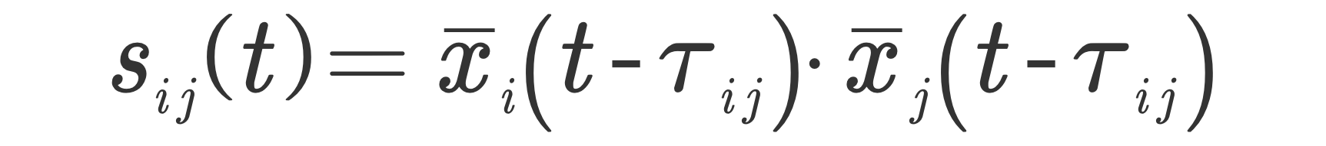We deviate from the original paper with our forced model. In the paper the government does not have a direct role as it does in our model. Instead of the government having its own node and interacting with other firms, in the paper governmental aid merely represents the idea that some external rescue input is available. The paper uses a Boolean delay equation in their forced model and has the production stock become available to the firm again after an impairment time has been taken to be equal to:



where Sij(t) represents the stock available to firm j from firm i during a given time step and where Tij is the actual impairment time.

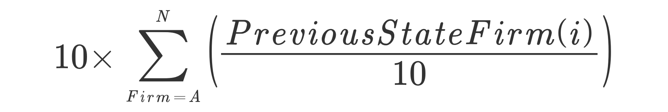 In our forced model the same concept is found, however, there is a “governmental node” in the middle of the circular brain chain that has connections with every single firm. The government (Gov) has directed edges leading into it from every firm and an edge going out to every firm as well. The forced model follows the same updating rule as the free model, however, the free model updating rule does not apply to the Gov node and additional rules are added. These are the rules: If the previous state of any firm i = 1 then the current state of Gov is:

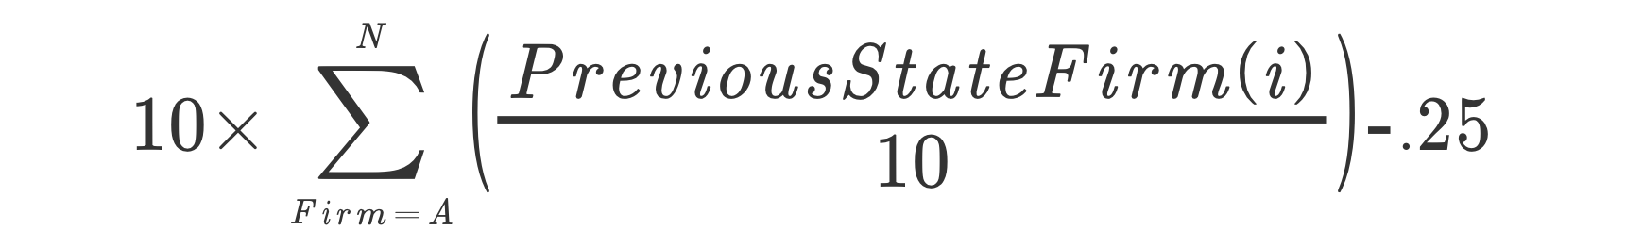This function is interpreted as Gov collecting an arbitrary 10% tax on all healthy firms (note that when the previous state of a firm i = 0 Gov does not collect any taxes). The coefficient 10 represents the fact that roughly 10% of government revenue comes from corporate income tax (and because we are only working with corporate income taxes in our model our representative government’s revenue must be multiplied by 10). If the previous state of any firm i = 0 then current state of firm i = previous state of firm i + .25 and current state Gov is:

Thus Gov receives $.10 from healthy firms as tax and shells out $.25 when firms are impaired. The above function can be interpreted that Gov is spending $.25 to help provide relief for firms that have been struck by the propagating damage. This is not to be interpreted that Gov is merely providing funds to the firms but that the government is playing an active role in rebuilding infrastructure that has been damaged that is preventing firms from being able to produce at their optimum level.

If previous state of firm i = .25, .5 or .75 then the current state of that node continues to be added to by .25 in each time step until a time step is reached where the previous state = 1. This concept is similar to the function found in the original paper except the delays introduced in our model are non-random and are controlled by a specific rule. Because of this rule, in the forced model firms can take on non Boolean values as can the Gov node. The Gov node is unique because it's value depends on the aggregate value of firms with with a state of 1 versus a state of 0, .25, .5 and .75. Therefore the Gov node can take on 46 different values which are course grained to 4 states depending on whether the value of the Gov nodes current state lies on a certain interval. The role of Gov becomes to maintain an environment where these firms can continue to produce.

OTHER MODELS THAT UTILIZES BDE IN ECONOMICS AND RELATED WORK HERE.

**Results**

We will use transfer entropy (TE) and Active Information (AI) as candidate measures for analyzing features that may be unique to the either model. For every pair of nodes (i,j) we calculated TE from node i to node j and rank ordered the pair according to its measured value of TE. Comparing figure 1 to figure 2 it is evident that having a regulatory governmental node makes a huge difference. For the forced model there are much higher values of TE on the whole. Another key difference is that there are many more pairs of nodes who exhibit high levels of TE. Lastly, the percentage of nodes with transfer entropy is higher in the forced model that in the free.

34% of nodes have a causal edge for forced

35% in free model

Active information is dependent upon the distance from the initial impaired firm in the Free model. FirmA’s neighbors which are dependent on its production exhibit no active information.

Active information is constant in the forced model. This is because firms which are impaired still become updated due to governmental role.

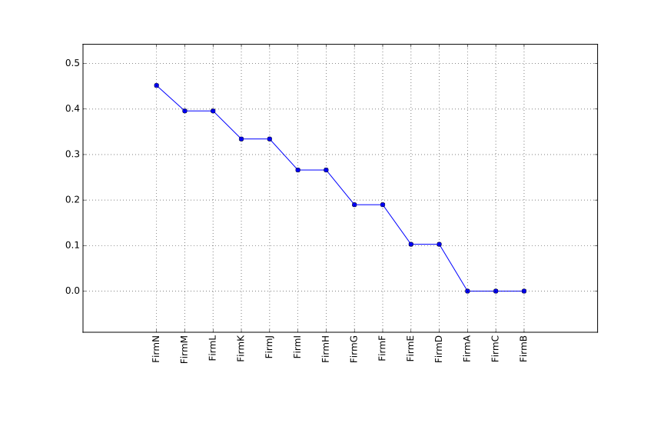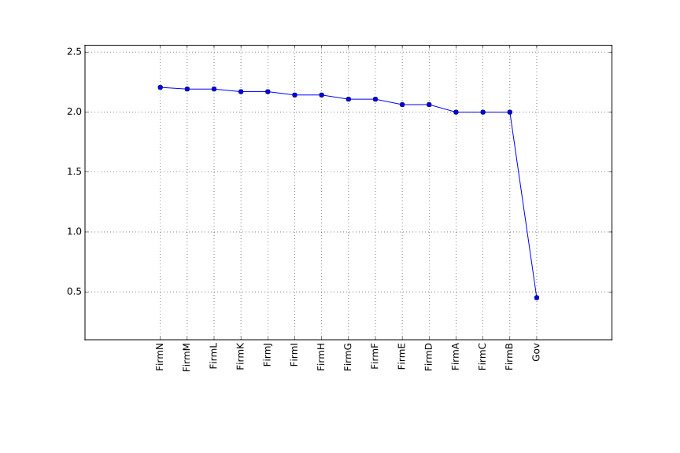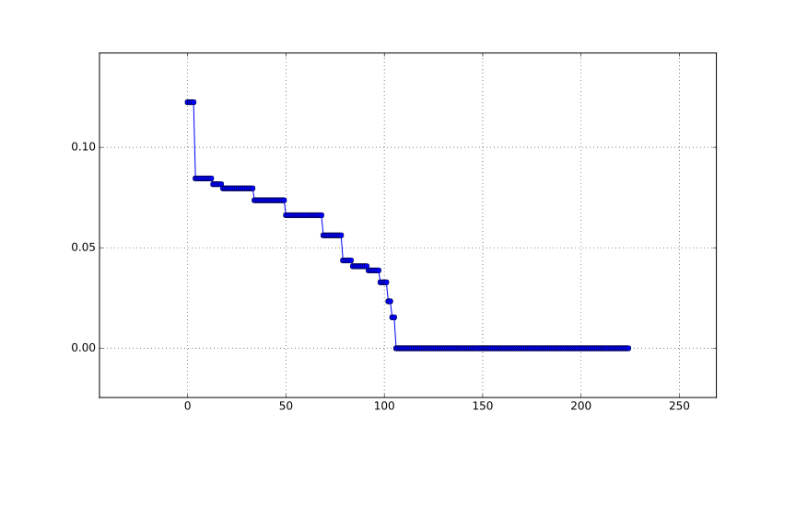

Figure 3: Active Information Free model

Figure 4: Active Information Forced Model

Figure 2: Transfer Entroy Forced Model

Figure 1: Transfer Entropy Free Model

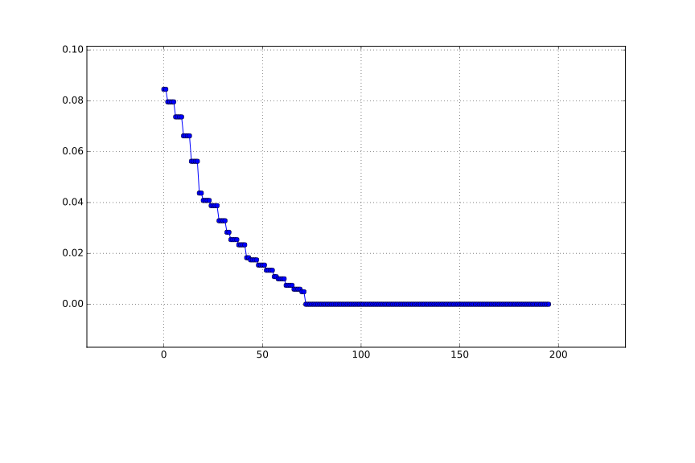

**References**

1 https://ipcc-wg2.gov/njlite_download2.php?id=9000

2 Handmer, J., and P. Thompson. 1997. “Economic Assessment of Disaster Mitigation: A Summary Guide.” Resource and Envi- ronmental Studies 13. Centre for Resource and Environmental Studies, Australian National University, Canberra.

3 http://www.mona.uwi.edu/cardin/virtual_library/docs/1266/1266.pdf

pan American Health Organization- R. Standard, M.F. Lechat

4 Boolean delay paper

5 Bernard Bolzano, Spisy Bernarda Bolzano - Bernard Bolzano's Schriften Vol. 1, Functionenlehre, Edited and with notes by K Rychlik. Foreword by K Petr (Královská Ceská Spolecnost Nauk, Prague, 1930).

6 Harcourt, G. C., & Kriesler, P. (2015). Post-Keynesian Theory and Policy for Modern Capitalism. Journal Of Australian Political Economy, (75), 27-41.

7 Palley, T. I. (1997). Aggregate Demand and Endogenous Growth: A Generalized Keynes-Kaldor Model of Economic Growth. Metroeconomica, 48(2), 161-176.

8 cobbs douglas