2025 Volunteer Lake Assessment Program

Individual Report: Akers Pond – Errol
Water Quality Summary: Overall, pond water quality remains within the thresholds typical of a mesotrophic, or medium-quality, lake, with low conductivity, chloride and turbidity values and acceptable pH values. On average, Akers Pond has slightly higher (better) water quality compared to the median NH lake, with parameters like total phosphorus (hypolimnetic) and Secchi disk transparency being slightly worse. There is evidence of internal phosphorus loading due to anoxic hypolimnetic conditions which is likely contributing to elevated hypolimnetic total phosphorus. Akers Pond does not exceed NH water quality thresholds for any parameters.
Recommended Actions: Great job resuming water quality monitoring in 2025! Actions such as stabilizing shorelines, reducing runoff from shoreline properties and dirt/gravel roads, properly maintaining septic systems and limiting fertilizer use can all help protect water quality. NHDES’ NH Homeowner’s Guide to Stormwater Management and UNH Cooperative Extension’s Landscaping at the Water’s Edge are great resources. We recommend adding inlet sampling to better understand potential nutrient and chloride inputs from precipitation events and increasing monitoring to once per month to more effectively capture seasonal patterns and support future trend analysis. Historical water quality trends can be established once 10 consecutive years of data have been collected. Keep up the great work!

Historical Water Quality Graphics - Deep Spot
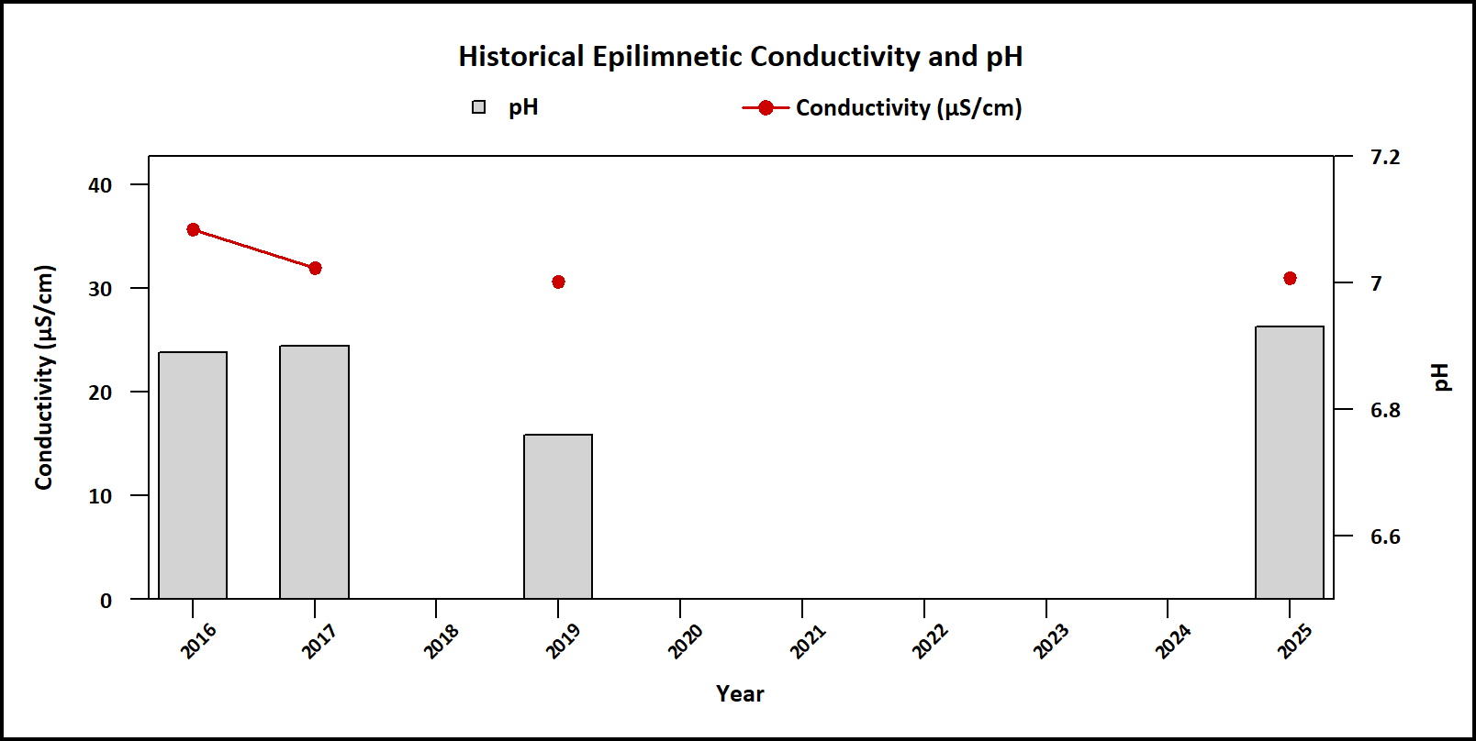
Figure 1. Median epilimnetic pH (red points) and conductivity (gray bars) by year.
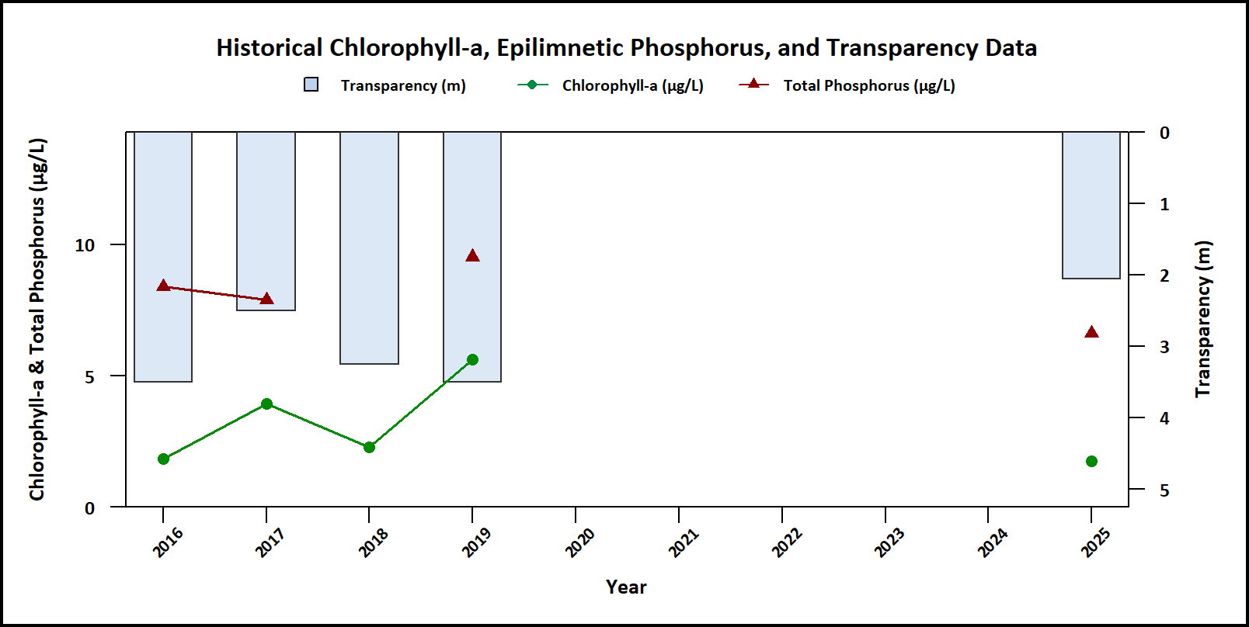
Figure 2. Median Secchi disk transparency (blue bars), epilimnetic phosphorus (red triangles), and chlorophyll-a (green points) by year.
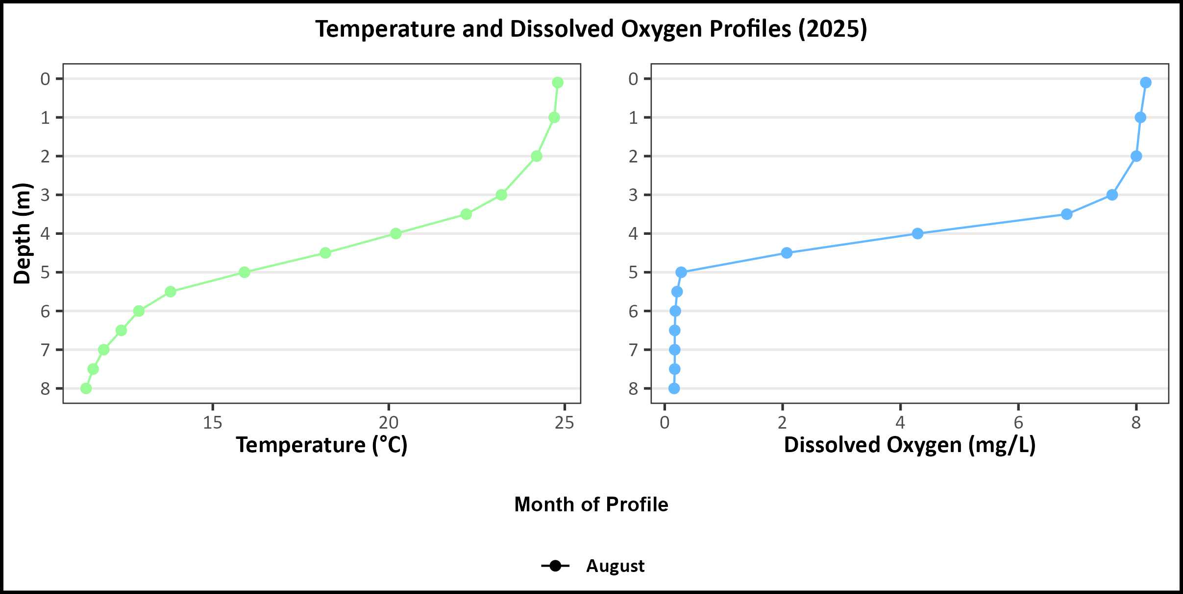
Figure 3. 2025 vertical profiles of temperature (°C; green points, left plot) and dissolved oxygen (mg/L; blue points, right plot) plotted against depth (m).
Table 1. 2025 Average Water Quality Data for Akers Pond – Errol
Station | Alk. (mg/L) | Chlor-a (μg/L) | Chloride (mg/L) | Color (pcu) | Cond. (μS/cm) | Total P (μg/L) | Trans. NVS (m) | Trans.  VS (m) | Turb. (ntu) | pH
Epilimnion | 6.1 | 1.74 | 1.5 | 56 | 30.97 | 6.62 | 2.06 | 2.69 | 0.72 | 6.93
Metalimnion | No Value | No Value | No Value | No Value | 31.26 | 9.03 | No Value | No Value | 1.10 | 6.94
Hypolimnion | No Value | No Value | No Value | No Value | 31.73 | 20.10 | No Value | No Value | 3.13 | 6.82

Observations (Refer to Table 1 and Historical Deep Spot Data Graphics):
- Chlorophyll-a (Chlor-a): Chlorophyll level was within a low range in August and was lower than in previous years. It remained below the state median and the threshold for mesotrophic lakes. Visual inspection of historical data indicates relatively stable chlorophyll levels over time.
- Conductivity (Cond.)/Chloride: Conductivity in the Epilimnion was within a low range for NH surface waters and was below the state median. Epilimnetic chloride level was also within a low range and below the state median. Visual inspection of historical data indicates relatively stable conductivity levels.
- Color: Apparent color measured in the epilimnion indicates the water was within a moderately tea colored, or brown, range.
- Total Phosphorus (Total P): Epilimnetic (upper water layer) phosphorus level was within a low range in August and was lower than in previous years. It remained less than the state median and was less than the threshold for mesotrophic lakes. Visual inspection of historical data indicates stable epilimnetic phosphorus levels over time. Total phosphorus values increased down the water column, with metalimnetic values still within range but hypolimnetic (bottom water layer) values were elevated. This suggests that there may be some internal phosphorus loading which is in alignment with the anoxic conditions of the hypolimnion.
- Transparency (Trans.): Transparency measured with (VS) and without (NVS) the viewscope was within an average range for the pond but was slightly lower than in previous years. Viewscope transparency is generally higher (better) than NVS transparency and likely a better measure of actual condition. Visual inspection of historical data indicates slightly worse transparency since monitoring began.
- Turbidity (Turb.): Epilimnetic, metalimnetic and hypolimnetic turbidity levels were within a low range.
- pH: Epilimnetic, metalimnetic and hypolimnetic pH levels were within the desirable range of 6.5-8.0 units and improved from the slightly acidic conditions measured in 2019. Visual inspection of historical data indicates stable epilimnetic pH levels over time.
- Temperature/Dissolved Oxygen (DO) Profile: Epilimnetic temperatures were approximately 25 °C, with DO concentrations around 8 mg/L. The metalimnion (thermocline) began at approximately 3.0 m, where both temperature and DO declined rapidly. By 5.0 m (the hypolimnion), temperatures stabilized between 16 and 11 °C and DO concentrations reached 1.5 mg/L.

How does your lake compare to New Hampshire lakes and water quality standards?
Table 2. New Hampshire Median Lake Water Quality Values. Median values generated from historic lake monitoring data
Parameter | Median Value
Alkalinity | 4.5 mg/L
Chlorophyll-a | 4.39 μg/L
Chloride | 5 mg/L
Conductivity | 42.3 μS/cm
Total Phosphorus | 11 μg/L
Transparency | 3.3 m
pH | 6.6

Table 3. New Hampshire Water Quality Standards. Numeric criteria for specific parameters. Water quality violation occurs if thresholds are exceeded.
Parameter | Threshold
Chloride | > 230 mg/L (chronic)
E. coli (beach) | > 88 cts/100 mL
E. coli (surface water) | > 406 cts/100 mL
pH | between 6.5-8.0 (unless naturally occurring)
Turbidity | > 10 NTU above natural

