2025 Volunteer Lake Assessment Program

Individual Report: Ashuelot Pond – Washington
Water Quality Summary: Pond quality is generally representative of mesotrophic, or average, conditions, with moderate levels of phosphorus and algal growth and low chloride levels. Historical trend analysis indicates stable phosphorus levels and phytoplankton population dynamics indicate Golden-Brown Algae are becoming more dominant in the lake. The worsening transparency trend is likely due to a combination of an increase in dissolved organic matter that imparts a “tea” or brown color to the water as well as the increased intensity of storm events. On average, Ashuelot Pond has similar water quality compared to the median NH lake and doesn’t exceed any NH water quality standards.
Recommended Actions: A spike in epilimnetic phosphorus after excessive rainfall in 2023 highlights the importance of minimizing nutrient loading within the watershed. Regular pumping and maintenance of septic systems, proper lawn care and stabilizing shorelines are all ways to minimize sediment and nutrient loading to the pond. We also highlight the importance of managing stormwater runoff in the watershed. NHDES’ NH Homeowner’s Guide to Stormwater Management is a great resource. Additionally, encourage local winter maintenance companies to obtain Green SnowPro Certification through UNH Technology Transfer Center. Finally, educate boaters on best practices when boating to prevent re-suspension of bottom sediments and shoreline erosion. NHDES’ fact WMB-25 Impacts of Motorized Craft on New Hampshire’s Waterbodies is a great resource. Keep up the great work and thank you for your continued participation in VLAP!

Historical Water Quality Trend Analysis
Table 1. Historical Water Quality Trends for Ashuelot Pond – Washington
Parameter | Trend
Conductivity (Epilimnion) | Slightly Improving
Chlorophyll-a (Composite) | Stable
pH (Epilimnion) | Improving
Transparency | Worsening
Phosphorus (Epilimnion) | Stable
Phosphorus (Hypolimnion) | Stable

Historical Water Quality Graphics - Deep Spot
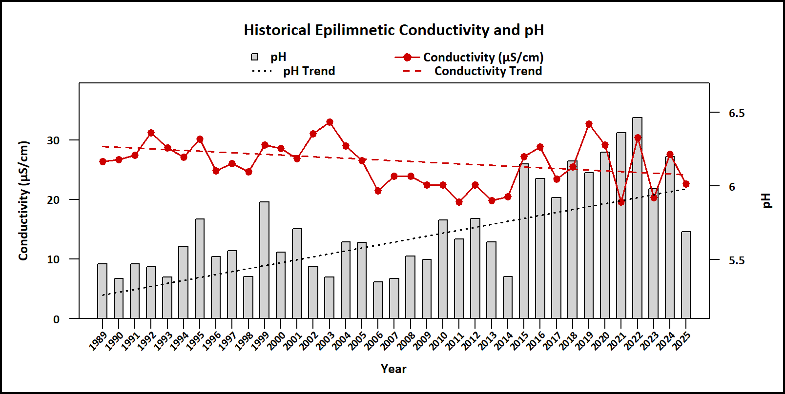
Figure 1. Median epilimnetic pH (red points) and conductivity (gray bars) by year, with corresponding trend lines shown as red and black dashed lines, respectively. Epilimnetic pH is improving and conductivity is slightly improving since monitoring began.
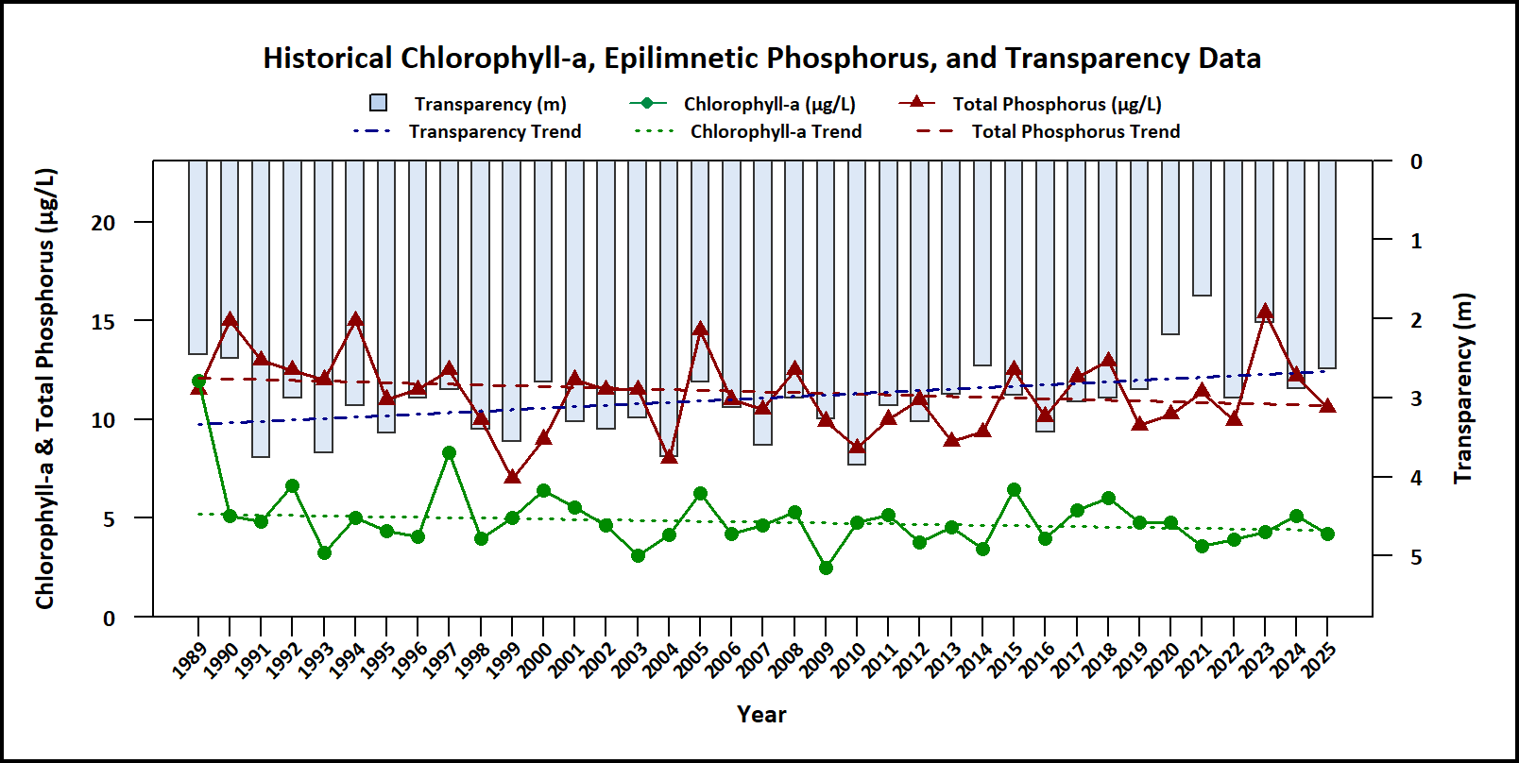
Figure 2. Median Secchi disk transparency (blue bars), epilimnetic phosphorus (red triangles), and chlorophyll-a (green points) by year, with corresponding trend lines shown as blue, red, and green dashed lines, respectively. Water transparency is worsening, phosphorus is stable, and chlorophyll-a is stable since monitoring began.
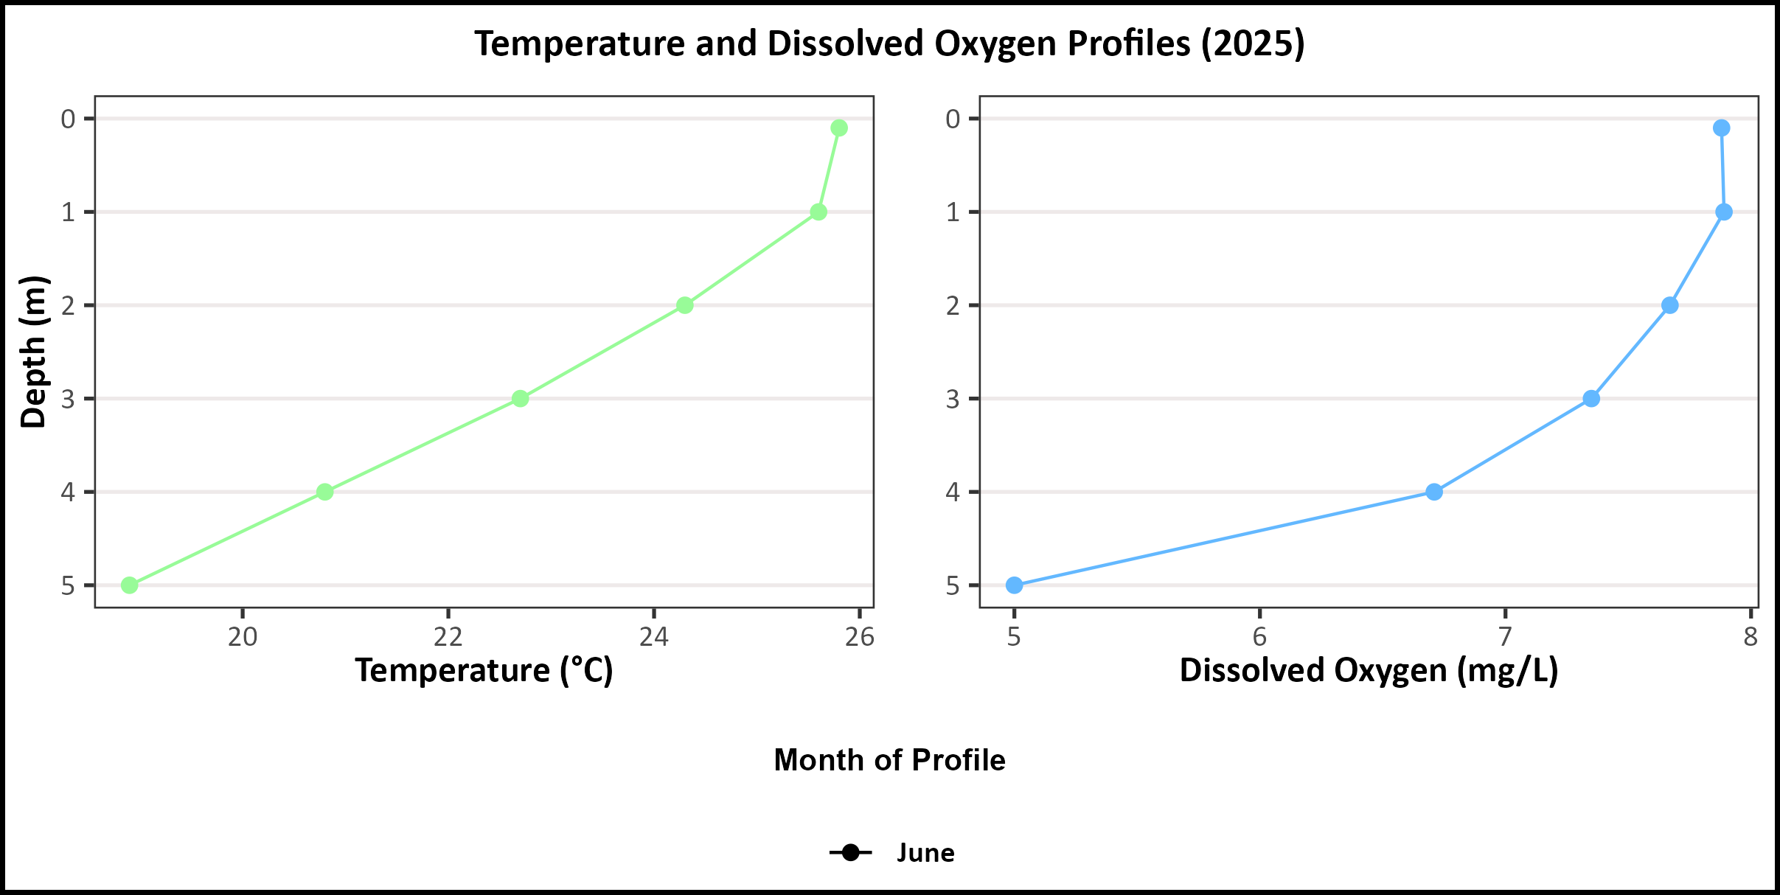
Figure 3. 2025 vertical profiles of temperature (°C; green points, left plot) and dissolved oxygen (mg/L; blue points, right plot) plotted against depth (m).
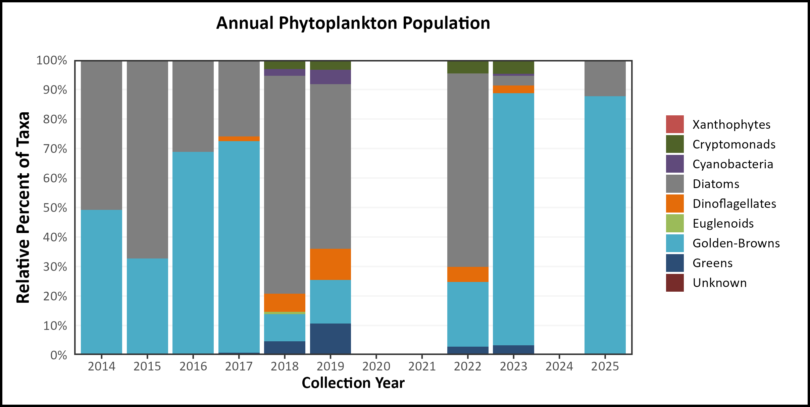
Figure 4. Phytoplankton community composition over time, expressed as relative abundance of major taxonomic groups.
Table 2. 2025 Average Water Quality Data for Ashuelot Pond – Washington
Station | Alk. (mg/L) | Chlor-a (μg/L) | Chloride (mg/L) | Color (pcu) | Cond. (μS/cm) | Total P (μg/L) | Trans. NVS (m) | Trans. VS (m) | Turb. (ntu) | pH | E. coli (mpn/100 mL)
Epilimnion | 1.3 | 4.12 | 11.17 | 72.67 | 22.82 | 11.36 | 2.88 | 3.65 | 0.9 | 5.73 | No Value
Metalimnion | No Value | No Value | No Value | No Value | 23.06 | 13.7 | No Value | No Value | 1.62 | 5.55 | No Value
Hypolimnion | No Value | No Value | No Value | No Value | 23.95 | 18.2 | No Value | No Value | 2.64 | 5.62 | No Value
Lae Beach Shallow | No Value | No Value | No Value | No Value | No Value | No Value | No Value | No Value | No Value | No Value | 10.6
Marina Inlet | No Value | No Value | No Value | No Value | 24.38 | 11.79 | No Value | No Value | 0.87 | 5.91 | No Value
Millen Inlet | No Value | No Value | No Value | No Value | 23.89 | 14.17 | No Value | No Value | 0.89 | 5.89 | No Value
Outlet | No Value | No Value | No Value | No Value | 22.57 | 10.97 | No Value | No Value | 0.79 | 6.04 | No Value
River Inlet | No Value | No Value | No Value | No Value | 24.22 | 13.2 | No Value | No Value | 0.88 | 5.95 | No Value

Observations (Refer to Table 2 and Historical Deep Spot Data Graphics):
- Chlorophyll-a (Chlor-a): Chlorophyll level was within an average range in August and decreased slightly in August. The median chlorophyll level decreased slightly from 2024, was slightly lower than the state median and slightly less than the threshold for mesotrophic lakes. Historical trend analysis indicates stable chlorophyll levels since monitoring began
- Conductivity (Cond.)/Chloride: Deep spot and tributary conductivity levels fluctuated within a low range, decreased slightly from 2024 and were less than the state median. The average epilimnetic chloride level was also low and below the state median. Historical trend analysis indicates slightly improving epilimnetic conductivity levels since monitoring began.
- Color: Apparent color measured in the epilimnion indicates the water was highly tea colored in June and lightened to moderately tea colored, or light brown, by August.
- Total Phosphorus (Total P): Epilimnetic phosphorus level was moderate throughout the summer. The median epilimnetic phosphorus level decreased slightly from 2024 and was within the threshold for mesotrophic lakes but remained slighter greater than the state median. Hypolimnetic phosphorus level was elevated in July. Historical trend analysis indicates stable epilimnetic and hypolimnetic phosphorus levels since monitoring began. Millen Inlet and River inlet average phosphorus levels remained high and Outlet and Marina Inlet average phosphorus levels were also elevated.
- Transparency (Trans.): Transparency measured with (VS) and without (NVS) the viewscope was average in June and increased (improved) gradually as the summer progressed. The median NVS transparency worsened from 2024 but remained lower (worse) than the state median. Historical trend analysis indicates significantly decreasing (worsening) NVS transparency since monitoring began
- Turbidity (Turb.): Epilimnetic turbidity level was slightly elevated in June potentially due to wind and wave activity mixing the water column. Hypolimnetic turbidity level was elevated in July potentially due to formation and accumulation or organic compounds under low dissolved oxygen conditions. Marina Inlet, Millen Inlet and River Inlet turbidity levels were within a low range. Outlet turbidity level was slightly elevated in August.
- pH: Deep spot and tributary pH levels fluctuated below the desirable range of 6.5-8.0 units and were slightly acidic to moderately acidic and potentially critical to aquatic life. The average epilimnetic pH was also more acidic than the state median. The median epilimnetic pH was more acidic compared to 2024. However, historical trend analysis indicates significantly increasing (improving) epilimnetic pH levels since monitoring began.
- E. coli: LAE Beach Shallow E. coli levels were low and much less than the state standard for public beaches.
- Temperature/Dissolved Oxygen (DO) Profile: Epilimnetic temperatures were approximately 26 °C, with DO concentrations around 8 mg/L. The metalimnion (thermocline) began at approximately 1.0 m, where both temperature and DO declined rapidly. By 4.0 m (the hypolimnion), temperatures stabilized between 20 and 18 °C and DO concentrations reached 5 mg/L.
- Phytoplankton Community: Since 2014, the phytoplankton community has been dominated by Diatoms and Golden-Brown algae. This year, Golden-Browns were the most abundant group, followed by Diatoms.

How does your lake compare to New Hampshire lakes and water quality standards?
Table 3. New Hampshire Median Lake Water Quality Values. Median values generated from historic lake monitoring data
Parameter | Median Value
Alkalinity | 4.5 mg/L
Chlorophyll-a | 4.39 μg/L
Chloride | 5 mg/L
Conductivity | 42.3 μS/cm
Total Phosphorus | 11 μg/L
Transparency | 3.3 m
pH | 6.6
Table 4. New Hampshire Water Quality Standards. Numeric criteria for specific parameters. Water quality violation occurs if thresholds are exceeded.
Parameter | Threshold
Chloride | > 230 mg/L (chronic)
E. coli (beach) | > 88 cts/100 mL
E. coli (surface water) | > 406 cts/100 mL
pH | between 6.5-8.0 (unless naturally occurring)
Turbidity | > 10 NTU above natural

