Volunteer Lake Assessment Program Individual Report

Angle Pond – Sandown (2025)
Water Quality Summary:
Recommended Actions:

Historical Water Quality Trend Analysis
Table 1. Historical Water Quality Trends for Angle Pond – Sandown
Parameter | Trend
Conductivity (Epilimnion) | Worsening
Chlorophyll-a (Composite) | Worsening
pH (Epilimnion) | Improving
Transparency | Slightly Worsening
Phosphorus (Epilimnion) | Worsening
Phosphorus (Hypolimnion) | Slightly Worsening

Historical Water Quality Graphics - Deep Spot
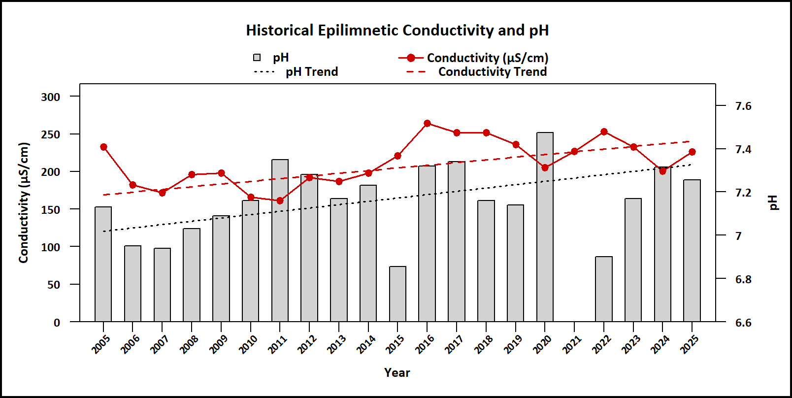
Figure 1. Median epilimnetic pH (red points) and conductivity (gray bars) by year, with corresponding trend lines shown as red and black dashed lines, respectively. Epilimnetic pH is improving and conductivity is worsening since monitoring began.
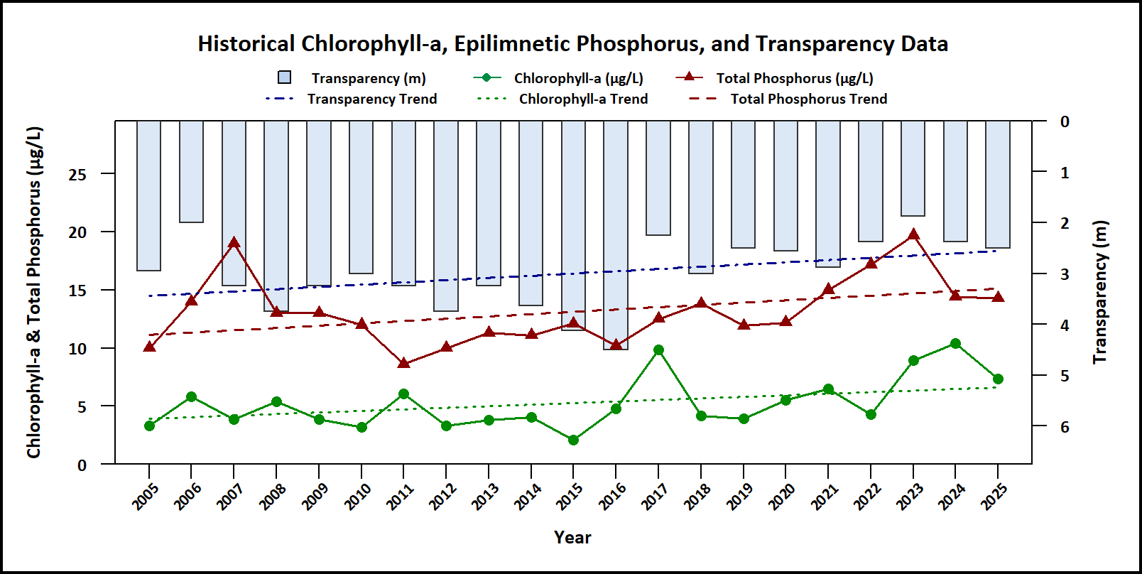
Figure 2. Median Secchi disk transparency (blue bars), epilimnetic phosphorus (red triangles), and chlorophyll-a (green points) by year, with corresponding trend lines shown as blue, red, and green dashed lines, respectively. Water transparency is slightly worsening, phosphorus is worsening, and chlorophyll-a is worsening since monitoring began.
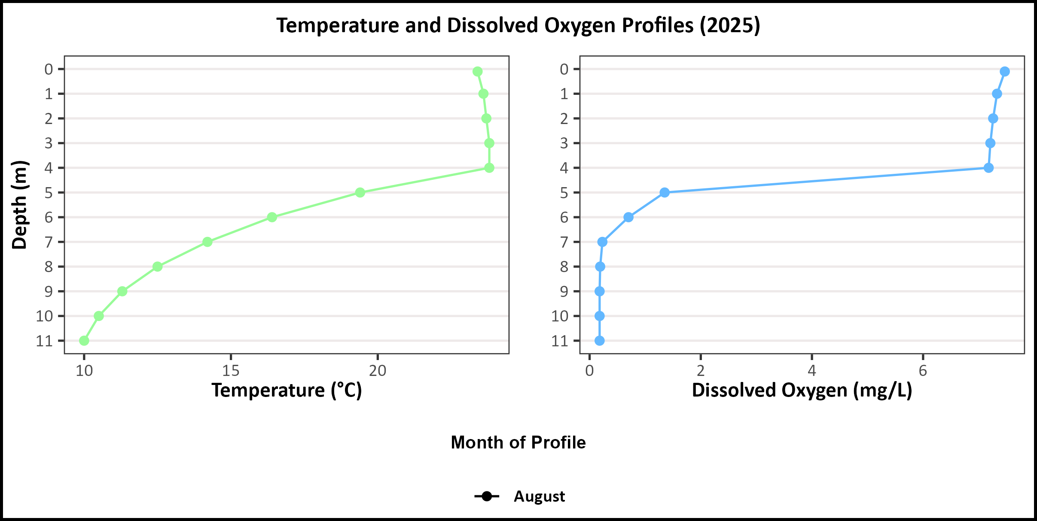
Figure 3. 2025 vertical profiles of temperature (°C; green points, left plot) and dissolved oxygen (mg/L; blue points, right plot) plotted against depth (m). Profile month is indicated by point shape and color intensity, with lighter shades representing earlier-season samples and darker shades representing later-season samples.
Figure 4. Phytoplankton community composition over time, expressed as relative abundance of major taxonomic groups.
Table 2. 2025 Average Water Quality Data for Angle Pond – Sandown
Station | Alk. (mg/L) | Chlor-a (μg/L) | Chloride (mg/L) | Color (pcu) | Cond. (μS/cm) | Total P (μg/L) | Trans. NVS (m) | Trans. VS (m) | Turb. (ntu) | pH
Epilimnion | 21.65 | 6.56 | 47.1 | 72.5 | 223.65 | 14.95 | 2.62 | 3.44 | 0.86 | 7.29
Metalimnion | No Value | No Value | No Value | No Value | 209.50 | 16.55 | No Value | No Value | 1.48 | 6.74
Hypolimnion | No Value | No Value | No Value | No Value | 216.05 | 46.23 | No Value | No Value | 2.63 | 6.73
Condos | No Value | No Value | 115 | No Value | 635.00 | 11.50 | No Value | No Value | 0.25 | 5.95
Lakeview Ramp | No Value | No Value | 54.6 | No Value | 273.60 | 40.80 | No Value | No Value | 2.25 | 6.75
North Inlet | No Value | No Value | 32.7 | No Value | 160.30 | 27.10 | No Value | No Value | 0.89 | 6.29
Outlet | No Value | No Value | No Value | No Value | 233.40 | 20.45 | No Value | No Value | 0.96 | 6.98
Sayre Inlet | No Value | No Value | 91.6 | No Value | 396.10 | 364.00 | No Value | No Value | 9.76 | 6.64
Smith Inlet | No Value | No Value | 115 | No Value | 498.10 | 60.10 | No Value | No Value | 4.30 | 6.65
West Inlet | No Value | No Value | 44.3 | No Value | 227.30 | 24.70 | No Value | No Value | 0.61 | 6.49

Observations (Refer to Table 2 and Historical Deep Spot Data Graphics):
- Chlorophyll-a (Chlor-a):
- Conductivity (Cond.) / Chloride:
- Color:
- Total Phosphorus (Total P):
- Secchi Disk Transparency (Trans.):
- Turbidity:
- pH:

How does your lake compare to New Hampshire lakes and water quality standards?
Table 3. New Hampshire Median Lake Water Quality Values. Median values generated from historic lake monitoring data.
Parameter | Median Value
Alkalinity | 4.5 mg/L
Chlorophyll-a | 4.39 μg/L
Chloride | 5 mg/L
Conductivity | 42.3 μS/cm
Total Phosphorus | 11 μg/L
Transparency | 3.3 m
pH | 6.6
Table 4. New Hampshire Water Quality Standards. Numeric criteria for specific parameters. Water quality violation occurs if thresholds are exceeded.
Parameter | Threshold
Chloride | > 230 mg/L (chronic)
E. coli (beach) | > 88 cts/100 mL
E. coli (surface water) | > 406 cts/100 mL
pH | between 6.5-8.0 (unless naturally occurring)
Turbidity | > 10 NTU above natural

