Optimizing age-based vaccination rates to minimize respiratory disease burden in a RSV, influenza, and SARS-CoV-2 “tripledemic”
Aim: To characterize the optimal age-based distribution of vaccines for RSV, influenza, and COVID-19 – diseases with different age profiles of severity – in a tripledemic season with finite healthcare resources.
Towards this aim, we will implement an age-stratified SEIR model that tracks each of the three pathogens. Individuals start in the S compartment, and become exposed (E) through contact with infectious (I) individuals. Infection can happen with SARS-CoV-2, influenza, or RSV. Infection might lead to recovery (back to S) or to hospitalization (H) after which the individual either recovers and moves back to S, or dies (D). Importantly, if hospital capacity is full then those in I who would otherwise become hospitalized immediately succumb to disease-related death. After recovery, individuals move back to the susceptible compartment where they remain until reinfection.
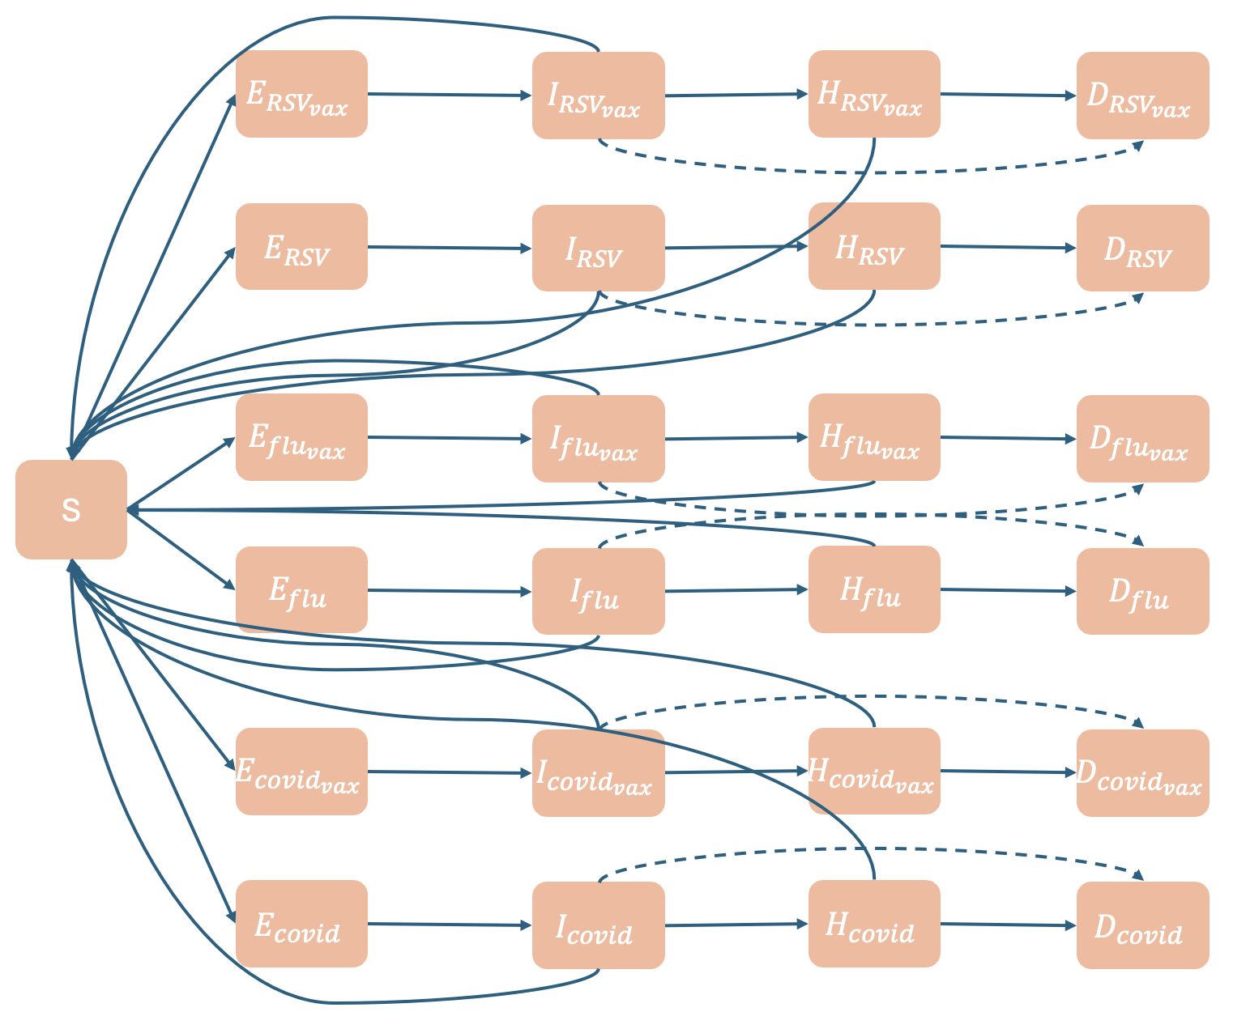
Figure 1. Compartmental diagram. Solid arrows indicate usual transition between compartments, while dashed arrows highlight transition from I to D which only happens when the number of individuals in all H compartments exceeds the number of available hospital beds.
The risk of infection, hospitalization, and disease-related death in this model will be parameterized using estimates from the literature. Age will be treated as a stratification into four groups with cross-group contact: (1) Children 0-5, (2) Older children 6-18, (3) Adults 18-64, (4) 65+. Population sizes will be taken from the American Community Survey sheet S0101 and contacts between groups will be generated using the socialmixr package in R.
Vaccination rates will be benchmarked for the United States from the CDC VaxView. The effects of vaccination will be considered in two ways. First, vaccination will reduce transmission through moderating the baseline force of infection $λ$, so that the rate moving into $I_{vax}$ for each pathogen is given by
$λ_{vaccinated}={VE}_{i}*V_{coverage}*λ$ (Equation 1)
and the rate moving into the unvaccinated $I$ compartment is given by
$λ_{unvaccinated}=(1-V_{coverage})*λ$ (Equation 1)
Second, vaccination will reduce severity through hospitalization risk for those in the $I_{vax}$ compartments. We will parameterize these efficacy values from the existing literature.
Analyses
We will simulate a single “tripledemic” disease season, where the population is broadly susceptible to all three pathogens and seasonal outbreaks of each pathogen follow similar timing, echoing the 2022-23 season. We will analyze various scenarios of vaccine coverage across groups given a limited number of vaccines to allocate and hospital beds available.
Analysis 1) First, we will run a scenario without vaccines (counterfactual) and a scenario at current vaccine coverage levels.
Analysis 2) Next, we will consider four discrete scenarios where the current allocation of existing vaccine doses is preserved, but we can also produce and deliver an extra X% more doses to allocate in the population in response to the tripledemic. In these scenarios, we will identify for each pathogen the best way to allocate these doses if we are concerned about infections, hospitalizations, or deaths.
Scenario 1 | Scenario 2 | Scenario 3 | Scenario 4
Extra doses allocated to seniors exclusively | Extra doses allocated to young children exclusively | Extra doses split proportionally between seniors and young children | Extra doses equally distributed throughout the population

This could be displayed as a three panel figure, where each panel is a time series of a metric (infection, hospitalization, death) and the colors are pathogens.

Analysis 3) Finally, we will overlay the four scenarios in Analysis 2 across the three pathogens, identifying those scenarios which minimize in aggregate both the peak and cumulative infections, hospitalizations, and deaths. We will compare and discuss the optimal scenarios in aggregate with the individual optimal strategies for each isolated pathogen.
Here, we could show a panel of the 4x4x4 scenarios colored by level of burden in 3d space; we will have to think about how to display this 3 dimensionally. Then have as additional panels the aggregate time series for minimal scenarios for each metric.

How this analysis differs from the parent vs. child vaccination paper
- We will focus on a crisis scenario that echoes the 2022-23 season when all three of these major respiratory pathogens peaked
- We will de-emphasize the survey and focus on the overall age distribution of vaccination and risk
- This paper will focus on optimizing allocation of resources given healthcare resource constraints, whereas the parent-child paper will focus on targeting specific groups for increasing vaccination rates which might be low due to vaccine hesitancy or limited access to existing resources
- This paper focuses on patterns of vaccination across age in general, rather than within households of parent/child
- This paper will include RSV and is a multi-pathogen SEIR; we will optimize disease burden in aggregate across three key pathogens rather than conducting completely separate analyses for each pathogen

Timeline
- July 21 - August 8: Implement and parameterize mechanistic model in R
- August 8-15: Run and finalize analyses
- August 15-29: Draft manuscript
- September 2-19: Circulate manuscript among SHIELD team
- By September 26: Submit to a journal (NatComm? BMC Public Health?)

