**Does state political affiliation affect the types of  mental health services or programs available in that state?**

We looked at data from a survey conducted by the *Substance Abuse and Mental Health Services Administration (SAMHSA)*. SAMHSA sent out a survey to all known mental health facilities in the U.S. The survey asked about the types of services each facility offered. Each mental health facility answered whether or not they had a dedicated program or service in the categories we analyzed.

To test our question we looked at percentage of mental health facilities that offer each program in each state. For each of our program categories we took the number of facilities that offered the program divided by the total number of facilities surveyed in the state. We defined state political affiliation by the party with the most votes in the 2016 federal election. We then compared the republican state mean to the democratic state mean in 2016. For some programs, we also compared factors that might influence the necessity of the program.

**Education Programs**

On average, 35% of Republican state mental health facilities offered education programs. On average, 30% of Democratic state mental health facilities offered education programs. The standard deviation is 9.7. Relative to the standard deviation, the difference in means is not very large. The top five states were all republican.

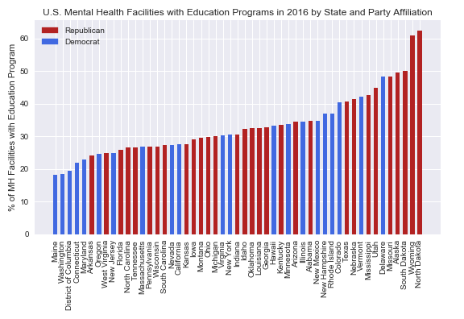

When compared to the mapping of education (percent of college graduates), it shows Democratic states on average have a higher per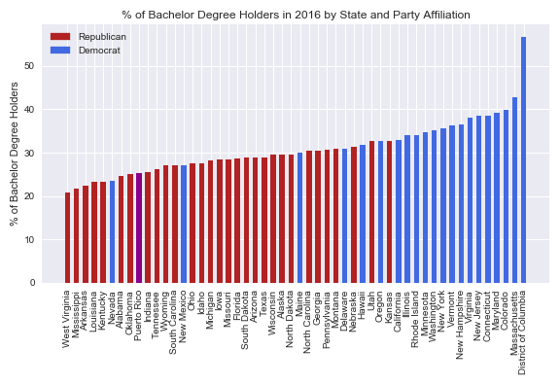

**Housing Programs**

On average, 19% of Republican state mental health facilities offered housing programs. On average, 25% of Democratic state mental health facilities offered education programs. The standard deviation is 8.0. Relative to the standard deviation, the difference in means is not very large.

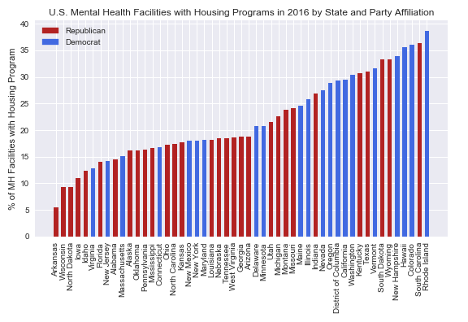

**Veteran Programs**

On average, 12% of Republican state mental health facilities offered veteran programs. On average, 12% of Democratic state mental health facilities offered education programs. The standard deviation is 5.1.

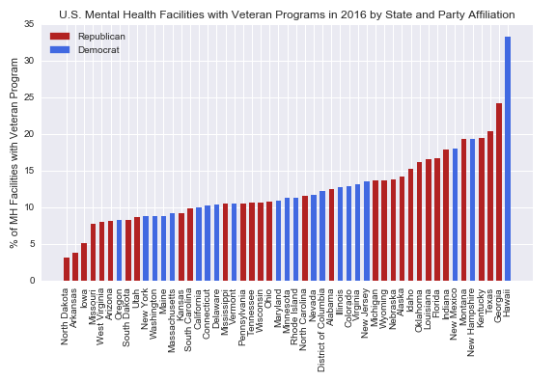

**LGBT Programs**

On average, 11% of Republican state mental health facilities offered lgbt programs. On average, 15% of Democratic state mental health facilities offered education programs. The standard deviation is 5.1.

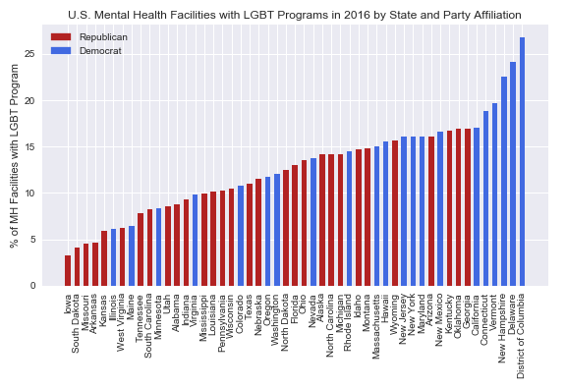

**Suicide Prevention Programs**

On average, 59% of Republican state mental health facilities offered suicide prevention programs. On average, 52% of Democratic state mental health facilities offered education programs. The standard deviation is 11.4.

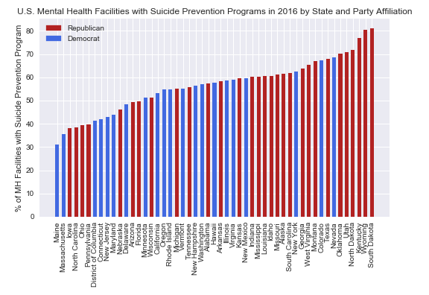

**Substance Abuse Programs**

On average, 57% of Republican state mental health facilities offered substance abuse programs. On average, 54% of Democratic state mental health facilities offered education programs. The standard deviation is 12.4.

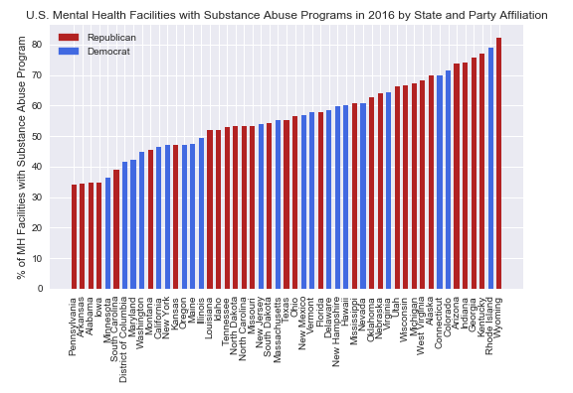

**Payment Assistance Programs**

On average, 52% of Republican state mental health facilities offered substance abuse programs. On average, 52% of Democratic state mental health facilities offered education programs. The standard deviation is 10.7.

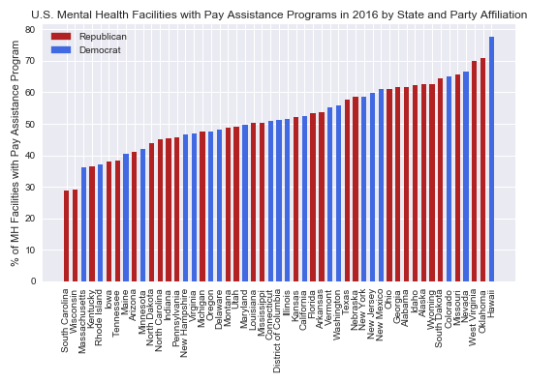

Overall we did not find a strong relationship between state affiliation and the types of mental health programs that were present in the state. We did find some interesting patterns in range of availability of programs. We found that the distributions related to a specific mental illness had higher standard deviations. Both suicide prevention (std = 11.4) and substance abuse programs (std = 12.4) had high variations between states.We belive this could be related to the prevelance of the mental illness in the state. When comparing state suicide death rates to the percentage of mental health facilities with suicide prevention programs we saw a strong positive correlation. Fo

We found that distributions related to demographic based programs had the lowest standard deviations. Veterans has a standard deviation of 5.1 and LGBT has a standard deviation of 5.1.

**Limitations**

Originally we thought about comparing the population of the state compared to number of mental health facilities. So that our metric for comparison would mental health facility per x persons in the state. We were concerned about using this metric since there was no measure of how large the facility was and not all mental health facilities in a state participated in the survey. Both large and small facilities would be represented in the same way.

**Further Exploration:**

* If we defined political affiliation differently would we get different results (state governor’s party, state senate majority)?
* Do primary health care programs vary by state in the same way?